Listening/Speaking Reading Grammar Writing
Topic: Dinosaurs In Our Daily Lives
(Language Target : Subjunctive)

Instructor:  SKY | Students Competency Level  Intermediate | Number of Students:  13 | Lesson Length:  50 minutes
Materials: (List the Names of all materials used in the lesson. Materials must be shown at the end of this document)
- White Board and Markers
- Drilling PowerPoint I
- Drilling PowerPoint II
- Dinosaur Picture #1
- Dinosaur Picture #2
- Dinosaur Picture #3
- Dinosaur Picture #4
- Dinosaur Picture #5
- Dinosaur Picture #6
- Dinosaur Picture #7
- Dinosaur Picture #8
- Key Words Table of the Dino Pictures
- Imaginary Dino Picture #1
- Imaginary Dino Picture #2
- Imaginary Dino Picture #3
- Imaginary Dino Picture #4
Aims: (What students will be able to achieve by participating in the activities of the lesson. (Ss gain or get by doing…)
- Improve Ss grammar skills about Subjunctive. by making their own sentences for the pictures provided in the main activity.
- Ss will improve speaking skills by discussing the situation of the Dinosaur Picture #1 to # 8. in the main activity.
- Ss will improve listening skill by listening to the teacher’s introduction, explanation, and the other students talk.
- Participate with fun in the main activity by sharing ideas from discussion pictures in the main activity
Language Skills: (Lists what activities language skills students will be using by participating in the activities of the lesson.)
- Reading: (Where did reading occur in the lesson?)
Drilling PPT chart, whiting sentences
- Listening: (Where did listening occur in the lesson?)
Teacher’s instruction and explanation, discussion.
- Speaking: (Where did speaking occur in the lesson?)
Responding to teacher, Sharing the opinions with other students in group discussion,
- Writing: (Where did writing occur in the lesson?)
Writing the subjunctive sentences of the main activity “Pictures for Discussion”

Language Systems: (Lists what language systems students will be using by participating in the activities of the lesson.)
- Phonology: (sound)
Discussion, Teacher talk, Activity participation.
- Function: (situation)
Expressing ideas
- Lexis: (meaning)
Vocabulary and phrases
- Grammar: (language structure)
Subjunctive
- Discourse: (communication)
Responding the teacher, talking to a partner and a class
Assumptions: (What students must already be able to do and what concepts must already be mastered before the lesson in order to achieve the aims of the lesson.)
- Ss know about the simple present and the simple past.
- Ss will enjoy discussion and sharing their opinions
- Ss know a few imaginary persons, animals or plants.
Anticipated Errors and Solutions: (What things might go wrong in the lesson and what the solution will be. An SOS activity should also be included)
- If activity lasts too long
: Teacher cuts the unnecessary parts.
- Some Ss might have difficulties in the activity.
: Teacher gives them a hint such the important words.
- If some Ss don’t give their opinions during the group discussion
: Teacher gives the opinion first
- If activity finishes too soon.
: Teacher makes suggestions.
(such as the new A.I machines you would like to have in the future.)
References:

Lead-In or Pre-Task Part (Warm-Up Part to activate and create interest in the lesson.)
Materials: (List the Names of all materials used in the Lead-In or Pre-Task Part of the lesson. Materials must be shown at the end of this document)

Time: | Classroom Set Up: | Student Activity and Goals: | Teacher Procedure & Instructions:
1 min  3 min  3 min | Whole  Whole  W - S | Ss greet the teacher  Ss listen to teacher  Ss talk their experiences to the class | Greeting.  Tell the story of “How much kids liked the dinosaurs. And share the story of ET with students.  Ask Ss “Have you ever liked the imaginary persons(like Santa, Harry Potter), animals(such as unicons, dragons), and so on?”. And let them share their experience with the class.  Let’s look at how our lives change if the Dinosaurs came again.

Pre-Activity or Task Familiarization Part (Presentation Part Presenting the language structure to be covered in the lesson. Prepares students for the communication activity.)
Materials: (List the Names of all materials used in the Pre-Activity or Task Familiarization Part of the lesson. Materials must be shown at the end of this document)

- White Board and Markers
- Drilling PowerPoint I
- Drilling PowerPoint II
- Dinosaur Picture #1
Time: | Classroom Set Up: | Student Activity and Goals: | Teacher Procedure & Instructions:
5 min  3 min | Whole  Whole | Ss read, listen, speak  and drill to learn and become familiar with subjunctive sentences  Ss guess the answers of the Dinosaur Picture #1. | Put drilling PPT on the white board  Do drilling with student.  Hand out the Dinosaur Picture #1.  Let the students discuss and make the subjunctive sentence starting with  “If the dinosaurs came again”

Main Activity or Task Realization Part (Practice to Production Part Teacher lead practice of the language presented and move to communication based more student centered activity)
Materials: (List the Names of all materials used in the Main Activity or Task Realization Part of the lesson. Materials must be shown at the end of this document)

- Dinosaur Picture #2
- Dinosaur Picture #3
- Dinosaur Picture #4
- Dinosaur Picture #5
- Dinosaur Picture #6
- Dinosaur Picture #7
- Dinosaur Picture #8
- Key Words Table of the Dino Pictures
- Imaginary Dino Picture #1
- Imaginary Dino Picture #2
- Imaginary Dino Picture #3
- Imaginary Dino Picture #4

Time: | Classroom Set Up: | Student Activity and Goals: | Teacher Procedure & Instructions:
1 min  8 min  5 min  10 min  5 min | Whole  Pair  Whole  Pair  Whole | Ss listen to Teacher.  Ss discuss and share the ideas of the situations in the Pictures. And make the Subjunctive sentences  Ss share the opinions with the class.  Ss discuss and share the ideas of the situations in the Pictures. And make the Subjunctive sentences  Ss share the opinions with the class. | Teacher explains the Dinosaur Picture #1.  And give students the teacher’s sentence for the Dinosaur Picture #1.  Teacher hands out the Dinosaur Pictures #2 to #8.  And ask students to discuss the situations and make the subjunctive sentences starting with  “If the dinosaurs came again”  If the students seem to have difficulties, teacher give them the ‘Key Words Table of the Dino Pictures’  Let the students describe the pictures and present their sentences to the class  And teacher says “Let’s use more imagination about our lives with the dinosaurs.”  Teacher hands out the Imaginary Dino #1 to #4.  And ask students to discuss the characteristics of the Dinos, imagine how our lives could be changed with the Dinos and make the subjunctive sentences.  Let the students explain the Dinos and present their sentences to the class

Post Activity or Post Task Part (Wrap-Up Part Close the Lesson on a high note to and consolidate language learned in a communication based activity new situation.)
Materials: (List the Names of all materials used in the Post Activity or Post Task Part of the lesson. Materials must be shown at the end of this document)

Time: | Classroom Set Up: | Student Activity and Goals: | Teacher Procedure Instructions:
2 min  1 min | Whole  Whole | Ss tell the opinions  Ss listen teacher. | Ask the students which sentence is the best and the reason.  Wrap up the class by thanking them for their participation .

[Drilling PowerPoint I]

If + Subject + Simple Present, Subject + Will + Base Verb.

[Drilling PowerPoint II]

If + Subject + Simple Past, Subject + Would or Could + Base Verb.

Dinosaur Picture #1
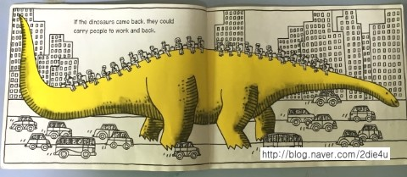

Dinosaur Picture #2
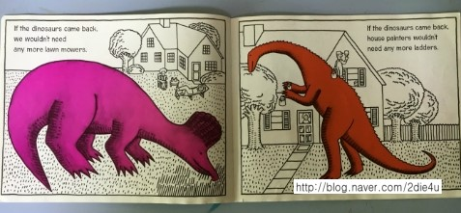

Dinosaur Picture #3
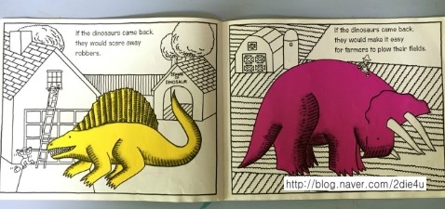
Dinosaur Picture #4
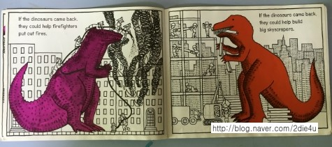

Dinosaur Picture #5
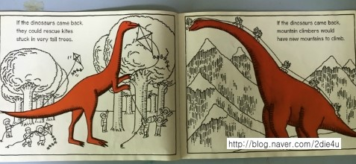

Dinosaur Picture #6
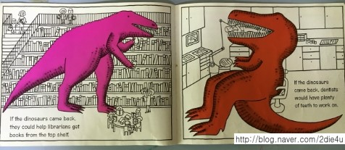
Dinosaur Picture #7
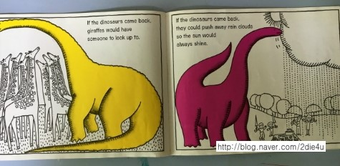

Dinosaur Picture #8
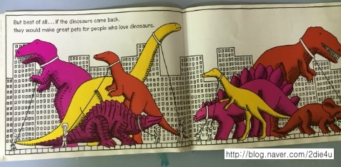

[Key Words Table of the Dino Pictures]

Lawn mowers / painter / ladders
robbers / farmers / plow their fields
Firefighters / put out / skyscrapers
Kites / stuck / mountain climbers
Librarians / dentists / plenty of teeth
Look up to / push away
pets

[Imaginary Dino Picture #1] Ankylosaurus

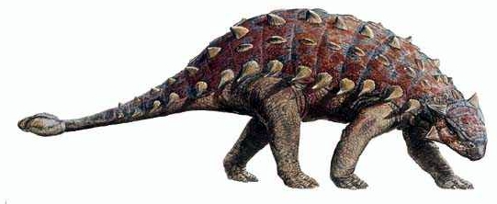

[Imaginary Dino Picture #2] Pteranodon
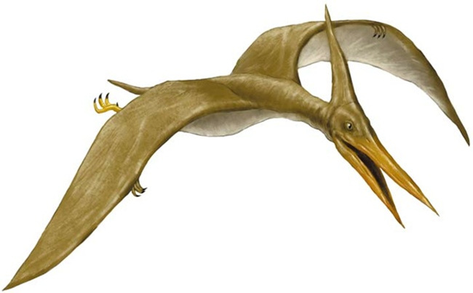

[Imaginary Dino Picture #3] Stegosaurus
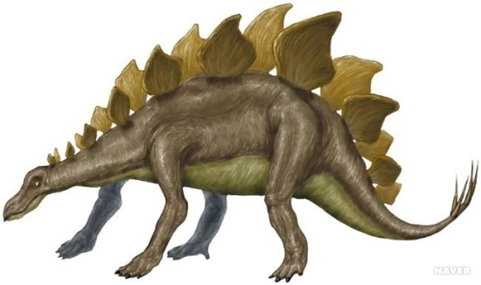

[Imaginary Dino Picture #4] Pachycephalosaurus

