Listening Speaking Reading Grammar Writing
Topic: Animals
(Language Target: Comparative and Superlative)
Instructor:  Kate | Students Competency Level  Lower Intermediate | Number of Students:  14 | Lesson Length:  54 minutes
Materials: (List the Names of all materials used in the lesson. Materials must be shown at the end of this document)
White Board and Markers
Teacher’s Story Pictures:
- Lizard
Comparative and Superlative Adjective Table Sheet
Animal Lists Worksheet with Pictures
Animal Lists Worksheet with Actual Speed
Aims: (What students will be able to achieve by participating in the activities of the lesson. (Ss gain or get by doing…)
- Improve listening skills by listening T’s story, Ss stories, drilling
- Improve listening to other Ss statements during pair/group discussion
- Improve Ss speaking skills by discussing in discussing groups and responding to
teacher questions
- Improve Ss grammar sills about comparative and superlative adjective by T
responding and rephrasing Ss thoughts, drilling, writing and group activity
Language Skills :( Lists what activities language skills students will be using by participating in the activities of the lesson.)
- Reading: (Where did reading occur in the lesson?)
Worksheets
- Listening :( Where did listening occur in the lesson?)
Teacher talk and explanation, Ss talk, discussion
- Speaking: (Where did speaking occur in the lesson?)
Small group discussion, answering teacher
- Writing: (Where did writing occur in the lesson?)
Taking notes the worksheet during a pair work and a group discussion
Language Systems: (Lists what language systems students will be using by participating in the activities of the lesson.)
- Phonology: (sound)
Drilling, T and Ss talk
- Lexis: (meaning)
Comparative and Superlative adjective use
- Grammar:(language structure)
- Comparative and Superlative adjective
- Discourse: (communication)
Talking to a partner and discussion in groups, sharing stories, and drilling
Assumptions :( What students must already be able to do and what concepts must already be mastered before the lesson in order to achieve the aims of the lesson.)
- Most of Ss understand about the language target as they are in lower intermediate
level.
- All Ss have opinion about the fastest and slowest animals
- All Ss wil enjoy discussion and sharing their opinion.
Anticipated Errors and Solutions :( What things might go wrong in the lesson and what the solution will be. An SOS activity should also be included)
- If Ss may not have many ideas ☞ Solution: T gives them little examples.
- If activity lasts too long ☞ Solution: T cuts the unnecessary parts.
- If activity finished too soon. ☞ Solution: T makes suggestions and shares ideas.
- If Ss may not understand. ☞ Solution: T shows demonstration.
- If certain Ss are shy. ☞ Solution: T encourages them, gives positive feedback, and changes roles for them.
References:

Lead-In or Pre-Task Part (Warm-Up Part to activate and create interest in the lesson.)
Materials: (List the Names of all materials used in the Lead-In or Pre-Task Part of the lesson. Materials must be shown at the end of this document)
White Board and Markers
Teacher’s Story Pictures:
- Lizard
Time: | Classroom Set Up: | Student Activity and Goals: | Teacher Procedure &Instructions:
1 min  3 min  5 min | Whole  Whole  Whole | Ss greet the teacher.  Ss listen to T’s story.  Ss talk their experience or opinions about animals and listen to other Ss thoughts. | Greeting.  T shares thoughts about animals to get Ss interested in topic.  T asks the thoughts about the topic to Ss.

Pre-Activity or Task Familiarization Part (Presentation Part Presenting the language structure to be covered in the lesson. Prepares students for the communication activity.)
Materials: (List the Names of all materials used in the Pre-Activity or Task Familiarization Part of the lesson. Materials must be shown at the end of this document)
White Board and Markers
Time: | Classroom Set Up: | Student Activity and Goals: | Teacher Procedure &Instructions:
2 min  5 min  3 min  5 min | Whole  Whole  Whole | Ss look at the drawings on the board.  Ss listen to T’s question and answer to them.  Ss look at the writing on the board.  Ss choose two animals and make sentences comparing their speed. | This part will be the brainstorming stage about animals.  T draws a spider map on the board with ‘Animals’ in the middle and three branches of ‘wild animals’ (with ‘sea’, ‘land’, ‘air’), ‘farm animals’, and ‘pets’.  T elicits Ss lots of animals’ words and writes them in the diagram.  T writes on the board:  ( ) is a lot faster/slower than ( ).  ( ) is quite a bit faster/slower than ( ).  ( ) is not much faster/slower than ( )  T asks several Ss to choose two animals and asks them to make a sentence comparing their speed.  E.g. A horse is a lot faster than a hedgehog.

Main Activity or Task Realization Part(Practice to Production Part Teacher lead practice of the language presented and move to communication based more student centered activity)
Materials: (List the Names of all materials used in the Main Activity or Task Realization Partof the lesson. Materials must be shown at the end of this document)
White Board and Markers
Comparative and Superlative Adjective Table Sheet
Animal Lists Worksheet with Pictures
Animal Lists Worksheet with Actual Speed
Time: | Classroom Set Up: | Student Activity and Goals: | Teacher Procedure &Instructions:
3 min  5 min  2 min  5 min | Whole  Whole  Whole  Group | Ss receive the tables.  Ss listen to T.  Ss listen carefully and repeat after T.  Ss read the worksheet.  Ss talk about their opinion on the speed of the animals and make the list.  Ss receive the worksheet and look at the information about the animals. Check their orders. | T hands out the comparative and superlative adjective table.  T read the table first.  T reads the table again and asks Ss to listen carefully and repeat after T.  T gives twelve animals worksheet.  : Elephant, giraffe, giant tortoise, Peregrine falcon, spider, black mamba snake, chicken, garden snail, human, cheetah, ostrich, greyhound  T asks to write the list of twelve animals from the fastest to the slowest. The two students have to discuss. Ss may use comparative and superlative adjective during discussion.  T hands out the animal list worksheet with their actual speed and asks Ss to check it.

Post Activity or Post Task Part (Wrap-Up Part Close the Lesson on a high note to and consolidate language learned in a communication based activity new situation.)
Materials: (List the Names of all materials used in the Post Activity or Post Task Part of the lesson. Materials must be shown at the end of this document)
White Board and Markers
Animal Lists Worksheet with Actual Speed
Time: | Classroom Set Up: | Student Activity and Goals: | Teacher Procedure Instructions:
2 min  13 min | Whole  Group | Ss look at writing on the board.  Ss listen and make sentences using comparative and superlative. Share the sentences with others. | T writes on the board  : Heavy, Light, Big, Small  T asks to make a group of 3~4 persons.  T asks to make sentences comparing animals’ actual speed from the list and using a quantifier and heavier, lighter, bigger or smaller.

Teacher’s Story Pictures
Lizard

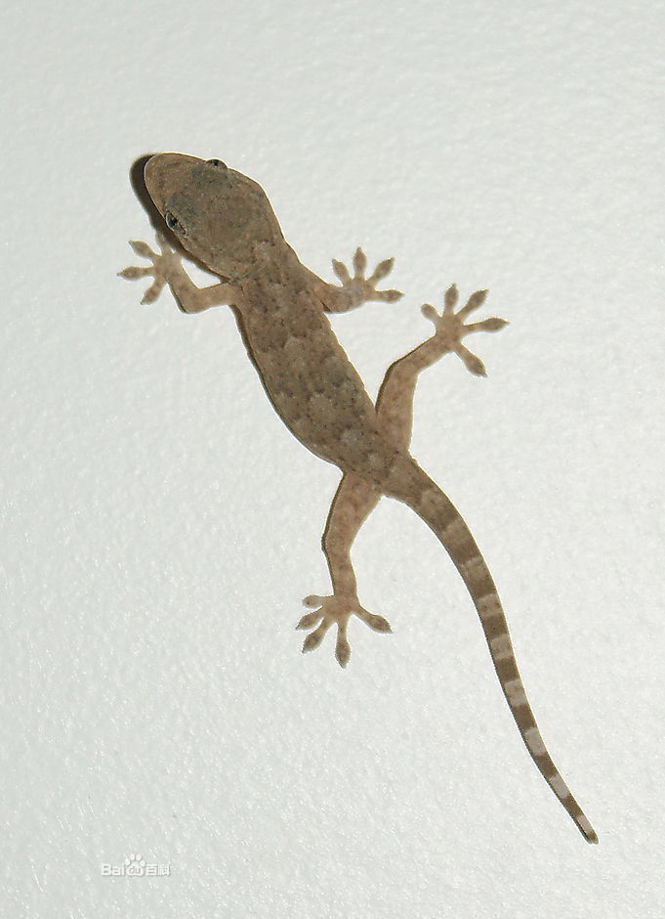

Comparative and Superlative Adjective Table

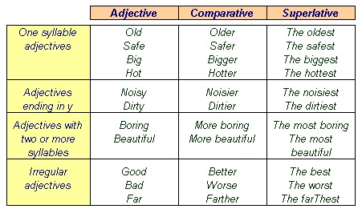

Animal List with Pictures

Elephant, giraffe, giant tortoise, Peregrine falcon, spider, black mamba snake, chicken, garden snail, human, cheetah, ostrich, greyhound

Elephant  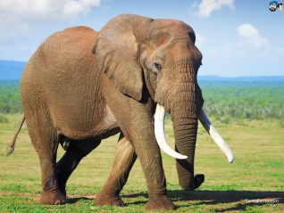 | Giraffe  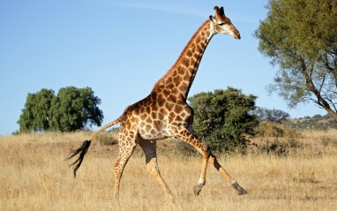 | Giant tortoise  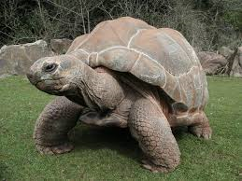 | Peregrine falcon  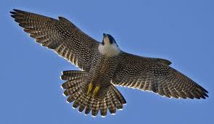
Spider  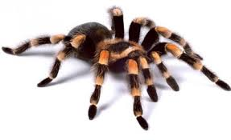 | Black mamba snake  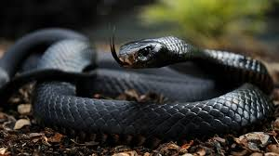 | Chicken  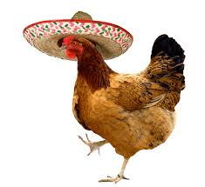 | Garden snail  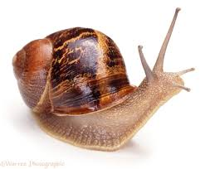l
Human | Cheetah  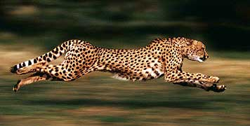 | Ostrich  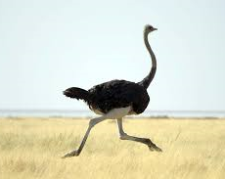 | Greyhound  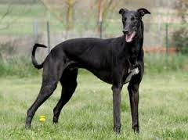

Animal List with Actual Speed

