Listening Speaking Reading Grammar Writing
Topic: This Is The Moment
(Language Target: Present Continuous)

Instructor:  Shine | Students Competency Level  Elementary Beginner  Pre Intermediate | Number of Students: 13 | Lesson Length:  55 minutes
Materials: (List the Names of all materials used in the lesson. Materials must be shown at the end of this document)
- Computer, Beam Projector & Screen, White Board & Markers
- Teacher's Motto Picture 'Today Is a Gift'
- Pre Activity Pictures
She's eating,
It's raining.
They're running.
- Timelines 'am/are/is + -ing'
- Substitution Tables 'am/are/is + -ing'
- Drilling Charts 'am/are/is + -ing'
- Worksheet for Exercises Filling in the Blanks
- Worksheet for Group Activity Make Your Story by Using the Form 'am/are/is + -ing'

Aims: (What students will be able to achieve by participating in the activities of the lesson. (Ss gain or get by doing…)
- Ss will be able to improve listening skills by listening T's story, Ss stories, Drilling and Group Activity presentation.
- Ss will be able to practice sentences in 'Be Verb + -ing' pattern.
- Ss will be able to improve speaking skills by answering T, Drilling, sharing stories and presentations.
- Ss will be able to express their ideas by discussing in groups.
- Ss will be able to improve communication ability by discussing in groups.

Language Skills: (Lists what activities language skills students will be using by participating in the activities of the lesson.)
- Reading: (Where did reading occur in the lesson?)
Timelines, Substitution Tables, Drilling Charts

- Listening: (Where did listening occur in the lesson?)
Listening to what T says, what classmates say in groups, what the other Ss say during the presentation

- Speaking: (Where did speaking occur in the lesson?)
Answering to T's questions, Speaking to partners during discussion, Presenting Ss' ideas to the class

- Writing: (Where did writing occur in the lesson?)
Taking notes on the worksheet during Group Activity Discussion

Language Systems: (Lists what language systems students will be using by participating in the activities of the lesson.)
- Phonology: (sound)
Repeating after T, Drilling and Ss talk

- Function: (situation)
Imagine and create the situation you want at this moment during Group Activity.

- Lexis: (meaning)
A variety of sentences related to Present Continuous

- Grammar: (language structure)
Present Continuous

- Discourse: (communication)
T-S, Drilling, Discussing in groups and sharing stories

Assumptions: (What students must already be able to do and what concepts must already be mastered before the lesson in order to achieve the aims of the lesson.)
- Ss know Be verb and -ing form of Verb.
- Ss can listen, speak, read and write sentences in English.
- Ss can discuss in groups and present their ideas.

Anticipated Errors and Solutions: (What things might go wrong in the lesson and what the solution will be. An SOS activity should also be included)
- If Ss cannot understand and present during Activities. > Solution: T show first and then ask Ss to do.
- If activity lasts too long. > Solution: T cuts the unnecessary parts.
- If activity finished too soon. > Solution: T can let them discuss more.
- If certain Ss do not participate. > Solution: T encourages them, gives more detail instructions and feedback them.

References:
- Essential Grammar in Use  Fourth Edition by Raymond Murphy | - Grammar in Use Intermediate  Third Edition by Raymond Murphy

Lead-In or Pre-Task Part (Warm-Up Part to activate and create interest in the lesson.)
Materials: (List the Names of all materials used in the Lead-In or Pre-Task Part of the lesson. Materials must be shown at the end of this document)
- Computer, Beam Projector & Screen
- Teacher's Motto Picture 'Today Is a Gift'

Time: | Classroom Set Up: | Student Activity and Goals: | Teacher Procedure & Instructions:
1min  2min  2min | Whole  Whole  Whole | Ss greet T  Ss listen to what T says and watch the images  Ss listen to what T says and answer some questions | Greeting  Talk about what Teacher's Motto is  Attracting Ss' attention by showing some images related to the T's Motto  T says and asks Ss to answer some questions relates to 'am/are/is + -ing' patterns  - "I am speaking in English.",  - "I am enjoying this moment."  - "Are you enjoying now?"  - "Are you listening to me?"  - ''What are you doing?"  - "What are you looking at?"  - "What are you wearing?"

Pre-Activity or Task Familiarization Part (Presentation Part Presenting the language structure to be covered in the lesson. Prepares students for the communication activity.)
Materials: (List the Names of all materials used in the Pre-Activity or Task Familiarization Part of the lesson. Materials must be shown at the end of this document)
- Computer, Beam Projector & Screen, White Board & Markers
- Pre Activity Pictures
She's eating,
It's raining.
They're running.
- Timelines 'am/are/is + -ing'
- Substitution Tables 'am/are/is + -ing'
- Drilling Charts 'am/are/is + -ing'

Time: | Classroom Set Up: | Student Activity and Goals: | Teacher Procedure & Instructions:
3min  12min | Whole  Whole | Ss listen to what T says and answer the questions watching the pictures  Ss read, listen, speak and drill to learn and become familiar with 'am/are/is + -ing' | T show some pictures and ask Ss to answer some questions related to 'am/are/is + -ing'  T show Timelines, Substitution Tables and Drilling charts on PPT  Do drilling with Ss  Transition to Main Activity for 'am/are/is + -ing'

Main Activity or Task Realization Part (Practice to Production Part Teacher lead practice of the language presented and move to communication based more student centered activity)
Materials: (List the Names of all materials used in the Main Activity or Task Realization Part of the lesson. Materials must be shown at the end of this document)
- Computer, Beam Projector & Screen, White Board & Markers
- Worksheet for Exercises Filling in the Blanks
- Worksheet for Group Activity 'Make Your Story by Using the Form 'am/are/is + -ing'

Time: | Classroom Set Up: | Student Activity and Goals: | Teacher Procedure & Instructions:
1min  1min  3min  5min  5min  10min  5min | Whole  Group  Group  Group  Whole  Group  Whole | Ss listen to T  Ss move into each group  Ss listen to T and receive the worksheet  Ss fill in the blanks by discussing in each group  Ss present in front of the board  Ss discuss and create their stories in each group  Ss present their stories | T introduce Group Activities by explaining what activities will begin and how you can do them together  - Exercises Filling in the Blanks for 'am/are/is + -ing' patterns  -Make Your Story by Using the Form 'am/are/is + -ing'  Divide Ss into groups  Distribute the Handout for Group Activities to each group  - Worksheet for Exercises Filling in the Blanks  - Worksheet for Group Activity Make Your Story by Using the Form 'am/are/is + -ing'  Let Ss fill in the blanks at worksheet for Exercises Filling in the Blanks first  Ask Ss to present the complete sentences in front of the board  Let Ss communicate with each other for Group Activity Make Your Story with animation characters by Using the Form 'am/are/is + -ing'  T monitors and gives encouragement to each group  Let Ss present their stories  Give Ss positive feedback and comments

Post Activity or Post Task Part (Wrap-Up Part Close the Lesson on a high note to and consolidate language learned in a communication based activity new situation.)
Materials: (List the Names of all materials used in the Post Activity or Post Task Part of the lesson. Materials must be shown at the end of this document)
None

Time: | Classroom Set Up: | Student Activity and Goals: | Teacher Procedure Instructions:
5min | Whole | Ss listen to what T says and answer the questions | Review the Form 'am/are/is + -ing' by  asking Ss to answer some questions related to 'am/are/is + -ing'  Close by giving Ss feedback about their accomplishment and improvement

* Teacher's Motto *

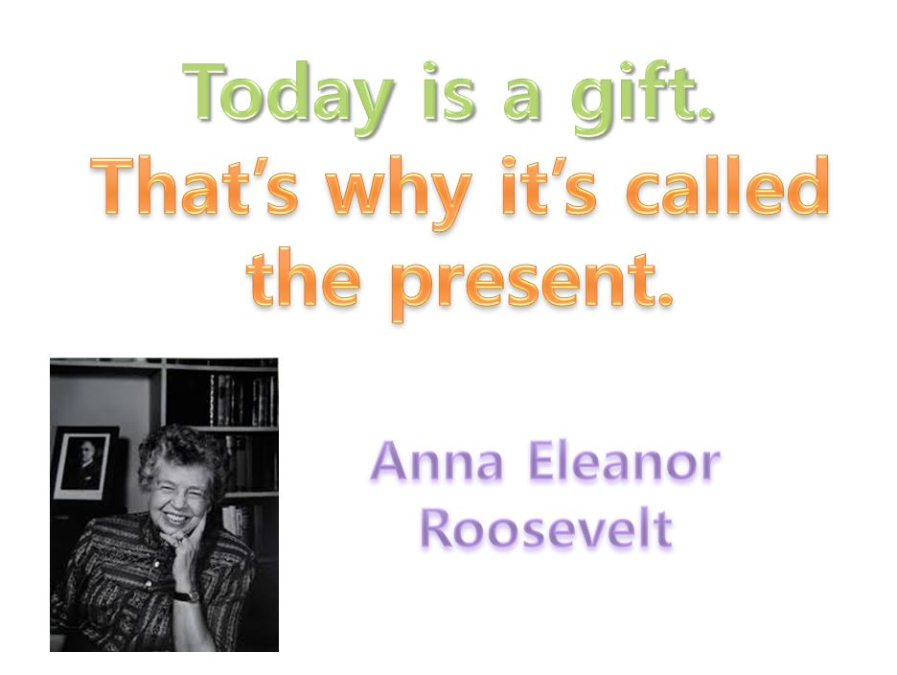

* Pre Activity Pictures *

1. She's eating. 2. It's raining. 3. They're running.
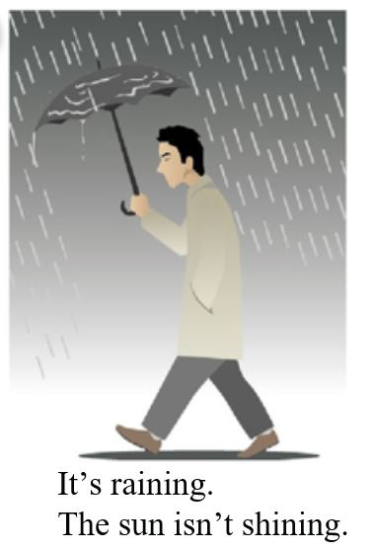
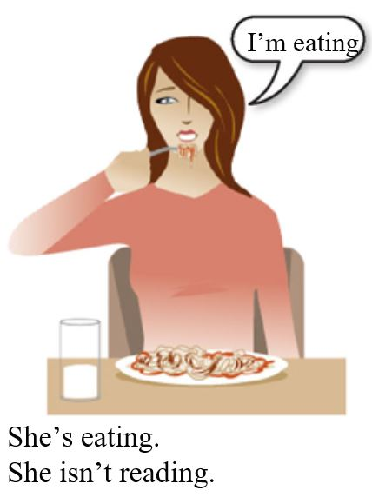
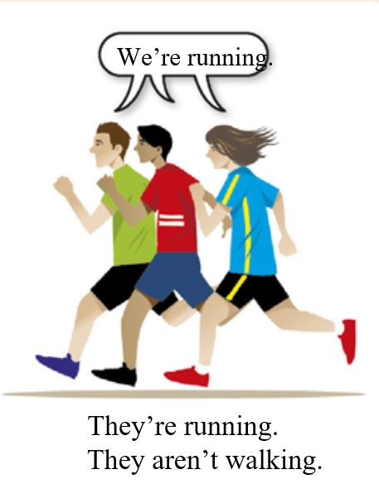

* Timelines - Subject + Be Verb (am/are/is) + -ing *
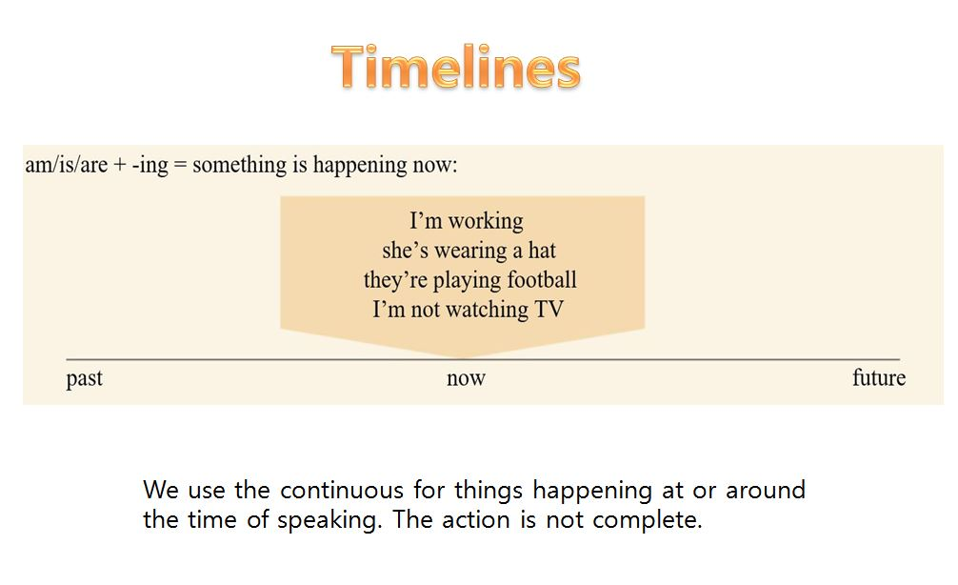

* Substitution Tables - Subject + Be Verb (am/are/is) + -ing *
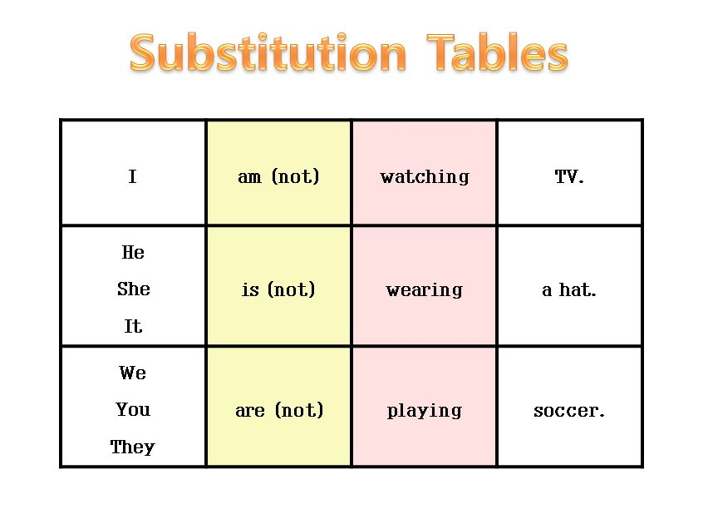

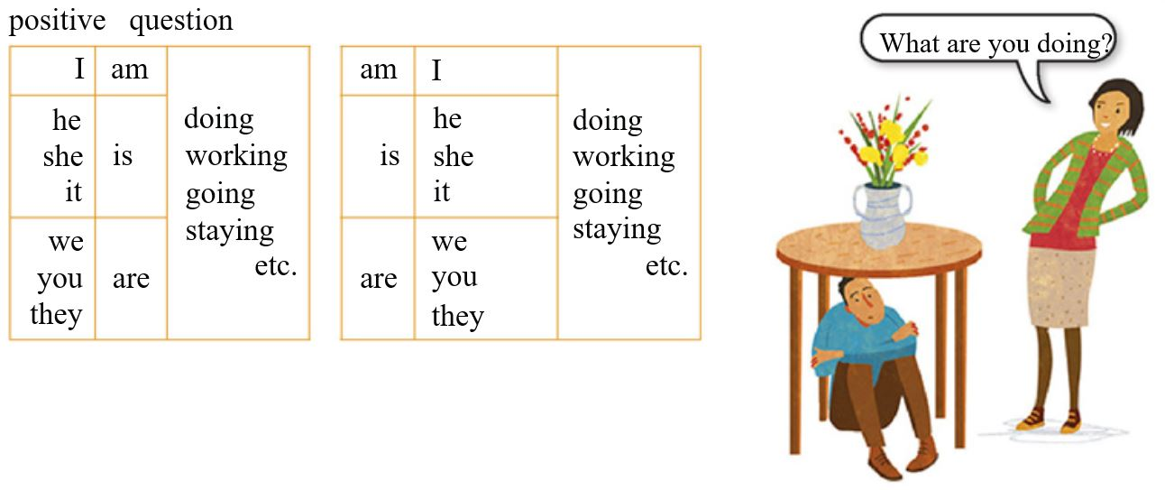

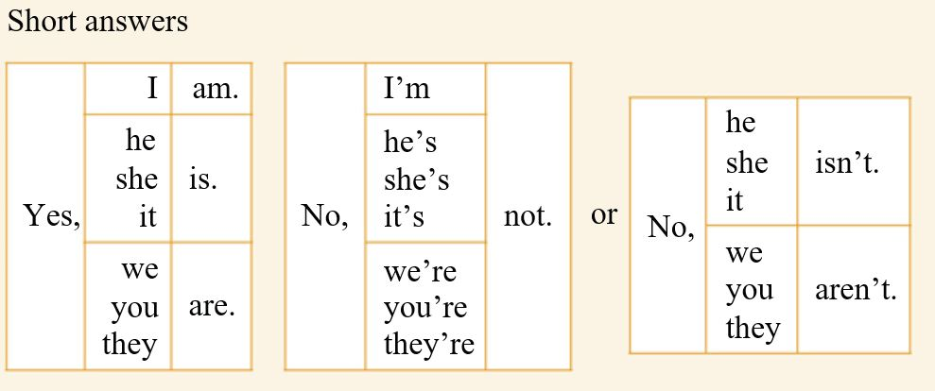

* Drills - Subject + Be Verb (am/are/is) + -ing *

① Please be quiet. I am working.

② Maria is reading a newspaper.
She isn’t (=is not) eating.

③ Look, there’s Sarah.
She is wearing a brown coat.

④ The weather is nice.
It’s (=It is) not raining.

⑤ ‘Where are the children?’
‘They are playing in the park.’

⑥ (on the phone)
We are having dinner now.
Can I call you later?

⑦ You aren’t (=are not) listening to me.

⑧ The children are doing their homework.

⑨ Are you going now?
Yes, I am.

⑩ Is Ben working today?
Yes, he is.

⑪ Is it raining?
No, it isn’t.

⑫ Are your friends staying at a hotel?
No, they aren’t. They’re staying with me.

* Group Activity 1 - Fill in the Blanks *
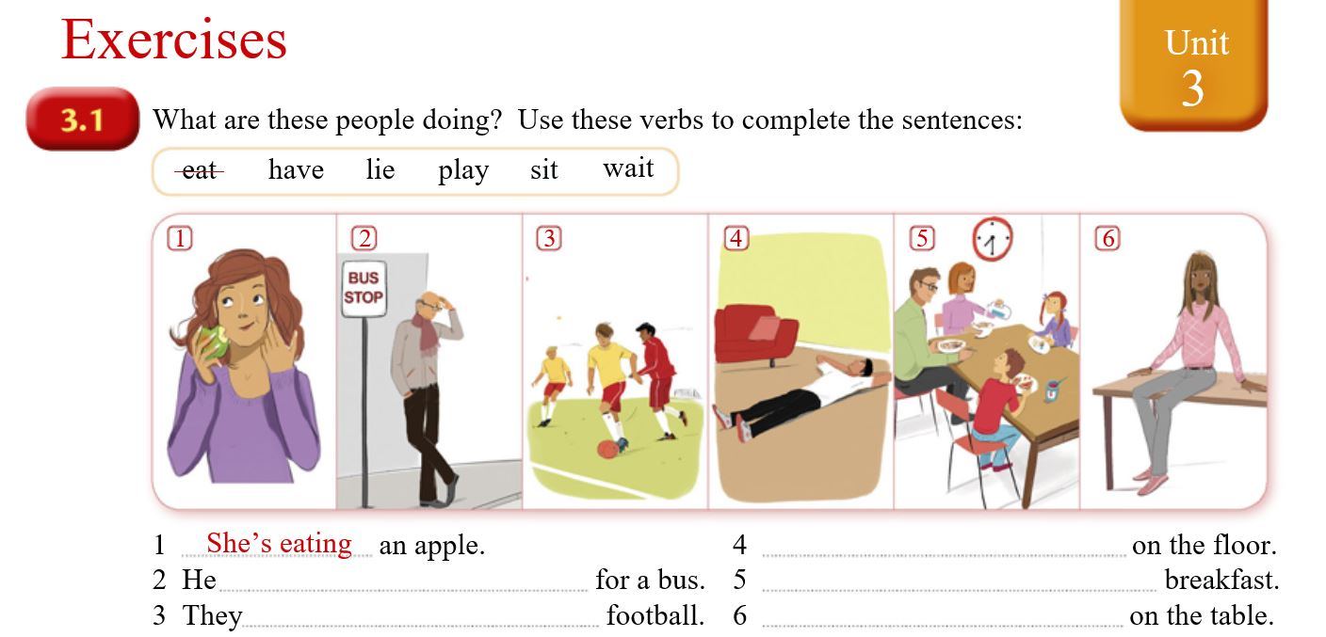

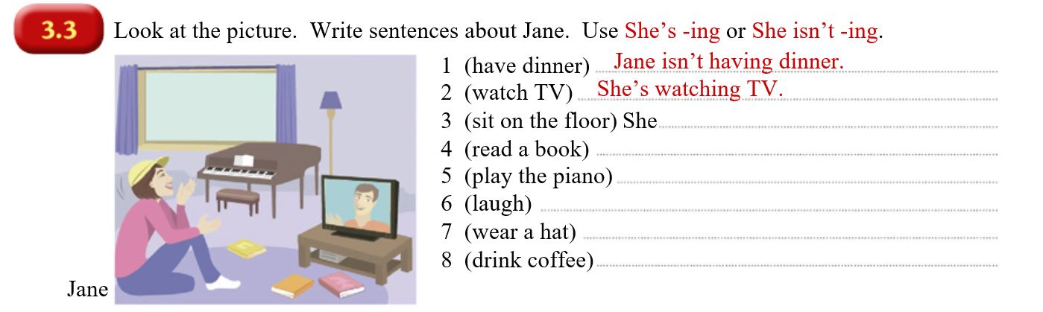

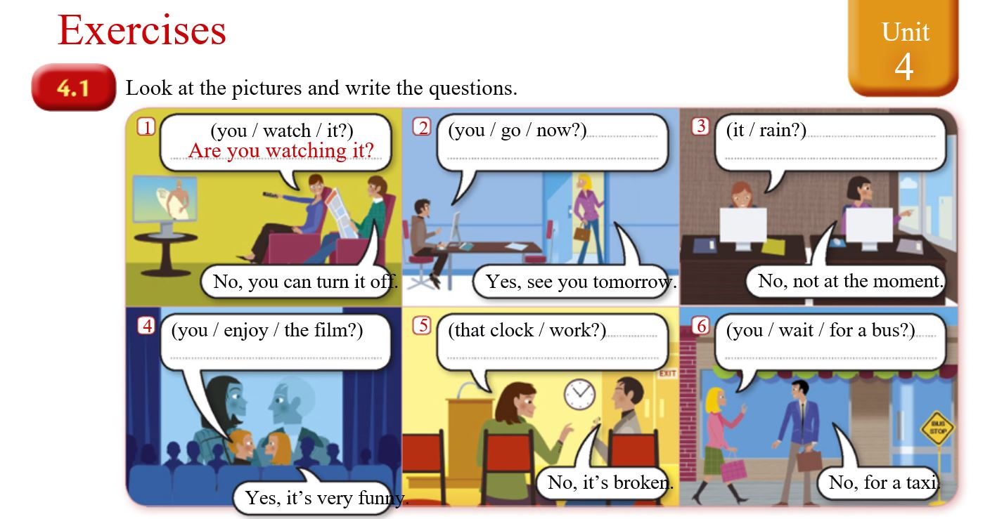
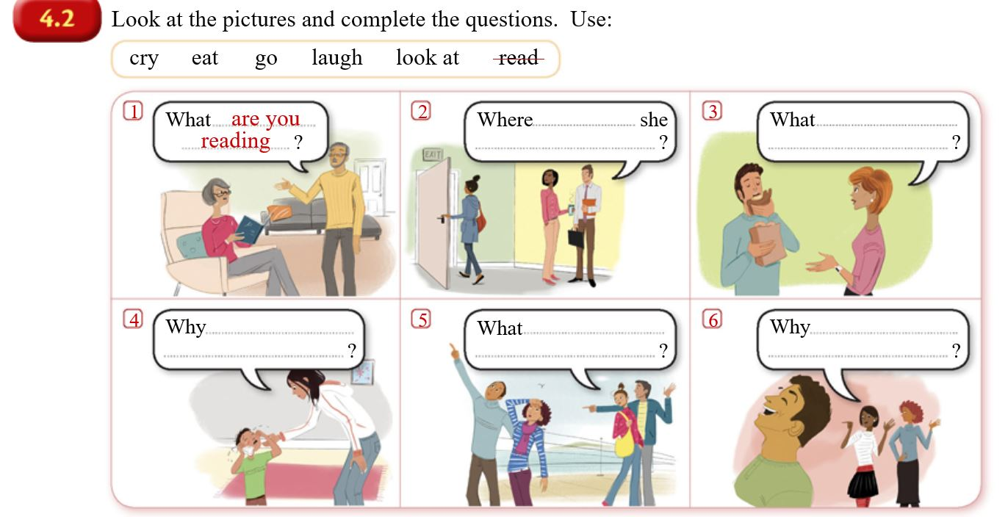
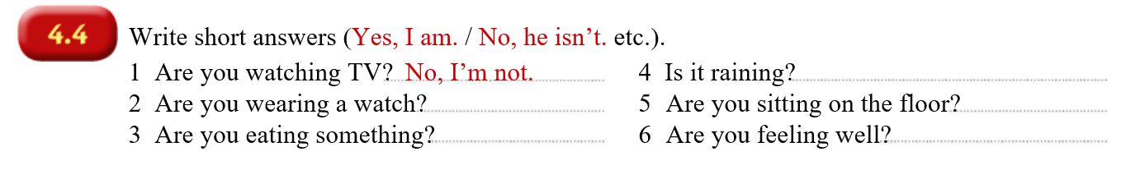
* Group Activity 2 - Make Your Story *

Let's make your story. Imagine and create the situation you want at this moment.
There are eight characters.
You can make and create dialogues by choosing some characters.
At least, you have to make 10 sentences by using the form like 'Be Verb + - ing'.

* Each character's name and image *
