Listening Speaking Reading Grammar Writing
Topic: What Am I?
(Language Target: Adjective Word Order)

Instructor:  Olivia | Students Competency Level: Pre-Intermediate | Number of Students: 13 | Lesson Length:  50 minutes
Materials: (List the Names of all materials used in the lesson. Materials must be shown at the end of this document)
Power Point Slides:
Slide 1
Slide2
Slide3
Slide4
Adjective Word Order Worksheet
Board and Markers

Aims: (What students will be able to achieve by participating in the activities of the lesson. (Ss gain or get by doing…)
-Improve speaking skills by answering teacher and group work.
-Improve listening skills by listening to teacher and group work.
-Improve writing skills by doing worksheet.
-Improve Ss grammar skills about describing a noun with adjectives in typical order.

Language Skills: (Lists what activities language skills students will be using by participating in the activities of the lesson.)
- Reading: (Where did reading occur in the lesson?)
PPT, worksheet, drilling
- Listening: (Where did listening occur in the lesson?)
Teacher talk, during the group work, drilling
- Speaking: (Where did speaking occur in the lesson?)
Group work, answering teacher, drilling
- Writing: (Where did writing occur in the lesson?)
Worksheet

Language Systems: (Lists what language systems students will be using by participating in the activities of the lesson.)
- Phonology: (sound)
Teacher talk, group work
- Lexis: (meaning)
Describe a noun with adjectives.
- Grammar: (language structure)
Adjective word order.
- Discourse: (communication)
Group work, responding the teacher, Ss presentations.

Assumptions: (What students must already be able to do and what concepts must already be mastered before the lesson in order to achieve the aims of the lesson.)
-All Ss know what is a noun.
-All Ss know what is an adjective.
-All Ss have described something.

Anticipated Errors and Solutions: (What things might go wrong in the lesson and what the solution will be. An SOS activity should also be included)
-If Ss may not have ideas. (solution: T gives them little examples.)
-If activity lasts too long. (solution: T cuts unnecessary parts.)
-If activity finished too soon. (solution: T makes suggestions and share ideas.
-If Ss may not understand. (solution: T shows demonstrations.)
-If certain Ss are shy. (solution: T encourages them, give positive feedback.
References:

Lead-In or Pre-Task Part (Warm-Up Part to activate and create interest in the lesson.)
Materials: (List the Names of all materials used in the Lead-In or Pre-Task Part of the lesson. Materials must be shown at the end of this document)

Time: | Classroom Set Up: | Student Activity and Goals: | Teacher Procedure & Instructions:
1min  4min  3min | Whole  Whole  Whole | Ss greet the teacher.  Ss listen to teacher.  Ss listen to teacher and answer to T. | Greeting.  Tell Ss T’s story about shopping skirt.  Describe the skirt by using some adjectives.  Ask Ss to share their stories using target language.  Transition- We use adjectives to describe nouns.

Pre-Activity or Task Familiarization Part (Presentation Part Presenting the language structure to be covered in the lesson. Prepares students for the communication activity.)
Materials: (List the Names of all materials used in the Pre-Activity or Task Familiarization Part of the lesson. Materials must be shown at the end of this document)
Power Point Slides:
Slide 1
Slide2
Slide3
Time: | Classroom Set Up: | Student Activity and Goals: | Teacher Procedure & Instructions:
4min  4min | Whole  Whole | Ss listen what T says and answer.  Ss look at the PPT and answer to T. | Ask Ss to answer some riddles.  Transition- Sometimes, we use more than one adjective.  Show pictures and ask Ss to describe the pictures with adjectives.  Transition-When there is more than one adjective, we usually use this order.

Main Activity or Task Realization Part (Practice to Production Part Teacher lead practice of the language presented and move to communication based more student centered activity)
Materials: (List the Names of all materials used in the Main Activity or Task Realization Part of the lesson. Materials must be shown at the end of this document)
Power Point Slide:
Slide4
Adjective Word Order Worksheet
Time: | Classroom Set Up: | Student Activity and Goals: | Teacher Procedure & Instructions:
1min  8min  5min  4min  1min  5min  4min | individual  Whole  Whole  Whole  Group  Group  S-W | Ss receive worksheet.  Ss look at the board and listen to T.  Ss complete the worksheet  Ss read, listen, speak and drill to learn and become familiar with conditionals.  Ss sit in groups.  Ss complete the worksheet as a group.  Ss have presentation as a group to class. | T give worksheet to Ss.  Show PPT and introduce the adjective word order.  Introduce examples.  Have Ss complete the worksheet.  Check answers and do drilling with Ss.  Put Ss in groups and introduce the activity.  Have Ss complete the worksheet.  Have Ss to present and give positive feedback.  Transition

Post Activity or Post Task Part (Wrap-Up Part Close the Lesson on a high note to and consolidate language learned in a communication based activity new situation.)
Materials: (List the Names of all materials used in the Post Activity or Post Task Part of the lesson. Materials must be shown at the end of this document)
Adjective Word Order Worksheet

Time: | Classroom Set Up: | Student Activity and Goals: | Teacher Procedure Instructions:
3min  2min  1min | Group  S-W  Whole | Ss listen to T and complete the worksheet as a group.  Ss have a talk in front of the class.  Other Ss listen.  Thank T and say goodbye. | Have Ss complete the worksheet as a group.  Choose Ss to present their answers.  Listen to Ss and give positive feedback.  Thank Ss for their attention and close the class.

<Power Point Slides>

Slide1.

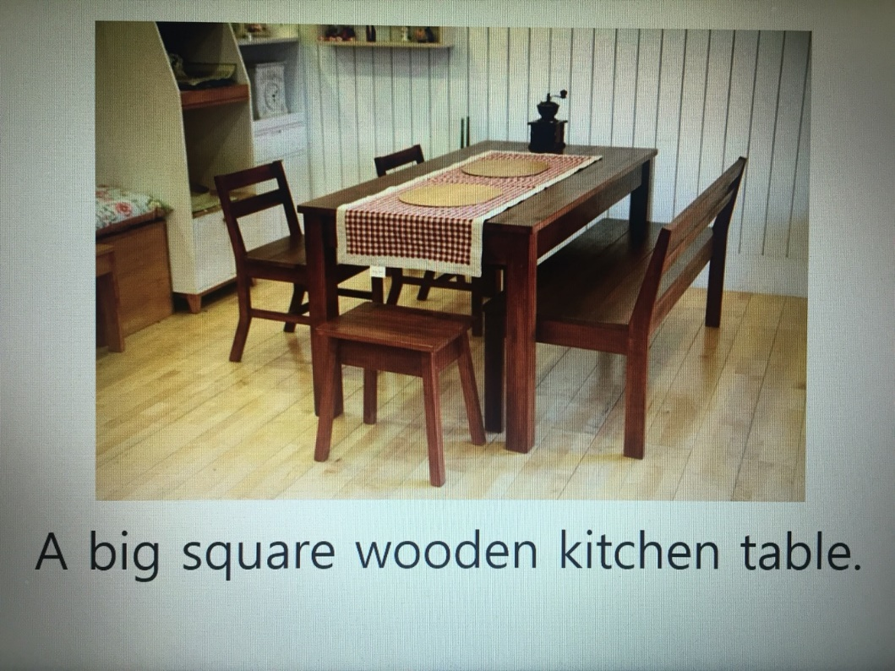
Slide2.

Slide3.

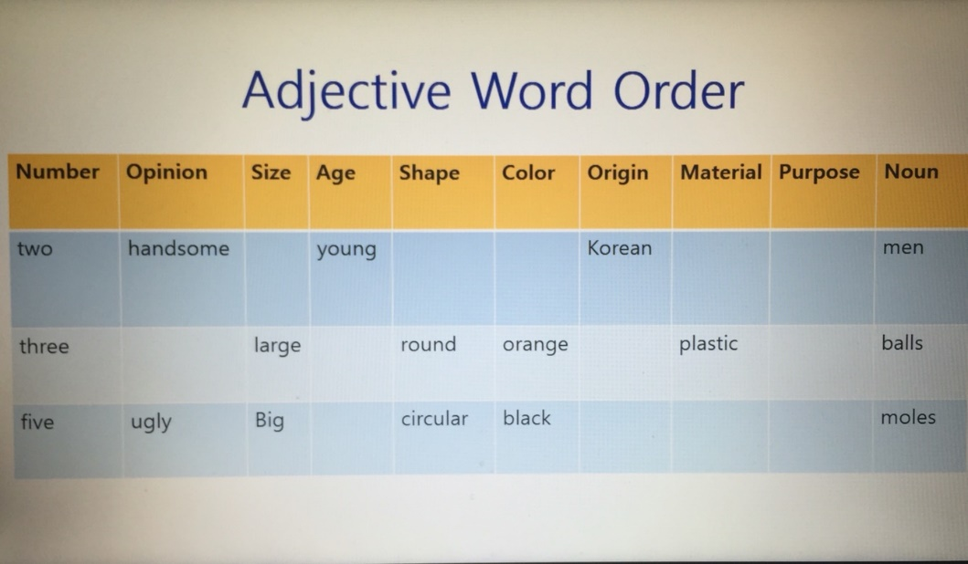
Slide4.

<Adjective Word Order Worksheet>

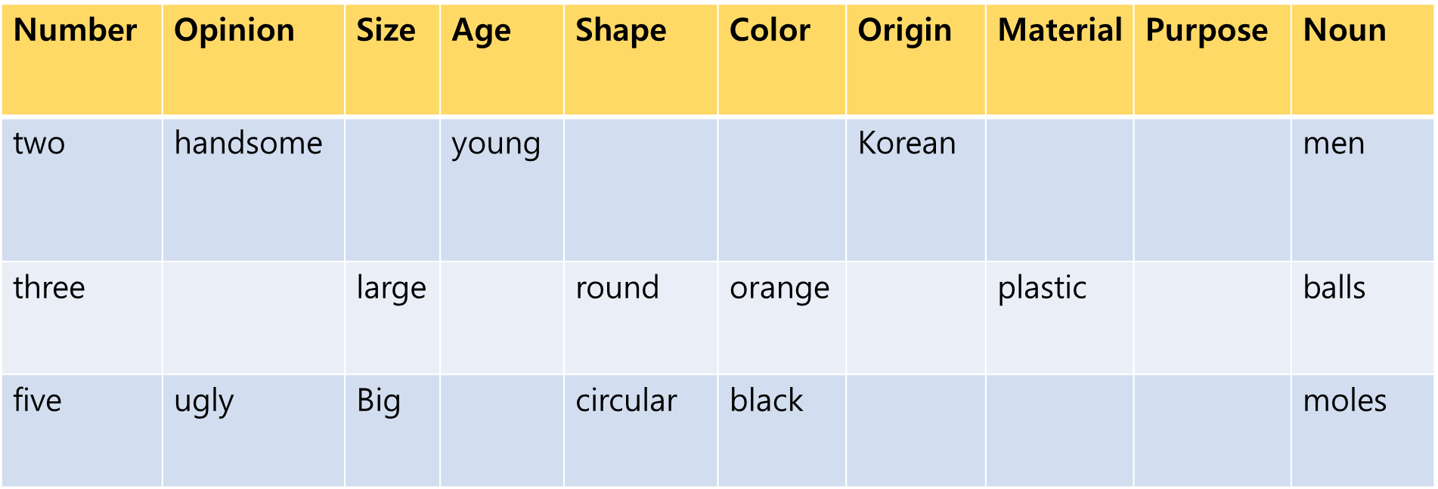

- Put these words into right order.

Ex) eyes/blue/big
-Big blue eyes.

- shirt/blue/old/working/an

- Asian/women/three/short/beautiful/young

- red/new/night/cotton/two/dresses

- ten/small/pills/slimming/orange/Chinese

- Make sentences using at least four adjectives for each.

Ex) Mug
-My mom accidentally broke my beautiful old pink ceramic mug.

- Spider

- Coat

- Bag

- Cellphone

- Dog

- House

- What are you wearing today? Write sentences describing 3 things your members are wearing. Use as many adjectives as you can for each.
- Ex) I’m wearing a clean, small, white, Korean, cotton, school shirt.

- Write sentences about 2 things you have. Use as many adjectives as you can for each.
- Ex) I have a cute, big, old, brown, American, furry teddy bear.

