Listening Speaking Reading Grammar Writing
Topic: Healthy Eating

Instructor:  Olivia | Students Competency Level: Intermediate | Number of Students: 14 | Lesson Length:  50 minutes
Materials:(List the Names of all materials used in the lesson. Materials must be shown at the end of this document)
Computer
Projector
Overhead Screen
Power Point Slides:
Picture1
Picture2
Picture3
Healthy Eating Text
After Reading Worksheet

Aims:(What students will be able to achieve by participating in the activities of the lesson. (Ss gain or get by doing…)
-Improve speaking skills by discussing in pair and group and answering teacher.
-Improve listening skills by responding to teacher, questions ICQ-CCQs and listening to other Ss.
-Improve writing skills by doing worksheet.
-Improve reading skills by reading the text and work sheet.

Language Skills:(Lists what activities language skills students will be using by participating in the activities of the lesson.)
- Reading: (Where did reading occur in the lesson?)
Text and worksheet
- Listening:(Where did listening occur in the lesson?)
Teacher talk and discussion
- Speaking: (Where did speaking occur in the lesson?)
Pair work, group work and answering teacher
- Writing: (Where did writing occur in the lesson?)
Worksheet

Language Systems: (Lists what language systems students will be using by participating in the activities of the lesson.)
- Phonology: (sound)
Teacher talk, PPT, Ss talk, discussion
- Function:(situation)
Talking about food.
- Lexis: (meaning)
Vocabulary related to food.
- Grammar:(language structure)

- Discourse: (communication)
Discussion

Assumptions:(What students must already be able to do and what concepts must already be mastered before the lesson in order to achieve the aims of the lesson.)
-All Ss have opinion about the topic and have thought about healthy eating.
-All Ss will enjoy discussion and sharing their opinions.
-All students know what “Junk food” is.

Anticipated Errors and Solutions:(What things might go wrong in the lesson and what the solution will be. An SOS activity should also be included)
-If Ss may not have ideas. (solution: T gives them little examples.)
-If activity lasts too long. (solution: T gives time warning.)
-If activity finished too soon. (solution: T gives more time for the discussion.)
-If Ss may not understand. (solution: T provides more examples.)
-If certain Ss are shy. (solution: T encourages them, give positive feedback.)

References:

Lead-Inor Pre-Task Part (Warm-Up Part to activate and create interest in the lesson.)
Materials: (List the Names of all materials used in the Lead-Inor Pre-Task Partof the lesson. Materials must be shown at the end of this document)
Computer
Projector
Overhead Screen
Power Point Slides:
Picture1

Time: | Classroom Set Up: | Student Activity and Goals: | Teacher Procedure &Instructions:
1min  3min  3 min | Whole  Whole  S-W | Ss greet the teacher.  Ss listen to teacher and see the screen.  Ss share their experience. | Greeting.  Show pictures of food.  Tell Ss food looks delicious.  Tell Ss of food that T eats when T feels happy or sad.  Ask Ss what they like to eat when they are happy or sad.  Transition- Let’s look at the picture.

Pre-Activity or Task Familiarization Part (Presentation Part Presenting the language structure to be covered in the lesson. Prepares students for the communication activity.)
Materials: (List the Names of all materials used in the Pre-Activity or Task Familiarization Part of the lesson. Materials must be shown at the end of this document)
Computer
Projector
Overhead Screen
Power Point Slides:
Picture2
Picture3

Time: | Classroom Set Up: | Student Activity and Goals: | Teacher Procedure &Instructions:
2min  2min | Whole  Whole | Ss look at the screen, listen what T says and answer to T.  Ss listen what T says. | Show PPT slides.  Let Ss to choose healthy and unhealthy food from pictures.  Show pictures of junk food and explain the word “Junk food”..  Transition- Let’s read the text.

Main Activity or Task Realization Part(Practice to Production Part Teacher lead practice of the language presented and move to communication based more student centered activity)
Materials: (List the Names of all materials used in the Main Activity or Task Realization Partof the lesson. Materials must be shown at the end of this document)
Healthy Eating Text
After Reading Work Sheet:

Time: | Classroom Set Up: | Student Activity and Goals: | Teacher Procedure &Instructions:
6min  2min  1min  8min  4min | Whole  Whole  Individual  Pair work  Whole | Ss listen to T. Receive text and read it carefully.  Ask questions as needed.  Ss shair their thoughts with class.  Ss get the worksheet.  Read and complete the worksheet with partner. Ss ask some questions if they don’t know some words and can’t understand meaning.  Listen to T and check the answers. | Introduce Healthy Eating text and hand out the text. Ask Ss to read the text carefully and use questions to increase interest in the text.  Ask Ss to share their thoughts about the text and facilitate classroom discussion and feedback.  Hand out worksheet. Put Ss in pairs to complete worksheet together.  Let Ss read and complete the work sheet in pairs, Facilitate S-T, S-S interactions.  Check Ss answers of the worksheet and tell right answers. Give positive feedback.  Transition: Let’s do an interesting activity.

Post Activity or Post Task Part (Wrap-Up Part Close the Lesson on a high note to and consolidate language learned in a communication based activity new situation.)
Materials: (List the Names of all materials used in the Post Activity or Post Task Part of the lesson. Materials must be shown at the end of this document)
Board and Markers

Time: | Classroom Set Up: | Student Activity and Goals: | Teacher Procedure Instructions:
2min  10min  5min  1min | Group  Group  G-W  Whole | Ss listen to T.  Ss share their opinions and make the choice as a group.  Ss have a talk in front of the class. Other Ss listen and share opinion.  Ss listen an say goodbye | Introduce the activity and set groups.  Let Ss discuss and choose best 5 Korean food and worst 5 Korean food to foreigners in group.  Facilitate Ss interactions.  Ask Ss to present their choices. Listen to Ss and give positive feedback.  Thank Ss for active participation and congratulate on their improvement

Power Point Slides

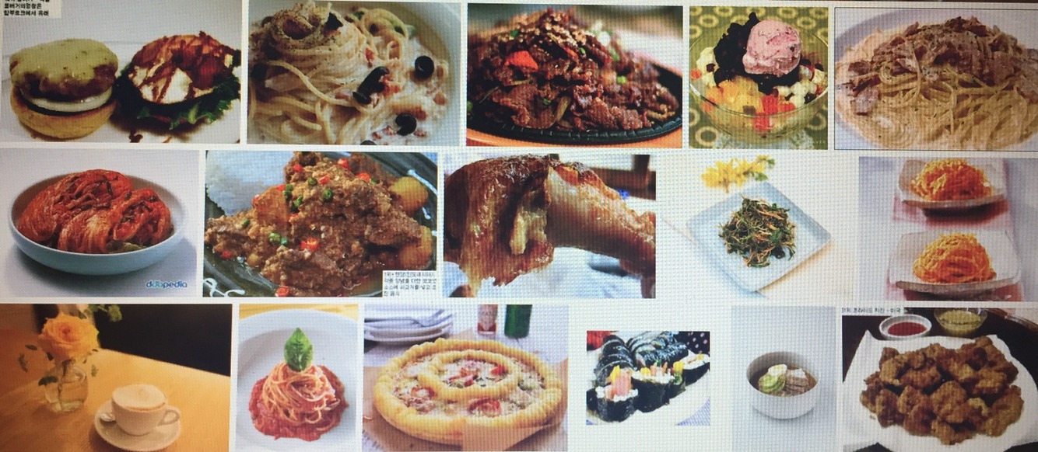

Picture1

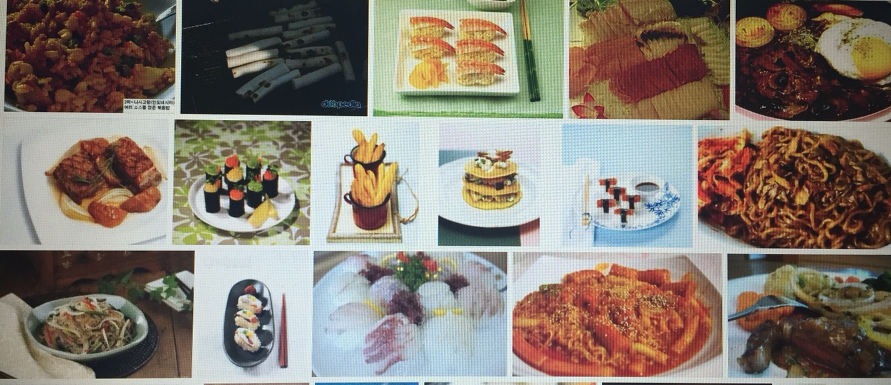

Picture2

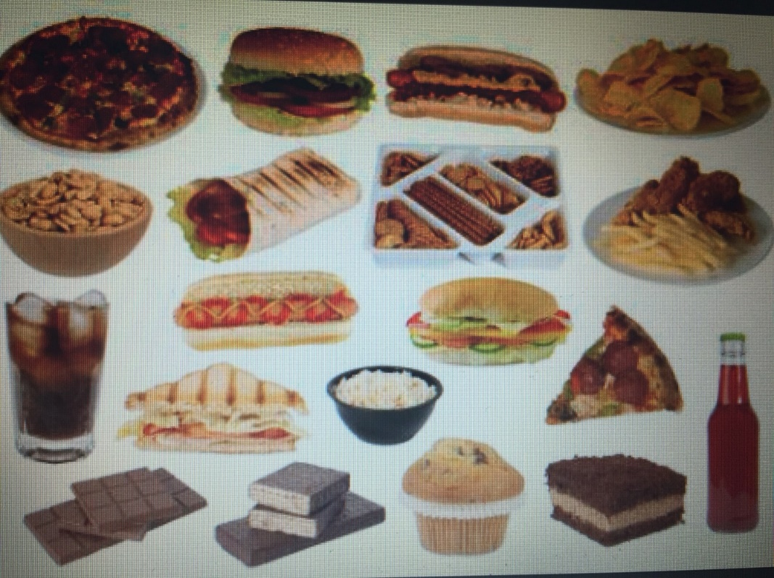

Picture3

Healthy Eating Text

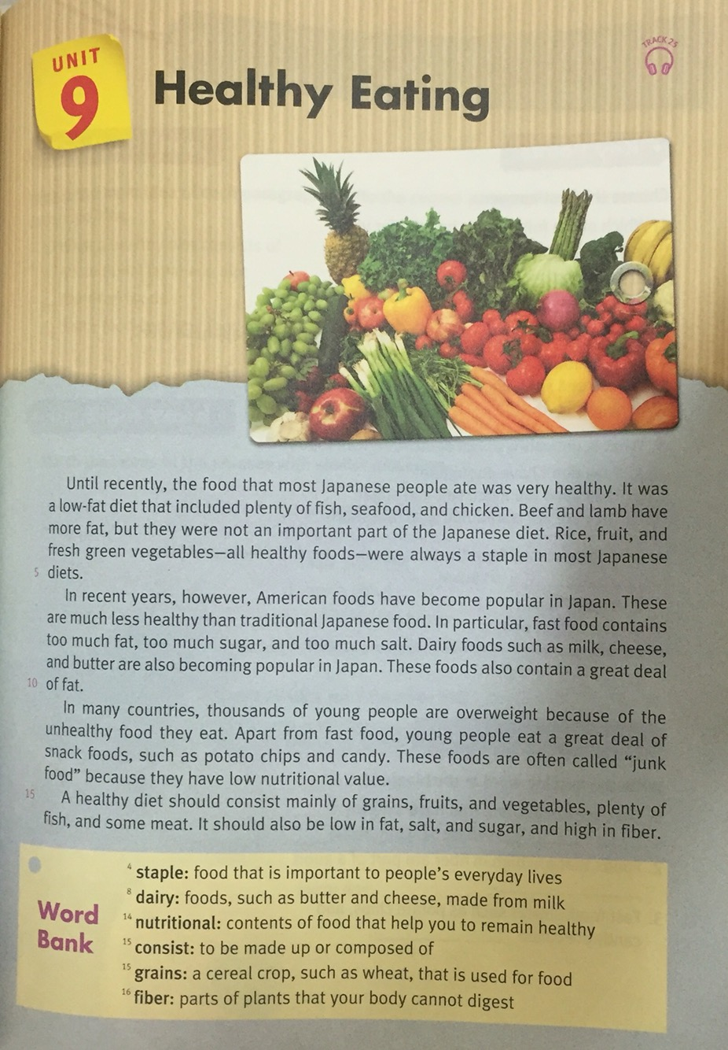

After Reading Worksheet.
