Listening Speaking Reading Grammar Writing
Topic: Fast? No, Slow!!!

Instructor:  Eunju Choi (Anna) | Students Competency Level intermediate | Number of Students: 14 | Lesson Length:  53mins
Materials: (List the Names of all materials used in the lesson. Materials must be shown at the end of this document)
Brainstorming Sheet
Slow Movement Reading Text
Reading For Understanding Text
Pre Activity Worksheet
After Reading Worksheet
Aims:(What students will be able to achieve by participating in the activities of the lesson. (Ss gain or get by doing…)
Improve Ss listening skill by listening to T introduction , question and ICQ-CCQs and speaking to other students during brainstorming and group discussion .
Improve Ss reading skills by reading and completing worksheets ,taking summary during discussion , communicatively interaction
Language Skills:(Lists what activities language skills students will be using by participating in the activities of the lesson.)
- Reading: (Where did reading occur in the lesson?)
reading Text (worksheets1,2)
- Listening: (Where did listening occur in the lesson?)
T instruction and explanation, interaction with group members
- Speaking: (Where did speaking occur in the lesson?)
Group discussion ,repeat after T
- Writing: (Where did writing occur in the lesson?)
Writing notes during group discussion
Language Systems: (Lists what language systems students will be using by participating in the activities of the lesson.)
- Phonology: (sound)
Text reading, Ss talk, T talk
- Function:(situation)
Expressing oneself to others
- Lexis: (meaning)
vocabulary
- Grammar:(language structure)
In the sentences
- Discourse: (communication)
discussion
Assumptions: (What students must already be able to do and what concepts must already be mastered before the lesson in order to achieve the aims of the lesson.) . (Ss gain or get by doing…)
Students can gain opinion about the topic and what is the meaing of slow life.
Students can be familiar with the topic and sharing their opinion.
Students enjoy completing their worksheets.
All students know what brainstorming is.
Anticipated Errors and Solutions: (What things might go wrong in the lesson and what the solution will be. An SOS activity should also be included)
If Ss don`t give the words for texts.
Solution :T starts one or two words for understanding
If Ss may not understand clear meaning.
Solution: provide more examples.
If students don`t give their opinion during the group discussion
Solution :encourage Ss to participate and give positive feedback
If activity takes too long
Solution :give time warning
References:
High school English reading and writing (page 188~207)

Lead-Inor Pre-Task Part (Warm-Up Part to activate and create interest in the lesson.)
Materials: (List the Names of all materials used in the Lead-In or Pre-Task Part of the lesson. Materials must be shown at the end of this document)
Brainstorming worksheet1
Time: | Classroom Set Up: | Student Activity and Goals: | Teacher Procedure &Instructions:
1min  2mins  2mins  3mins | Whole  Whole  Whole  pair | Ss greet T  Students listen and look at teacher  Ss get brainstorming sheet  Check their life style  Share opinions | Greet Ss  Start with T`s story about slow life  T gives a brainstorming sheet and let Ss find out their life style.  T divides into pair

Pre-Activity or Task Familiarization Part (Presentation Part Presenting the language structure to be covered in the lesson. Prepares students for the communication activity.)
Materials: (List the Names of all materials used in the Pre-Activity or Task Familiarization Part of the lesson. Materials must be shown at the end of this document)

Preactivity Worksheet
Time: | Classroom Set Up: | Student Activity and Goals: | Teacher Procedure &Instructions:
1mins  2mins  3mins | Whole  W  group | Ss get a worksheet.  Ss read and complete the sheet  Ss talk about their experiences and share thoughts of members and write down their thought.  . | Introduce a worksheet and hand out.  Give Teacher`s example which influenced to teacher`s life  Give an example who can change the life  Let students to do the sheet .  T devides into 4 groups of 3members .  Let Ss talk about their life how to change and share their opinions

Main Activity or Task Realization Part(Practice to Production Part. Teacher leads practice of the language presented and move to communication based more student centered activity)
Materials: (List the Names of all materials used in the Main Activity or Task Realization Partof the lesson. Materials must be shown at the end of this document)

Slow Movement Reading Text
Reading For Understanding Text

Time: | Classroom Set Up: | Student Activity and Goals: | Teacher Procedure &Instructions:
1mins  7mins  15mins | Whole  Whole  Group | Students get reading texts.  Listen and respond  Move to group and discuss  Share their opinions and complete the reading for understanding text and check the answers. | Teacher gives Texts.  T read the Text and have students listen  Explain about the main idea and topic and ask some questions about slow life that makes Ss interested  Give some examples related to slow life.  Put Ss into groups to discuss.  Encourage Ss to share their opinion about the text and facilitate classroom discuss and feed back and make Ss complete Reading for understanding text and give answers.

Post Activity or Post Task Part (Wrap-Up Part. Close the Lesson on a high note to and consolidate language learned in a communication based activity new situation.)
Materials: (List the Names of all materials used in the Post Activity or Post Task Part of the lesson. Materials must be shown at the end of this document)
After Reading Worksheet
Time: | Classroom Set Up: | Student Activity and Goals: | Teacher Procedure Instructions:
2mins  7mins  2mins | Group  group  whole | Ss get worksheet  Discussion & present in front of the class  Positively respond | T gives a worksheet  Explain about worksheet and give an example about teacher`s life how to change and how to improve.  Ask Ss how to change your life and let Ss write down and let Ss present about their discussion  Close by giving Ss feedback about their accomplishment and improvement

Brain Storming Worksheet

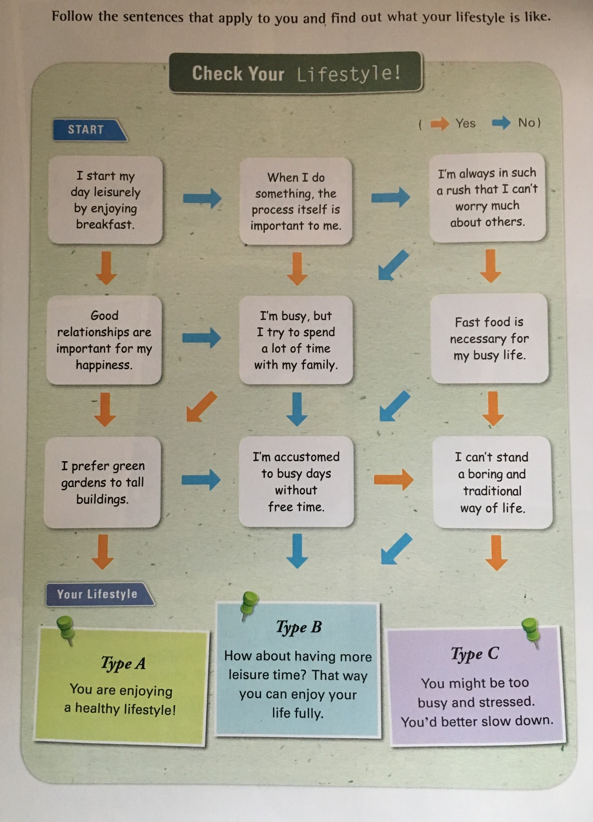
Slow Movement Reading Text

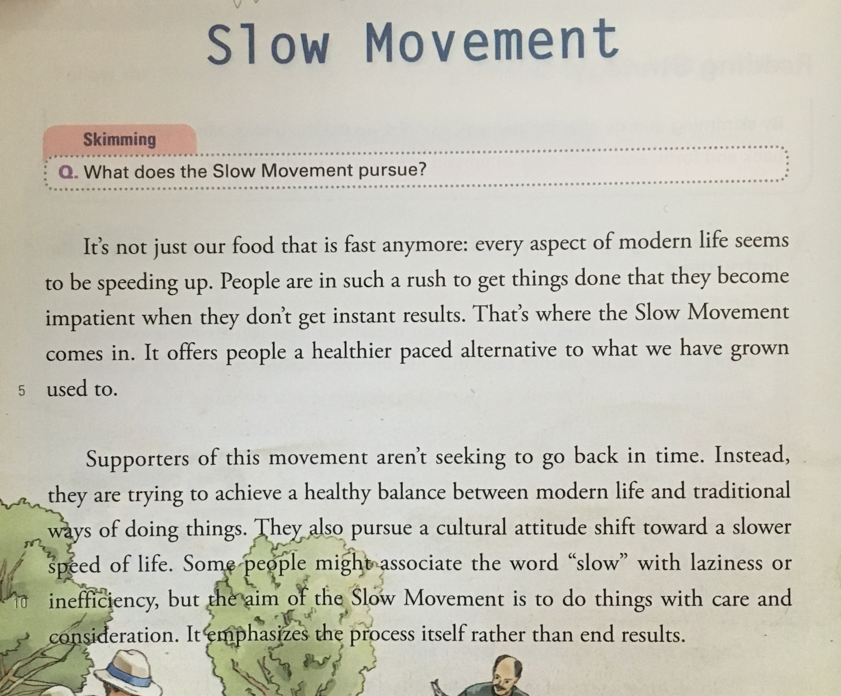

Reading For Understanding Text

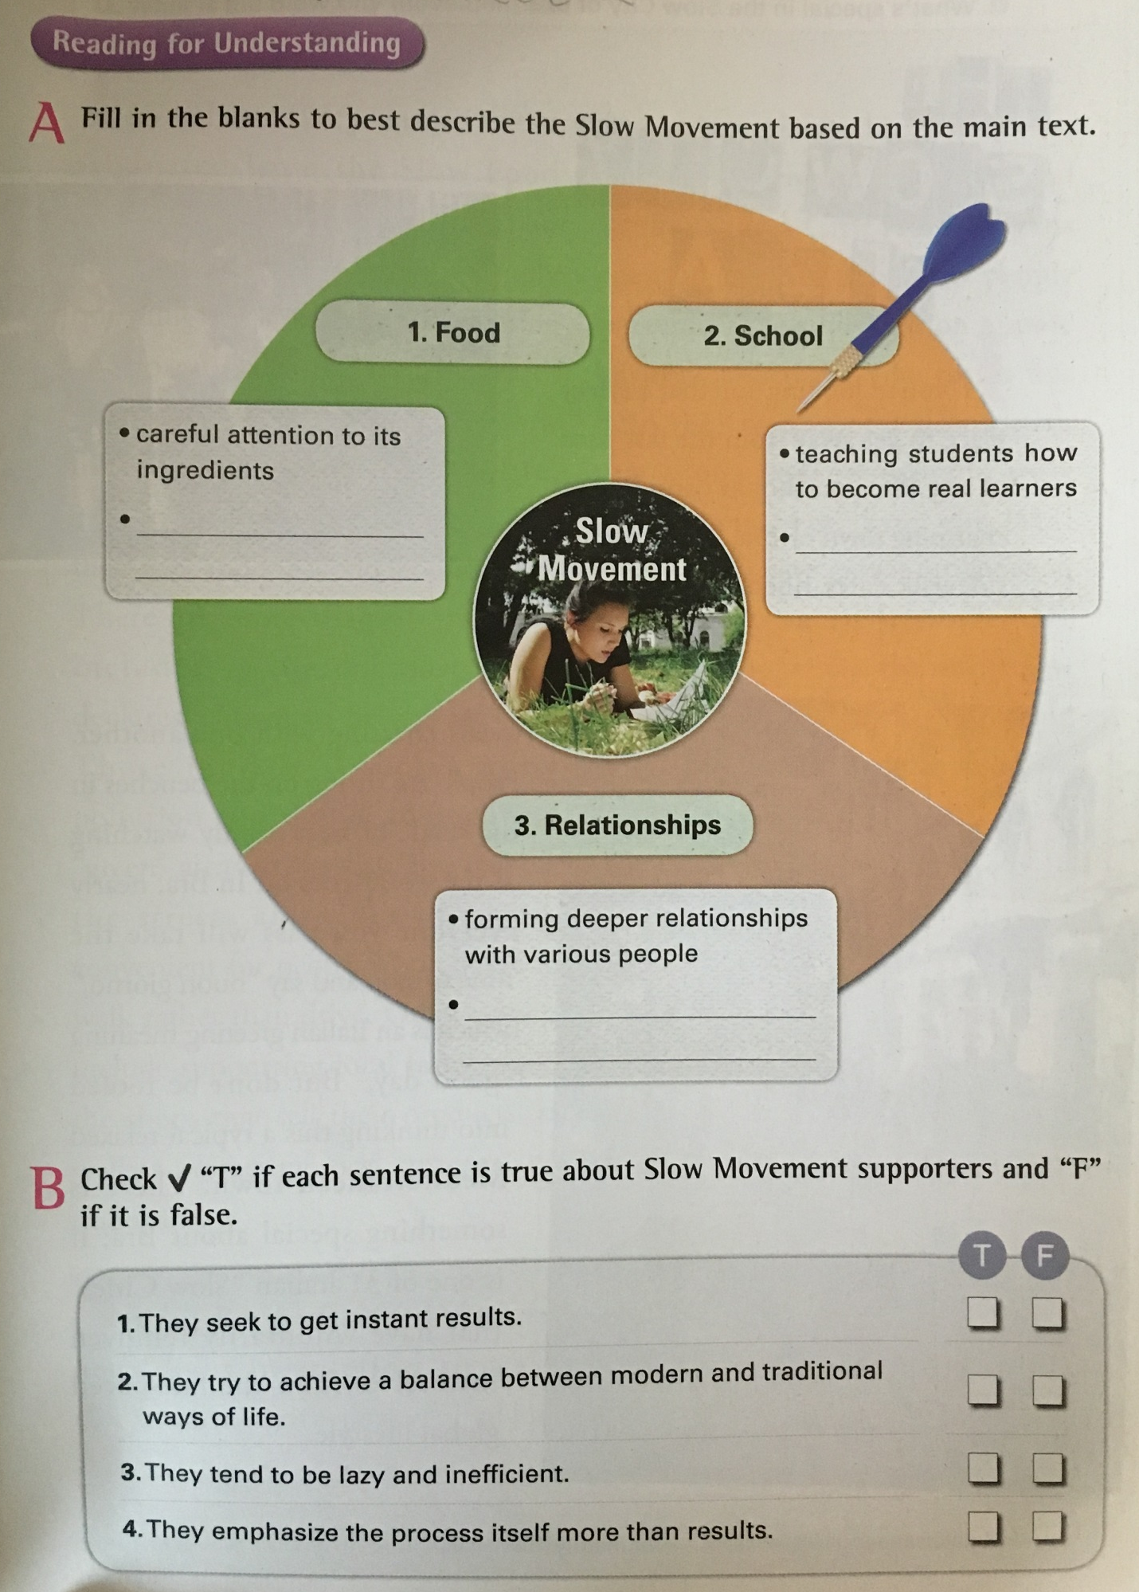
Pre Activity Worksheet

Think about someone or something that influenced to your life,
What? Who? When? And How?

When?
Explain
How?
Explain
Explain
Who?
Explain
What?
Change Your Life

After Reading Worksheet

Step 1: In groups of five, discuss what should be improved for a happier life

Step 2: Write down briefly what your group wants to change.
Things I want to change | How to improve
●not care for my friends | ●praise my friends every day

Step 3: Make promises based on the chart above.

Example
Promises for _______________
One: Praise my friend every day
Two: Begin the day by reading books for 30 minutes
Three: Write a letter to a friend onve a month

Times Media TESOL Center Micro-Teaching Self Reflection - Evaluation Form

Name:______________________ Date: _____________ TESOL Class No. 130

Topic: __________________________________________________

Speaking/ListeningReadingGrammar

Did you achieve your aims in your Micro-Teaching? How do you knowyou achieved your aims and why do you think so? What evidence was therethat you achieved your aims during in your micro-teaching?

What specifically did you think you did well in your micro-teaching? What specifically do you feel you did not do well.

Were the materials/activities successful in achieving the aims of Micro-Teaching?

What specific areas of your teaching do you want to work on in your next micro-teaching?

If you were going to teach the same lesson topic again, what would you change?

After receiving feedback from your TESOL instructorhow do you feel about your micro-teaching and about how you will do your next Micro-Teaching or how you will teach English in the future?

After receiving feedback from your Peer Instructors how do you feel about your micro-teaching and about how you will do your next Micro-Teaching or how you will teach English in the future?

