Listening Speaking Reading Grammar Writing
Topic: To Enjoy My Life
Language target: Using Infinitive Verbs

Instructor:  Anna (Eunju Choi) | Students Competency Level  intermediate | Number of Students:15 | Lesson Length:  55mins
Materials: (List the Names of all materials used in the lesson. Materials must be shown at the end of this document)
Board and Markers
Teacher`s Story Pictures:
- Riding A Bike
- Drinking Coffee
- Drinking Water
- At the Beach
- Anna And Son(smiling picture)
- In The Snow
Activity Pictures
- Drawing Pictures
- Riding An Autobike
- Nice To Meet You
- Talking Together
- Running
Drilling Wall Chart
Aims: (What students will be able to achieve by participating in the activities of the lesson. (Ss gain or get by doing…)
- Improve Ss listen skills by listening to T`s story , Ss stories , making a dialogues and presentations
- Improve Ss speaking skills by answering T, Ss presentations, sharing stories, making a dialogue
- Improve Ss grammar skills by using infinitives in drilling and during communication activities
- Improve communication by responding to T and rephrasing Ss thoughts, and writing and making a dialogue.
Language Skills: (Lists what activities language skills students will be using by participating in the activities of the lesson.)
- Reading: (Where did reading occur in the lesson?)
Drilling wall chart

- Listening: (Where did listening occur in the lesson?)
Sharing Ss stories about their happy life , answering T, making a dialogue

- Speaking: (Where did speaking occur in the lesson?)
T talk, Ss talk, dialogue

- Writing: (Where did writing occur in the lesson?)
Writing sentences about happy life in activity

Language Systems: (Lists what language systems students will be using by participating in the activities of the lesson.)
- Phonology: (sound)
Drilling, T and Ss talk

- Function: (situation)
Discussing life

- Lexis: (meaning)
To use infinitive

- Grammar: (language structure)
To use infinitive

- Discourse: (communication)
T-S, Ss presentations, sharing stories, drilling and making a dialogue

Assumptions: (What students must already be able to do and what concepts must already be mastered before the lesson in order to achieve the aims of the lesson.)
- All Ss know about infinitive and base verb
- All Ss talk about happy life though making a dialogue
- All Ss know how to use to+ base verb when they talk

Anticipated Errors and Solutions: (What things might go wrong in the lesson and what the solution will be. An SOS activity should also be included)
- If Ss can`t imagine happy life: tell Ss when they feel happy and satisfied and charged
- If Ss take a long time to make sentences with pictures: never push Ss, give more time and encourage them.
References:
none

Lead-In or Pre-Task Part (Warm-Up Part to activate and create interest in the lesson.)
Materials: (List the Names of all materials used in the Lead-In or Pre-Task Part of the lesson. Materials must be shown at the end of this document)
Board and Markers
Teacher`s Story Pictures:
- Riding A Bike
- Drinking Coffee
- Drinking Water
- At The Beach
- Anna And Son
- In the Snow

Time: | Classroom Set Up: | Student Activity and Goals: | Teacher Procedure & Instructions:
1min  4min  7min | Whole  Whole  Ss - W | Greet T  Listen to T and become aware of the target language structure.  Share Ss story  Ss share their thoughts with the class | Greet Ss  Talk about ‘my enjoy life’ showing teacher`s story pictures by using infinitive  Ask Ss to share their story about their enjoy life .T rephrases and responds using infinitive.

Pre-Activity or Task Familiarization Part (Presentation Part Presenting the language structure to be covered in the lesson. Prepares students for the communication activity.)
Materials: (List the Names of all materials used in the Pre-Activity or Task Familiarization Part of the lesson. Materials must be shown at the end of this document)
White Board and Markers
Drilling Wall Chart

Time: | Classroom Set Up: | Student Activity and Goals: | Teacher Procedure & Instructions:
5min  3min  5min  5min  5min | W-Ss  Whole  Whole  Pairs  S-W | Ss read ,listen ,speak and drill to learn and become familiar with infinitives  Listen to T and observe T drawing on the board  Ss receive the drawing sheet, color pencils , and start drawing their happy life. Making 3 infinitive sentences  Ss share their drawings and sentences with partner.  Ss present partner`s sentences and drawings to class | Put drilling wall charts on the white board  Do drilling with students.  Accuracy important.  T introduces drawing activity by drawing pictures of T imagination on white board and making a infinitive sentence.  Hand out the drawing sheet, color pencils  Ask Ss to draw their happy life and to write 2 sentences based on their stories, T assist as needed.  Put Ss in pairs and tell Ss share their drawing and 2sentences with their partner.  Ask Ss to present partner`s sentences to class

Main Activity or Task Realization Part (Practice to Production Part Teacher lead practice of the language presented and move to communication based more student centered activity)
Materials: (List the Names of all materials used in the Main Activity or Task Realization Part of the lesson. Materials must be shown at the end of this document)
Activity pictures :
-Drawing pictures
-Riding an autobike
-Nice to meet you
-Talking together
-Running

Time: | Classroom Set Up: | Student Activity and Goals: | Teacher Procedure & Instructions:
5min  8min  8min | W-Ss  Pairs  Pairs-W | Listen to T and responds about pictures. Thinks about pictures  Ss work in pairs to create a dialogue using infinitives sentences.  Ss present their dialogue and other Ss watch them. | T shows activity pictures and puts them on the board. Ask for Ss comments. Introduces my own dialogue about the pictures using infinitives.  Sentences based on pictures and teach others.  Put Ss in pairs to create a dialogue about the pictures using infinitive sentences.  Ask pairs to come front of class and present their dialogue by using infinitives.  T facilitates class response and feedback.

Post Activity or Post Task Part (Wrap-Up Part Close the Lesson on a high note to and consolidate language learned in a communication based activity new situation.)
Materials: (List the Names of all materials used in the Post Activity or Post Task Part of the lesson. Materials must be shown at the end of this document)

Time: | Classroom Set Up: | Student Activity and Goals: | Teacher Procedure Instructions:
5min  2min | W  W | Ss repeat after T the drilling wall chart  Thank T and say good bye | Ask Ss to repeat after T sentence by sentence of the drilling wall chart again to remind them of today`s language target  Thank all Ss for their active participation for the class. Close by giving positive feedback about their work done.

Teacher’s Story Picture
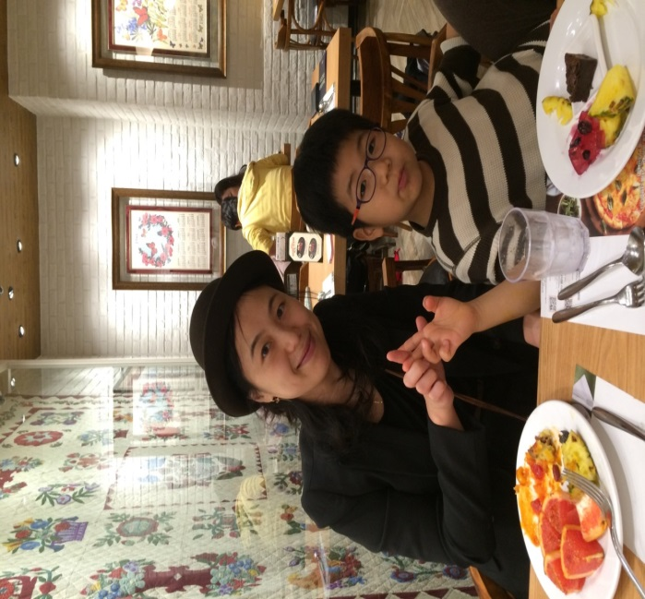  Anna and Son | 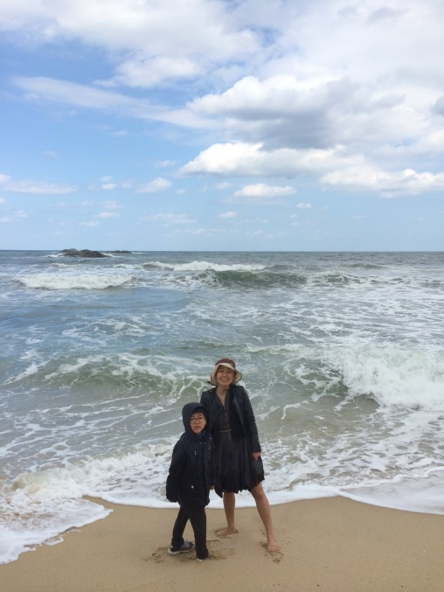  At the Beach
Drinking a Coffee | 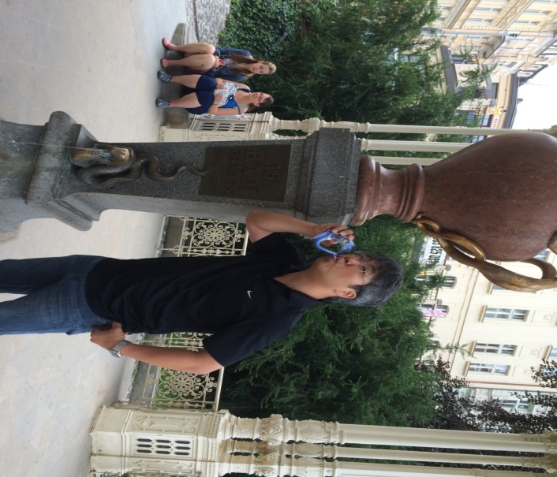  Drinking Water

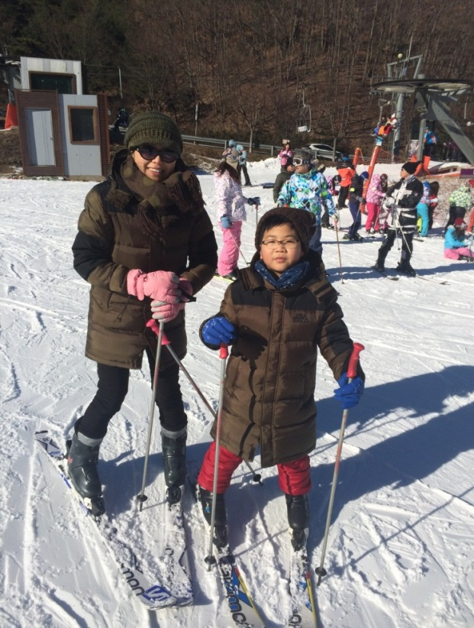  In the Snow | 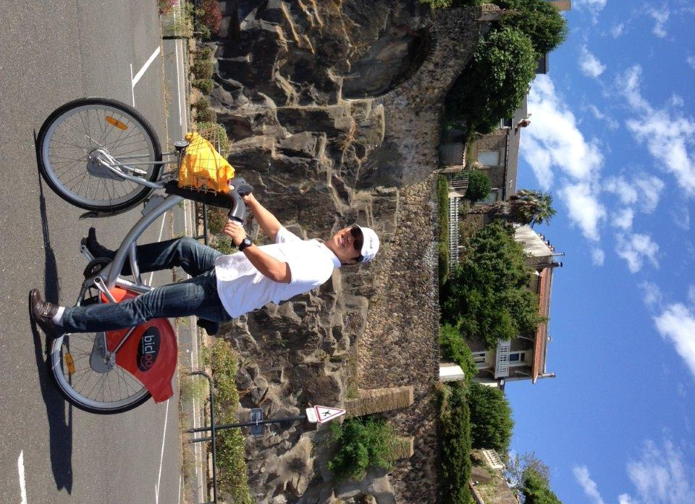  Riding a Bike

Activity Picture
Talking together | Nice to meet you
Riding an Autobike | 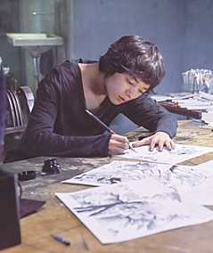  Drawing Pictures

Running

Drilling Wall Chart : To + Base Verb

1. Subjects
To do the right thing is not easy.
To learn a new language is helpful.

2.Objects
I want to help you.
They love to travel.

3.Subject Complements
Her job is to assist you.
My dream is to open a business

4.Adjectives
I told you to wait.
He wants me to leave.

5.Adverbs
We must study to learn
I want to learn to sing.

