Listening - Speaking Reading X Grammar Writing
Topic: Traveling

Instructor  :  Amy |  | Students Competency Level  Pre-Intermediate |  |  | Number of Students  13 | Lesson Length:  55minutes
Materials: (List the Names of all materials used in the lesson. Materials must be shown at the end of this document)
Computer
Projector
Overhead Screen
White Board and Markers
Power Point Pictures:
-Jeju Island
-Japan
- Mount Everest
- Himalayas
- In Order of Height
- Who is the biggest?
Tables:
-Seoul vs Daegu
Drilling Charts Ⅰ – adjective - er + than ☞Comparative sentences

Drilling Charts Ⅱ- the + adjective –est ☞Superlative Sentences

Aims: (What students will be able to achieve by participating in the activities of the lesson. (Ss gain or get by doing…)
Students improve Ss listening skills by listening T’s story, Ss stories, drilling and presentations.
Students improve Ss speaking skills by answering T, Ss presentations, sharing stories, drilling, and travel plans.
Students improve Ss grammar skills about comparative and superlative by T using Comparative and Superlative, T responding and rephrasing Ss thoughts, drilling, writing, and presentations.
Language Skills: (Lists what activities language skills students will be using by participating in the activities of the lesson.)
- Reading: (Where did reading occur in the lesson?)
Drilling Wall Chart, Writing sentences, Presentations
- Listening: (Where did listening occur in the lesson?)
Teacher talk, Ss talk, Presentations
- Speaking: (Where did speaking occur in the lesson?)
Sharing Ss stories about their travel plan, their preference for travel place
- Writing: (Where did writing occur in the lesson?)
Writing sentences about travel plan

Language Systems: (Lists what language systems students will be using by participating in the activities of the -lesson.)
- Phonology: (sound)
Drilling ,T and Ss talk
- Function: (situation)
Choosing best place for travel
Lexis: (meaning)
Comparative Superlative
- Grammar: (language structure)
Comparative Superlative
- Discourse: (communication)
T-S-T ,Ss presentations, sharing stories, drilling and planning for travel

Assumptions: (What students must already be able to do and what concepts must already be mastered before the lesson in order to achieve the aims of the lesson.)
All Ss know about the comparative and superlative sentences.
All Ss can talk about planning for travel through comparison among the countries.
All Ss know how to compare and choose best thing between different things.
Anticipated Errors and Solutions: (What things might go wrong in the lesson and what the solution will be. An SOS activity should also be included)
-If Ss cannot have special place for travel
Solution: provide more examples for place for travel
-If Ss take long time to make plan for travel.
Solution: never push students, give more time and encourage them.
References:

Lead-In or Pre-Task Part (Warm-Up Part to activate and create interest in the lesson.)
Materials: (List the Names of all materials used in the Lead-In or Pre-Task Part of the lesson. Materials must be shown at the end of this document)
Board and Markers
Pictures
-Jeju Island
-Japan
Time: | Classroom Set Up: |  | Student Activity and Goals: | Teacher Procedure & Instructions:
1mins  5mins  5 min | Whole  Whole  S-W |  | Ss greet teacher  Listen to T, become aware of the target language structure.  Ss share Ss’s story. | <Greeting>  Talk about ‘My plan for trip’ showing Teacher’s story by using comparative and superlative sentences. (Jeju Island vs Japan)  Asks Ss to share their preference place for travel. T phrases and responds using comparative and superlative sentences.  Now let’s find place which is best you think.

Pre-Activity or Task Familiarization Part (Presentation Part Presenting the language structure to be covered in the lesson. Prepares students for the communication activity.)
Materials: (List the Names of all materials used in the Pre-Activity or Task Familiarization Part of the lesson. Materials must be shown at the end of this document)
White Board and Markers
Drilling Charts Ⅰ – adjective - er + than ☞Comparative sentences
Drilling Charts Ⅱ- the + adjective –est ☞Superlative Sentences
Pictures:
-Mount Everest
- Himalayas
- In Order of Height
- Who is the biggest?
Tables:
-Seoul vs Daegu

Time: | Classroom Set Up: | Student Activity and Goals: | Teacher Procedure & Instructions:
5mins  5mins | Whole-Ss  Whole | Ss read, listen, speak and drill to learn and become familiar with comparative and superlative sentences.  Practice making target language sentences with using some pictures and tables. | Put drilling wall chats on the white board Do drilling with student. Accuracy important.  Elicit students make sentences using target language sentences with some pictures and tables.

Main Activity or Task Realization Part (Practice to Production Part Teacher lead practice of the language presented and move to communication based more student centered activity)
Materials: (List the Names of all materials used in the Main Activity or Task Realization Part of the lesson. Materials must be shown at the end of this document)

Lists of Choosing either A or B about the place for travel
-Paris vs Swiss
-Philippine vs Thailand
-Japan vs China

Time: | Classroom Set Up: | Student Activity and Goals: | Teacher Procedure & Instructions:
7mins  3mins | Pairs  Whole | Ss choose one place between two places which they picked and talk about why they choose that place using at least 2 comparative sentences and 1 superlative sentence.  Present their opinions. | Hands out lists of choosing either A or B and ask Ss to pick one place between two places and then talk about using target language items.  Ask Ss to present their opinion freely.

Post Activity or Post Task Part (Wrap-Up Part Close the Lesson on a high note to and consolidate language learned in a communication based activity new situation.)
Materials: (List the Names of all materials used in the Post Activity or Post Task Part of the lesson. Materials must be shown at the end of this document)
Internet
Paper
Time: | Classroom Set Up: | Student Activity and Goals: | Teacher Procedure Instructions:
14mins  10mins  1min | Group  Whole  Whole | Gather people who have same opinion about where they want to go.  Share their opinion including comparison to the other countries among the lists.  Describes what is the most charming in that country.  Plan for their travel  Present writing for travel plan to the other students.  Ss say good bye | Makes group depending on their preference for travel  Elicits students to share their opinion using with target language items.  Helps students get information by searching the Internet to find what is the most popular in that country they picked.  Let Ss have the time to present their writing for travel plan.  Thank Ss for their active participation.
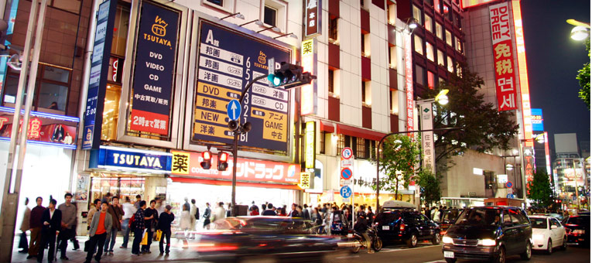
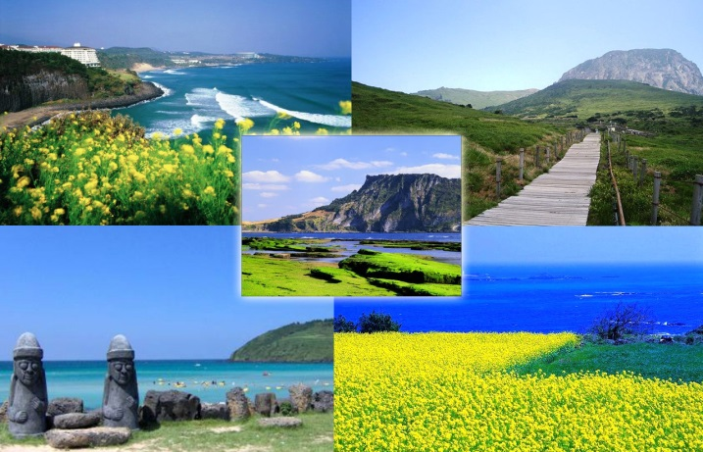

Jeju Island VS Japan

Mount Everest (8,848m
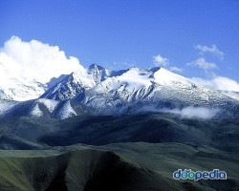
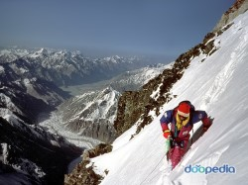

vs
H Himalayas(2,400m))

 | Seoul | Daegu
Population | 10,528,774 | 2,507,432
The highest temperature | 38.4 ℃ | 41˚C

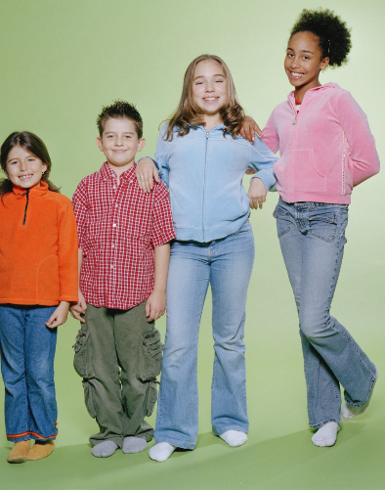
In Order of Height

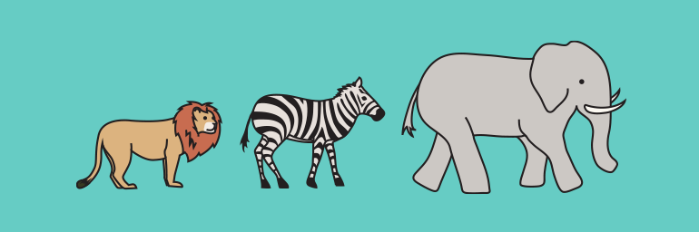
Who is the biggest?

Lists of Choosing either A or B about place for travel
-choose either A or B and state why you choose that place
Ex) price, climate, sightseeing, transportation, kindness of people

- Paris Vs Switzerland
- Philippines Vs Thailand
- Japan Vs China

