Listening Speaking Reading Grammar Writing
Topic: What Are You Going To Do?

Instructor:  Olivia | Students Competency Level: Intermediate | Number of Students: 13 | Lesson Length:  50 minutes
Materials: (List the Names of all materials used in the lesson. Materials must be shown at the end of this document)
Power Point
Worksheet
Aims: (What students will be able to achieve by participating in the activities of the lesson. (Ss gain or get by doing…)
-Improve speaking skills by practicing dialog in pair and answering teacher.
-Activate, increase interest and participate with fun in an English communication activity by sharing stories of teacher and students.
-Improve listening skills by pair work and responding to teacher.
-Improve writing skills by doing worksheet.
-Improve interaction and communication skills by asking and answering in pair and whole class.
Language Skills: (Lists what activities language skills students will be using by participating in the activities of the lesson.)
- Reading: (Where did reading occur in the lesson?)
PPT, worksheet
- Listening: (Where did listening occur in the lesson?)
Teacher talk, during the pair work
- Speaking: (Where did speaking occur in the lesson?)
Dialog, pair work, answering teacher
- Writing: (Where did writing occur in the lesson?)
Worksheet

Language Systems: (Lists what language systems students will be using by participating in the activities of the lesson.)
- Phonology: (sound)
Teacher talk, PPT, pair work
- Function: (situation)
Ask plan.
- Lexis: (meaning)
Vocabulary that we can plan and do.
- Grammar: (language structure)
Verbs
- Discourse: (communication)
Dialog, responding the teacher

Assumptions: (What students must already be able to do and what concepts must already be mastered before the lesson in order to achieve the aims of the lesson.)
-All Ss understand the basic of dialog.
-All Ss have made plans for something.

Anticipated Errors and Solutions: (What things might go wrong in the lesson and what the solution will be. An SOS activity should also be included)
-If Ss may not have ideas. (solution: T gives them little examples.)
-If activity lasts too long. (solution: T cuts unnecessary parts.)
-If activity finished too soon. (solution: T makes suggestions and share ideas.
-If Ss may not understand. (solution: T shows demonstrations.)
-If certain Ss are shy. (solution: T encourages them, give positive feedback.
References:

Lead-In or Pre-Task Part (Warm-Up Part to activate and create interest in the lesson.)
Materials: (List the Names of all materials used in the Lead-In or Pre-Task Part of the lesson. Materials must be shown at the end of this document)
Powerpoint
Time: | Classroom Set Up: | Student Activity and Goals: | Teacher Procedure & Instructions:
1min  4min | Whole  Whole | Ss greet the teacher.  Ss listen to teacher and look at the board. | Greeting.  Show T’s bucket list.  Ask Ss who have planner and have made bucket list  Transition- Let’s see some expressions.

Pre-Activity or Task Familiarization Part (Presentation Part Presenting the language structure to be covered in the lesson. Prepares students for the communication activity.)
Materials: (List the Names of all materials used in the Pre-Activity or Task Familiarization Part of the lesson. Materials must be shown at the end of this document)
Powerpoint

Time: | Classroom Set Up: | Student Activity and Goals: | Teacher Procedure & Instructions:
3min  2min | Whole  Whole | Ss listen what T says.  Answer to T.  Ss listen what T says and answer. | Show PPT and introduce expressions.  Read a script and ask questions.  Transition- Let’s practice with your partner.

Main Activity or Task Realization Part (Practice to Production Part Teacher lead practice of the language presented and move to communication based more student centered activity)
Materials: (List the Names of all materials used in the Main Activity or Task Realization Part of the lesson. Materials must be shown at the end of this document)
Powerpoint
Worksheet
Time: | Classroom Set Up: | Student Activity and Goals: | Teacher Procedure & Instructions:
5min  2min  1min  4min  4min | Pair work  Pair work  Whole  Pair work  Pairwork | Ss talk in pairs using examples on PPT.  Ss talk in pairs about their weekend plans.  Ss listen to T.  Repeat after T.  Ss talk in pairs using examples on PPT.  Ss complete the worksheet and talk with partner. | Introduce the dialog. Set pairs.  Introduce an example.  Introduce expressions.  Introduce the dialog. Set pairs  Introduce the activity.  Transition

Post Activity or Post Task Part (Wrap-Up Part Close the Lesson on a high note to and consolidate language learned in a communication based activity new situation.)
Materials: (List the Names of all materials used in the Post Activity or Post Task Part of the lesson. Materials must be shown at the end of this document)
Powerpoint
worksheet
Time: | Classroom Set Up: | Student Activity and Goals: | Teacher Procedure Instructions:
10min  14min | whole  Whole | Ss listen to T.  Think about this year and make plans.  Complete the worksheet.  Ss have a talk in front of the class.  Other Ss listen and share opinion. | Introduce the activity.  Listen to Ss and give positive feedback.

<Powerpoint>

1.
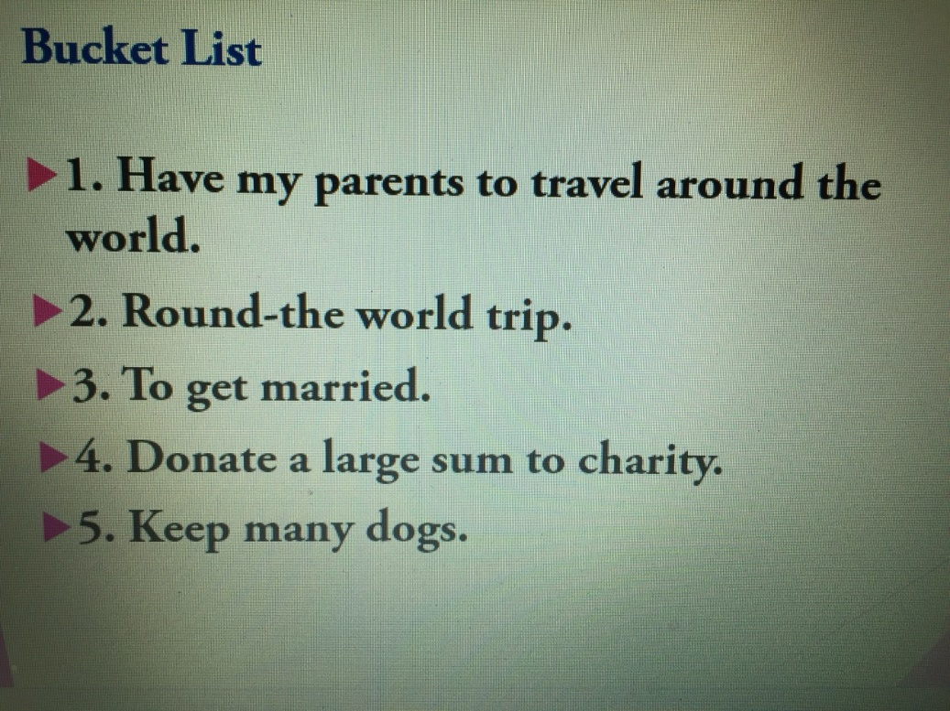

2.
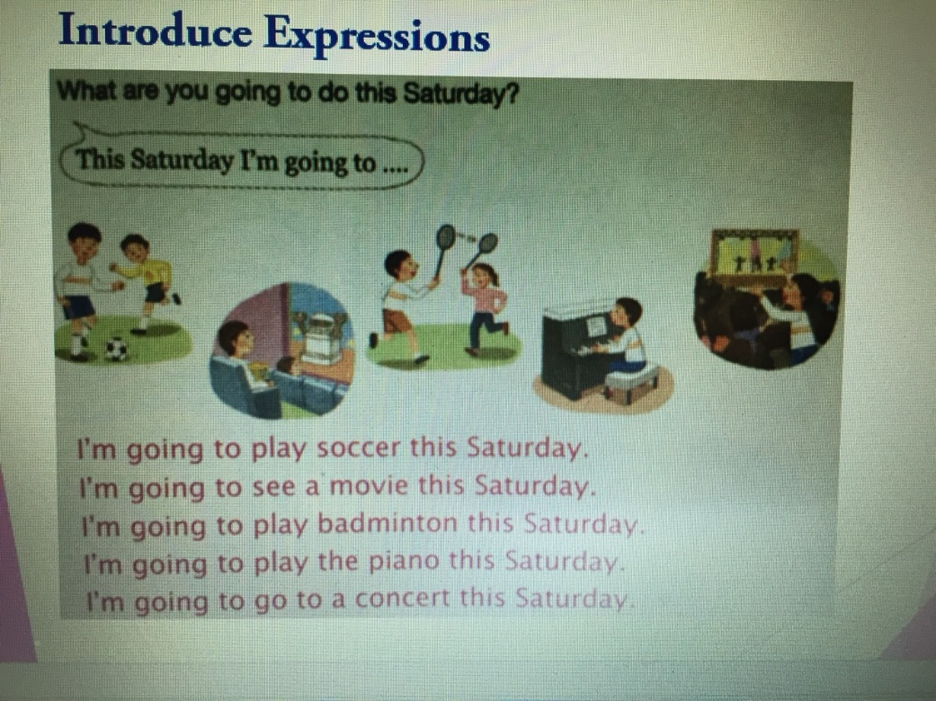

3.
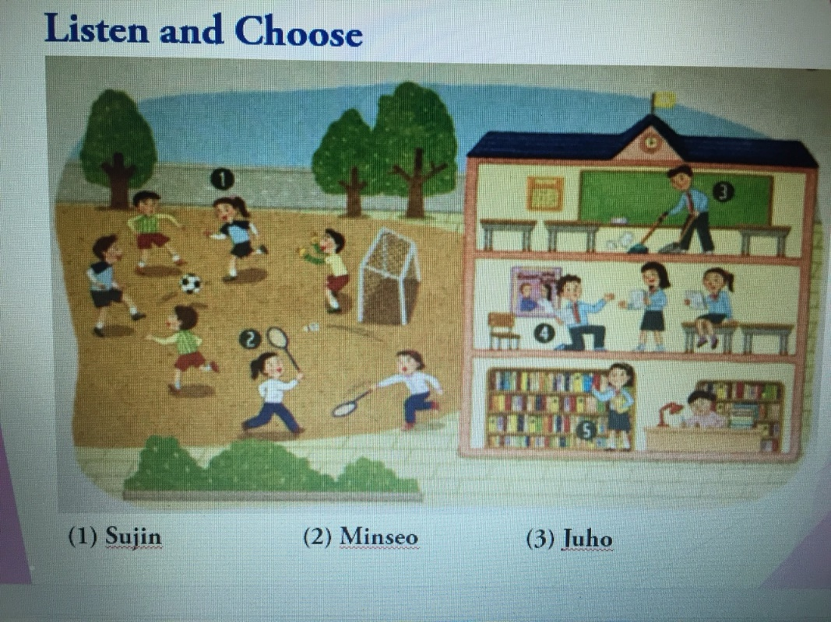

4.
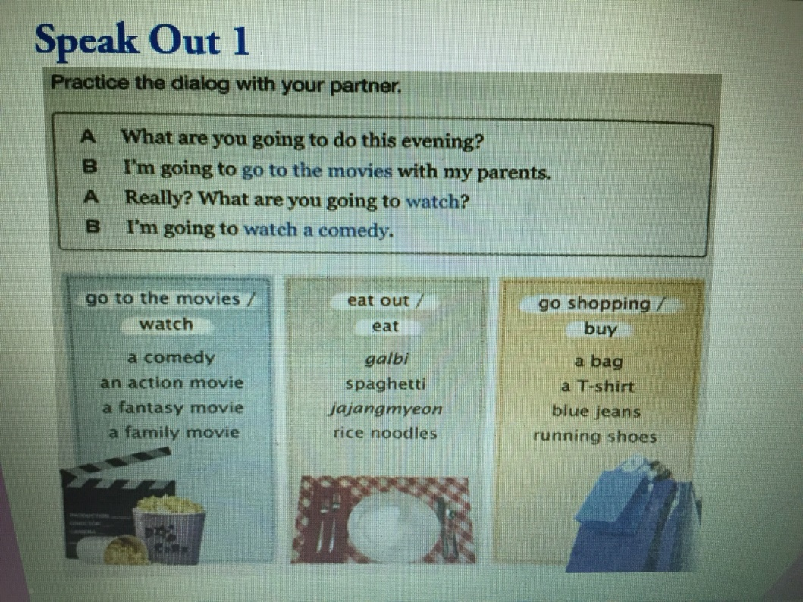

5.
.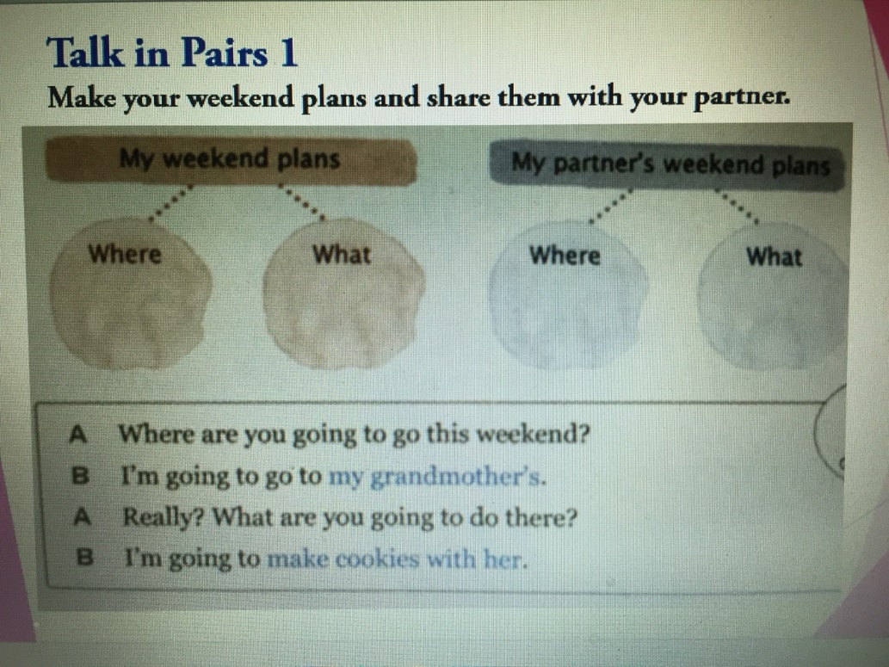

6.
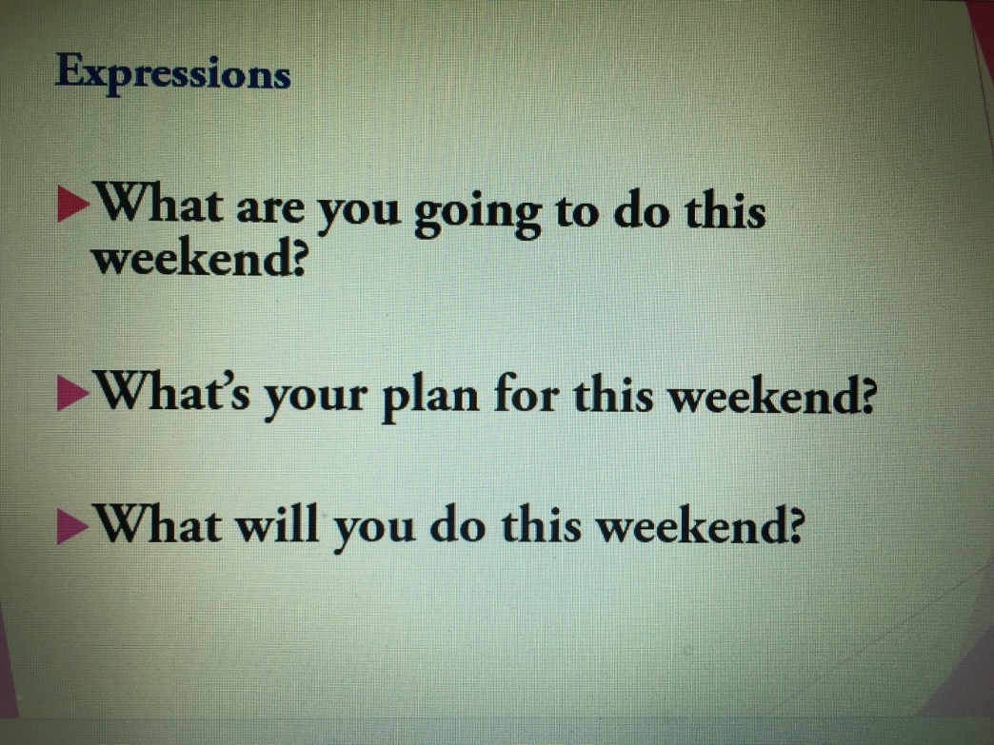

7.
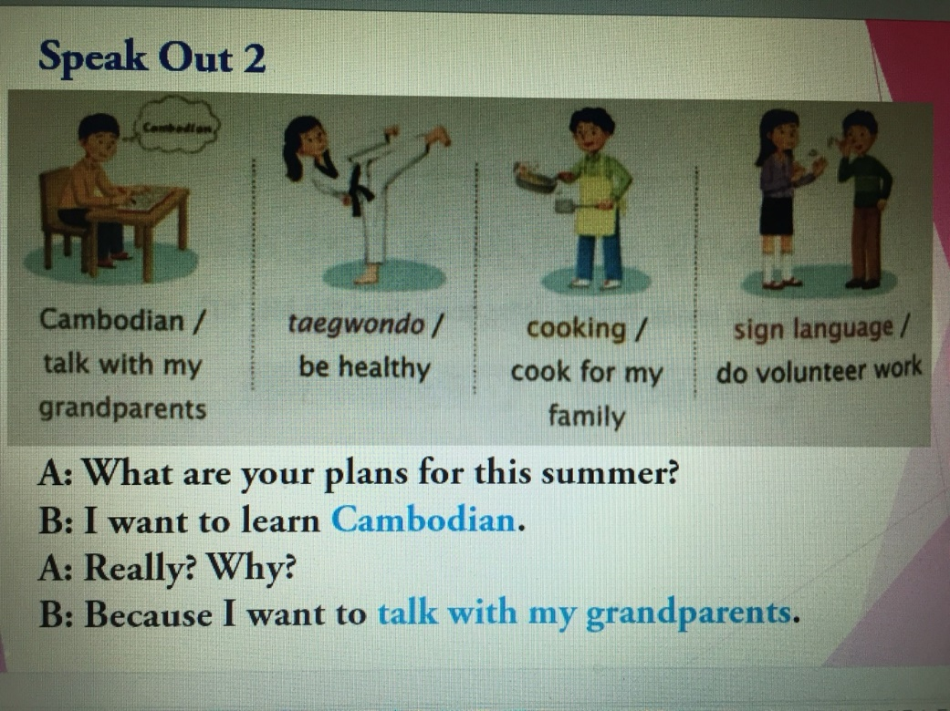

8.
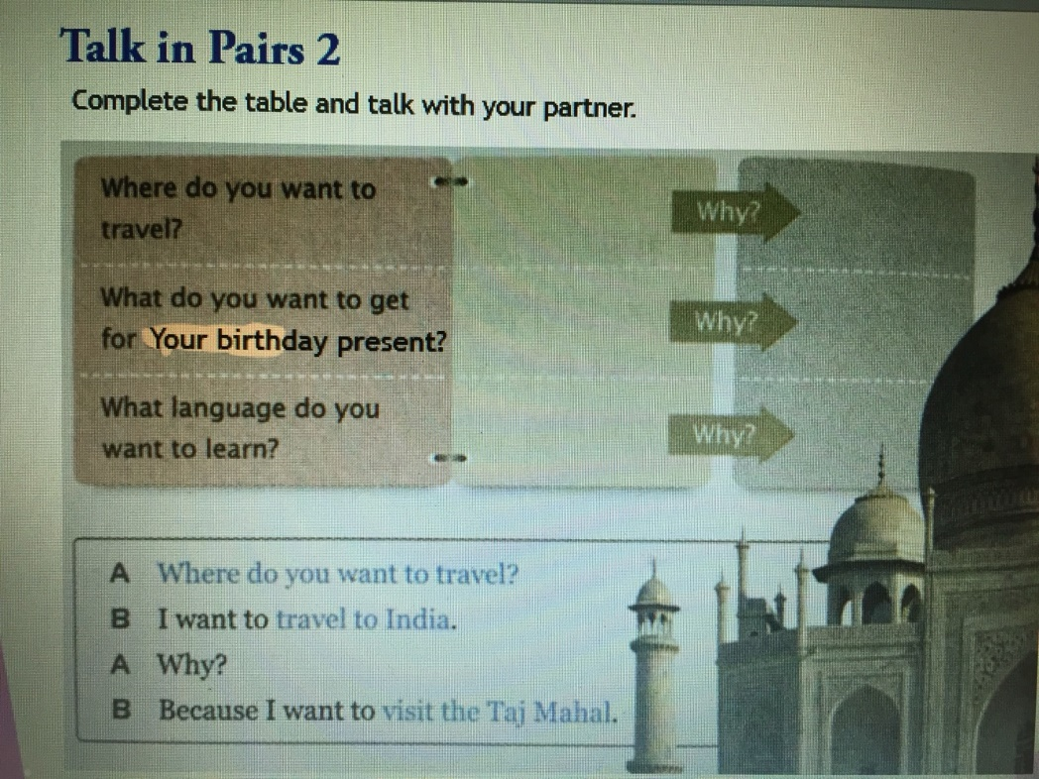

9.
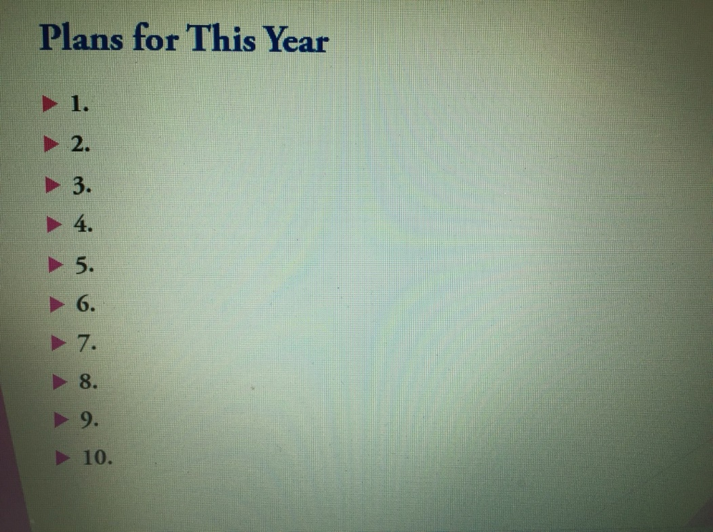

<Listen and Choose Script>

- M: What are you going to do this afternoon, Sujin?
W: I’m going to play soccer.

- M: Will you go to the movies with me this afternoon, Minseo?
W: Sorry, I already have plans. I’m going to help my teacher in the library.

- W: Are you going o practice the school play this afternoon, Juho?
M: Yes, I am.

<Worksheet>

- Complete the table and talk with your partner.

Where do you want to travel? |  | Why?
What do you want to get for your birthday present? |  | Why?
What language do you want to learn? |  | Why?

- Plans for this year.

