Listening – Speaking Reading X Grammar Writing
Topic: Fairy Tales
(Language Target: Relative Pronouns; What, Whose, Which, That)

Instructor:  Mina | Students Competency Level : Pre-Intermediate | Number of Students: 15 | Lesson Length:  53 minutes
Materials: (List the Names of all materials used in the lesson. Materials must be shown at the end of this document)
- White Board and Markers
- Computer Screen
- Projector
- Activity Pictures
Children’s Book Illustration #1
Children’s Book Illustration #2
Children’s Book Illustration #3
- Drilling Wall Chart 1 / A Relative Pronoun ‘What’
Drilling Wall Chart 2 / A Relative Pronoun ‘Whose’
Drilling Wall Chart 3 / A Relative Pronoun ‘Which’
Drilling Wall Chart 4 / A Relative Pronoun ‘That’
- <Who or What Is It?> The Main Characters from Fairy Tales
-Complete the Story Worksheet 1
Complete the Story Worksheet 2
Aims:(What students will be able to achieve by participating in the activities of the lesson. (Ss gain or get by doing…)
- Ss will be able to improve their listening skills by listening to T’s story, Ss’ story, drilling and playing games.
- Ss will be able to improve their speaking skills by answering T, drilling, and playing games.
- Ss will be able to improve their grammar skills about relative nouns by T using them, T responding and rephrasing Ss answers, drilling and playing games.
- Ss will be able to improve their writing skills by ‘Complete the Story’ activity.
Language Skills:(Lists what activities language skills students will be using by participating in the activities of the lesson.)
- Reading: (Where did reading occur in the lesson?)
Drilling wall chart and ‘Complete the Story’ activity.
- Listening: (Where did listening occur in the lesson?)
Listening to what T says(T talk, instructions, feedback, etc.) and Listening to what other Ss say for playing games.
- Speaking: (Where did speaking occur in the lesson?)
Speaking for playing games and answering T.
- Writing: (Where did writing occur in the lesson?)
‘Complete the Story’ activity.
Language Systems: (Lists what language systems students will be using by participating in the activities of the lesson.)
- Phonology: (sound)
Drilling, Repeating after T, T and Ss talk.
- Function:(situation)
Adding information and making a sentence.
- Lexis: (meaning)
Relative pronouns explain about fairy tales.
- Grammar:(language structure)
Relative pronouns.
- Discourse: (communication)
Playing games, responding a teacher and talking to a partner.
Assumptions: (What students must already be able to do and what concepts must already be mastered before the lesson in order to achieve the aims of the lesson.)
- Ss know about pronouns and antecedents. .
- Ss know about the famous fairy tales.
- Ss know how to combine sentences when they talk.
Anticipated Errors and Solutions: (What things might go wrong in the lesson and what the solution will be. An SOS activity should also be included)
- If Ss don’t know about some fairy tales. ☞ Solution: T provide another one.
- If Some Ss have trouble to combine sentences. ☞ Solution: T finds what troubles they have and rephrases it.
- If Some Ss have trouble to guess the right answer. ☞ Solution: T encourages them and let the group help them.
References:

Lead-In or Pre-Task Part (Warm-Up Part to activate and create interest in the lesson.)
Materials: (List the Names of all materials used in the Lead-Inor Pre-Task Partof the lesson. Materials must be shown at the end of this document)
Time: | Classroom Set Up: | Student Activity and Goals: | Teacher Procedure &Instructions:
1min  2min  3min | Whole  Whole  Ss | Ss greet the teacher.  Ss listen to the teacher and respond.  Ss share their story. | Greeting.  T tells a story related to the topic with using relative pronouns.  T asks Qs and elicits the stories from Ss.  T rephrases and responds using relative pronouns.  Let’s look at the famous fairy tales.

Pre-Activity or Task Familiarization Part (Presentation Part Presenting the language structure to be covered in the lesson. Prepares students for the communication activity.)
Materials: (List the Names of all materials used in the Pre-Activity or Task Familiarization Part of the lesson. Materials must be shown at the end of this document)
- White Board and Markers
- Computer Screen
- Projector
- Activity Pictures
Children’s Book Illustration #1
Children’s Book Illustration #2
Children’s Book Illustration #3
- Drilling Wall Chart 1 / A Relative Pronoun ‘What’
Drilling Wall Chart 2 / A Relative Pronoun ‘Whose’
Drilling Wall Chart 3 / A Relative Pronoun ‘Which’
Drilling Wall Chart 4 / A Relative Pronoun ‘That’
Time: | Classroom Set Up: | Student Activity and Goals: | Teacher Procedure &Instructions:
5min  2min  1min  1min  2min  1min  1min  3min  3min  2min | Whole  Whole  Whole  Whole  Whole  Whole  Whole  Whole  Whole  Whole | Ss read, listen, speak and drill to learn and become familiar with relative pronouns.  Ss listen to T and answer.  Ss listen to T and answer.  Ss listen to T and repeat after T.  Ss listen to T and answer.  Ss listen to T and answer.  Ss listen to T and repeat after T.  Ss listen to T and answer.  Ss listen to T and answer.  Ss listen to T and repeat after T. | T puts drilling wall charts on the white board.  T does drilling with Ss. Accuracy is important.  T shows ‘Children’s Book Illustrations #1.’  T asks Ss to make 2 sentences to describe the illustrations and write them down on the white board.  T asks Ss to combine sentences using relative pronouns.  T rephrases it and makes Ss repeat after T.  T shows ‘Children’s Book Illustrations #2.’  T asks Ss to make 2 sentences to describe the illustrations and write them down on the white board.  T asks Ss to combine sentences using relative pronouns.  T rephrases it and makes Ss repeat after T.  T shows ‘Children’s Book Illustrations #3.’  T asks Ss to make sentences as many as they can to describe the illustrations and write them down on the white board.  T asks Ss to combine sentences using relative pronouns. (At first, let them combine 2 sentences, and then 3 sentences…)  T rephrases it and makes Ss repeat after T.

Main Activity or Task Realization Part(Practice to Production Part Teacher leads practice of the language presented and move to communication based more student centered activity)
Materials: (List the Names of all materials used in the Main Activity or Task Realization Part of the lesson. Materials must be shown at the end of this document)
- White Board and Markers
- Computer Screen
- Projector
- Activity Pictures
Children’s Book Illustration #1
Children’s Book Illustration #2
Children’s Book Illustration #3
- Drilling Wall Chart 1 / A Relative Pronoun ‘What’
Drilling Wall Chart 2 / A Relative Pronoun ‘Whose’
Drilling Wall Chart 3 / A Relative Pronoun ‘Which’
Drilling Wall Chart 4 / A Relative Pronoun ‘That’
- <Who or What Is It?> The Main Characters from Fairy Tales
Time: |  | Classroom Set Up: |  | Student Activity and Goals: |  | Teacher Procedure &Instructions:
1min  3min  2min  12min |  | Whole  Whole  Whole  Group |  | One S from each group picks the slip of paper.  Ss listen to T and respond.  Ss listen to T.  Ss describe the characters from fairy tales and guess the answer. |  | T divides Ss into groups and let one S from each group pick one slip of paper which has the main character’s name from fairy tales on it.  T explains about the rules.  -Ss must not say any word on the paper. It has several taboo words (words that are listed in the brackets can’t be used) related to the fairy tale aside from the character’s name.  -The S who picked the paper describes about the character’s name to the group using relative pronouns.  -The rest of Ss in the group guess the answer. If someone who says the incorrect answer will be out and no more chance to talk anything.  -Guessing the answer goes on until anyone get the right answer or everyone in the group loses their chance to talk.  T shows a demonstration.  T let Ss start playing the game.  T facilitates the game and monitors Ss’ performance. When Ss have problem to describe the characters, T gives hints to continue it.
Post Activity or Post Task Part (Wrap-Up Part Close the Lesson on a high note to and consolidate language learned in a communication based activity new situation.)
Materials: (List the Names of all materials used in the Post Activity or Post Task Part of the lesson. Materials must be shown at the end of this document)
- White Board and Markers
-Complete the Story Worksheet 1
Complete the Story Worksheet 2
Time: | Classroom Set Up: |  | Student Activity and Goals: |  | Teacher Procedure Instructions:
1min  5min  3min  1min | Whole  Pair  Whole  Whole |  | Ss listen to T.  Ss discuss with partner and fill out blanks.  Ss read out the part of a story.  Ss listen and respond. |  | T pairs up Ss.  T cuts up two worksheets and hands out one piece for each group.  T lets Ss fill out blanks to complete the story. (Each group can’t share what they have.)  T lets each pair read out what they wrote.  (This will form two short fairy tales.)  T thanks all Ss for their participation and closes the class.

<Children’s Book Illustration 1>
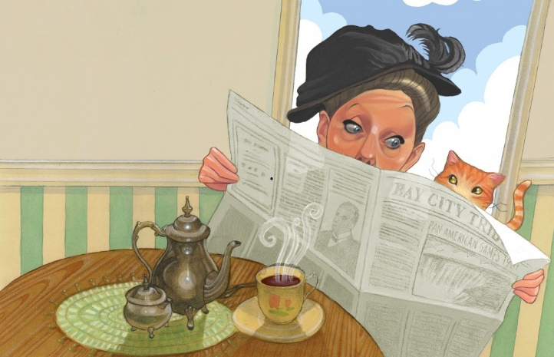
<Children’s Book Illustration 2>
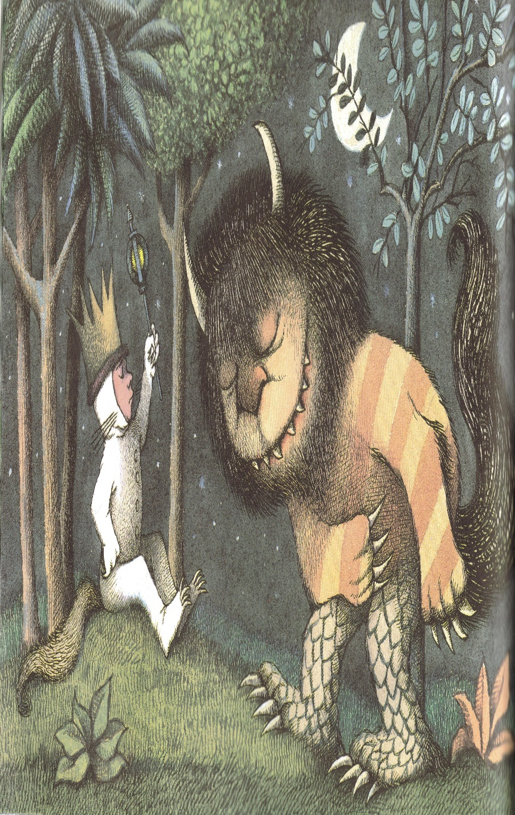
<Children’s Book Illustration 3>
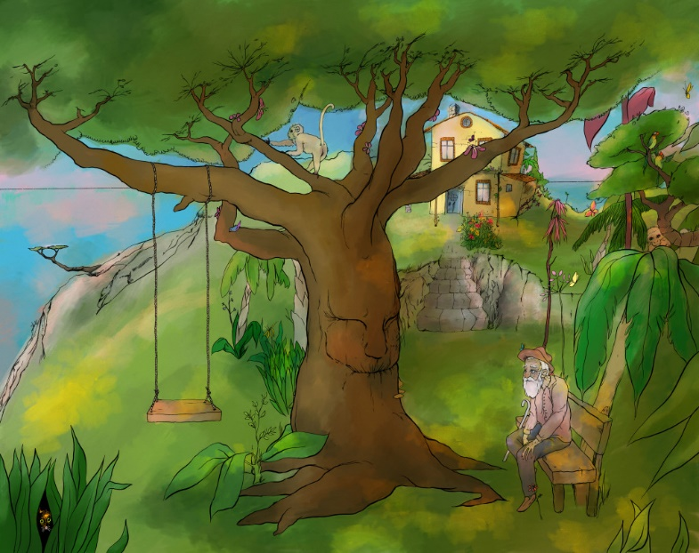

Drilling Wall Chart 1
A relative pronoun ‘What’
The beautiful girl is a princess. She lives in the palace.
The beautiful girl who lives in the palace is a princess.

Drilling Wall Chart 2
A relative pronoun ‘Whose’
The prince was crying. His crown was stolen.
The prince whose crown was stolen was crying.

Drilling Wall Chart 3
A relative pronoun ‘Which’
This is the day. I’ve been waiting for it.
This is the day which I’ve been waiting for.

Drilling Wall Chart 4
A relative pronoun ‘That’
The princess married the prince. She met him in the forest.
The princess married the prince that she met in the forest.

<Who or What Is It?> The Main Characteres from Fairy Tales

Bell (Beauty / the Beast / the Rose)

Snow White (Snow / White / Seven Dwarfs / apple / mirror / princess)

Seven Dwarfs (Snow / White / apple / mirror / princess)

Alice (Alice / Wonderland / rabbit)

Pinocchio (Pinocchio / nose / puppet)

Cinderella’s Stepmother (Cinderella / stepmother / glass shoes / prince)

Cookie House (Hansel and Gretel / witch / bread crumbles / cookie)

Genie (Aladdin / magic carpet / lamp / wishes / Open sesame)

Tinker Bell (Peter Pan / Wendy / Captain Hook / wing / adult)

Beanstalk (Jack and the Beanstalk / Giant / golden goose)

Complete the Story 1

(1)
It was a fine summer’s day and a fox which ________________________ was out looking for food that _______________________________. He spotted a crow which _____________________________________ was sitting on the branch.
-------------------------------------------------------------------------------------------
(2)
The fox which ____________________________ looked up towards the crow and he said, “The other day I saw a bird whose feathers _________________________________________. It was you! I heard from my friend that it is your voice which _____________________________. May I hear you sing?”
-------------------------------------------------------------------------------------------
(3)
The crow which______________________________ was a very famous bird whose voice ________________________________________________. She opened her mouth and started singing as loudly as she could. As soon as she did, the fox which ________________________________________ ran to her and stole her food.

Complete the Story 2

(1)
There was a girl whose ______________________________________________. The big party was coming soon and this time the prince was going to choose a princess from his kingdom, to marry. The day of the party, the girl really wanted to go but she couldn’t because of her stepmother who ___________________________________________. That night, she ran to the party and finally saw the prince who _________________________________________________.
-------------------------------------------------------------------------------------------
(2)
The prince whose __________________________________________ was hypnotized by her beauty and asked her to dance. However, she refused and ran away. On her way home, she bumped into a man who ___________________________________________.
He was with a dog which ____________________________________________________. She came home with a dog.
-------------------------------------------------------------------------------------------
(3)
The next day, the girl was talking with her stepmother who ____________________________________. All of sudden, a knocking was heard at the door. There was the man standing there and looking for the dog. He said he was a prince who ______________________________________________. He travelled all over the world to find a princess whose ____________________________________.
-------------------------------------------------------------------------------------------
(4)
The man gave her a little gift which ___________________________________________. The girl who_________________________________________ was so happy because in the house which _______________________________ no one has cared about her for a long time and showed her that much bright smile. He promised that he would take her to his kingdom which ________________________________ and she would be the queen.

