Listening Speaking Reading Grammar Writing
Topic: Design My Life
(Language Target : Future Tense)

Instructor:  Ella | Students Competency Level : Intermediate | Number of Students: 13 | Lesson Length:  50 minutes
Materials:(List the Names of all materials used in the lesson. Materials must be shown at the end of this document)

WILL / BE GOING TO
Graphic Life Map Planning Sheet
White Board and Marker
Drilling Future Event Instruction

Aims:(What students will be able to achieve by participating in the activities of the lesson. (Ss gain or get by doing…)
- Ss will gain information about future tense by listening and talking about future.
- Ss will be able to use expressions, “will” and “be going to” by writing sheet
- Ss will be able to exercise using the expressions, “will” and “be going to” by drilling
Language Skills:
- Reading:
Reading future sentences in the material “WILL / BE GOING TO”
- Listening:
Listening to what teacher says (T talk, instructions, feedback, etc.) and students’ talk
- Speaking:
Speaking to the class about students’ own designed life using future tense
- Writing:
Answering of the “WILL / BE GOING TO” sheet
Language Systems: (Lists what language systems students will be using by participating in the activities of the lesson.)
- Phonology:
Pronounce of what teacher says and other Ss with classroom participation.

- Function:(situation)
Think about what Ss design for their life in the future.

- Lexis: (meaning)
Learning vocabulary related to life plan.

- Grammar:(language structure)
Grammar how to distinguish “Will” and “Be going to”.

- Discourse: (communication)
Talking to the class and answering for teacher’s questions.

Assumptions:
- Ss need to think and plan for their future life
Anticipated Errors and Solutions:(What things might go wrong in the lesson and what the solution will be. An SOS activity should also be included)
- Some Ss might not know some words in the materials
: Explain with some example of sentence and encourage Ss guess the meaning.
- Some Ss have difficulties to answer some question of question sheet.
: Help Ss answer question by eliciting thinking related with the question

References:

Lead-In or Pre-Task Part (Warm-Up Part to activate and create interest in the lesson.)
Materials: (List the Names of all materials used in the Lead-In or Pre-Task Part of the lesson. Materials must be shown at the end of this document)

Time: | Classroom Set Up: | Student Activity and Goals: | Teacher Procedure &Instructions:
3min  2min | W  T-SS | Ss listens T says a story  Ss answer the question. | T talks teacher’s own story about planning for future  Ask question to Ss what plan do Ss have.

Pre-Activity or Task Familiarization Part (Presentation PartPresenting the language structure to be covered in the lesson. Prepares students for the communication activity.)
Materials: (List the Names of all materials used in the Pre-Activity or Task Familiarization Part of the lesson. Materials must be shown at the end of this document)

WILL / BE GOING TO
White Board and Marker

Time: | Classroom Set Up: | Student Activity and Goals: | Teacher Procedure &Instructions:
2min  8min  5min  3min | T-SS  S-W  W-S  T-S | Ss get the material and listen what they would do  Ss listen what T says and fill in the blank with T and read the sentences follow to T  Ss fill in the blank  Ss one by one read one sentence and check the answer of the blanks | T gives the material and explain that we will fill in the blank together  T writes down first 3 sentences in the sheet “WILL / BE GOING TO” on white board and helps Ss fill in the blank for 3 sentences and reads the sentences and drills  Ask Ss to fill in the remained blank  T asks Ss one by one to read each sentences for checking answer of the blanks together

Main Activity or Task Realization Part(Practice to Production PartTeacher lead practice of the language presented and move to communication based more student centered activity)
Materials: (List the Names of all materials used in the Main Activity or Task Realization Partof the lesson. Materials must be shown at the end of this document)

Graphic Life Map Planning Sheet

Time: | Classroom Set Up: | Student Activity and Goals: | Teacher Procedure &Instructions:
3min  3min  1min  15min | T-Ss  T-Ss  W  4groups | Ss are given the sheet and instruction from teacher  Ss understand and think more in detail and easily to do the worksheet  Ss set the group  Ss write down about their life event on the sheet as many as possible | T hands out the Graphic Life Map Planning Sheet and gives instruction that we are going to set some life plan except “Image” on the material  T gives an example of life event using the material  T divides Ss by 4 groups  T lets each groups do the Graphic Life Map Planning Sheet for 10min and look around with helping Ss who need any help

Post Activity or Post Task Part (Wrap-Up PartClose the Lesson on a high note to and consolidate language learned in a communication based activity new situation.)
Materials: (List the Names of all materials used in the Post Activity or Post Task Part of the lesson. Materials must be shown at the end of this document)

Graphic Life Map Planning Sheet
Drilling Future Event Instruction

Time: | Classroom Set Up: | Student Activity and Goals: | Teacher Procedure Instructions:
2min  3min  10min | 4groups  4groups  4groups | Each groups get the instruction for “Drilling Future Event” game  Each groups prepare the game following the instruction  Ss play the game | T gives instruction for playing game “Drilling Future Event”  T gives 2min to Ss to prepare the game following the instruction  T helps Ss play game smoothly if any Ss need helps
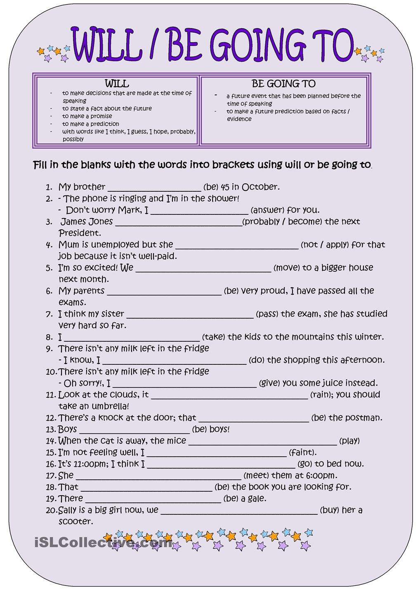

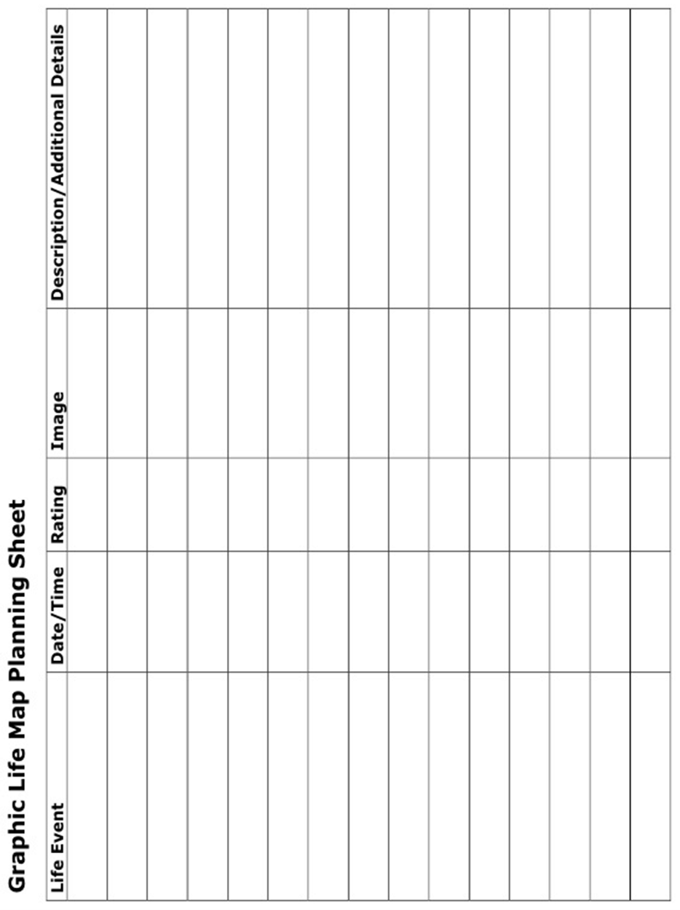

Drilling Future Event Instruction

- Divide to 4 groups
- Fill the blank on “Graphic Life Map Planning Sheet”
- With the contents on the “Graphic Life Map Planning Sheet”, make sentences using future tense “will” or “be going to” as many as possible within set time (The time is flexible depends on situation of player)
- Decide an playing order in each group. The person who plays first is Player1 and next is player2.
- Player1s in each group stand up.
- The Player1 in Group1 says one sentence that Group1 made
- The Player1 in Group2 has to repeat the sentence previously said in Group1 and says one sentence that Group2 made
- The Player1 in Group3 has to repeat the sentence previously said in Group2 and says one sentence that Group3 made
- The Player1 in Group4 has to repeat the sentence previously said in Group3 and says one sentence that Group4 made
- Player2s in each group stand up.
- The Player2 in Group1 has to repeat the sentence previously said in Group4 and says one another sentence that Group1 made
- Repeat 5~11 until all players finished to say the sentences they made

[advices]
- If any player cannot remember previous sentence get 1 penalty
- If any player cannot repeat previous sentence then the next player has to repeat the sentence
- If any player cannot say a sentence they made or there is no more sentence to say get 2 penalty
- If any group has no more sentence to say again they lose and cannot play the game anymore
(Hint : one member who is far from the order to play can make more sentences during the game if sentences are few)

[Winner]
- The winner is the group which gets less penalty

