Listening Speaking Reading Grammar Writing

Topic: Second conditional grammar

Instructor:  Luna  (Noh Poo Reun) | Level:  Intermediate  (Adults) | Students:  4 | Length:  30 Minutes

Materials:
-2 card sets for ‘If I were a refuge, what would you choose?’ Activity
-Computer(Laptop) and speaker or IPad(for music), Beam projector
-Situation pictures for ‘If I were a refuge, what would you choose? ‘Activity
-Music video, Bruno Mars’s “Count on me”(Shown on screen)
-Second conditional Situation dice-1, Second conditional Situation dice-2
-Markers and Board
-Hand out paper

Aims:
-Main aim: Ss will be able to use second conditional by practicing through activities.
-Second aim : Students will be able to understand first conditional and second
conditional difference.
-Personal aim: Ss can think about how can be the refuge life by activity.

Language Skills:
-Reading: Ss will read words on cards for activity
-Listening: Ss will listen to music ‘Count on me’ song which is related with second conditional.
Ss will listen to teacher’s instructions, explanation and class mate’s opinions.
-Speaking: Ss will share their idea to use second conditional.
-Writing: Ss will write about unreal situation their decisions using second conditional.

Language Systems:
-Grammar: Use of second conditional (‘If I were~, I would~.’)
-Function: Describing unreal situation

Assumptions:
-Students already learned first conditional last class.
-Students are able to make sentences to complete.
-Students are all females.
-Students have enough lexis skill.(vocabularies)

Anticipated Problems and Solutions:
- If Ss have difficulty to choose items while they do activity in limited time.
→ Give them hint what they could need and make them feel like real
situations as a refuge and try to choose the items as soon as possible.
- If Ss have difficulty to keep using second conditional while they do the activity
→ Listen to students and encourage them to use second conditional such as
“If I were a refuge, I would choose~ because~.” And make sure them to
keep using this form while they do the activity.

References:
- Music video with lyrics
https://www.youtube.com/watch?v=Yc6T9iY9SOU
-card set pictures
https://www.google.co.kr/search?q=clothes&biw=980&bih=659&source=lnms&tbm=isch&sa=X&ved=0ahUKEwih06HD87jMAhXILpQKHUmQDCwQ_AUIBigB#imgrc=Bx-vFB4CyG1_ZM%3A
https://www.google.co.kr/search?q=clothes&biw=980&bih=659&source=lnms&tbm=isch&sa=X&ved=0ahUKEwih06HD87jMAhXILpQKHUmQDCwQ_AUIBigB#tbm=isch&q=juice+box&imgrc=HppowS76oNH5cM%3A
https://www.google.co.kr/search?q=clothes&biw=980&bih=659&source=lnms&tbm=isch&sa=X&ved=0ahUKEwih06HD87jMAhXILpQKHUmQDCwQ_AUIBigB#tbm=isch&q=canned+food&imgrc=Y1jWRBCD2iN-vM%3A
https://www.google.co.kr/search?q=clothes&biw=980&bih=659&source=lnms&tbm=isch&sa=X&ved=0ahUKEwih06HD87jMAhXILpQKHUmQDCwQ_AUIBigB#tbm=isch&q=bank+book&imgrc=1IBRTedVy4moEM%3A
https://www.google.co.kr/search?q=clothes&biw=980&bih=659&source=lnms&tbm=isch&sa=X&ved=0ahUKEwih06HD87jMAhXILpQKHUmQDCwQ_AUIBigB#tbm=isch&q=pets&imgrc=8thRX4eHeTRcNM%3A
https://www.google.co.kr/search?q=clothes&biw=980&bih=659&source=lnms&tbm=isch&sa=X&ved=0ahUKEwih06HD87jMAhXILpQKHUmQDCwQ_AUIBigB#tbm=isch&q=album&imgrc=AabgVBoVMZ7LeM%3A
https://www.google.co.kr/search?q=clothes&biw=980&bih=659&source=lnms&tbm=isch&sa=X&ved=0ahUKEwih06HD87jMAhXILpQKHUmQDCwQ_AUIBigB#tbm=isch&q=bottle+water&imgrc=e_-eLLyebcs1hM%3A
https://www.google.co.kr/search?q=clothes&biw=980&bih=659&source=lnms&tbm=isch&sa=X&ved=0ahUKEwih06HD87jMAhXILpQKHUmQDCwQ_AUIBigB#tbm=isch&q=cash&imgrc=jzkc98whIt58MM%3A
https://www.google.co.kr/search?q=License&biw=919&bih=715&source=lnms&tbm=isch&sa=X&ved=0ahUKEwj9s6mRmr7MAhXLq5QKHUuAByIQ_AUIBigB#imgrc=zvDGWYA3YqnrNM%3A
https://www.google.co.kr/search?q=underwear+for+kids&biw=919&bih=715&source=lnms&tbm=isch&sa=X&ved=0ahUKEwjwh_Hymr7MAhVBF5QKHXvxAgcQ_AUIBigB#tbm=isch&q=inner+wear+illust&imgrc=u-5RgeCc-pHxYM%3A
https://www.google.co.kr/search?q=underwear+for+kids&biw=919&bih=715&source=lnms&tbm=isch&sa=X&ved=0ahUKEwjwh_Hymr7MAhVBF5QKHXvxAgcQ_AUIBigB#tbm=isch&q=%EC%A0%84%EC%9F%81%EC%8B%9D%EB%9F%89&imgrc=1tLfk89fhIZDmM%3A
https://www.google.co.kr/search?q=underwear+for+kids&biw=919&bih=715&source=lnms&tbm=isch&sa=X&ved=0ahUKEwjwh_Hymr7MAhVBF5QKHXvxAgcQ_AUIBigB#tbm=isch&q=jewelry&imgrc=9joB4JIyfEkYoM%3A
https://www.google.co.kr/search?q=underwear+for+kids&biw=919&bih=715&source=lnms&tbm=isch&sa=X&ved=0ahUKEwjwh_Hymr7MAhVBF5QKHXvxAgcQ_AUIBigB#tbm=isch&q=potable+radio&imgrc=p2AaUFAXDgfiIM%3A
https://www.google.co.kr/search?q=underwear+for+kids&biw=919&bih=715&source=lnms&tbm=isch&sa=X&ved=0ahUKEwjwh_Hymr7MAhVBF5QKHXvxAgcQ_AUIBigB#tbm=isch&q=medicine&imgrc=yeOHzwxAh3jEFM%3A
https://www.google.co.kr/search?q=underwear+for+kids&biw=919&bih=715&source=lnms&tbm=isch&sa=X&ved=0ahUKEwjwh_Hymr7MAhVBF5QKHXvxAgcQ_AUIBigB#tbm=isch&q=cosmetic&imgrc=1OwdIDidduyGvM%3A
https://www.google.co.kr/search?q=underwear+for+kids&biw=919&bih=715&source=lnms&tbm=isch&sa=X&ved=0ahUKEwjwh_Hymr7MAhVBF5QKHXvxAgcQ_AUIBigB#tbm=isch&q=passport&imgrc=8EnmA79Mmr8yuM%3A
https://www.google.co.kr/search?q=underwear+for+kids&biw=919&bih=715&source=lnms&tbm=isch&sa=X&ved=0ahUKEwjwh_Hymr7MAhVBF5QKHXvxAgcQ_AUIBigB#tbm=isch&q=towel&imgrc=NQXHtY6gNZdIhM%3A
https://www.google.co.kr/search?q=underwear+for+kids&biw=919&bih=715&source=lnms&tbm=isch&sa=X&ved=0ahUKEwjwh_Hymr7MAhVBF5QKHXvxAgcQ_AUIBigB#tbm=isch&q=socks&imgrc=htykZcvUyhQieM%3A
https://www.google.co.kr/search?q=underwear+for+kids&biw=919&bih=715&source=lnms&tbm=isch&sa=X&ved=0ahUKEwjwh_Hymr7MAhVBF5QKHXvxAgcQ_AUIBigB#tbm=isch&q=collection&imgrc=L3H9r1XcqwwtDM%3A
https://www.google.co.kr/search?q=underwear+for+kids&biw=919&bih=715&source=lnms&tbm=isch&sa=X&ved=0ahUKEwjwh_Hymr7MAhVBF5QKHXvxAgcQ_AUIBigB#tbm=isch&q=certification+of+graduation&imgrc=tvtrUKQgrdDVWM%3A
https://www.google.co.kr/search?q=underwear+for+kids&biw=919&bih=715&source=lnms&tbm=isch&sa=X&ved=0ahUKEwjwh_Hymr7MAhVBF5QKHXvxAgcQ_AUIBigB#tbm=isch&q=artic+clothes&imgrc=khdzOhGmZMeVTM%3A
https://www.google.co.kr/search?q=underwear+for+kids&biw=919&bih=715&source=lnms&tbm=isch&sa=X&ved=0ahUKEwjwh_Hymr7MAhVBF5QKHXvxAgcQ_AUIBigB#tbm=isch&q=Cooking+Utensils&imgrc=7e7d4gAsw5vyuM%3A
https://www.google.co.kr/search?q=underwear+for+kids&biw=919&bih=715&source=lnms&tbm=isch&sa=X&ved=0ahUKEwjwh_Hymr7MAhVBF5QKHXvxAgcQ_AUIBigB#tbm=isch&q=laptop&imgrc=iOPbn6lCS-2w0M%3A
https://www.google.co.kr/search?q=underwear+for+kids&biw=919&bih=715&source=lnms&tbm=isch&sa=X&ved=0ahUKEwjwh_Hymr7MAhVBF5QKHXvxAgcQ_AUIBigB#tbm=isch&q=Traveler%E2%80%99s+checks&imgrc=YCytYunzYUxE8M%3A
https://www.google.co.kr/search?q=underwear+for+kids&biw=919&bih=715&source=lnms&tbm=isch&sa=X&ved=0ahUKEwjwh_Hymr7MAhVBF5QKHXvxAgcQ_AUIBigB#tbm=isch&q=rice&imgrc=BXsTfe5kCYzw7M%3A
https://www.google.co.kr/search?q=underwear+for+kids&biw=919&bih=715&source=lnms&tbm=isch&sa=X&ved=0ahUKEwjwh_Hymr7MAhVBF5QKHXvxAgcQ_AUIBigB#tbm=isch&q=torch&imgrc=oftaoKJBXwQHHM%3A
https://www.google.co.kr/search?q=underwear+for+kids&biw=919&bih=715&source=lnms&tbm=isch&sa=X&ved=0ahUKEwjwh_Hymr7MAhVBF5QKHXvxAgcQ_AUIBigB#tbm=isch&q=cell+phone&imgrc=8R--tUDvl-qZrM%3A
https://www.google.co.kr/search?q=underwear+for+kids&biw=919&bih=715&source=lnms&tbm=isch&sa=X&ved=0ahUKEwjwh_Hymr7MAhVBF5QKHXvxAgcQ_AUIBigB#tbm=isch&q=potable+knife&imgrc=tm9y_LQ6soDDKM%3A
https://www.google.co.kr/search?q=underwear+for+kids&biw=919&bih=715&source=lnms&tbm=isch&sa=X&ved=0ahUKEwjwh_Hymr7MAhVBF5QKHXvxAgcQ_AUIBigB#tbm=isch&q=writing+supplies&imgrc=yEZ45y4xAEaf1M%3A
https://www.google.co.kr/search?q=underwear+for+kids&biw=919&bih=715&source=lnms&tbm=isch&sa=X&ved=0ahUKEwjwh_Hymr7MAhVBF5QKHXvxAgcQ_AUIBigB#tbm=isch&q=book&imgrc=7dxS0sz0uXnLgM%3A
https://www.google.co.kr/search?q=underwear+for+kids&biw=919&bih=715&source=lnms&tbm=isch&sa=X&ved=0ahUKEwjwh_Hymr7MAhVBF5QKHXvxAgcQ_AUIBigB#tbm=isch&q=gold&imgrc=9fXT-cc2t45XtM%3A
https://www.google.co.kr/search?q=underwear+for+kids&biw=919&bih=715&source=lnms&tbm=isch&sa=X&ved=0ahUKEwjwh_Hymr7MAhVBF5QKHXvxAgcQ_AUIBigB#tbm=isch&q=snack&imgrc=xW0nMlUKESOndM%3A
https://www.google.co.kr/search?q=underwear+for+kids&biw=919&bih=715&source=lnms&tbm=isch&sa=X&ved=0ahUKEwjwh_Hymr7MAhVBF5QKHXvxAgcQ_AUIBigB#tbm=isch&q=ipod&imgrc=-KkGxWhl-VhuUM%3A
https://www.google.co.kr/search?q=underwear+for+kids&biw=919&bih=715&source=lnms&tbm=isch&sa=X&ved=0ahUKEwjwh_Hymr7MAhVBF5QKHXvxAgcQ_AUIBigB#tbm=isch&q=TISSUE&imgrc=Iz1Rb1FcaJJKnM%3A
https://www.google.co.kr/search?q=underwear+for+kids&biw=919&bih=715&source=lnms&tbm=isch&sa=X&ved=0ahUKEwjwh_Hymr7MAhVBF5QKHXvxAgcQ_AUIBigB#tbm=isch&q=TISSUE&imgdii=BaiDRBXP2xdJNM%3A%3BBaiDRBXP2xdJNM%3A%3BJT9yq97I79VniM%3A&imgrc=BaiDRBXP2xdJNM%3A
https://www.google.co.kr/search?q=underwear+for+kids&biw=919&bih=715&source=lnms&tbm=isch&sa=X&ved=0ahUKEwjwh_Hymr7MAhVBF5QKHXvxAgcQ_AUIBigB#tbm=isch&q=LUNCH+BOX&imgrc=Sw1cWxeAH_QeIM%3A
https://www.google.co.kr/search?q=underwear+for+kids&biw=919&bih=715&source=lnms&tbm=isch&sa=X&ved=0ahUKEwjwh_Hymr7MAhVBF5QKHXvxAgcQ_AUIBigB#tbm=isch&q=driver+licence&imgrc=33bQax4st4unuM%3A
https://www.google.co.kr/search?q=underwear+for+kids&biw=919&bih=715&source=lnms&tbm=isch&sa=X&ved=0ahUKEwjwh_Hymr7MAhVBF5QKHXvxAgcQ_AUIBigB#tbm=isch&q=TV+&imgrc=hW28Xsl3n_FutM%3A
https://www.google.co.kr/search?q=underwear+for+kids&biw=919&bih=715&source=lnms&tbm=isch&sa=X&ved=0ahUKEwjwh_Hymr7MAhVBF5QKHXvxAgcQ_AUIBigB#tbm=isch&q=BLANKET&imgrc=GEY3A6U3S0LAMM%3A
https://www.google.co.kr/search?q=underwear+for+kids&biw=919&bih=715&source=lnms&tbm=isch&sa=X&ved=0ahUKEwjwh_Hymr7MAhVBF5QKHXvxAgcQ_AUIBigB#tbm=isch&q=HOUSE+DEED&imgrc=JIswz4QXsacg9M%3A
https://www.google.co.kr/search?q=underwear+for+kids&biw=919&bih=715&source=lnms&tbm=isch&sa=X&ved=0ahUKEwjwh_Hymr7MAhVBF5QKHXvxAgcQ_AUIBigB#tbm=isch&q=Livestock&imgrc=BV-_gfX0Di1ABM%3A
https://www.google.co.kr/search?q=underwear+for+kids&biw=919&bih=715&source=lnms&tbm=isch&sa=X&ved=0ahUKEwjwh_Hymr7MAhVBF5QKHXvxAgcQ_AUIBigB#tbm=isch&q=MAP&imgrc=u7Pq0t4yUy_dfM%3A
-Situation pictures
https://www.google.co.kr/search?q=underwear+for+kids&biw=919&bih=715&source=lnms&tbm=isch&sa=X&ved=0ahUKEwjwh_Hymr7MAhVBF5QKHXvxAgcQ_AUIBigB#tbm=isch&q=natural+disaster&imgrc=E_IUalE5kUDG4M%3A
https://www.google.co.kr/search?q=underwear+for+kids&biw=919&bih=715&source=lnms&tbm=isch&sa=X&ved=0ahUKEwjwh_Hymr7MAhVBF5QKHXvxAgcQ_AUIBigB#tbm=isch&q=out+of+food&imgrc=4SwxRy7tv7hAPM%3A
https://www.google.co.kr/search?q=underwear+for+kids&biw=919&bih=715&source=lnms&tbm=isch&sa=X&ved=0ahUKEwjwh_Hymr7MAhVBF5QKHXvxAgcQ_AUIBigB#tbm=isch&q=immigrants+walking&imgrc=J_ME7YC-qQwLrM%3A
https://www.google.co.kr/search?q=underwear+for+kids&biw=919&bih=715&source=lnms&tbm=isch&sa=X&ved=0ahUKEwjwh_Hymr7MAhVBF5QKHXvxAgcQ_AUIBigB#tbm=isch&q=sick&imgrc=XLcbKeaJ1Qd1EM%3A
https://www.google.co.kr/search?q=underwear+for+kids&biw=919&bih=715&source=lnms&tbm=isch&sa=X&ved=0ahUKEwjwh_Hymr7MAhVBF5QKHXvxAgcQ_AUIBigB#tbm=isch&q=country+border&imgrc=uB3NI3fH_mH9mM%3A
https://www.google.co.kr/search?q=underwear+for+kids&biw=919&bih=715&source=lnms&tbm=isch&sa=X&ved=0ahUKEwjwh_Hymr7MAhVBF5QKHXvxAgcQ_AUIBigB#tbm=isch&q=%EA%B5%AC%EC%A1%B0%EB%8B%A8%EC%B2%B4&imgrc=zlJtin5a_LkgOM%3A
-Grammar
http://www.perfect-english-grammar.com/second-conditional.html
-Dice maker
http://www.toolsforeducators.com/dice/make1_text.php

Lead-In
Materials: IPad or Laptop, Speaker, Beam projector,
A music video song with Lyrics(Bruno Mars-Count on me)
Time | Set Up | Student Activity | Teacher Talk
2 mins | Whole  class | Listening to music and answering T’s warm-up questions | Warm up  (Turn on the music “Count on me”)  “Hello, everyone! How are you? What about this song? Did you enjoy?”  (Wait for Ss reply)  “What kind of story does it have?”  (Wait for Ss reply)  “Is that real situation or unreal situation?”  (Wait for Ss reply)

Pre-Activity
Materials: Markers, Board
Time | Set Up | Student Activity | Teacher Talk
8 mins | Whole class | Listening to the explanation about ‘second conditional’ grammar and review of first conditional.  Answer T’s questions  Complete the sentence  Answer the question | “Like this music, today we will  learn about second Conditional.”  Review  “Last time we learned about first conditional. Did first conditional is related with real situation or unreal situation?”  (Wait for Ss respond)  “Right! It’s relate with real situation. So first conditional is related with real situation but second conditional is related with unreal situation.  “Look at the board that how can we make second conditional form.”  (Write form on the board like below)  - If + past simple, ...would + infinitive~.  “The second conditional uses the past simple after if, then ‘would and the infinitive like this form. So we can use it to talk about things in future that are probably not going to be true. ”  “Ok. Then let’s complete this sentence.”  (Write the sentence below and wait for students respond)  - If I met Song-jungi, I would ~.  “Great. Also we can used it to talk about something in the present which is impossible, because it’s not true. I will give you example.”  (Write the sentence below.)  - If I had his number, I would call him.  “With this sentence What can you guess? Did “I” have his number?.”  (Wait for students respond)  “Good, “I” didn’t have his number now, so it’s impossible for “me” to call him. Right? Good job.

Main Activity
Materials: 2 Card sets, Situation pictures
Time | Set Up | Student Activity | Teacher Talk
3 mins  2 mins  2 mins  2 mins  1min  2 mins  2 mins  2 mins  2mins | Whole class  Whole  Class  Pair work  Pair work  Whole  class  Pair work  Pair work  Pair work  individual | Respond of the question  Answer the questions  Answer the questions  Answer the questions  Answer the questions  Students will discuss with their partner to choose right items for their refuge journey activity.  Answer the questions  Share what they choose and why  Students will discuss with their partner to choose right items for their refuge journey activity.  Answer the questions  Share what they choose and why  Remove food and medicine cards.  Answer the question  Answer the question  Answer the question  Answer the question | Instruction  “Ok, Let’s divide two group that we will do activity with these card sets.”  (Make two groups with 2 students on each group and give a card set each group.)  “Spread all cards on the table to show the pictures. Every group done to spread cards?”  (Waiting for students reply)  “Good. Now I will give you this sentence.”  (Write the sentence below)  - If I were a refuge, which items would I take to survive?  Instruction  “This time you will discuss you’re your partner to choose items according to each situation as a refuge. I will give you two minute for each situation to discuss and choose items.”  CCQ  “How many minutes for each situation?  (Wait for students reply)  “In two minutes, what do you need to do?  (Wait for students reply)  “Are a real refuge?”  (Wait for students reply)  “So which sentence form do you need to use?”  (Wait for students reply)  “Perfect! Now let’s start.  Instruction  “First situation, You have natural disaster, you need to take only 15 items with you. Among 40items choose only 15 items with you partner.”  “Ok! Time’s up. Did you choose only 15 items?”  (Waiting for Ss reply)  “Ok. Let’s see which items did you choose and why did you choose the items.”  Instruction  “This time you need to walk for long so you can’t take all items. So choose only 7 items.”  “Ok! Time’s up. Did you choose only 7 items?”  (Even if students can’t choose 7 items in limited time. Make sure them stop choosing more and it makes them more into this activity. Waiting for Ss reply)  “Ok. Let’s see which items did you choose and why did you choose the items.”  Instruction  “Ok. Oh no~. you have a patient among your family members and out of food. Remove all food card include water and medicine.”  “Ok! How many cards do you have?”  (Check each teams’ cards)  Instruction  “Ok. Now you reach country border that you need to cross the border. What do we need when we cross the border?”  (Wait for students reply)  “Which team has pass port? Give me the pass port card. And which team doesn’t have passport?  (If teams don’t have passport and ask this question below.)  “Oh!! You don’t have passport!! Then how will you cross with you item?  Discuss with your partner and tell me the final decision and the reason to do that.  (Wait for students reply)  Instruction  “Ok. Finally you reach safe village and let’s talk about how will you settle down with you items individually?”

Post Activity
Materials: Second conditional dice-1
Time | Set Up | Student Activity | Teacher Talk
2 mins  1mins  1 min | Whole class  Whole class  Whole class | Students stand up and make a circle.  Students roll the dice and complete the sentence which they see on the dice. | Instruction  “Ok here is a second conditional dice. it. Let’s stand up everybody and make a circle.”  (waiting for students to make a circle)  Instruction  “Ok each of you will roll the dice and after you rolling the dice you will see sentence and complete the sentence using second conditional.”  Model  “For example, I roll the dice and see.  I got this sentence ‘If I had a tail, I would~.’ And I can complete sentence like this.”  “If I had a tail, I would dance with my tails like Avata.”  “Is this clear? Ok good. Let’s roll. Joy first and then roll clock way.”  Conclude lesson  “Okay, Today we learned about second conditional and share your decision about unreal situation as a refuge and complete sentences using second conditional. It was interesting everybody has different opinions about the situations and well done everyone. Next time we will learn about third conditional. Hope you have great weekends. See you next Tuesday.”
SOS Activities
Materials: Second conditional dice-2, hand out paper
Time | Set Up | Student Activity | Teacher Talk
5 min | Whole class | Make them roll the dice-2 and write to complete the sentence and reasons to do that  Answer the questions  Share the complete sentences each student | Instruction  “I have another dice which also relate with second conditional situations. Let’s roll this dice and write to complete your sentence and write the reasons to do that on this hand out paper. I will give you 3 minutes to finish this writing.”  (Hand out the paper and make students roll the dice-2)  CCQ  “Ok What do you need to do first?  (Wait for students reply)  “And then what do you need to write?”  (Wait for students reply)  “How much time do we have to finish this writing?  (Wait for students reply)  “Time’s up! Let’s share you sentences and reasons. From Grace and clock way.”

Card sets (40 cards)

Clothes  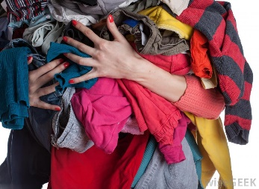 | Juice  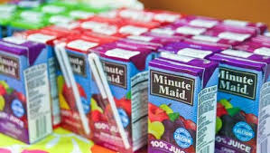 | Canned food  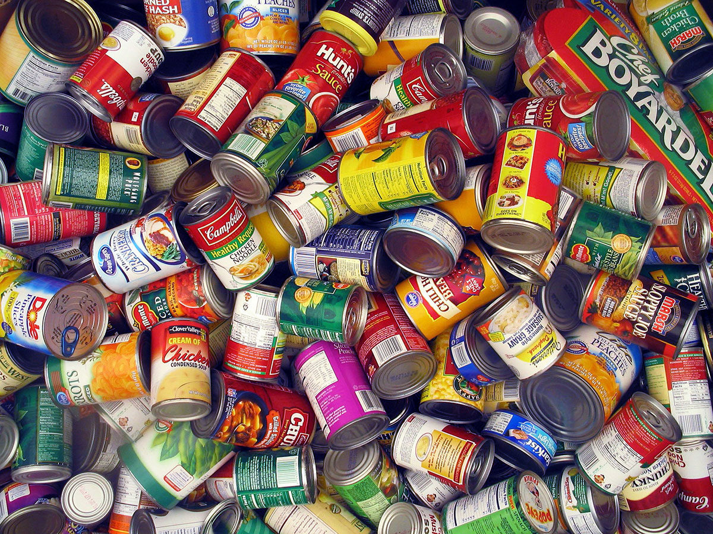 | Bank books  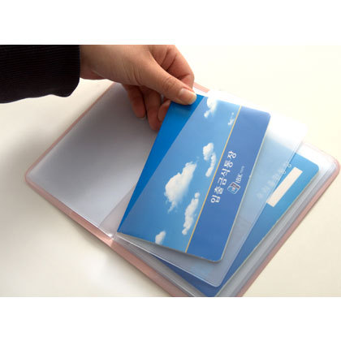
Pets  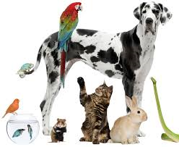 | Albums  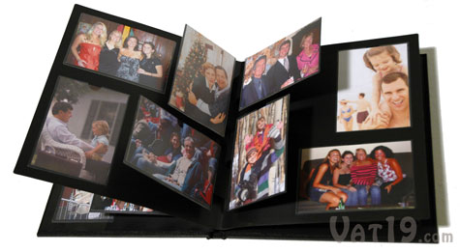 | Water  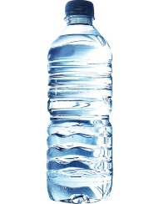 | Cash
Licenses  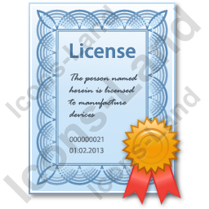 | inner wears  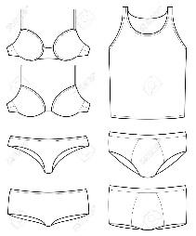 | Preserved food  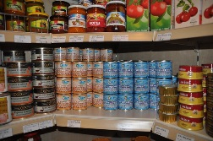 | Jewelries
A portable radio  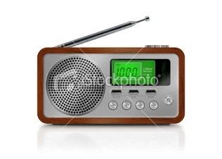 | Medicines | A pass port  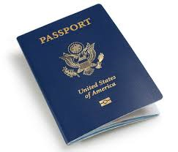 | Cosmetics  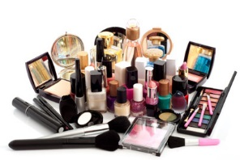
Towels and  Socks  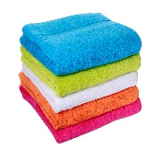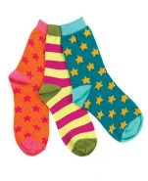 | Collections  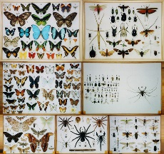 | Certificate of Graduation | Artic clothes  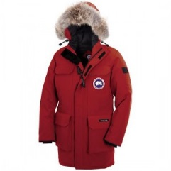
Cooking Utensils  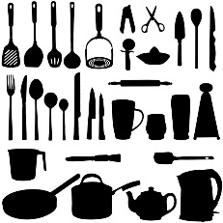 | A lap top  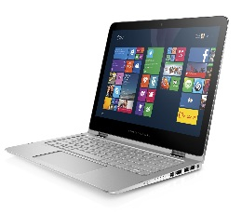 | Traveler’s checks  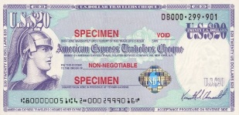 | Rice  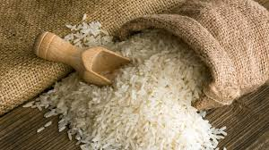
A torch  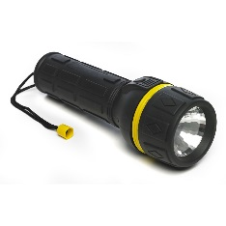 | A cell phone  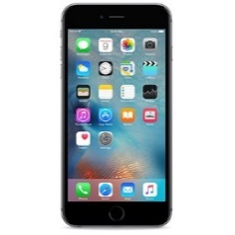 | A portable knife  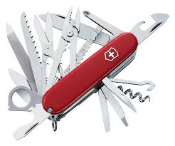 | Writing supplies  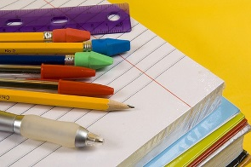
Gold | Books | Snacks  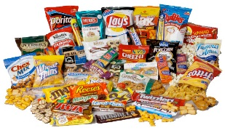 | IPOD  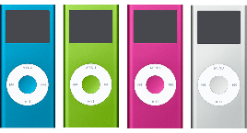
Tissues and Toilet paper  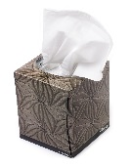 | A lunch box  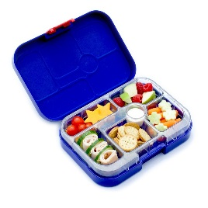 | Drive license  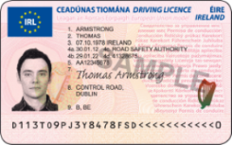 | TV  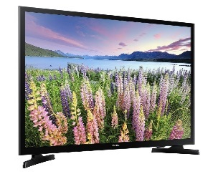
Blankets  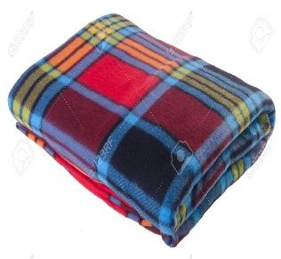 | A house deed | Livestock  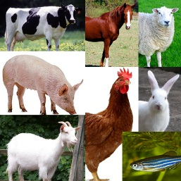 | A map  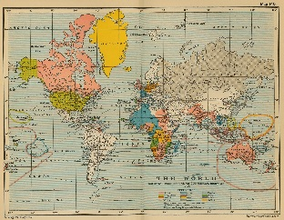

1. Natural disaster
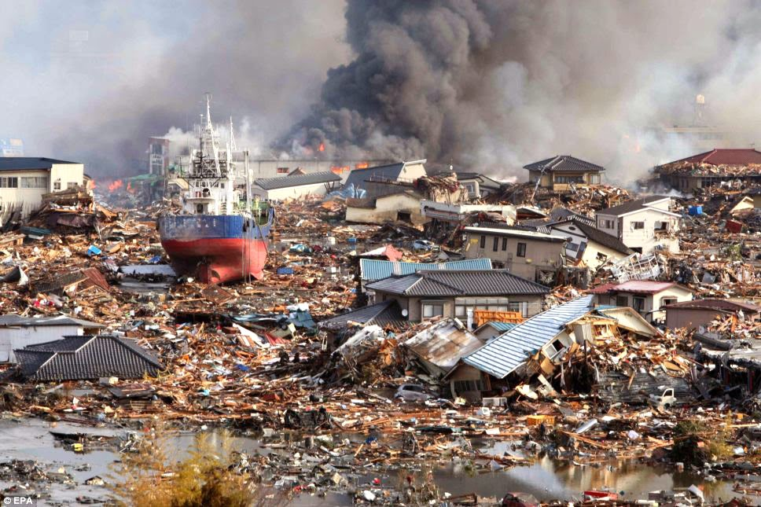
2. Walk a lot to move farther and farther
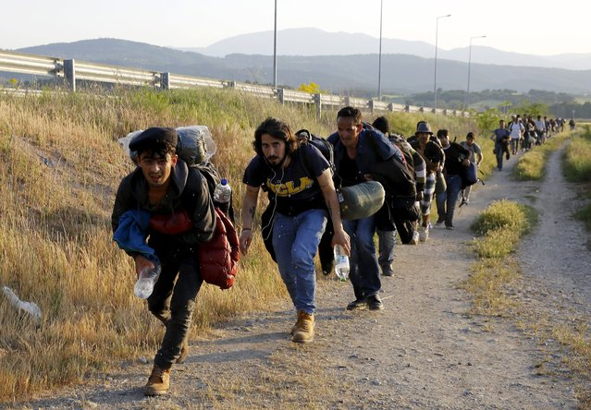
3. Out of food!! One of family member is sick.
He/she needs medicine.
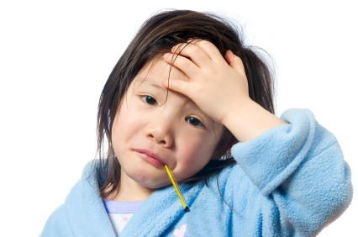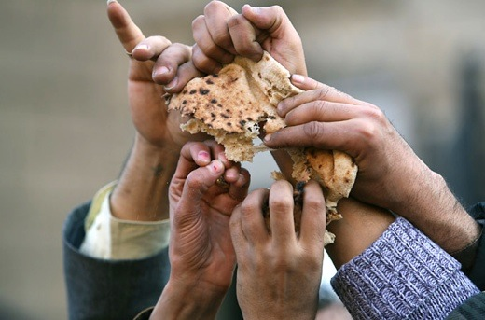
5. We need to cross the country border.
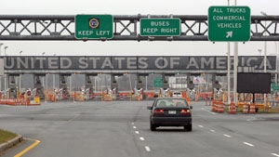
We arrive safe village!!!
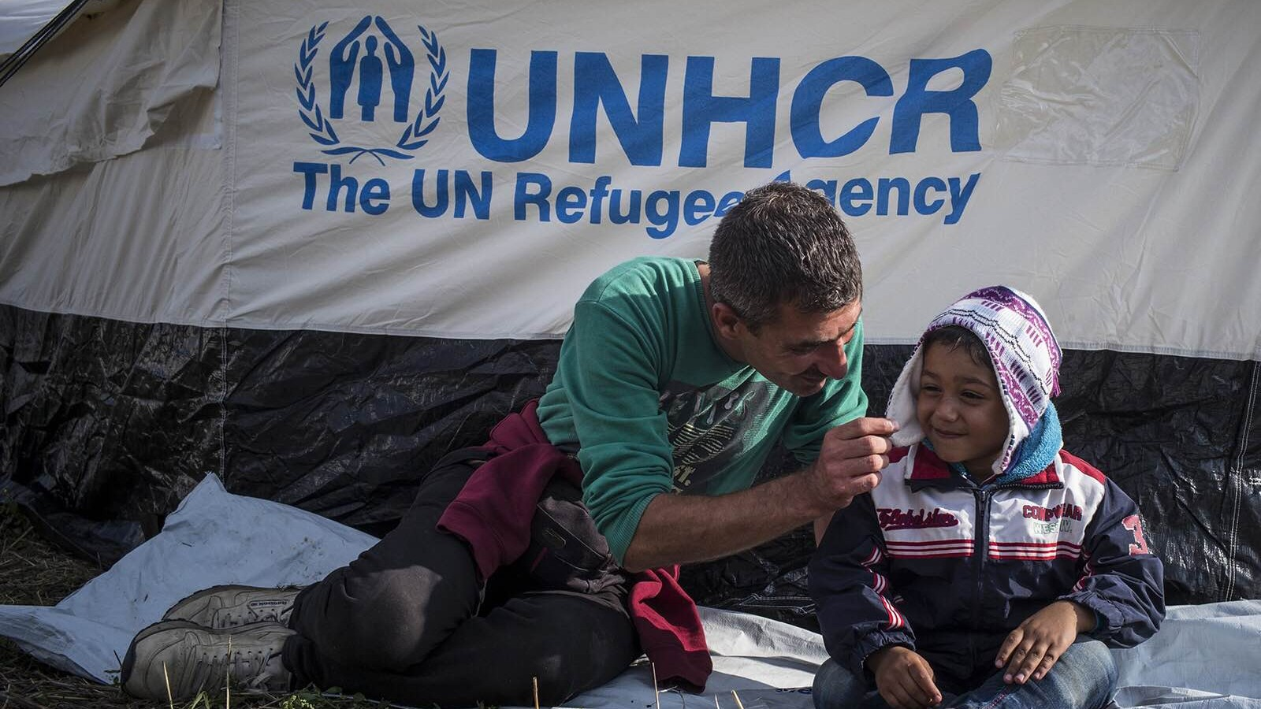
Second conditional dice-1
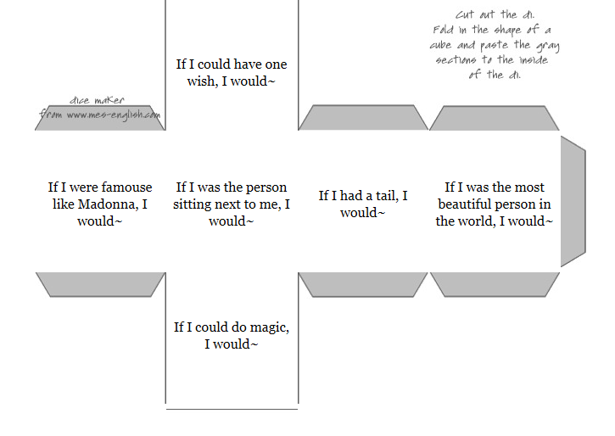
Second conditional dice-1
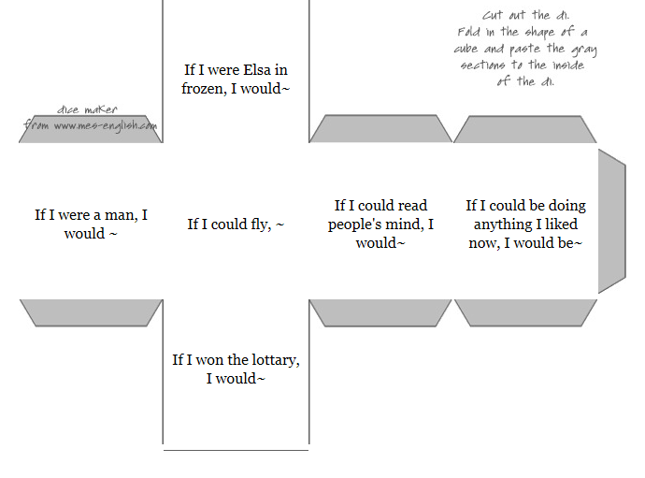
Name:
What is you sentence?:

Write to complete your sentence and reasons to do that.

