Listening Speaking Reading Grammar Writing

Topic: Security checkpoint at the airport

Instructor:  KJ (Kaapjoo Park) and  Grace (JI Hye Yoon) | Level:  Intermediate | Students:  4 students | Length:  30 Minutes

Materials:
-Flash cards (Appendix 1) –pre activity
-Matching quiz worksheet (Appendix 2) -pre-activity
-Podcast listening audio clip (internet) and worksheet (Appendix 3) -main activity
-Instructions and worksheet (Appendix 4) -post activity
-Crosswords worksheet (Appendix 5) –SOS activity

Aims:
-Main aim: S will be able to pass the security checkpoint safely and comfortably at the airport.
-Secondary aim: S will be able to understand airport arrival & departure procedures and practice listening to airport announcements and instructions.
-Personal aim: Through this lesson, we hope S could build up confidence in the international airports or other foreign places.

Language Skills:
-Reading : S will read the dialogue and worksheets.
-Listening : S will listen to teacher’s explanation & instruction, dialogue.
-Speaking : S will speak about their experience and ideas/opinions about security check, and answer the questions.
-Writing : S will fill in the blanks of worksheets.

Language Systems:
-Phonology : Aerosol [|erəsɔ:l] / Liquid [|lɪkwɪd] /
-Lexis : New vocabularies particularly used at security check at the airport
-Grammar : Present tense
-Function : Understanding about security check in airport,
-Discourse : Brainstorming, Instructions

Assumptions:
-Students already have experience in passing through security check at the airport and know some vocabularies related to airport security.

Anticipated Problems and Solutions:
-If students don’t have much experience of airport and security check
Share ideas with other students who have experience, explain departure procedure in the airport briefly and let them understand.
-If students address any errors from the activities
Fix them together through feedback.

References:
Pictures
http://meanttothrive.com
http://www.safelec.co.uk
http://www.overstock.com/Luggage-Bags/Single-Suitcase/1000000/cat.html
http://www.avclub.com/review/liam-neeson-hunts-hijacker-mile-high-mystery-non-s-201572
http://www.rheumtutor.com
https://spyproductsinindia.wordpress.com/2013/10/24/latest-metal-detector-in-delhi/
http://www.clearbags.com/8-x-10-sliding-zip-top-bags-3-mil-100-pieces-3sz810.html

Vocabulary activity : http://eslflow.com

Worksheets
https://www.eslpod.com/website/show_podcast.php?issue_id=12757071#
http://www.skypeenglishclasses.com/airport-english-tips-for-check-in-security-customs-and-more/
http://www.breakingnewsenglish.com/0804/080421-airport_security.html

Crosswords activity : http://puzzle-maker.com

Lead-In
Materials:

Time | Set Up | Student Activity | Teacher Talk
2min | Whole  class | Listening & Answering T’s question | “Good morning, everyone! How are you? Did you have great weekend? Has anyone traveled abroad during the weekend?”

Pre-Activity
Materials: Flash card vocabularies, worksheet (Appendix 1, Appendix 2)

Time | Set Up | Student Activity | Teacher Talk
6min | Whole  class | Guessing and Answering  Doing worksheets | Elicit  Show Ss flash cards  (Appendix1)  “Everyone, Look at these cards, can you guess what these are about?”  “What comes to your mind?”  “Where can you see these things?”  (Elicit Students answer ‘security check in airport’)  “That’s right, we are going to talk about security check in the airport today.  (Distribute a worksheet to students)  (Appendix2)  Now we’re going to have simple words quiz time. On your worksheet, there are some words in the middle, you can match the right words to the pictures, you need to write the words down below the pictures. I will give you 3min.  ICQ  “How much time do you have?”  “After finding the right word and picture, what should you do?”  “Ok, Time’s up”  Check answer  “Let’s check the answer. What is your picture No.1? Who will answer?”  (Let one students speak their answer one by one, let the other Ss listen and check)  “Is there any difficult words among these?”

Main Activity
Materials:
One dialogue listening podcast, Dialogue worksheet (appendix 3)

Time | Set Up | Student Activity | Teacher Talk
2 min  1 min  5 min  2 min  2 min | Whole class | Listening, Speaking  Listening, Writing, Speaking | Instruction  “I have a dialogue regarding to Passing Through Airport Security at the airport.”  Show students the audio clip from computer. “Please listen carefully once and imagine what they are talking about.”  Show students worksheet (appendix 3)  “Please open your worksheet (appendix 3) and fill out the blank while you listen to the podcast repeatedly twice”  Ss compare their answers to the next students and speak complete dialogue with the partner.  ICQ  “How many times will you listen to the podcast?”  “When do you start to work on worksheet?”  “What do you do in worksheet?”  “What do you do after you finish filling words in the blank?”  Play the podcast and Ss begin to listen to the podcast.  Monitoring  Check answers  “Did you enjoy the listening activity?”  “Did you find any interesting words used in the dialogue?”  Short Debate  “You can express your opinions on whether you support airports using body scanners that can see through clothes to beef up security”  Ss should listen carefully to other Ss opinions and express their own opinions.

Post Activity
Materials: Worksheet (Appendix 4)

Time | Set Up | Student Activity | Teacher Talk
1 min  1 min  5 min  1 min  1 min | Whole class | Listening, Speaking  Listening instructions, Finding vocabularies, Replacing a word with appropriate one in the sentence | Instruction  “I have important instructions at security check. I will read you full instructions once and please listen carefully.” “Please open your worksheet (appendix 4) and find appropriate words in the blank. “Please replace them with other proper words from the examples and please explain your answers clearly”  ICQ  “How many times will you listen to the instructions?”  “What do you do in worksheet?”  “What do you do after you find the right words in the blank?”  I start to read the instructions and Ss begin to listen and work on worksheet (appendix4).  Monitoring  Check answers  “Did you understand the instructions?”  “Could you find any exchangeable words used in the instructions?”  Conclude lesson  Summarize today’s lesson by checking useful information and vocabularies from dialogues and instructions.  Feedback  “It is very important to understand how you can pass through security check without any troubles and I hope that you will have a safe and pleasant travel through this lesson.”  “Also you will improve listening skills for public announcement and instructions as well as speaking skills by expressing your opinions rationally.”
SOS Activities
Materials: Worksheet (Appendix 5)

Time | Set Up | Student Activity | Teacher Talk
3min  ~  5min | individually | Crosswords game | (Appendix5)  (distribute a worksheet to students)  “Ok, everyone, We’ve got about 5minutes left, we’re going to do crosswords now.  I want you to remind all of the words we learned today.”

Appendix 1
At the Security Checkpoint
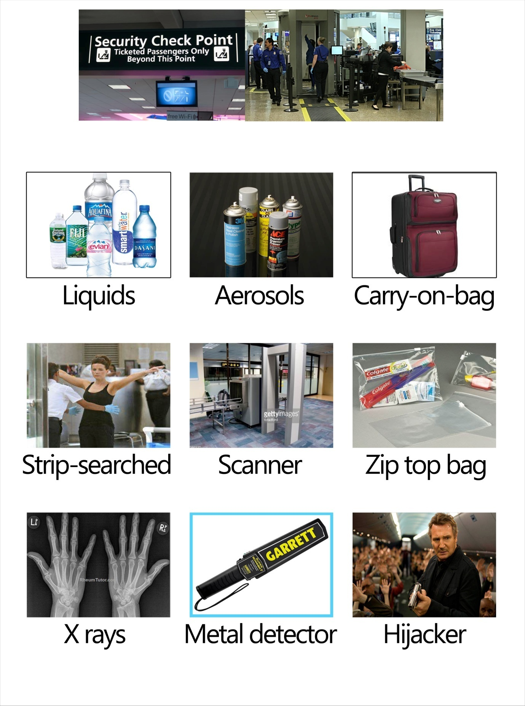
Appendix 2
Matching Quiz
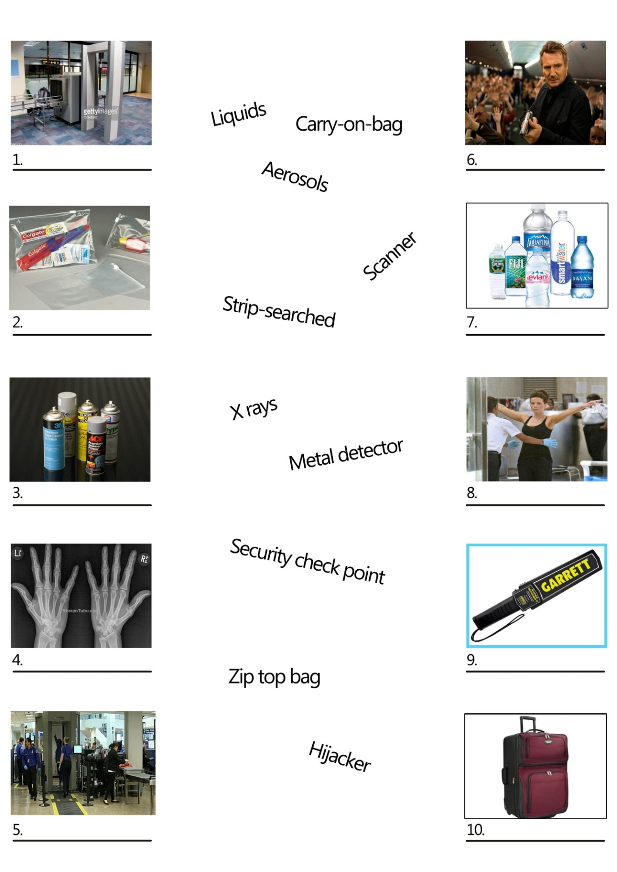
Appendix 2: Answer Key
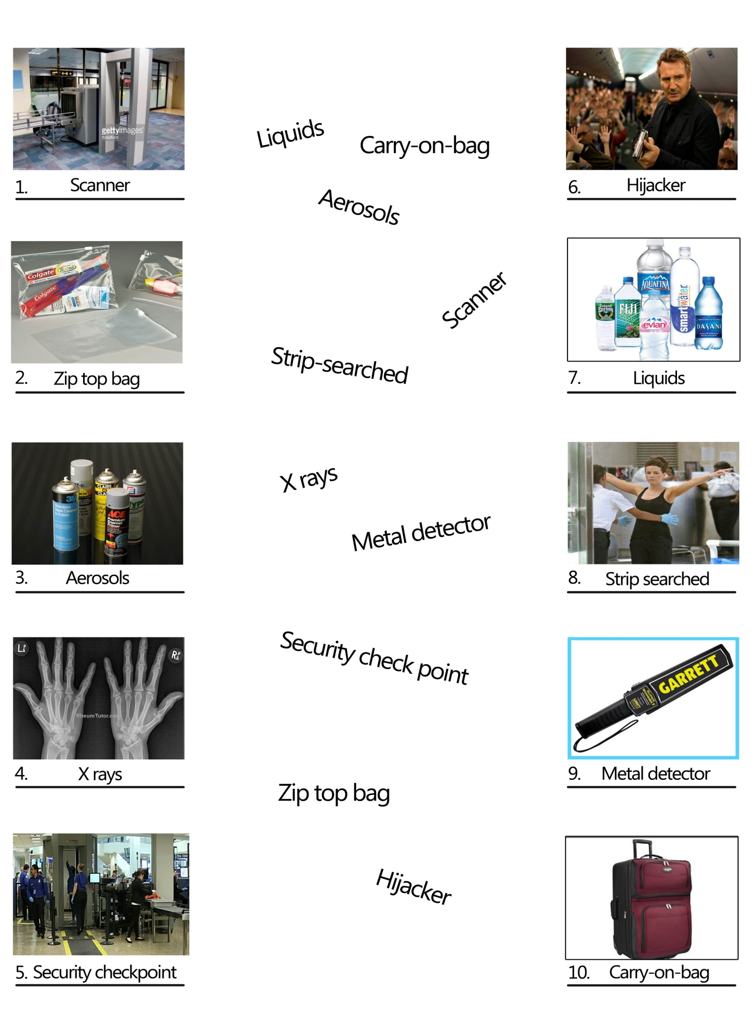

Appendix 3

Podcast: https://www.eslpod.com/website/show_podcast.php?issue_id=12757071#

Passing Through Airport Security

Roland: Why are you so nervous about flying?
Natalie: I’m not nervous about being in the air. It’s going through security. I hear it’s a hassle and I don’t want to end up being --------------.
Roland: You won’t be strip-searched. All you need to do is to follow a few simple rules. When you get to security screening, put your ---------- and all metal objects in a bin so that it can go through the -------.
Natalie: But I heard I couldn’t bring any ------- with me.
Roland: You’re only allowed three ounces of liquids, -------, or gels. Those should go inside a ---------- and be placed in a bin.
Natalie: Do I have to take off my shoes and get one of those body scans?
Roland: You don’t have to take off your shoes, but you do have to get a body scan.
Natalie: I knew it! They’re going to bombard me with harmful ----. And you wonder why I’m nervous about flying!
Roland: You won’t be bombarded with any harmful rays. You walk through the ------ -------- and stand in front of the scanner. It’s not dangerous.
Natalie: Oh, why do they have to treat every passenger like a potential -------- or --------? Do I look like a terrorist? I feel like walking through security with my hands up saying, “I am not a terrorist. I am not a terrorist.”
Roland: I wouldn’t do that if I were you. That’s a sure way to get the TSA’s attention. Just stay calm and follow the instructions.
Natalie: Just like a lamb to the slaughter?

QUICK DEBATE:
Pro: Students A strongly support airports using body scanners that can see through clothes to beef up security.
Con: Students B are strongly against this.

Appendix 3: Answer Key

Podcast: https://www.eslpod.com/website/show_podcast.php?issue_id=12757071#

Roland: Why are you so nervous about flying?
Natalie: I’m not nervous about being in the air. It’s going through security. I hear it’s a hassle and I don’t want to end up being strip-searched.
Roland: You won’t be strip-searched. All you need to do is to follow a few simple rules. When you get to security screening, put your carry-on bag and all metal objects in a bin so that it can go through the scanner.
Natalie: But I heard I couldn’t bring any liquids with me.
Roland: You’re only allowed three ounces of liquids, aerosols, or gels. Those should go inside a zip-top bag and be placed in a bin.
Natalie: Do I have to take off my shoes and get one of those body scans?
Roland: You don’t have to take off your shoes, but you do have to get a body scan.
Natalie: I knew it! They’re going to bombard me with harmful rays. And you wonder why I’m nervous about flying!
Roland: You won’t be bombarded with any harmful rays. You walk through the metal detector and stand in front of the scanner. It’s not dangerous.
Natalie: Oh, why do they have to treat every passenger like a potential hijacker or terrorist? Do I look like a terrorist? I feel like walking through security with my hands up saying, “I am not a terrorist. I am not a terrorist.”
Roland: I wouldn’t do that if I were you. That’s a sure way to get the TSA’s attention. Just stay calm and follow the instructions.
Natalie: Just like a lamb to the slaughter?

Appendix 4
Security Check
Can you put all personal belongings in the plastic ----------, please?
Please remove your shoes and belt and place them in a separate ---------.
You are not permitted to carry open food or ------- beyond this point.
Excuse me, sir/madam, since you have set off the security alarm, we need to search you.
Sorry sir but potentially dangerous items like ---------------- cannot be carried onto the plane. Can you please remove them from your ---------.
Thank you for your co-operation, you can now proceed to your designated ----.
- knives and razors (a hat, medicines, a lighter, a passport)
- luggage (hand bag, glove, backpack, baggage, hat)
- gate (fence, door, entrance, exit)
- belongings (possessions, properties, assets, favorites)
- container (tray, bowel, box, cup)
- drinks (gels, oils, liquids, beverages)

Appendix 4: Answer Key
Security Check
Can you put all personal belongings in the plastic container, please?
Please remove your shoes and belt and place them in a separate container.
You are not permitted to carry open food or drinks beyond this point.
Excuse me, sir/madam, since you have set off the security alarm, we need to search you.
Sorry sir but potentially dangerous items like knives and razors cannot be carried onto the plane. Can you please remove them from your hand luggage.
Thank you for your co-operation, you can now proceed to your designated (given) gate.
- knives and razors (a hat, medicines, a lighter, a passport)
- luggage (hand bag, glove, backpack, baggage, hat)
- gate (fence, door, entrance, exit)
- belongings (possessions, properties, assets, favorites)
- container (tray, bowel, box, cup)
- drinks (gels, oils, liquids, beverages)

Answer
d (possessions), e (tray), f (beverages), a (a lighter), b (hand bag, backpack, baggage), c (entrance)

Appendix 5: Crosswords Game

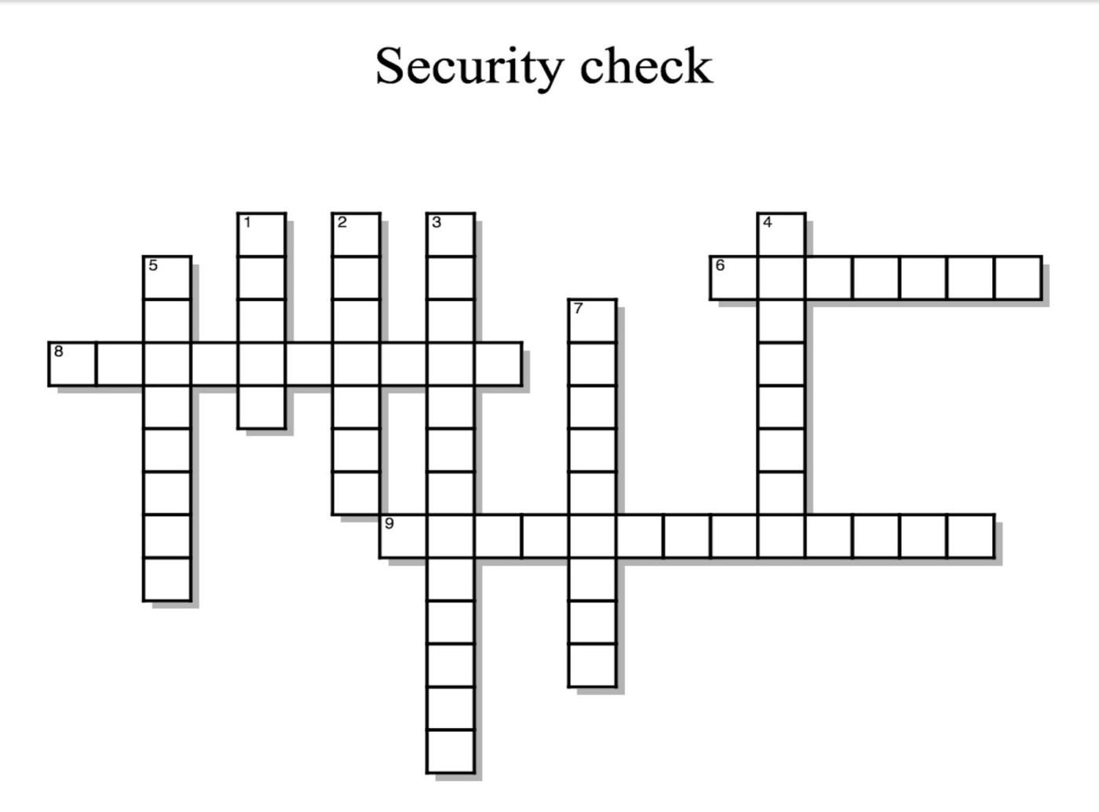

Across
6 Water, orange juice, coke, coffee
8 Another word for Hand luggage or cabin baggage
9 You need to take off your shoes, jacket, and shirt

Down
1 One of the most common and beneficial uses of this is for medical imaging
2 A device that is used to see inside something
3 An electronic instrument which detects the presence of metal nearby
4 A person who kidnap airplane
5 A spray or foam through a push-button valve
7 Clear plastic bag you can put liquids into at the security check

Appendix 5: Crosswords Game Answer Key

Across
6 Liquids
8 Carry on bag
9 Strip searched

Down
1 X rays
2 Scanner
3 Metal detector
4 Hijacker
5 Aerosols
7 Zip top bag

