Listening Speaking Reading Grammar Writing

Topic: Movie ‘Twinsters’

Instructor:  Luna  (Noh Poo Reun) | Level:  Intermediate  (Adults) | Students:  4 | Length:  30 Minutes

Materials:
-2 Posters of the movie ‘Twinsters’
-4 copies of reviews and storyline about the movie
-4 Pictures of twins
-2 pieces of worksheet for pair work-A
-2 pieces of comprehension level questions making worksheet
-4 pieces of ‘pros and cons’ worksheet about twins
-4 pieces of Worksheet to make ending story line of the movie-B
-Markers
-A timer

Aims:
-Main aim: Ss will be able to get the main idea by skimming the reading article and making comprehension questions for each level.
-Second aim: Ss will be able to guess and find out the words meaning which they don’t know by reading.
-Personal aim: Ss can understand long lost twins feelings and make ending storyline and think and share opinions about twins

Language Skills:
-Reading: Ss will read article about ‘Twinsters’ and worksheet.
-Listening: Ss will listen to Ts instruction, modeling and classmates’ ideas.
-Speaking: Ss will share ideas with pair and discuss about the questions and answer each team’s questions
-Writing: Ss will write about pros and cons of twins and ending part of storyline of the movie.

Language Systems:
-Phonics: irrevocably
-Lexis: identical twins, Fraternal twins, fortuitous,
-Grammar: Second conditional(If I were ~, I would~)

Assumptions:
Students already know what literal, interpretive, applied question meanings are and how to make these comprehension level questions.

Anticipated Problems and Solutions:
- If Ss have difficulty to write about answers
→ Give them some tips or hint to think about the questions and make them have their own idea.
- If Ss have difficulty to read the article
→ Encourage them to read it and give them some words meanings to read easily
References:
- Twins pictures
https://www.google.co.kr/search?q=twins&biw=1536&bih=747&source=lnms&tbm=isch&sa=X&ved=0ahUKEwij4p66h-HMAhWE6aYKHSvOBXkQ_AUIBigB#imgrc=VknNflqnJifmtM%3A
https://www.google.co.kr/search?q=twins&biw=1536&bih=747&source=lnms&tbm=isch&sa=X&ved=0ahUKEwij4p66h-HMAhWE6aYKHSvOBXkQ_AUIBigB#imgrc=S9IO7ZCzDTrZtM%3A
https://www.google.co.kr/search?q=twins&biw=1536&bih=747&source=lnms&tbm=isch&sa=X&ved=0ahUKEwij4p66h-HMAhWE6aYKHSvOBXkQ_AUIBigB#imgrc=vDvqlldkhGGEqM%3A
https://www.google.co.kr/search?q=twins&biw=1536&bih=747&source=lnms&tbm=isch&sa=X&ved=0ahUKEwij4p66h-HMAhWE6aYKHSvOBXkQ_AUIBigB#imgdii=vDvqlldkhGGEqM%3A%3BvDvqlldkhGGEqM%3A%3BecXZTVEMl7JnNM%3A&imgrc=vDvqlldkhGGEqM%3A
-Poster of the movie “Twinsters”
https://www.google.co.kr/search?q=twins&biw=1536&bih=747&source=lnms&tbm=isch&sa=X&ved=0ahUKEwij4p66h-HMAhWE6aYKHSvOBXkQ_AUIBigB#tbm=isch&q=twinsters+poster&imgrc=RTsGDG3Xt1eYtM%3A
http://imagesearch.naver.com/search.naver?sm=ext&viewloc=1&where=idetail&rev=31&query=%EC%98%81%ED%99%94%20%ED%8A%B8%EC%9C%88%EC%8A%A4%ED%84%B0%EC%A6%88&section=image&res_fr=0&res_to=0&ie=utf8&face=0&color=0&ccl=0&aq=0&spq=1&nx_search_query=%EC%98%81%ED%99%94%20%ED%8A%B8%EC%9C%88%EC%8A%A4%ED%84%B0%EC%A6%88&nx_and_query=&nx_sub_query=&nx_search_hlquery=&nx_search_fasquery=&datetype=0&startdate=0&enddate=0&start=23&img_id=blog13962002%7C29%7C220651304458_1
-Article about the movie
http://www.hollywoodreporter.com/review/twinsters-film-review-809855
Lead-In
Materials: Twins pictures, marker
Time | Set Up | Student Activity | Teacher Talk
2 mins | Whole  class | Answering T’s warm-up questions | “Hello, everyone! How are you?  (Wait for students respond)  (Attach twins picture on picture)  Eliciting  “Ok. Look at these pictures. Who are they? Can you guess?”  (Wait for students respond)  “Good they are twins. How can you know they are twins?”  (Wait for students respond)  “Ok. Good! What kind of twins they are?  (Wait for students respond)  (Write the words ‘ Fraternal twins’, ‘identical twins)  “Fraternal twins are twins of different or same gender who look different who born together.  And identical twins are twins of the same sex who look exactly the same who born together.

Pre-Activity
Materials: Worksheet about twins questions
Time | Set Up | Student Activity | Teacher Talk
2 mins  3mins  2mins | Whole class  Pair work  Whole class | Listen to the teacher’s instruction and answer the questions  Answer the questions on the worksheet and share with partners. If they don’t understand fully then ask what they don’t understand  Share the answers together and talk about answers | Instruction  “Ok, Today we will talk about twins.  So here are the questions about twins.  Write the answer on the worksheet  and share with you partner about your  answers.  I will give you 3 minutes.  (Hand out worksheets)  CCQ  “How many minutes for this activity?”  (Wait for students respond)  “Good. What do you need to do with your partner?”  (Wait for students respond)  “Very good. Do this activity with your partner.”  (Wait 3minutes to do activity and if students couldn’t understand questions make them understand and share their answer.)  Instruction  “Ok Let’s share your answer together. Give me your worksheets”  (Collect the worksheets and attach them on the board and share their answer together and ask them the reasons to answer like that.)

Main Activity
Materials: Article review and storyline about the movie ‘Twinsters’
Poster of the movie ‘Twinsters’
Comprehension questions worksheet
Time | Set Up | Student Activity | Teacher Talk
5 mins  3 mins  1min  1min  3 mins  2 mins | Whole class  Whole class  Whole class  Pair work  Whole class | Answer the teacher’s question about the movie and guess story line through the poster of the movie ‘Twinsters’  Read the article and  Ask if there are words that you don’t know.  Repeat after teacher  Make comprehension questions about the articles with partners.  Share the questions and respond of the questions from other team | Instruction  “Ok. Today we will talk about a movie  called ‘Twinsters’ which is based on  true story.  Can you guess what the meaning of  twinsters is?”  (Wait for students respond)  “Like you guess that it’s compound  word with twins and sisters.”  Eliciting  (Attached the poster on the board)  “Look at these posters. What kind of  posters are these?  (Wait for students respond)  “What are they doing on these posters?”  (Wait for students respond)  “Right. The twins are lying on a bed together on first poster and we can know where they come from on second poster.  Can you guess what kind of story of this movie?  (Wait for students respond)  (Hand out the article and worksheet)  Instruction  “Read this article about review and storyline of this movie. I will give you 3 minutes to read it.”  (Wait 3 minutes for reading article)  “Ok. Times up!  Is there any word that you don’t know the meaning?  (If students don’t know some words meaning then make them guess the meaning)  Then guess the meaning through article. What can be this word meaning?”  (Wait for students respond)  “Can you find the word ‘irrevocably’? This word is hard to pronouns so repeat after me.  Irrevocably, Irrevocably.  (Wait for students repeating after teacher)  Good job.”  I will give you 3 minutes to make 3 questions from each of the categories of comprehension levels with your partners.”  CCQ  “How many questions for each levels?”  (Wait for students respond)  “How much time do you have to do it?  (Wait for students respond)  “Ok. Let’s share the questions that you make each team and answer each other team’s questions. First Sherry’s team?”  (Wait for students respond)

Post Activity
Materials: pros and cons about twins worksheet
Time | Set Up | Student Activity | Teacher Talk
4 mins  1 min | Pair work  Whole class | Listen to the teacher’s direction and write the pros and cons about twins with partner  Share the answers all together | Instruction  (Hand out pros and cons worksheet)  “Let’s think about pros and cons about twins with your partner. I will give you 3 minutes.  Modeling  For example, pros of twins is always twin best friends there for you in whole life. And cons of twins is loose identity as identical twins.  (Waiting for students to think and write with their partners)  “Ok! Let’s share your answers all together~!”  Conclude lesson  “Okay, Today we read about long lost twinster story and think and talk about twins’ pros and cons.  Good job everybody. Hope you have a good weekend and See you next week”
SOS Activities
Materials: Worksheet for ending story writing of the movie
Time | Set Up | Student Activity | Teacher Talk
5 min | Whole class | Write about ending story of the movie and share about it. | Instruction  “Write about ending part of this movie. If you are the director of this movie, how can you make ending part of this movie? I will give you 3 minutes to write it and then let’s share you ending story  (Wait 3 minutes and share students’ ending story)  “Very good. I hope you all enjoy today’s activities.”
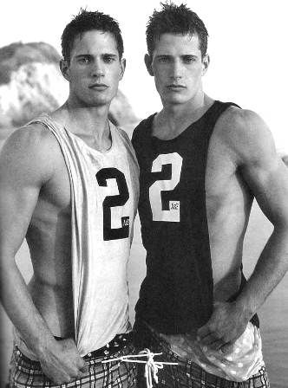

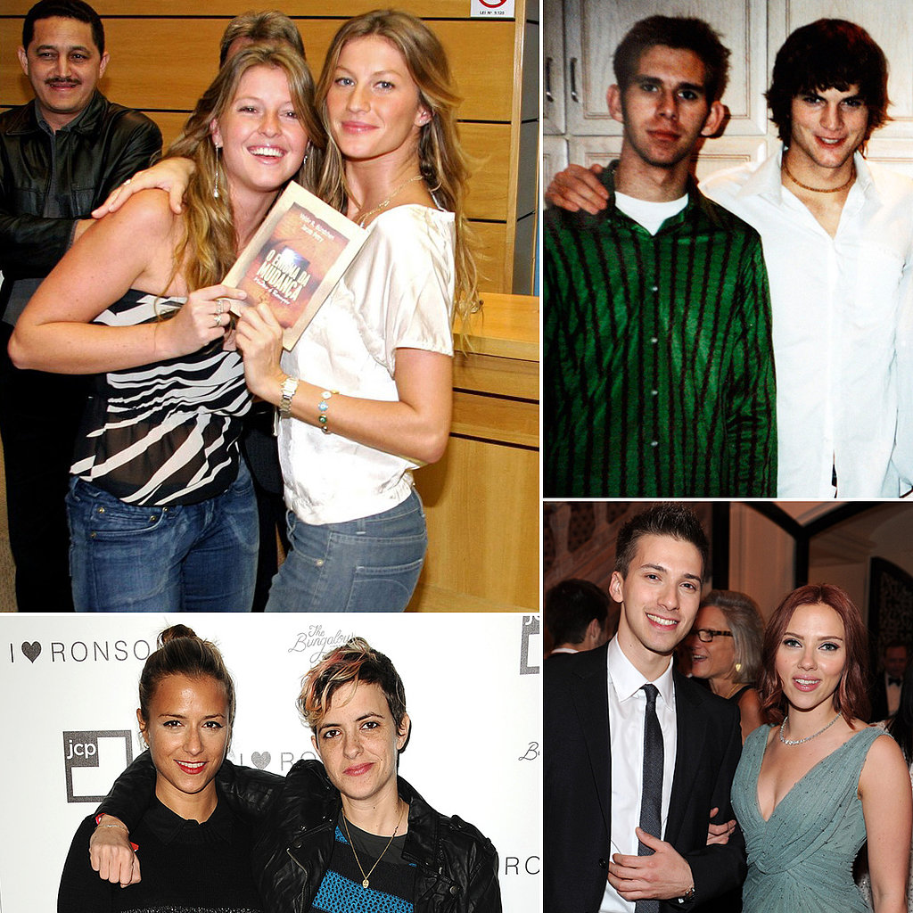
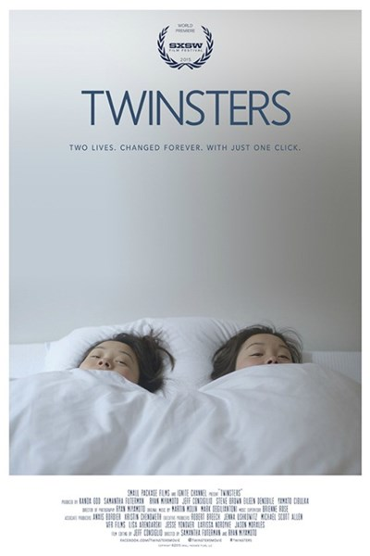
Write the answers of these questions about twins.

- Do you know any twins around you?
If you know someone are twins then write about them.
If you don’t know anyone as twins then what kind of twins do you want to be friend?

- Do you want to be twins? Write the reasons that you want to be twins or not.

- What’s the benefit about twins?

Using the article about ‘Twinsters’, make 3 questions from each of the categories of comprehension levels.

Literal
1.
2.
3.

Interpretive
1.
2.
3.

Applied
1.
2.
3.

Write 3 pros and cons about twins.

Pros | Cons
Write about ending part of this movie.
If you were the director, how could you make ending part of this movie?

A remarkable true story for the Internet age. TWITTER

United by common heritage but separated as infants, two sisters experience an unexpected reunion.
Actress Samantha Futerman’s roles in TV and feature films, including Man Up and 21 and Over, helped launch her Hollywood career, but it was her appearance in a viral YouTube video that irrevocably changed her life. In her feature directing debut, Futerman makes a momentous discovery that she adeptly shapes into an affecting emotional journey as well as a telling example of how the fortuitous intervention of social media continues to reshape lives in unexpected ways. Winner of a 2015 SXSW special jury award, Twinsters should manage to charm a broad audience in theatrical release before extending its reach worldwide in digital formats.
Futerman’s story begins naturally enough with her adoption from South Korea by a Caucasian couple and growing up in New Jersey with her parents’ two sons. After moving to Los Angeles to pursue her acting career, she met up with YouTube comedy sensation Kevin Wu, aka KevJumba, appearing in an episode of his wildly popular video series.
See more Summer's 23 Most Intriguing Indie Films
Surfing online videos half a world away in 2013, French university student Anais Bordier saw Futerman in KevJumba’s “High School Virgin” episode and noted not only their physical resemblance, but also the similarity in their vital stats: both born in Busan, South Korea on the same date and each put up for adoption by an unwed mother. Bordier contacted Futerman on Facebook and after a series of messages, intense Skype sessions and further comparison of life histories, they gradually reached the startling consensus that they were identical twin sisters separated soon after birth. With the help of a DNA test that confirmed their sisterly suspicions, they began making plans to meet for the first time.
Traveling to London where Bordier was a fashion student, Futerman was overwhelmed to discover how much the artistically inclined sisters had in common even after 25 years of separation. Following a celebratory reunion that included both families, Bordier visited Futerman in Los Angeles and the two began making plans to visit South Korea in an attempt to identify their birth mother, despite discouraging reports from their respective Korean adoption agencies regarding prospects for familial reconciliation.
Twinsters (a fusion of “twins” and “sisters”) began as Futerman started documenting her experience in YouTube selfie videos (as “samfuterman”) just as she was getting to know her sister. Fairly quickly she realized that her unusual relationship with Bordier deserved more in-depth treatment and although she wasn’t a filmmaker herself, she called on her friend and cinematographer Ryan Miyamoto for assistance.

Read More 'Star Wars: The Force Awakens' Named Fandango's Most Anticipated Movie of 2015
The two launched a Kickstarter campaign to fund their personal documentary project, which not only garnered essential contributions, but also resulted in an ongoing stream of supportive comments and social media interactions. Over the past 50 years, more than 200,000 South Korean children have been given up for adoption worldwide, with the vast majority finding families in the U.S., so there was no shortage of empathy for Futerman’s situation.
The response from the sisters’ families was similarly enthusiastic, but still not comparable to the women’s ecstatic reunion. Assisted by Miyamoto, who gradually assumed the role of co-director, Futerman was able to record the highlights of her first interactions with Bordier and their immediate bonding. “It’s crazy to unconditionally love someone you've never met,” Futerman says at one point and if there were any major disagreements between these adorkable siblings, they don’t appear in the film.
While technically a modest film overall, Futerman and Miyamoto’s skill level visibly develops onscreen, along with the twins’ deepening relationship as the film progresses. Brief animated sequences and social media-style text exchanges impressively integrated into the footage by editor Jeff Consiglio help enliven some of the film’s more prosaic moments.
Production company: Small Package Films
Directors: Samantha Futerman, Ryan Miyamoto
Producers: Steve Brown, Yamato Cibulka, Jeff Consiglio, Samantha Futerman, Kanoa Goo, Ryan Miyamoto, James J. Yi, Eileen DeNobile
Executive Producers: Michael Scott Allen, Lisa Arendarski, Robert Breech, Jason Morales, Jenna Ushkowitz, Jesse Yonover, Larissa Nordyke
Director of photography: Ryan Miyamoto
Music: Martin Molin, Mark DegliAntoni
Editor: Jeff Consiglio

