Listening Speaking Reading Grammar Writing

Topic: The best room for you

Instructor:  Grace Yoon | Level:  Intermediate | Students:  5 students | Length:  30 Minutes

Materials:
- Pictures of room (Bedroom in Arles by Vincent van Gogh) 3 copies
- White board & marker
- Work sheets for main activity 5 copies
- Work sheets for post activity 5 copies
- Adhesive tape

Aims:
- Main aim: S will be able to decide their proper room to rent in foreign country.
- Secondary aim: S will be able to express their opinion, compromise the most important part. S will practice speaking with vocabulary relate to renting.
- Personal aim: Through this lesson, I hope S could build up confidence to find out proper room when they are in foreign country.

Language Skills:
-Reading : S will read the vocabulary T wrote and worksheets.
-Listening : S will listen to teacher’s explanation & instruction, and other S talking.
-Speaking : S will speak about their experience and ideas/opinions about renting room.
-Writing : S will write description for advertisement for renting.

Language Systems:
-Phonology : Landlord[|lӕndlɔ:rd] / storage[|stɔ:rɪdƷ]
-Lexis : ceiling, storage, roommate, deposit, utility(heat, lights, cable, water)
-Grammar : Do you prefer 00? / Because 00 / I need 00.
-Function : Asking question, giving reason, expressing needs/desires
-Discourse : Compromising, negotiating, writing advertisement

Assumptions:
-Some students already have experience in renting a room.
-Some students would not know the meaning of some vocabularies.

Anticipated Problems and Solutions:
-Ss might want more information about ranking activity
: T explain
-Ss want to talk longer
:give them time time warning

References:

Picture (Appendix1)
http://jezebel.com/you-can-rent-van-goghs-bedroom-in-arles-on-airbnb-in-ch-1758424847

Picture (Appendix2)
http://www.dailymail.co.uk/property/article-1134202/Relief-court-ends-student-tenant-scam.html

Picture (Appendix3)
https://www.arlberghospiz.at/365-r_id5-standard-single-room.html
https://flatmates.com.au/317127
http://www.uaier.com/prepossessing-painting-ideas-for-teenage-girls-room-inspiring-design/
http://erasmusu.com/en/erasmus-cebu/rent-studio/rooms-for-rent-cebu-fully-furnished-124848
http://1home.eu/properties/comfortable-room-rent-7-room-apartment-warsaw/

Lead-In
Materials:
Time | Set Up | Student Activity | Teacher Talk
3min | Whole  class | Listening & Answering T’s question  Sharing experiences | “Good morning, everyone! How are you today? Did you have relax time in your place last night? Is anyone who currently living in rented room? (if yes, How is it? Do you like your room? / if no, then who has experience for living in rented room in Korea or foreign country? How was it?)

Pre-Activity
Materials: Whiteboard, marker
Pictures (Bedroom in Arles by Vincent van Gogh) 3 copies (Appendix1)

Time | Set Up | Student Activity | Teacher Talk
3min  4min | Whole  class | Guessing and Answering  Speaking about ideas and pinions | Elicit  “OK, Everyone, here is a picture of a room.  “Whose room is this? Does anyone know?” (wait Ss answer)  “This is ‘Bedroom in Arles’ by Vincent Van Gogh, famous painter.  “What can you see in this picture?”  (Elicit Students answer bedroom, window, pictures on wall etc.)  “Good, except these things, If you’re going to be a tenant, rent a room, what else do you need to consider?”  (Elicit Students answer size of the room, landlord, utility, kitchen etc.)  (Distribute picture to students)  (Appendix2)  “Now we’re going to have short discussion. I’ll give you this picture, imagine you’re living in this room. I think something makes you happy, and something makes you unhappy.  For example, I don’t like the color of the wall. It makes me sad.  We will do this in group. (2,3 students)  I’ll give you 2 minutes.  ICQ  “How much time do you have?”  “Ok, Time’s up”

Main Activity
Materials: Worksheet (Appendix2) 5copies

Time | Set Up | Student Activity | Teacher Talk
1min  6min  2min | In  Group  Whole  Class | Ranking & compromising the most important part  Talking about their opinion | “Everyone has slightly different preferences about room. I think It’s quite interesting! Right?  If you know what your priority is, It would be very helpful when you decide your room.  In this time, I’ll give you the consideration list, (distribute worksheets to each students)  I would like you to decide the ranking in group first, (making groups) and after that, we will do it in class. The most important thing should be number 1, I’ll give you 2minutes for group talk, and 3minutes for class talk.”  ICQ  “What’s the number for the most important thing?”  “How much time do you have for group? And how about for class?”  Check answer  “What’s your number 1?”  “What’s your number 10?”  “Good job, everyone!”

Post Activity
Materials: Worksheet (Appendix3) 5copies, Adhesive tape

Time | Set Up | Student Activity | Teacher Talk
8min  -9min | individually  Whole  class | Writing Description for room advertisement | “Now, This time, imagine that you’re going to be a landlord(the owner of the room) and you will put an advertisement for your room in internet.  (distribute worksheets to each students)  I gave each of you different advertisement, there is picture of the room, see this, and complete your description. You need to write it in sentences. This is advertisement, so try to make tenant wants to live. Write some advantages. You can use your imagination if you want.”  I’ll give you 4minutes.  ICQ  “Can you write just words? Or sentences?”  “Are you going to write disadvantages about your room?”  “Ok, time’s up”  (stick 5advertisements on the board)  “Everyone, come here and see which room is your favorite. Choose the room you want to live.”  “Let’s wrap it up here! Did you enjoy the class? See you next time.”
SOS Activities
Materials: Worksheet (Appendix4) 5copies

Time | Set Up | Student Activity | Teacher Talk
5min | individually | Matching vocabulary | (Appendix4)  (distribute a worksheet to students)  “Ok, everyone, We’ve got about 5minutes left, we’re going to do matching quiz now.  Through this, I want you to remind some words we learned today.”  “Let’s wrap it up here! Did you enjoy the class? See you next time.”

Appendix1

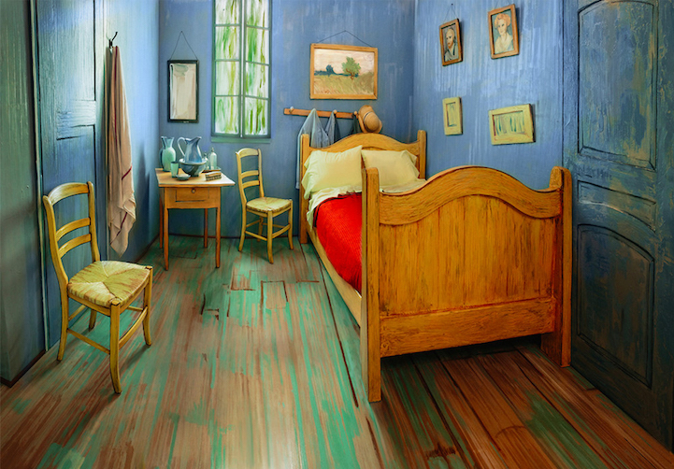

Appendix2

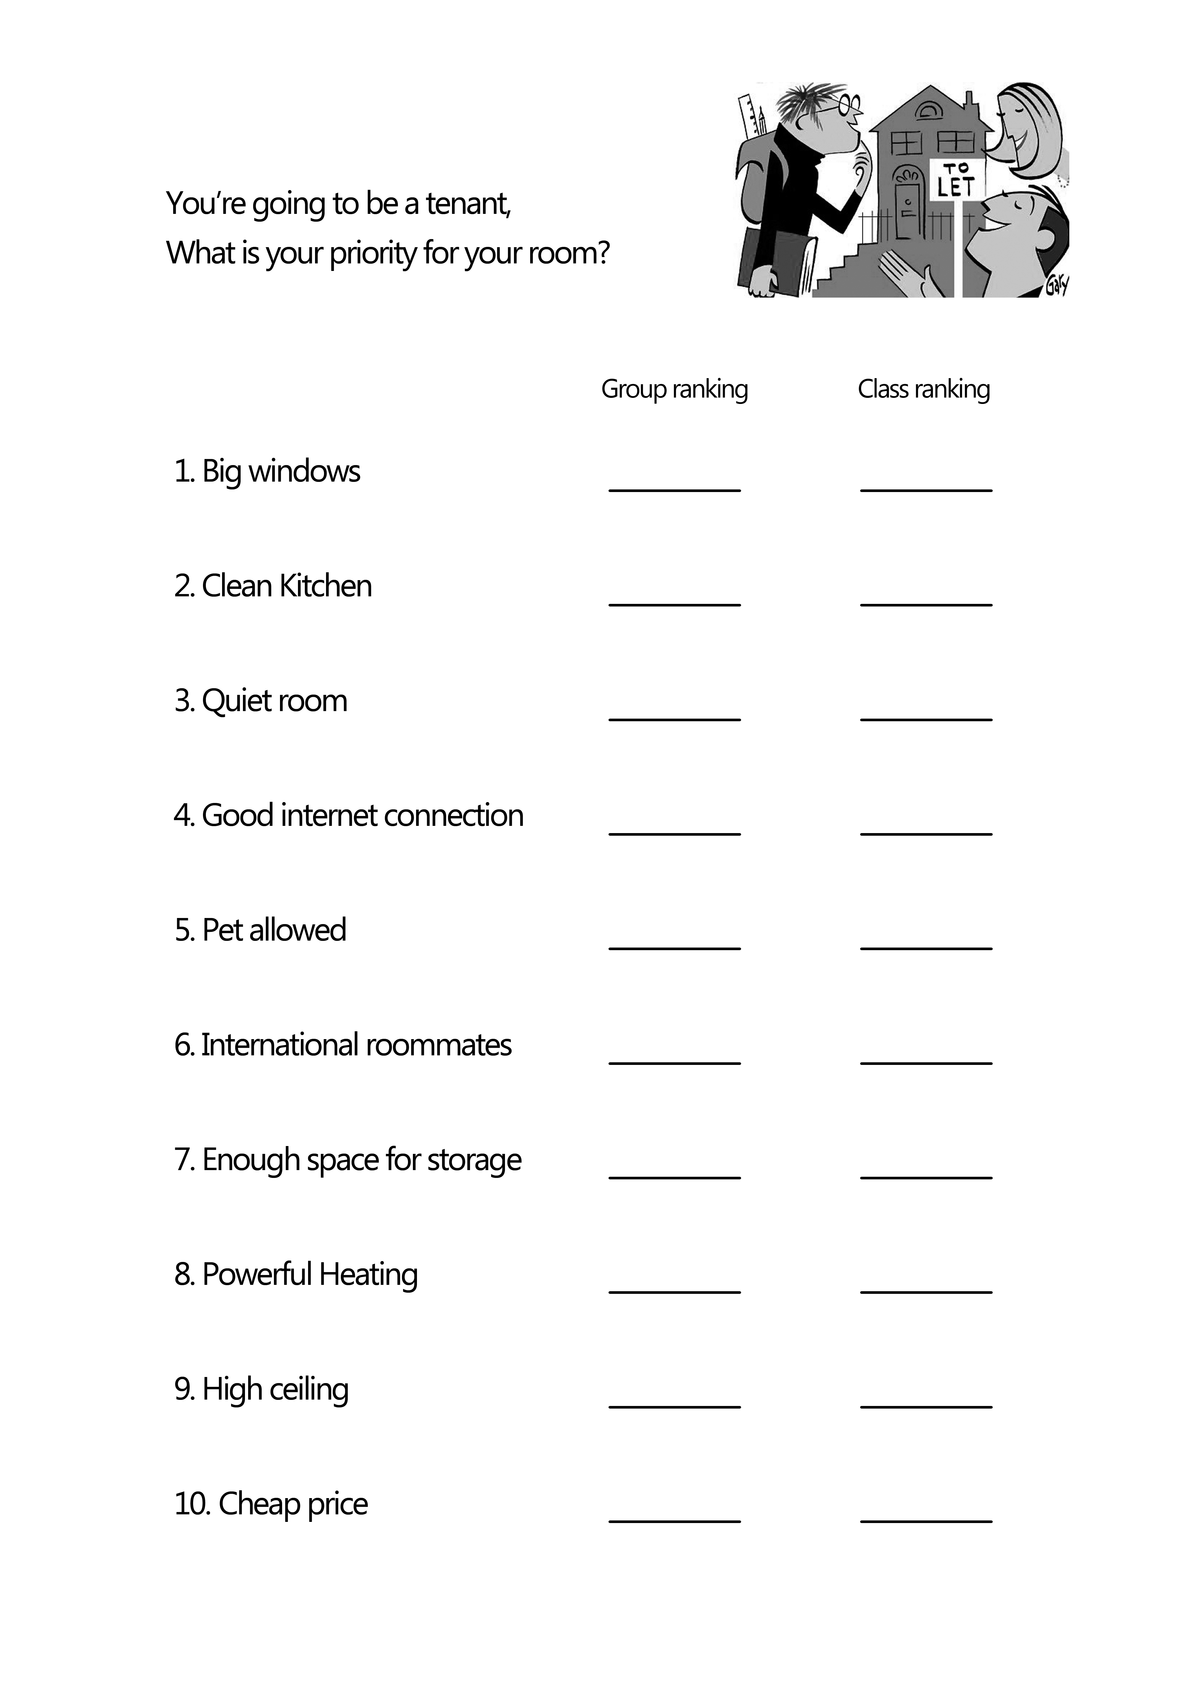
Appendix3_1
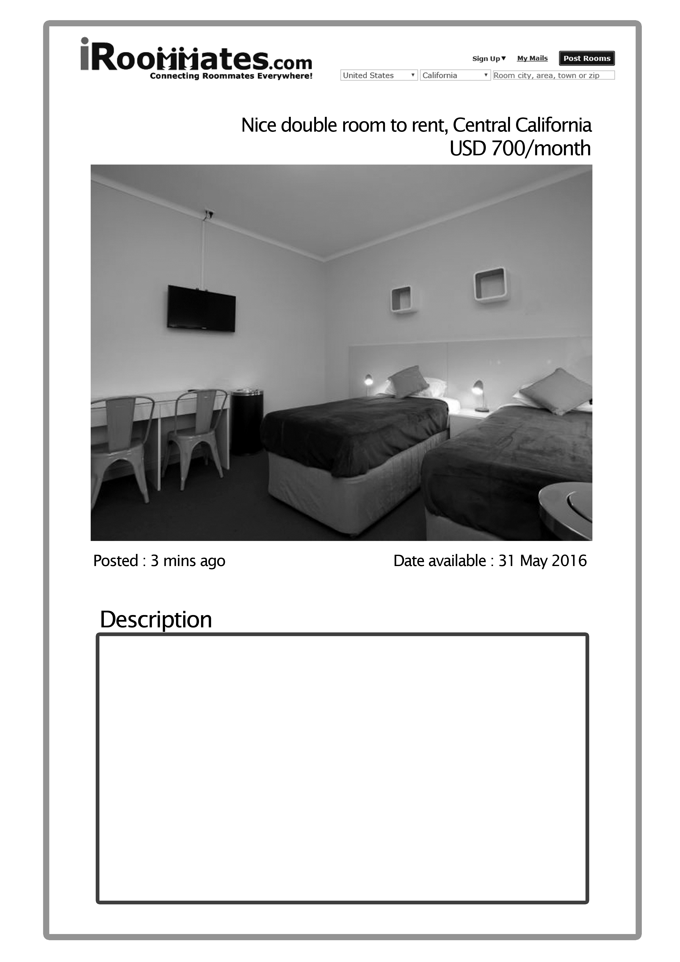
Appendix3_2
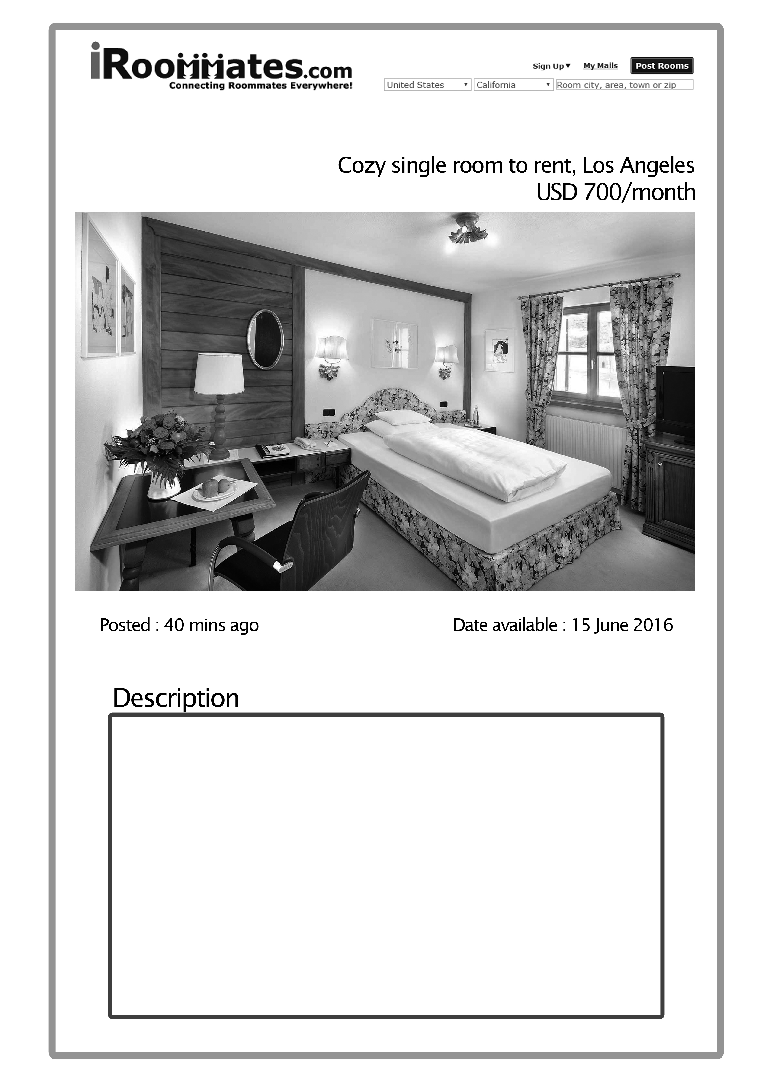
Appendix3_3
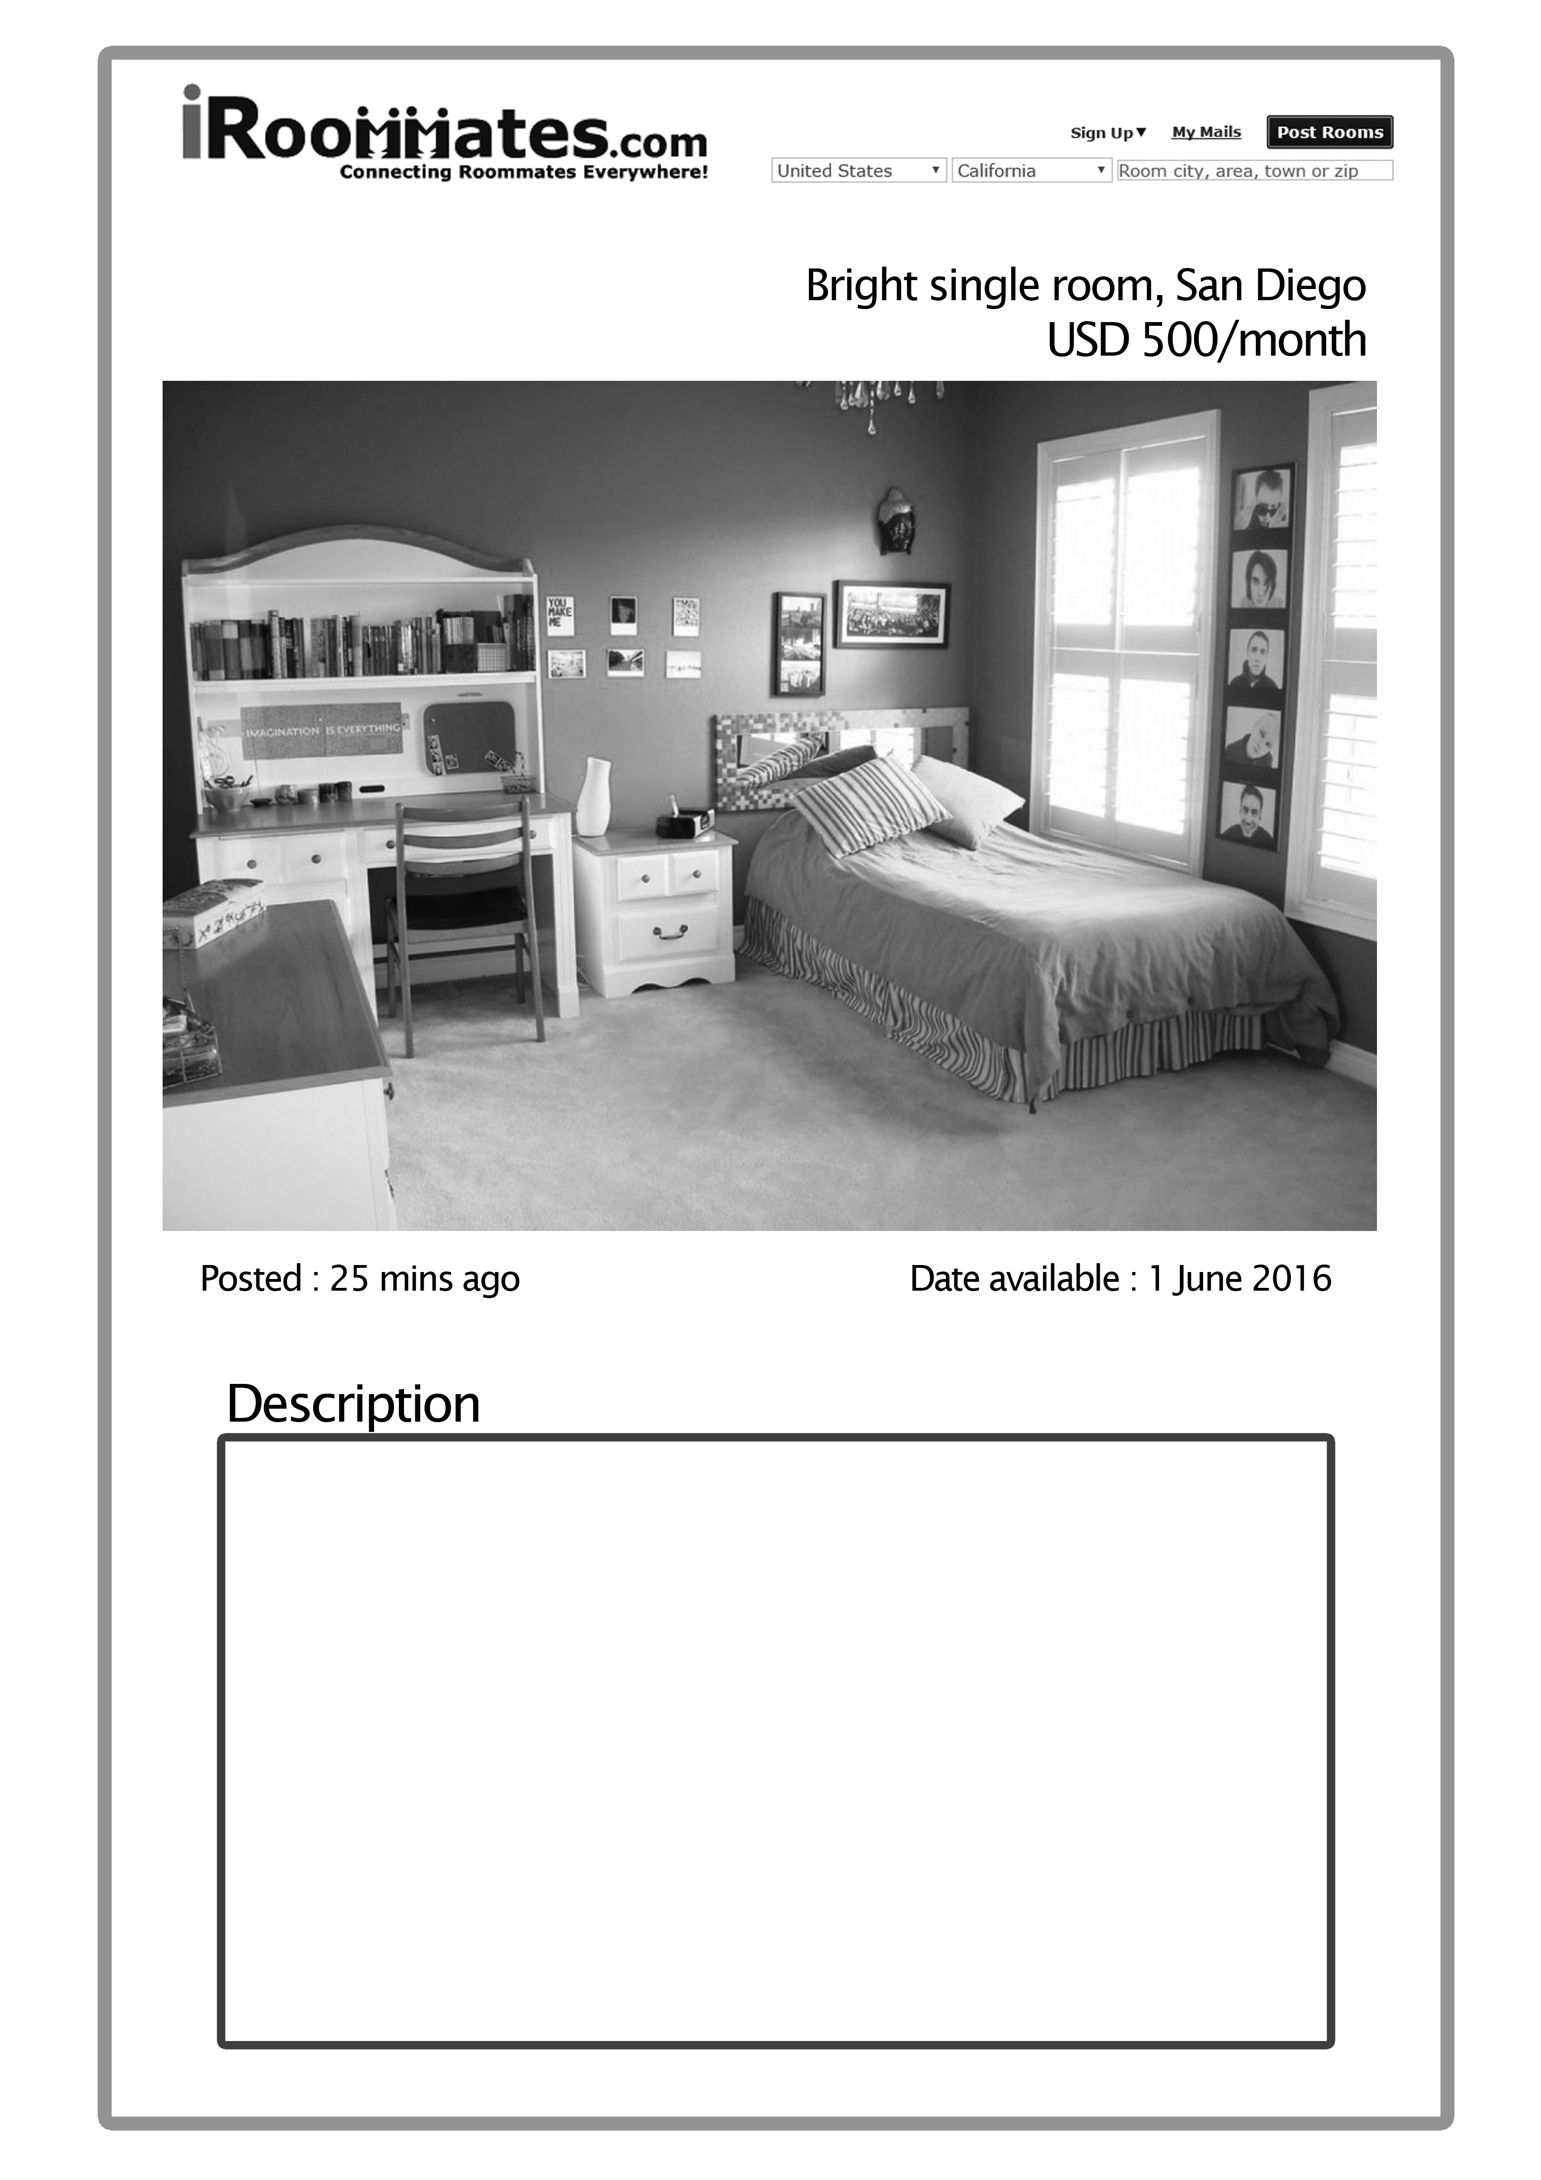

Appendix3_4
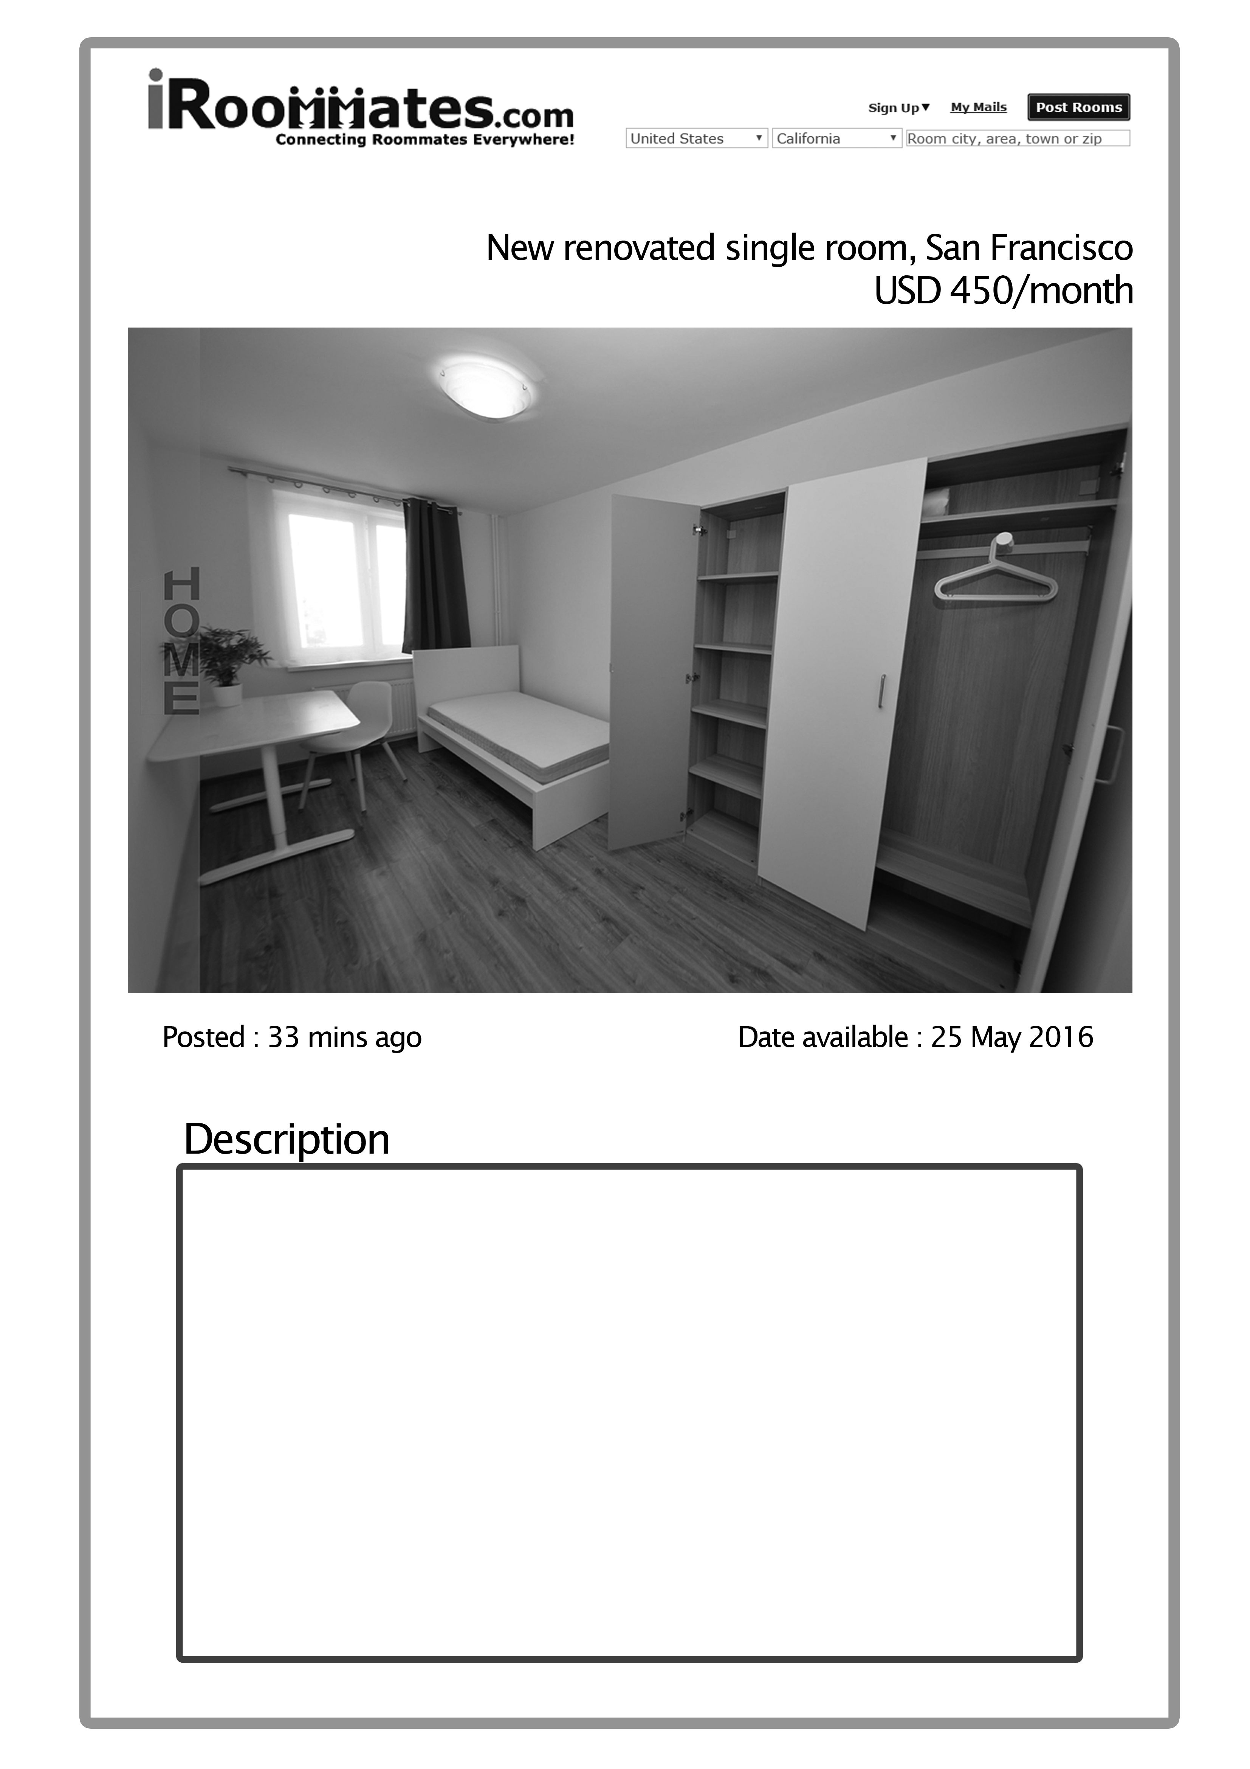
Appendix3_5
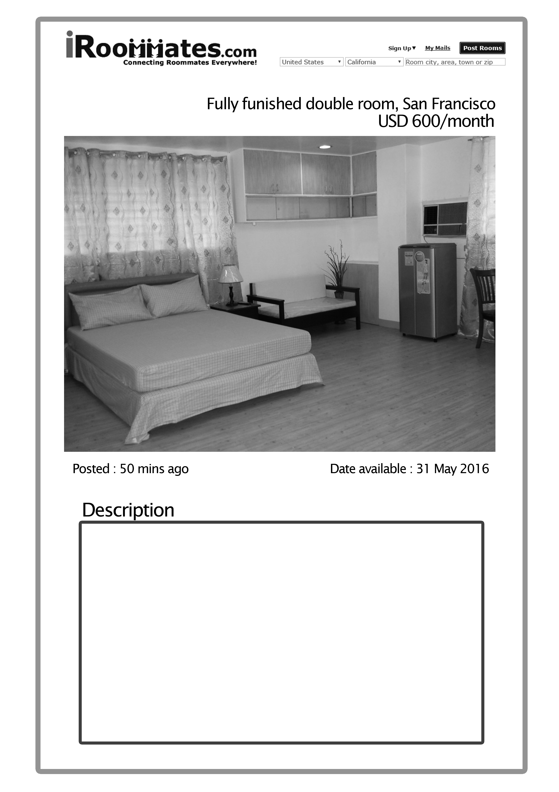
Appendix4
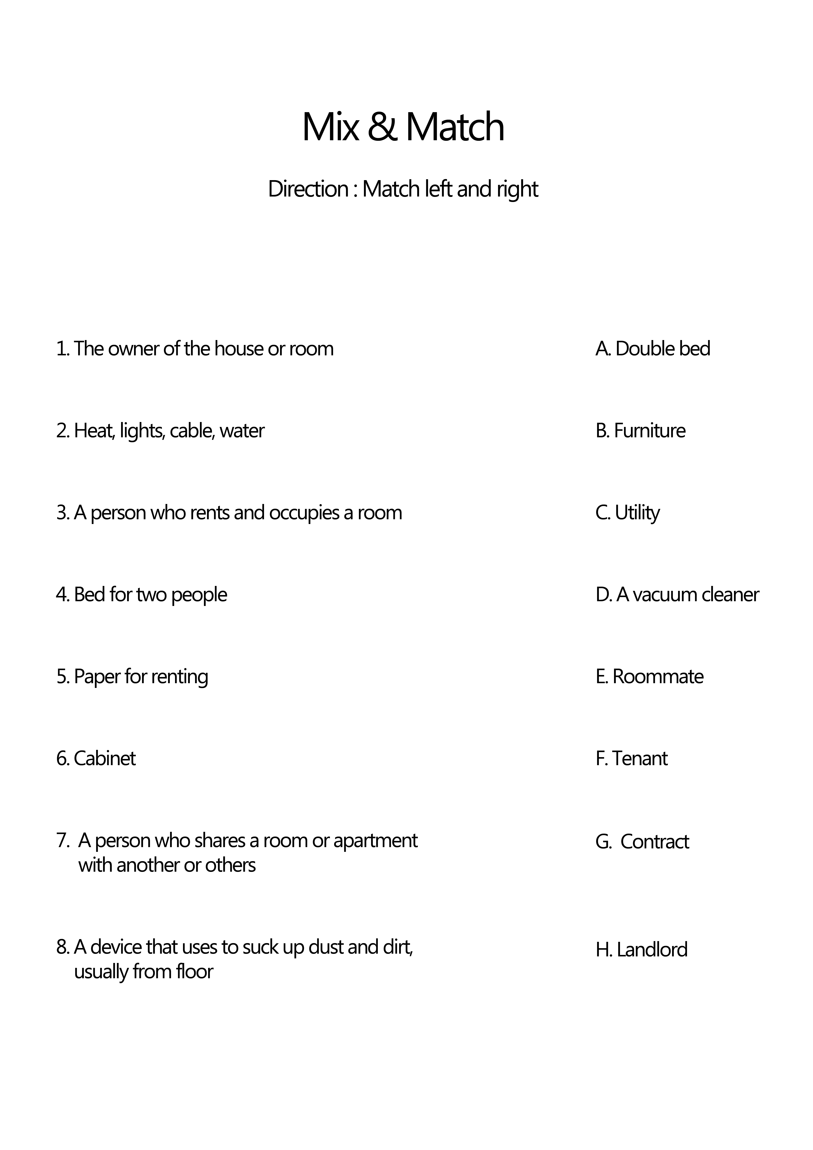
Appendix4 (answer)


