Listening Speaking Reading Grammar Writing

Topic: what you can and can’t do in your classroom

Instructor:  Park Chan Hee  (Steffy) | Level:  Intermediate | Students:  5 Students | Length:  30 Minutes

Materials:

- Pictures of signs, markers, a board-lead in
- Signs worksheet-pre activity
- Classroom activity cards-main activity
- Rule template-post activity
- SOS activity worksheet

Aims
:
- Main: Students will learn how to use the modal verb “can” in positive, negative, and question form
- Secondary: Students will practise using “can” in real life situations for permission
- Personal aim: I like to work on teaching grammar in new, fun ways through games and activities.

Language Skills

- Listening: Students will listen to each other in order to find the answer while playing the game
- Speaking: Students will ask and answer questions during the game
- Reading: Students will read the words on classroom activity cards
- Writing: Students will write class rules and regulations on rule template

Language Systems:

- Phonology: Students will differentiate the sound of can and can’t
- Lexis: the difference between the meaning of can and must
- Function: expressions regarding permission using “can”
- Grammar: modal verb “can”
- Discourse: asking and answering questions

Assumptions:

- Students know how to makes sentences with a modal verb
- Students know the rules and settings of the classroom

Anticipated Problems and Solutions:

- Students have difficulty pronouncing can and can’t
-have a student explain the difference
- Students cannot differentiate must and can
-have a student explain and help

References:

Signs
https://www.google.co.kr/search?q=signs&biw=1067&bih=488&tbm=isch&tbo=u&source=univ&sa=X&ved=0ahUKEwjm8NKliPXMAhUCK6YKHd9XCKMQsAQIHw#imgrc=oP1CrRP7hGx0xM%3A

Sign worksheet
https://www.google.co.kr/search?q=sign+worksheet&biw=1280&bih=586&tbm=isch&tbo=u&source=univ&sa=X&sqi=2&ved=0ahUKEwjY4NHZ8vTMAhWE5qYKHcsyAnsQsAQIGQ#tbm=isch&q=rules+worksheet&imgrc=KLqsbAQUryAu4M%3A

Rule template
http://livingsweetandsimple.blogspot.kr/2012/04/simple-rules-of-house-free-printable.html

SOS activity worksheet
https://www.google.co.kr/search?bih=586&biw=1280&tbm=isch&sa=1&btnG=%EA%B2%80%EC%83%89&q=modal+verbs+poster&oq=modal+verb&gs_l=img.12..0j0i30l9.13224.18385.14.23631.10.9.0.1.1.0.109.843.2j6.8.0....0...1c.1.64.img..1.9.853...0i10i30.6EVHwJ63sCc#imgrc=n2_EwmURvFGD7M%3A

Lead-In
Materials:
Picture of signs, markers, a board

Time | Set Up | Student Activity | Teacher Talk
2min. | Whole class | Look at the signs  Answer teacher’s questions | Instruction  (show signs)  What are these?  What do they tell you?

Pre-Activity
Materials:
Signs worksheet, markers, a board

Time | Set Up | Student Activity | Teacher Talk
7min. | Small groups | Write the worksheet | Instruction  Let’s work in small groups.  (assign teammates)  Look at each sign and write down the rules for them. Write down what you can or can’t do.  ICQ  What do you have to write for each sign?  Demo  KJ, what is the first sign?  What can or can’t you do when you see this sign?  (wait for students’ response and write them on the board)  Answer check  Let’s take turns for reading rules for each sign  (ask a student to begin)

Main Activity
Materials:
Classroom activity cards, markers, a board

Time | Set Up | Student Activity | Teacher Talk
15min. | Whole class | Ask and answer questions  Guess the name of the classroom activity | Instruction  You will be given a random card for a classroom activity. Don’t show your card to others.  Students will take turns asking you 15 questions about your word. Students should ask questions with “can”  You get a chocolate each time you get the answer  CCQ  What modal verb can you use for permission?  ICQ  What word do you have to use when you ask a question?  Demo  What kind of questions can you ask?  Can you drink coffee?  Can you talk on the phone?  (wait for more students’ response and write them down on the board)  Instruction  Pick a card(tell the student to begin the game with) and don’t show it to others  Let’s take turns asking questions(Let the student sitting next to the person who just pick the card ask the first question)  Please, answer the question

Post Activity
Materials:
Markers, a board, rule template

Time | Set Up | Student Activity | Teacher Talk
6min. | pair | Write the rules | Instruction  Write your classroom rules with your partner.  We already know what we must or mustn’t do in our classroom.  Now, we are writing about what you can and can’t do in our classroom  CCQ  What must you do in our classroom?  ICQ  What are we writing about?  Demo  What can we do in our classroom?  (wait for students’ response and write them on the board)  (distribute the rule templates)  Wrap-up  1 students from each team comes out and write the rules on the board
SOS Activities
Materials:
SOS activity worksheet

Time | Set Up | Student Activity | Teacher Talk
10min | Small group | Do the worksheet | Instruction  Look at the signs in each box and write the rules with using can/can’t.  Answer check  Compare your answers with the other team

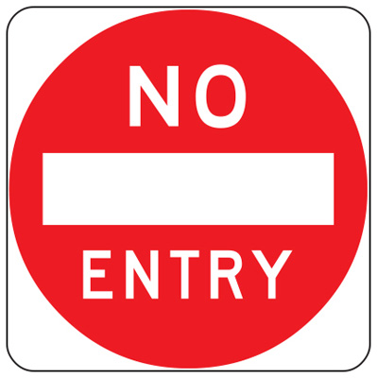

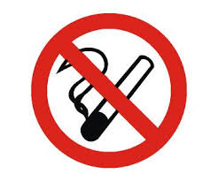

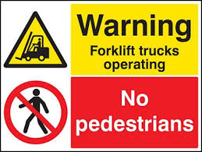

Sign worksheet
Look at the signs and write the rules with “can”/”can’t”
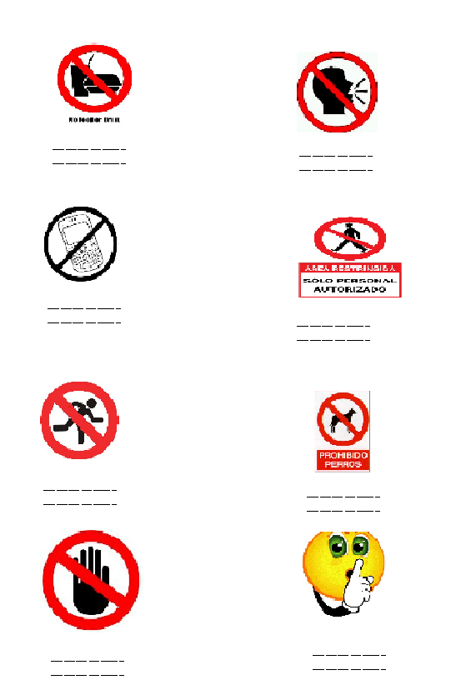

CLASSROOM ACTIVITIES CARDS

LUNCH BREAK

BREAK

MICRO TEACHING

TEST

BEFORE CLASS

RULES TEMPLATE
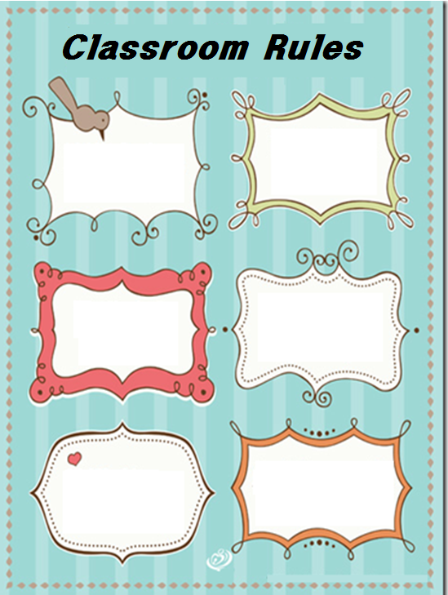
SOS ACTIVITY WORKSHEET
