Listening Speaking Reading Grammar Writing

Topic: importance of keeping healthy teeth

Instructor:  Sara Kang | Level:  Intermediate | Students:  5 | Length:  30 Minutes

Materials:
- pic1, pic2, pic3, pic4, worksheet1, glue, food pictures – pre activity
- article, worksheet2, worksheet3 – main activity
- worksheet4 – post activity
- worksheet5 – S.O.S activity

Aims:
- Main : Ss will be able to have good habituation for healthy teeth
- Secondary : Ss will be able to know what is good food or bad food for teeth
- Personal : I want to make Ss interesting and i want to enjoy the class

Language Skills:
- Listening : Ss will listen to about the teeth health and other Ss opinions
- Reading : Ss will read article and good habituation for teeth health
- Speaking : Ss will speak their opinions and will share their thoughts
- Writing : Ss will write their own thoughts and will write the reason for ranking

Language Systems:
- Lexis : key vocabularies about the teeth health
- Grammar : have to / should (have to-stronger than should, should=suggestion)
- Phonology : Discolour (lou -lə) , phosphorus (pho-fa, pho-fə, rus-rəs)
- Function : solve the problems and share opinions with pairs for ranking
- Discourse : classification, write down their thought, rank with pair

Assumptions:
Students already know
- How the class is set up and run
- Dental vocabularies
- How to work in pairs and groups
- Students have an experience to think about teeth health
- Students know the importance of teeth health

Anticipated Problems and Solutions:

- Students might classify incorrectly
T give correct answer to students and explain

- Students have a difficulty to solve the problems
T encourage Ss and give a hint

- Students might not be able to write their thoughts for 5min
T give a suggestion

- Students might not be able to know time to spare
T has to give a time warning

References:
Article
http://www.news.com.au/lifestyle/health/nutritionist-susie-burrells-best-foods-for-healthy-teeth/news-story/571400da915bf680a7a7d07dc923de36
teeth picture
http://www.sakura-teeth.com/how-to-whiten-your-teeth-at-home/
dentist picture
http://www.123dentist.com/
reference about food for teeth
http://www.netdoctor.co.uk/beauty/dental/a25772/16-foods-for-whiter-teeth/

Lead-In
Materials: none
Time | Set Up | Student Activity | Teacher Talk
2min | T-w | Greeting and answering  Answering | Good morning everyone I’m good to see you again!  I hope you had a great weekdays  Do you brush your teeth once a day?  (Ss might say ‘no! three times!’)  Yes brushing teeth is very important to keep your teeth  What other factor will help to keep your teeth?  (Ss might say: don’t eat sweets, brush teeth immediately after eating)  Yes that’s right!

Pre-Activity
Materials: pic1, pic2, pic3, pic4, worksheet1, glue, food pictures
Time | Set Up | Student Activity | Teacher Talk
2min  3min  2min | Whole class  Individually  Whole class | Listening and answering  Classifying  Sharing and checking | (show the picture for healthy teeth)  Now I want to show pictures  Do you know what this is?(onion pic)  yes that’s right(explain about onion)  What is this?(kiwi pic)  Yes this is kiwi(explain about kiwi)  I will give you worksheet to classify  You have to think what is good food for your teeth or what is bad food for your teeth and you will work individually  I will give you 3minutes for classification  You should think carefully because there are some trick maybe you think  This is bad for teeth or this is good for teeth! But sometimes your guessing is not correct  Think carefully!  (ICQ)  What are you going to do?  (classification)  How much time do you have? (3min)  Are you working in pair? (no)  Ok, good!  Let’s start! (distribute worksheet and glue)  Time warning  1min left!  Time’s up~  Ok let’s check the answer  Jiwon can you tell us your answer?  Good!  Steffy can you tell us your answer?  Good! Who has different answer with them?  Oh~ thank you for telling us  Lets’ check the answer!  For teeth~  Green tea, cheese, chicken, carrot and mustard are good for teeth!  (Ss might ask something, T explain why --- is good for teeth)  Coffee, chocolate, wine, lemon and dried fruits are not good for your teeth!  (Ss might ask something, T explain why --- is not good for teeth)  Ok everybody good job

Main Activity
Materials: article, worksheet2, worksheet3
Time | Set Up | Student Activity | Teacher Talk
1min  3min  5min  3min | Whole class  individually  In pair  Whole class | Listening and answering  Reading  Solving and sharing opinion with pair  Sharing answer and listening | Now we will going to read article about best food for healthy teeth  After reading  I will give you question worksheet  Read by yourself  i will give you 3min for reading!  Start~  (distribute worksheet)  Time warning  1min left!  Time’s up  Ok now june, grace,and kj are team and steffy and jiwon are team  I will give you 4min  You have to write down answer with your partner  (ICQ)  What are you going to do? (solve, write)  How much time do you have? (4min)  Are you working in pair? (yes)  Good! Let’s start!  Time warning  1min left!  Time’s up~  Let’s check the answer  June can you tell us question 1  Grace can you tell us question 2  (Ss will answer one by one, if Ss answer is wrong T will give correct answer)  Everybody good job!

Post Activity
Materials: worksheet4
Time | Set Up | Student Activity | Teacher Talk
1min  2min  3min  2min | Whole class  Individually  In pair  Whole  class | Listening and answering  Rank  Sharing and choosing  Listening and sharing | ok now you will rank the habituation to keep your teeth by yourself  you can rank from first to last  I will give you 2min  (distribute worksheet)  Let’s start!  30seconds left!  Time’s up  Ok now you will share your opinion and choose the best with your partner  I will give you 3min  (ICQ)  How much time do you have?(3min)  What are you going to do?(share, choose the best)  Ok let’s start  1min left!  Time’s up  I want to know your choice  June! What is your team’s choice and reason? Can you tell us?  Good!!  Jiwon can you tell us?  Good!  Everyone good job today~!
SOS Activities
Materials: worksheet5
Time | Set Up | Student Activity | Teacher Talk
3min | Whole class | Listening and writing | We have little time  Now you can imagine  If you were dentist what would you say to your patient to keep healthy teeth?  I will give you 3min!  (distribute worksheet)  Everyone good job today  Thank you!
Pre activity
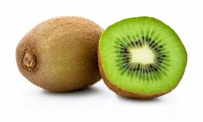

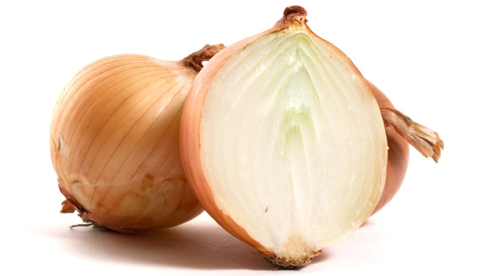

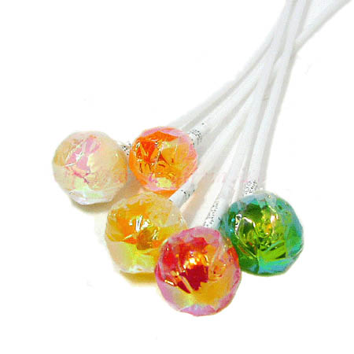

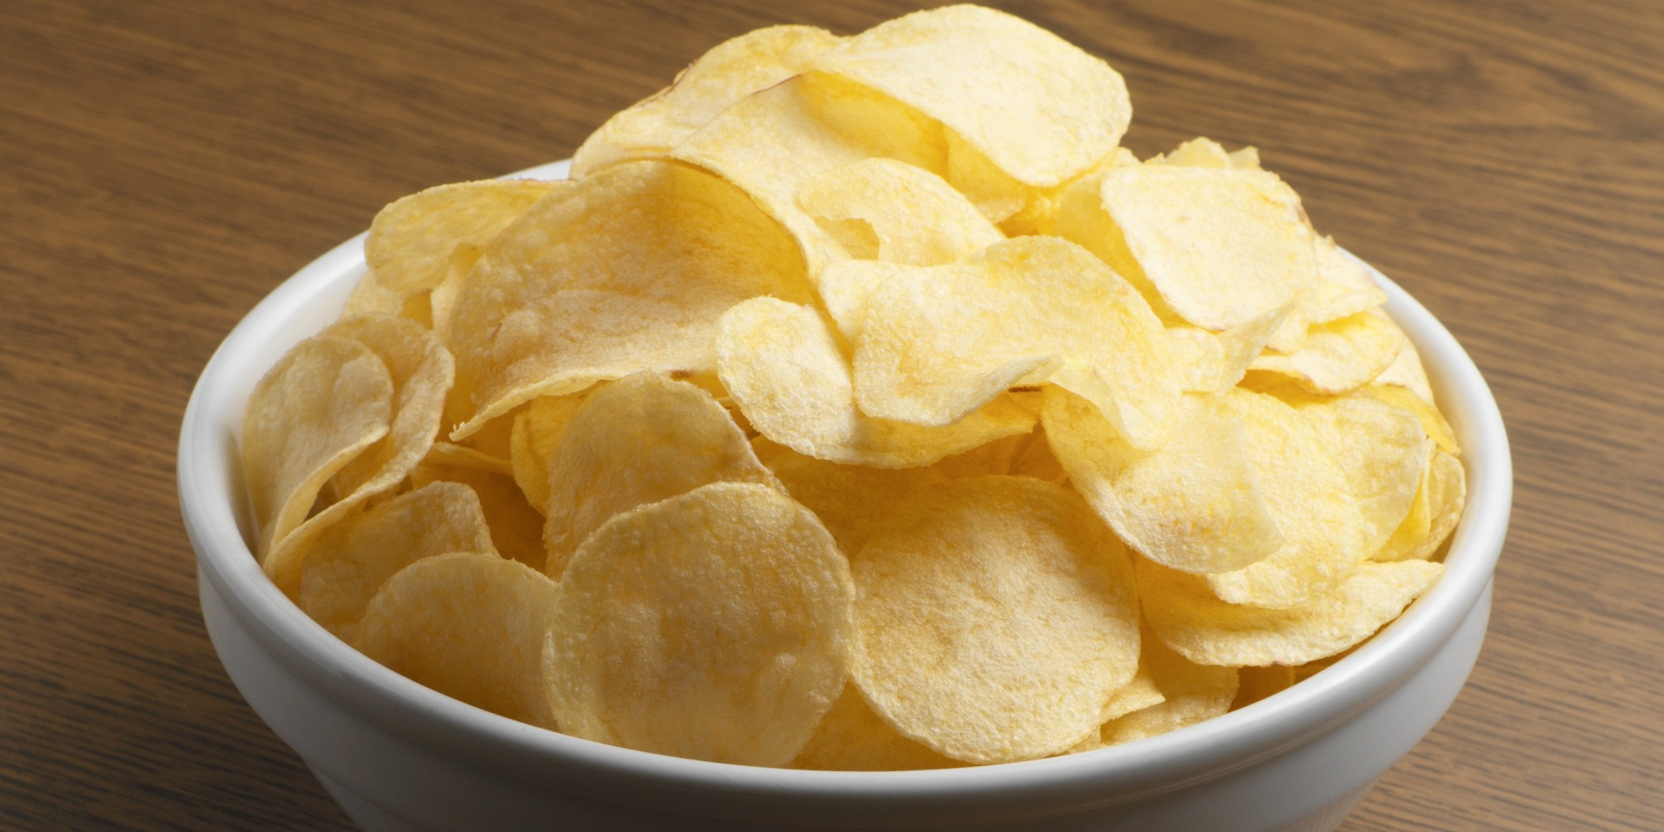

Pre activity (worksheet1)
Classification healthy food & unhealthy food for teeth

Healthy food Unhealthy food

Pre activity pictures for classification
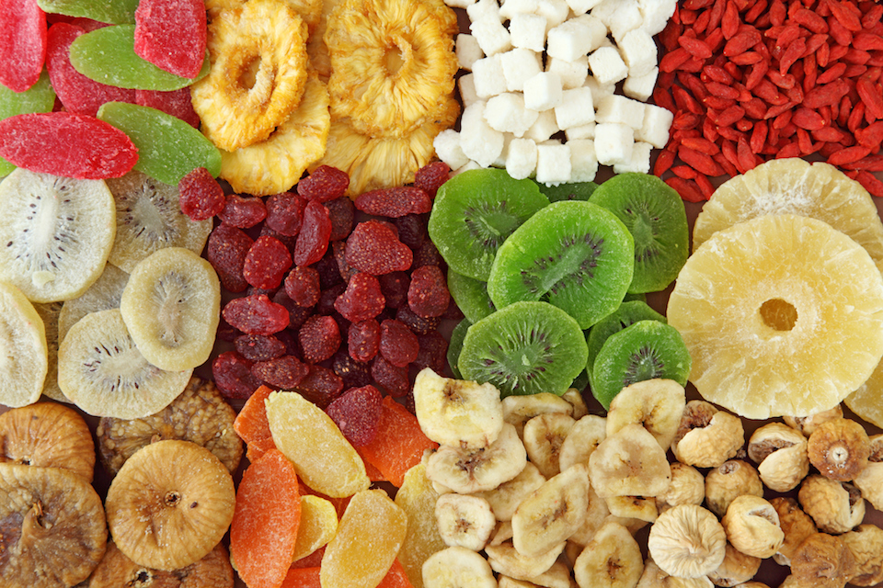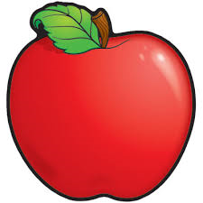
Dried fruits Apple
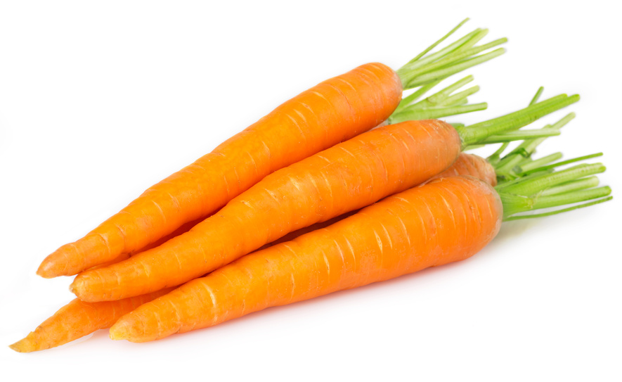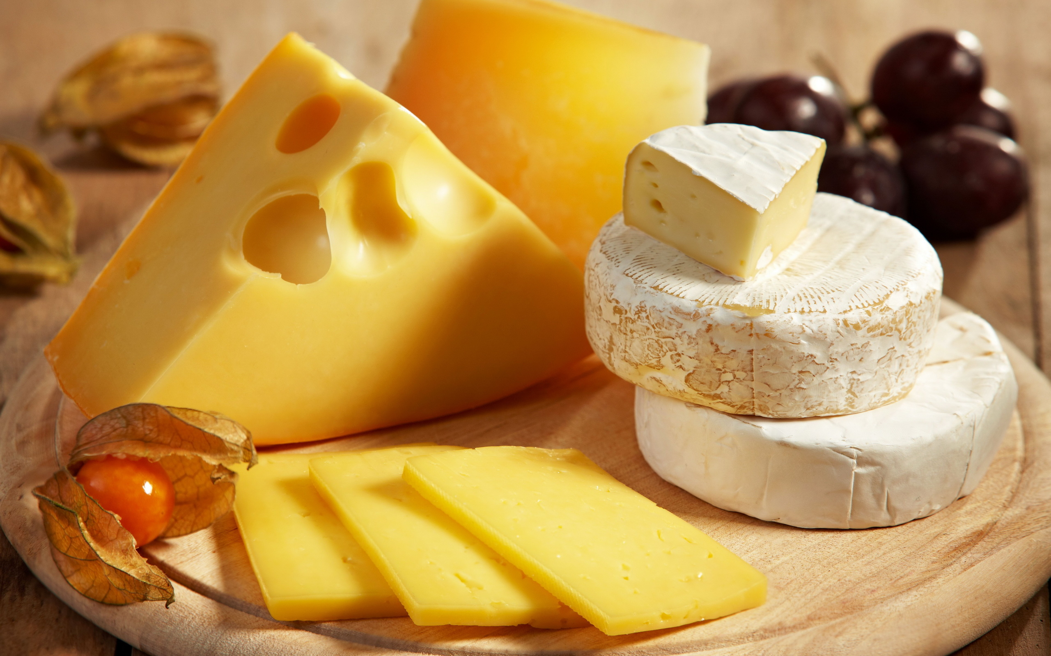
Carrot Cheese
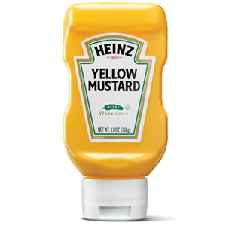
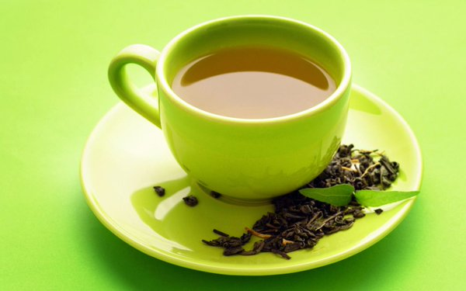
Mustard Green tea
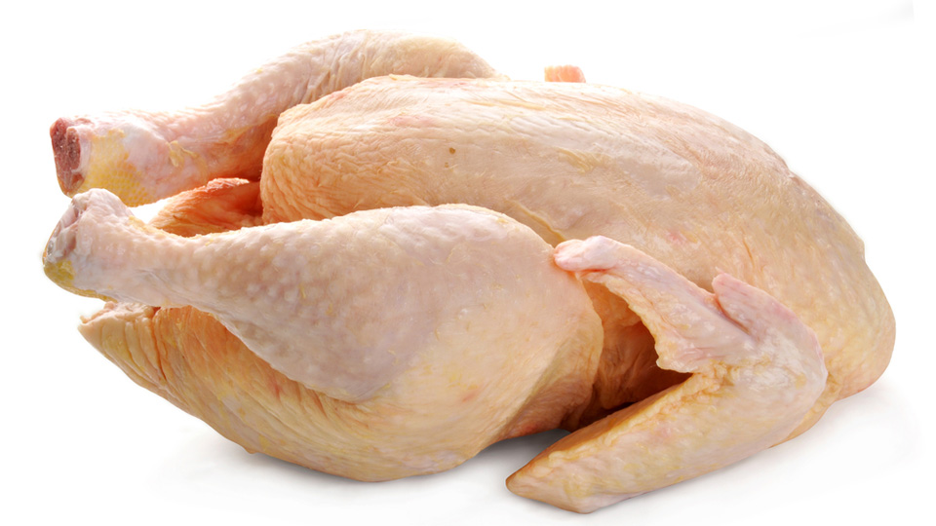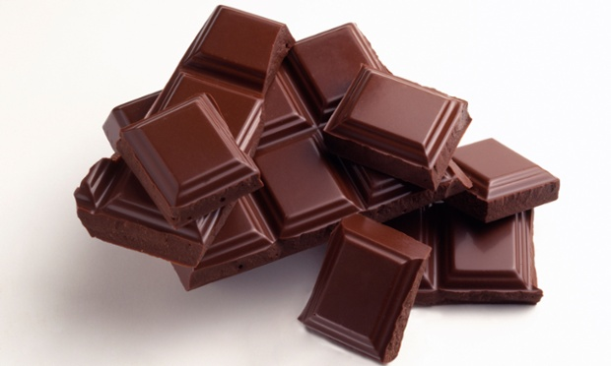
Chicken Chocolate
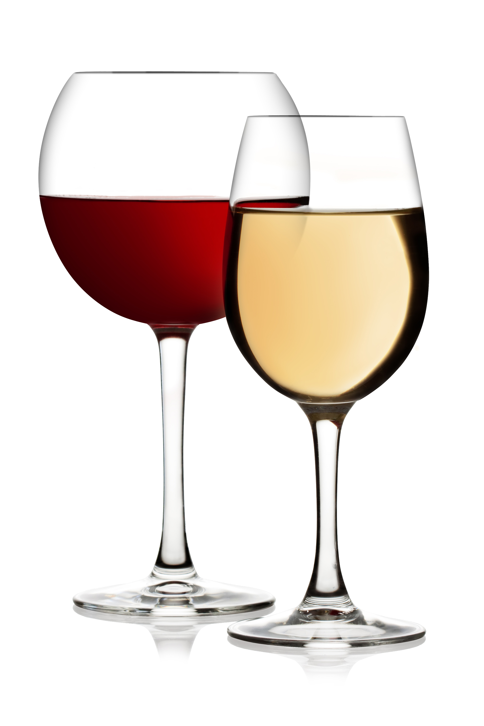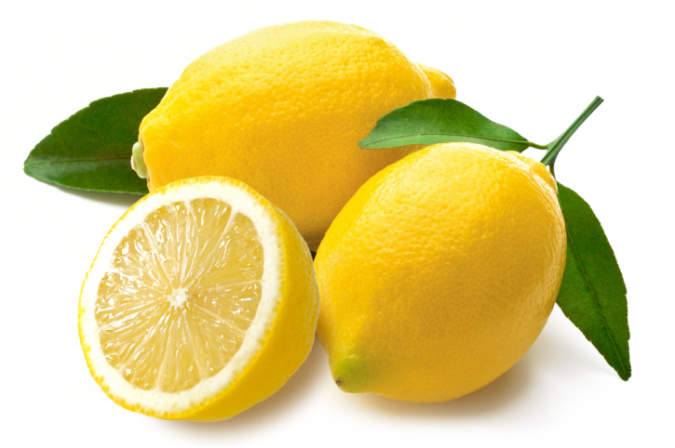
Wine Lemon

Main activity (worksheet2)
Nutritionist Susie Burrell’s best foods healthy teeth
FOR anyone who has had a hefty dental bill courtesy of damaged or discoloured teeth, you’ll understand the importance of dental health to look after our pearly whites and avoid further hits to your back pocket.
While we hear much about the foods that cause damage to our teeth (soft drink, sugars, lollies), we hear far less about the foods we should focus on to help keep our teeth at their best.
WATER
It may seem obvious but one of the easiest ways to promote dental health is to keep well-hydrated. Not only will our salivary glands be at their best when we are well-hydrated but regularly drinking water will help to naturally flush out the mouth. In addition, good old tap water (in most Aussie states) offers the added protection of having fluoride added. Fluoride is a mineral that can help to prevent tooth decay from progressing as it helps reduce the ability of bacteria in the mouth to make the acids that attack tooth enamel as well as helping to prevent further mineral loss in tooth enamel.
CHEESE
Yes you finally have a reason to eat more cheese. Cheese is a rich source of the protein casein. Casein is found in all dairy foods but the extra good thing about cheese is that it does not come with the natural sugars that milk and yoghurt does and hence is extra good for teeth. When we consume cheese, particularly after a meal the casein it contains combines with the calcium and phosphorus also found in dairy to create a protective film over the surface enamel of the teeth helping to reduce the risk of tooth decay.
NUTS
When it comes to choosing snacks we are regularly drawn to fruit, crackers, muesli bars, milk coffee and biscuits, yet all of these foods offer the sugars that can be a nightmare for dental health. For this reason, nutrient rich nuts are the perfect in-between meal snack when it comes to dental health. Offering a range of essential nutrients including magnesium, calcium and protein known to directly benefit dental health, nuts contain little to no sugars which means a handful of mixed nuts in between meals will not contribute to dental decay.

Main activity (worksheet3)
(QUESTION)
1. What’s the wrong answer?
a. drinking water will help to naturally flush out the mouth
b. cheese can create a protective film over the surface enamel of the teeth
c. we hear far about the food that cause damage to our teeth

2. What is the benefit to drinking water?

3. What is the benefit to eating nuts?

4. If you will eat cheese for your teeth, what food will you make?

5. Do you know any other good food for your teeth? Why is that good?

Post activity (worksheet4)
What is the best for teeth?
First, Rank these individually and then choose the best with your partner. Put the thing that is best for the teeth at the blank.
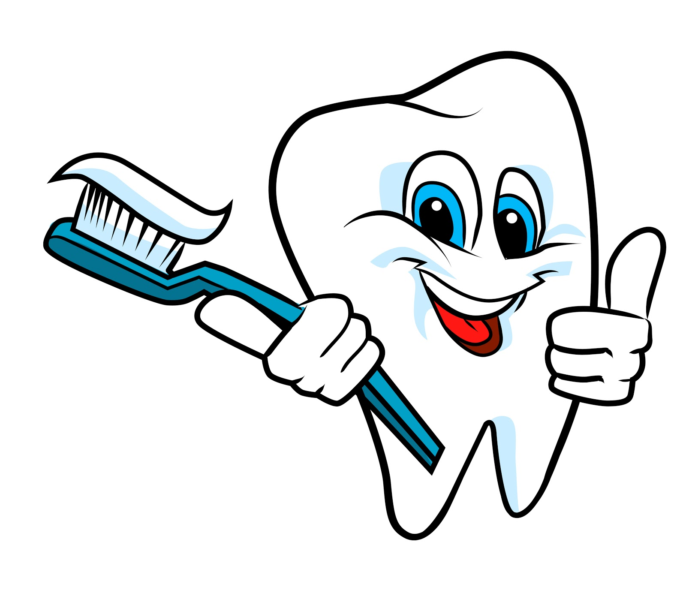
- Don’t bite your nail ( )
- Don eat hot food and cold food at the same time ( )
- Don’t eat solid food ( )
- After drinking soft drinks don’t brush your teeth immediately ( )
- No smoking ( )
- Using dental floss once a day ( )
- Do not crunch ice ( )
- Do not eat sweets ( )
Best

Reason for best

S.O.S activity (worksheet5)

If you were dentist what would you say to your patient?



