Listening Speaking ★ Reading Grammar Writing

Topic: Commencement speech and graduation party

Instructor:  KJ (Kaapjoo Park) | Level:  Intermediate (adults) | Students:  5 | Length:  30 Minutes

Materials:
Lead-in (2 min), Pre activity (about 6 min)
- Pictures related to the concept of ‘Graduation’ (Appendix 1) - 1 copy
- The gist of commencement speech (Appendix 2) - 2 copies
- Marker

Main activity (about 13 min)
- The excerpt of commencement speech (Appendix 3) - 5 copies
- Worksheet for True/False questions (Appendix 4) - 5 copies
- The picture of Steve Jobs (Appendix 5) – 1 copy
- Marker

Post activity (9 min)
- Letter papers for writing something about classmates - 6 letter sets
- Bring a sample (Realia)
- Marker

SOS activity (5 min)
- Finding a match between public speakers and excerpts (Appendix 6) - 2 copies

Aims:

- Main aim: Ss will be able to inspire and motivate their classmate through reading and discussing graduation speech done by keynote speakers.

- Secondary aim: Ss will be able to get the main idea of the reading material by skimming it and get appropriate answers for T/F questions by scanning the text.

- Personal aim: I want Ss to be motivated and inspired by the commencement speech done by my hero, Steve Jobs, who has inspired so many people.

Language Skills:

- Reading: Ss will read text ‘commencement speech’ and worksheets.

- Listening: Ss will listen to teacher’s instructions/demonstration and classmates’ presentation/explanation/ideas during the activities.

- Speaking: Ss will engage in sharing/discussing ideas in a group and present their ideas/answers to the whole class.

- Writing: Ss will write a letter to classmates/teacher and answer true & false questions.

Language Systems:

- Phonology: graduation [|grӕdƷu|eɪʃn], congratulation [kən|grӕtʃu|leɪʃn], celebration [|selɪ|breɪʃn], compliment [kɑ:mplɪmənt]

- Lexis: commencement, address, speech, diploma, graduation, congratulation, gown, cap (vocabularies related to graduation)

- Grammar: Usage of imperative (do/don’t)

- Function: Polite request, advice/suggestion, compliment

- Discourse: Public speech, conversation or discussion ideas with partners

Assumptions:

- Most of Ss have attended a graduate ceremony before.

- Ss might have heard public speech or read articles

- Ss are used to working individually and in a group.

- Ss know the difference between intensive and extensive reading.

Anticipated Problems and Solutions:

- Students may not know the words related to graduation.
→ In the activity, familiarize students with the ‘graduation’ and the key words for graduation.

- There may be not enough time to complete post activity (writing a letter to classmates).
→ Assign the post activity as an after class assignment.

- There may be a lot of time left.
→ Start SOS activity (finding a match between an excerpt and a keynote speaker).

References

All images (Appendix 1) were copied from Google search:
https://www.google.com/?gfe_rd=cr&ei=SpBBV9SGD-TC8geGt5boCw&gws_rd=cr&fg=1

Steve Jobs Commencement Address at Stanford University, 2005:
https://news.stanford.edu/2005/06/14/jobs-061505/

Navy Admiral William McRaven Commencement Address University of Texas at Austin 2014:
http://news.utexas.edu/2014/05/16/mcraven-urges-graduates-to-find-courage-to-change-the-world

Other excerpts of public speech:
http://www.jfklibrary.org/Asset-Viewer/BWC7I4C9QUmLG9J6I8oy8w.aspx
http://www.nydailynews.com/news/politics/hillary-clinton-nyu-commencement-speech-yankee-stadium-state-dept-hiring-article-1.408987
http://www.rightattitudes.com/2010/05/04/three-great-commencement-speeches/
https://www.entrepreneur.com/article/276561

Lead-In
Materials:
- Pictures (Appendix 1), tape, marker

Time | Set Up | Student Activity | Teacher Talk
2 min | Whole class | Looking at the picture and sharing their thoughts  Answering questions | Preparation (before class):  - Arrange 2 tables to be close each other.  - Have the ‘Mr. Obama’ picture posted on the board and be ready for lead-in.  Greeting and arousing Ss interest on today’s topic:  Hi everyone!  What is it in this picture?  Wait for Ss response.  (President of USA, Mr. Obama).  Eliciting  What is he doing?  Is he doing political campaign?  What do you think of his outfits?  What for Ss response.  (He is giving a graduation speech)  Show another picture to Ss.  Can you describe this picture?  Wait for Ss response.  Who do you think they are?  Are they related?  Wait for Ss response.  (Husband & wife)  What do you think they are doing?  Wait for Ss response.  (They are doing commencement address together)  When is usually graduation held?  Wait for Ss response.  (In May in USA or In Feb in Korea)  Have you ever attended any graduation ceremony?

Pre-Activity
Materials:

- Marker
- The gist of commencement address by William McRaven (Appendix 2) - 2 copies

Time | Set Up | Student Activity | Teacher Talk
1 min  3 min  3 min | Whole class  Group work | Listening to the instructions  Talking with group members, analyzing the gist of the address and differentiating advices  Speaking and listening each group’s result | Instruction:  Now, I will give a gist of commencement speech by Admiral William McRaven at UT at Austin.  Can you guess why Admiral William McRaven gave a commencement speech at UT at Austin?  Any special reason?  Wait for Ss response.  (UT is his alumni, he became a chancellor at UT at Austin 2015)  There are 10 key advices from his speech.  Among these 10 advices, please choose top three most impressive advices which you definitely feel connected and bottom two least impressive advices which you don’t have any strong feeling .  Please work with group partners.  I will give you 3 min.  CCQ  What is in the worksheet?  (commencement address)  How many most impressive and least impressive advices will you choose?  (Top 3, bottom 2)  How long do you have for choosing advices?  (3 min)  Let’s begin  (teacher monitors)  Group 1, please presents your choices and explains the reason.  Group 2, please presents your choice and explains the reason.  Great! You guys did good job

Main Activity
Materials:
- Marker
- The excerpt of commencement address by Steve Jobs (Appendix 3) - 5 copies
- True/False worksheet (Appendix 4) - 5 copies
- The picture of Steve Jobs *Appendix 5) – 1 copy

Time | Set Up | Student Activity | Teacher Talk
1 min  3 min  1 min  3 min  2 min  2 min | Whole class  Whole Class  Whole class  Individual work  Whole class  Whole class | Listening to teacher  Listening instruction  Listening and watching demo  Answering ICQ  Reading worksheet  Checking T/F/No information  Speaking and listening to each group’s result  Listening and answering CCQ | Now, I will give an excerpt of commencement speech at Stanford University (Appendix 3).  Please read the address carefully.  I will give you 3 min for reading.  ICQ  How long do you have for reading the text?  (3 min)  Hand out the text (Appendix 3)  You may read the text.  Instruction:  Now, I will give you a worksheet (Appendix 4) containing true or false questions.  Check true, false, or no information based on the excerpt that you just read.  You can always go back to the article to find answers.  This activity is individual work.  I will give you 3 min for answering T/F questions  Demonstration  For example, has the speaker worked in Google company?  I couldn’t find any information about it in the text.  So I will check ‘No information’  ICQ  What will you do in this activity?  (checking true/false/no information)  How much time do you have for this activity?  (3 min for answering T/F questions)  Hand out a worksheet (Appendix 4)  Let’s start  Each person presents their results and Ss discuss different results (if any).  CCQ  Who might be the main audience for this public speech?  Wait for Ss response.  (Young students).  Is the speaker is woman or man?  (man)  How old was the speaker at the time of that commencement (in 2015)?  Stay Hungry. Stay Foolish.  What does this phrase mean?  Do you have any idea?  (not satisfied (keep improving), try new things that nobody can do)  Can you guess who the speaker is?  (Steve Jobs)  Show his picture (Appendix 5).  Great! You guys did good job.

Post Activity
Materials:
- Letter set (letter paper & envelope) - 6 letter sets
- A sample (if available) - Realia

Time | Set Up |  | Student Activity |  | Teacher Talk
1 min  1 min  1 min  6 min | Whole class  Whole class  Group work  Whole class |  |  | Listening to the teacher  Listening instruction  Listening and answering CCQ  Writing a letter | Eliciting  What is it?  Show envelope.  Let’s see what is inside of envelope.  Take a letter out of envelope.  There are some sentences describing KJ.  Can you guess what this is about?  Wait for Ss response.  (Many friends wrote a short letter to KJ)  Have you written or received this kind of letter before?  Instruction:  Let’s do some meaningful writing today.  I will give a letter paper where somebody’s name on it.  You can think about the person briefly and write a short letter to the person.  The length of letter may be 1~3 sentences.  We can circulate the letter papers clockwisely until you finish writing to all classmates and teacher.  After finishing writing letters, I will keep them in each envelope and give everybody on our graduation day.  CCQ  What are you doing in this activity?  (writing letters to classmates/teacher)  How do you circulate letter papers to write?  (clockwisely)  How many sentences can you write for each person?  (1~3 sentences)  Hand out letter papers to everyone including teacher.  Let’s begin  (teacher monitor and participate Ss activity)  Please put the finished letter to corresponding envelope.  Good job!
SOS Activity
Materials:
- Finding a match between public speakers and excerpts (Appendix 6) - 2 copies

Time | Set up | Student Activity |  |  | Teacher Talk
1 min  3 min  1 min | Whole class  Group work | Listening instruction  Talking/discussing with partners  Writing answers  Speaking/listening each other |  |  | Instruction  Now, I will give you a worksheet (Appendix 6) where a gist of commencement speech and keynote speakers’ name.  Please find a match between a text and a speaker by discussing with group partners.  I will give you 3 min.  ICQ  What are in worksheet?  (a gist of commencement speech and keynote speakers’ name)  What are you doing in this activity?  (find a match between a text and a speaker)  Hand out a worksheet (Appendix 6)  Let’s begin  Group 1 and Group 2, please present answers alternatively.  Good job!

Appendix 1
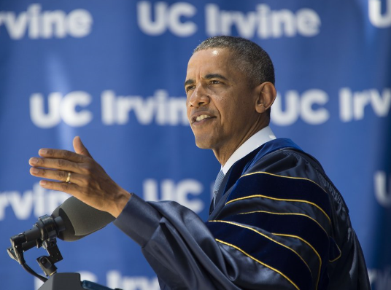

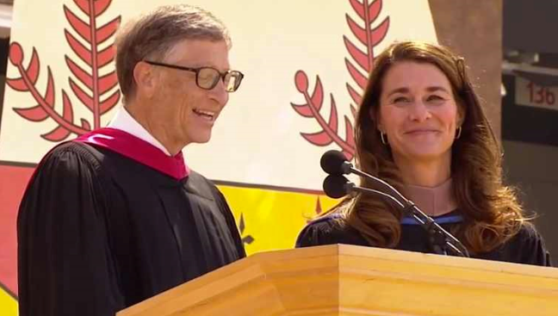
Appendix 2
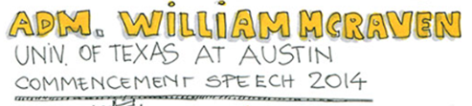
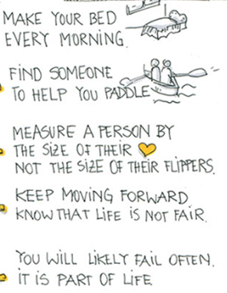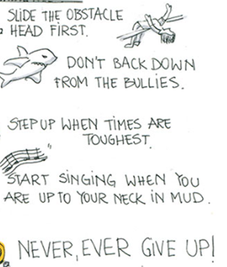

Appendix 3

Commencement Address at Stanford University, 2005
EXCERPTS
When I was 17, I read a quote that went something like: "If you live each day as if it was your last, someday you'll most certainly be right." It made an impression on me, and since then, for the past 33 years, I have looked in the mirror every morning and asked myself: "If today were the last day of my life, would I want to do what I am about to do today?" And whenever the answer has been "No" for too many days in a row, I know I need to change something.
Remembering that I'll be dead soon is the most important tool I've ever encountered to help me make the big choices in life. Because almost everything - all external expectations, all pride, all fear of embarrassment or failure - these things just fall away in the face of death, leaving only what is truly important. Remembering that you are going to die is the best way I know to avoid the trap of thinking you have something to lose. You are already naked. There is no reason not to follow your heart.
Your time is limited, so don't waste it living someone else's life. Don't be trapped by dogma - which is living with the results of other people's thinking. Don't let the noise of others' opinions drown out your own inner voice. And most important, have the courage to follow your heart and intuition. They somehow already know what you truly want to become. Everything else is secondary.
When I was young, there was an amazing publication called The Whole Earth Catalog, which was one of the bibles of my generation. It was created by a fellow named Stewart Brand not far from here in Menlo Park, and he brought it to life with his poetic touch. This was in the late 1960's, before personal computers and desktop publishing, so it was all made with typewriters, scissors, and polaroid cameras. It was sort of like Google in paperback form, 35 years before Google came along: it was idealistic, and overflowing with neat tools and great notions.
Stewart and his team put out several issues of The Whole Earth Catalog, and then when it had run its course, they put out a final issue. It was the mid-1970s, and I was your age. On the back cover of their final issue was a photograph of an early morning country road, the kind you might find yourself hitchhiking on if you were so adventurous. Beneath it were the words: "Stay Hungry. Stay Foolish." It was their farewell message as they signed off. Stay Hungry. Stay Foolish. And I have always wished that for myself. And now, as you graduate to begin anew, I wish that for you.
Stay Hungry. Stay Foolish.

Appendix 4

Commencement Speech | True | False | No information
1. The speaker had a serious cancer
2. The speaker has worked in IT/computer industry
3. This commencement was probably held at the speaker’s alma mater
4. The speaker created the quote “Stay hungry” “Stay foolish”
5. The speaker was very afraid of dying soon
6. When the speaker was young, he/she worked at The Whole Earth Catalog company.
7. The speaker graduated from university with honors
8. If the commencement was held in 2005, the speaker has been already passed away.
9. The speaker always has the courage to follow his heart and intuition and he has never regretted his life
10. The speaker has donated lots of money to the charity to help young students

Appendix 4

Commencement Speech | True | False | No information
1. The speaker had a serious cancer | O
2. The speaker has worked in IT/computer industry |  |  | O
3. This commencement was probably held at the speaker’s alma mater |  |  | O
4. The speaker created the quote “Stay hungry” “Stay foolish” |  | O
5. The speaker was very afraid of dying soon |  | O
6. When the speaker was young, he/she worked at The Whole Earth Catalog company. |  | O
7. The speaker graduated from university with honors |  |  | O
8. If the commencement was held in 2005, the speaker has been already passed away. | O
9. The speaker always has the courage to follow his heart and intuition and he has never regretted his life | O
10. The speaker has donated lots of money to the charity to help young students |  |  | O

Appendix 5
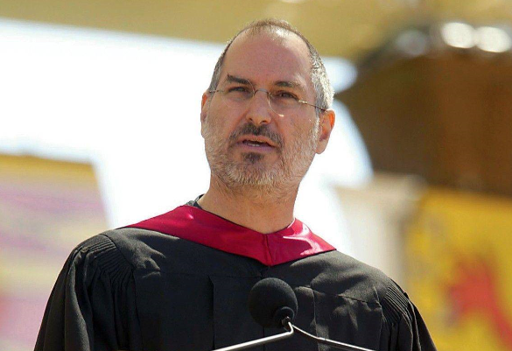
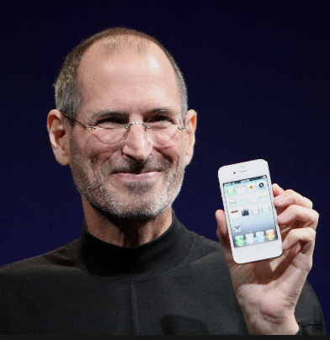

Appendix 6

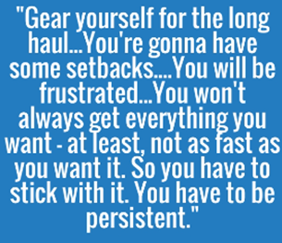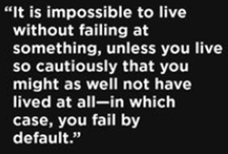
( ) ( )

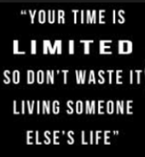
( ) ( )

( )

"One of the best lines from one of my favorite baseball movies, 'A League of Their Own,' said it well - 'If it were easy, anyone could do it.' ( )

I hope you will judge yourselves not on your professional accomplishments alone, but also on how well you have addressed the world’s deepest inequities … on how well you treated people a world away who have nothing in common with you but their humanity.( )

I wish you all a true, Hollywood-style happy ending. I hope you outrun the T. rex, catch the criminal and for your parents’ sake, maybe every now and then, just like E.T.: Go home.
( )

If we cannot end now our differences, at least we can make the world safe for diversity.
( )

Bill Gates
Steve Jobs (2)
Steven Spielberg
Hillary Clinton
Barack Obama
Michael J. Fox
J.K Rowling
J.F Kennedy

Appendix 6 (Answer)

Barack Obama J.K. Rowling

Steve Jobs Steve Jobs Michael J. Fox

"One of the best lines from one of my favorite baseball movies, 'A League of Their Own,' said it well - 'If it were easy, anyone could do it.' (Hillary Clinton)

I hope you will judge yourselves not on your professional accomplishments alone, but also on how well you have addressed the world’s deepest inequities … on how well you treated people a world away who have nothing in common with you but their humanity. (Bill Gates)

I wish you all a true, Hollywood-style happy ending. I hope you outrun the T. rex, catch the criminal and for your parents’ sake, maybe every now and then, just like E.T.: Go home.
(Steven Spielberg)

If we cannot end now our differences, at least we can make the world safe for diversity.
(John F. Kennedy)

