Listening □ Speaking □ Reading □ Grammar □ Writing
Topic: Release Your Stress

Instructor:  Sonya Kim | Students Competency Level  Pre-intermediate | Number of Students:  10 | Lesson Length:  50 minutes
Materials:
- White Board and Markers
- Word Cards
- Stress Route Map

Aims:
- Improve listening skills by listening to the teacher, role playing with peers.
- Improve speaking skills by role playing with peers, responding to the teacher.
- Improve reading and writing skills by taking notes on the board, Word Cards and Stress Route Map.
- Improve interaction and communication by planning a role play.

Language Skills:
- Reading:
Note taking, Word Cards, Stress Route Map
- Listening:
Teacher talk, role playing
- Speaking:
Answering to teacher, role playing
- Writing:
Note taking, Stress Route Map

Language Systems:
- Phonology: (sound)
Teacher talk, role playing
- Function: (situation)
Consulting, giving advice
- Lexis: (meaning)
Vocabulary about illness, and leisure activities
- Grammar: (language structure)
Present perfect tense, question and answer
- Discourse: (communication)
Responding the teacher, role playing

Assumptions:
- All students are having their own way to release their stress.
- All students are willing to release their stress.
- All students are willing to help their peers to release their stress.

Anticipated Errors and Solutions:
- If students do not have understand → Teacher do the demonstration, show it first.
- If students cannot find words to answer → Let student explain it in English.
- If activity lasts too long → Teacher alarm students to finalize their activities in 3 mins before.
- If activity finished too short → Teacher ask students about the details.
- If students are too shy → Teacher encourages students with asking simple questions and praising them.

References:

x
Lead-In or Pre-Task Part
Materials:
White Board and Markers
Time: | Classroom Set Up: | Student Activity and Goals: | Teacher Procedure & Instructions:
1min | Whole | Students greet to the teacher | Greeting
5min | Whole | Students listen to teacher | Tell teacher’s story about how teacher released stress.
4min | Whole | Students response to teacher | Elicit stories from students.  <Transition>  Let’s do a role play about consulting with mental therapist.

Pre-Activity or Task Familiarization Part
Materials:
White Board and Markers
Word Cards
Stress Route Map
Time: | Classroom Set Up: | Student Activity and Goals: | Teacher Procedure & Instructions:
5min | Whole | Listen to the teacher, repeat after words and sentences. | Teacher introduce several leisure activities by showing Word Cards.  Write sentences on White Board.
2min | Whole | Listen to the teacher | Teacher introduce about the activity.
1min | Whole | 5 students take role of mental therapist, stand in outer-circle. 5 students take role of patients and stand in inner circle. | Teacher set the class for role play.  Hand out Stress Route Map.

Main Activity or Task Realization Part
Materials:
White Board and Markers
Stress Route Map
Time: | Classroom Set Up: | Student Activity and Goals: | Teacher Procedure & Instructions:
1min | Whole | Look at the teacher. | Teacher do a demonstration with one student.
10min | Whole | 5 students as a patients meet their mental therapist in front of them and do role play. As finished, they move to the left. | Let students do the role play.
1min | Whole | Take their seat. | Finalize the activity.

Post Activity or Post Task Part
Materials:
White Board and Markers
Time: | Classroom Set Up: | Student Activity and Goals: | Teacher Procedure Instructions:
5min | Whole | Listen and answer to the teacher. | Teacher ask students result of their activity.
5min | Whole | Listen to the teacher and respond | Close the lesson by summarizing expression they learnd.

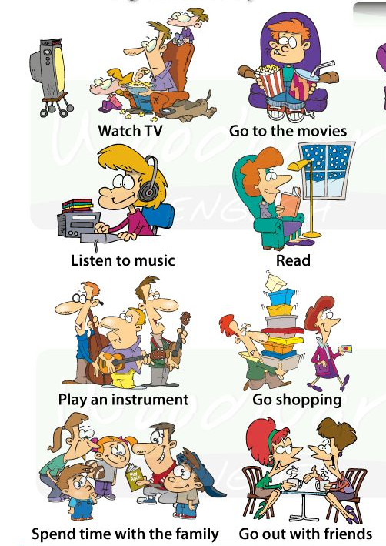
Word Cards

Stress Route Map
