(o) Listening (o) Speaking (o)Reading ( )Grammar (o)Writing

Topic:
Where are they?

Instructor:  Youn Hee, Lee | Level:  Age 7 | Students:  8 | Length:  30 Minutes

Materials:
▶Non-woven fabric board of the shape of a house,
▶Velcro for picture cards
▶Picture cards ( 6 pieces )
▶Letter cards
( 2 pairs of 4 pieces : /ch/, /ou/, /ar/, /oo/, kit--en, c—kie, h—se, j-- )
▶Reading passage sheet ( 8 copies )
▶Vocabulary worksheet-1( 8 copies )
▶Computer for listening, CD
▶Reading & Listening worksheet-2( 8 copies )
▶Summary worksheet-3 ( 8 copies )
▶Blank paper, a picture of candy, colored pencils

Aims:
▶Main aim :
1)Ss will be able to expand the vocabulary with relevant, high frequency words. 2)Ss will be able to develop and improve reading fluency and sight word recognition.

▶Secondary aim : Ss will be able to review some phonics already learned
& needed more practice.

▶Personal aim :
1)Ss will be motivated and have a self-confidence for reading.
2)Ss will be learned cooperation mind through a active-based learning.

Language Skills:

▶Reading : Ss will read phonics words and the passage over 5 times
▶Listening : Ss will listen the passage and have a short test through the CD
▶Speaking : Ss will answer the questions for checking their comprehension
of the passage and retell the situations with pictures
▶Writing : Ss will fill in the blanks of the sentences to summary

Language Systems:

▶Phonology : /ch/, /ou/, /ar/, /oo/, /k/, /h/, /c/, /j/
▶Lexis : Kitchen, in, house, cat, jar, cookie
▶Discourse : creative passage

Assumptions:
*Ss already know
▶How to set up and run the class
(There will be 4 students at each table)
▶How to pronounce the short & long vowels and blending
▶There are irregular phonics words

Anticipated Errors and Solutions:
▶If Ss forget the sounds of the alphabets or phonics rules
Tr will remind them how to pronounce
▶If Ss can’t understand the passage,
Tr will give a few hints to understand in Korean
▶If Ss are bored on reading
Tr will tell them again what the aim of this class

References:
▶A book published by Compass Publishing
▶Picture cards from http://www.compasspub.com/ser
▶Attached CD on the text book

Lead-In
< Greeting >
Materials: A shape of the house made of non-woven fabric

Time | Set Up | Student Activity | Teacher Talk
1’ | Whole  class | Answering teacher’s questions | Hello~ everyone~~  There is a beautiful house here.  Can you guess what are in it?  Are there any dogs, spiders or monsters?  Who can tell me?

Pre-Activity
< Introducing the class >
Materials:
Reading passage sheet(book), Board, Board marker, picture cards, word cards,
phonics cards, word cards with missing letters
Time | Set Up | Student Activity | Teacher Talk (Procedure)
1’  3’ | Whole  Class  Whole  Class  &  Each  team | Answering teacher’s questions  < Play >  Matching the pictures and the words | 1.Brainstorming  Eliciting  (Show the Ss Pictures in the book)  What can you see in the picture?  Where is here?  Where is the cat?  Why do you think so?  (Tell why the cat is there)  How does it look?  Happy or sad?  Is it hungry?  It is not hungry any more.  Why?  It ate yummy cookies  Model  Write the subject on the board  “Where are they ?”  CCQ  Where is the cat? Why is it there?  Do you like cookies?  How about the cat?  Does it like cookies?  2.New vocabulary  Instruction  We are going to learn the new words before reading.  I have 6 picture cards and matching words cards..  Look! What’s this?  Yes, ‘house’ you can live here  What’s this? Look at my gesture.  I am cooking. Where is here?  Yes, ‘kitchen’  Miaow~ what animal is it?  Yes, ‘cat’  You can put something in it.  Yes, ‘ jar’  I’m eating something.  What’s this~?  Yes, ‘cookie’  Um~ I like this made of chocolate  .  Demonstration  Put all the picture cards and words cards on the board.  Match the pictures and words,  Focus on the first sound of the words  We are going to put a word card under the matching picture card  I’ll say a word, then find it and match  Stand up one S of your team.  Who can match the cards faster.  “Kitchen”~~~  Go! Go A team~~  Go! Go B team~~

Main Activity
< Reading a passage >
Materials : Book, Computer, CD, Vocabulary worksheet, Reading & Listening worksheet
Time | Set Up | Student Activity | Teacher Talk
3’  9’  3’ | Each  Team,  Indivi-sually  Team  Individually | Doing work sheet  Checking answers  Listening & Reading the passage  Answering the questions  < Play >  Reading the passage alternately  Doing the worksheet-2 | 1.Prediction  Instruction  I’ll give you worksheets before listening.  (Distribute the Vocabulary worksheet-1)  Show all the pictures and words cards  quickly  Can you remember all the words?  Look at the sheet.  Do this individually  But you can ask about it to your friends  ICQ  Can you do it?  Are you working individually or togerher?  How much time do you have?  Monitoring  Monitor individually.  Answer students if they ask.  Give time warning;  1 minute left~  Do it faster~  Time’s up~~  Check answers  Let’s check the answers together.  Complete the sheet checking.  2.Listening for the main story  Instruction  Can you read a book by yourselves?  We are going to listen the story.  (play the CD)  Can you understand?  Let’s look at the words at the bottom.  What are these?  Let’s read the story together.  ~~~~~~~~~~  “The kitchen is -----?”  “The cat is~”  “The jar is~”  “The cookie is~”  “The cat is ~”  Good job kids,  Helping to be comprehensive  Now, I’m going to ask you some questions  “What is in the house?”  “What are in the kitchen?”  “what are in the jar?”  “Excellent~~  Explaining of play  It’s time to practice reading  You’re going to read the story alternately.  If you don’t read the sentence on your turn, other team will get 5 points.  There are 5 sentences.  So, We will read the last sentence together  (play the CD without pausing or stopping  1 more)  ICQ  How can you read?  After the other team reading, what will you do?  Do you read the last sentence?  How?  3.Reading and Listening practice  Here we have one more sheet.  (Distribute the reading & listening worksheet-2)  Look at the pictures on the sheet  Read a,b sentences  What is the right answer?  Let’s have a very short listening.  Listen carefully and choose the answer~  ICQ  Are you done?  Do you need time more?  Did you check all of the answers?  Checking answers  Now let check the answers together~  What is the answer, a or b?  Great~~

Post Activity
< Doing activities for summarizing the lesson >
Materials:
Fill-in-the-blank worksheet-3, a picture of the candy, blank paper, colored pencils
Time | Set Up | Student Activity | Teacher Talk
5’ | Team and  Individually | Doing worksheet-3  Checking answers and  talking about their own pictures | Production  ( Fill in the blanks with some words in this lesson or other words)  Now we will talk about more things which is in the kitchen.  Demonstrate where the candy can go on the board.  There is a candy.  Where could the candy be?  In the jar? In the cookie?  Look at the sheet.  There are some words in the box  And there are some blanks in the sentences.  Fill in the blanks and draw one or two pictures of the sentences~  Where is a candy and a mouse?  You can discuss together~  ICQ  Are you doing in team?  Do you know what to draw?  Do you need any colored pencils?  Conclude the lesson  We are going to talk about our work.  Look at your sheet  Where is your candy?  What is in the kitchen?  Please tell me on your own.  ‘A’ team goes first~~  It’s B team’s turn  You all kids did a very good job today~  Reading fluently is important and it can give you a proud of reading in English~  Thank you for participating in joy~~

SOS Activity
< Doing more activities for helping >
Materials:
Missing letter cards, phonics cards

Time | Set Up | Student Activity | Teacher Talk
5’ | Team | < play >  Matching the words cards with missing letters and the phonics letter cards. | Instruction  (Show the phonics letter cards and words cards with missing letters)  After mixing them all,  you can find the matching cards.  I’ll tell you a word.  Then you’ll find matching cards.  If you complete the words and read faster,  you will be the winner~  I’ll give 2 candies for the winner  and 1 for the others  (Spread the cards on the board)  ICQ  Do you think about the first sound of the words?  Do you put sounds card in the middle?  Are you working in team?  Check answer  Let’s check the answers together.  /C/ -----/kie/  What comes in the middle?  /oo/? /ar/?  Which one?  Great~~  You did a very good job today~~^

° | °

° | °

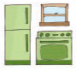  ° | °

Worksheet-1

Where is the cat?

Vocabulary Practice

a.Write the word for each picture.

kitchen cookie house cat jar

1. | 2. | 3. | 4. | 5.
 |  |  | 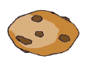
[ ] [ ] [ ] [ ] [ ]

b. Write the correct words.

1. ____ ____ ____ c h ____ ____
2. ____ o u ____ ____
3. j ____ ____
4. ____ o o ____ ____ ____

Worksheet - 3

1. Put the word in the blank.

in jar house cat cookie kitchen

The kitchen is in the ____________.
The cat is in the ____________.
The jar is ____________ the kitchen.
The ____________ is in the jar.
The ____________ is in the ____________!

2. Fill in the blanks. Use each word only once.

cat house jar mouse cookie kitchen
① The candy is in the ____________.
____________.
____________.

② The _____________ is in the kitchen.
_____________
_____________

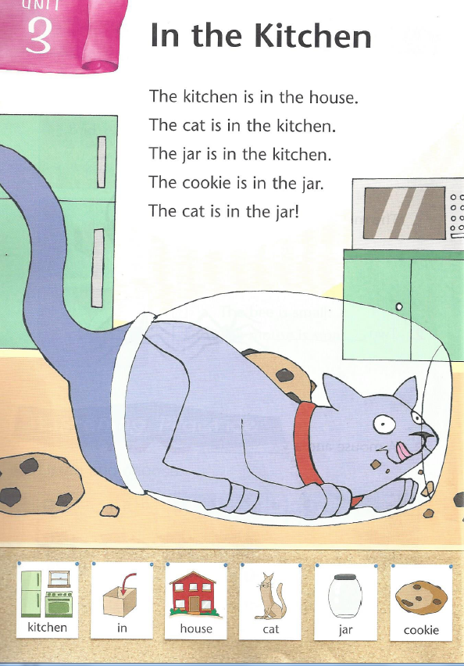
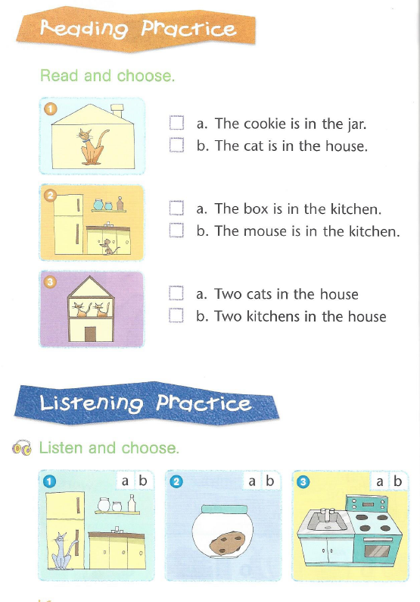

Worksheet-2

