Listening Speaking Reading Grammar Writing

Topic: Traveling

Instructor:  Sang Ji Lee  (Lilly) | Level:  High intermediate | Students:  5 students | Length:  30 Minutes

Materials:
- Picture of traveling people
- White board and board marker
- Powerpoint
- Travel experience worksheet (5copies)
- Discussion worksheet (5copies)
- Simple discussion worksheet (5copies)

Aims:
- Main aim: Ss will be able to improve speaking skills.
- Secondary aim: Ss will be able to improve fluency on the related topic.
- Personal aim: I want Ss to improve their ability to express themselves freely on the related topic.

Language Skills:
- Reading: Ss will skim through the powerpoint.
- Listening: Ss will listen to other’s opinion.
- Speaking: Ss will discuss and share their idea.
- Writing: Ss will take note.

Language Systems:
- Phonology: none
- Lexis: Difference between TRAVEL, TRIP, and JOURNEY
- Function: Question and answer
- Grammar: The usage for verb and noun (travel & trip)
- Discourse: Discussion

Assumptions:
Students already know
- four language skills and language systems
- they should not discourage other students in any way

Anticipated Errors and Solutions:
- Students may need more time to work on the worksheet
- give students little more time to finish it
- If certain students dominates the discussion
- ask them to give other students a chance to speak

References:
https://www.youtube.com/watch?v=8oIAceWWNEU

Lead-In
Materials: None
Time | Set Up | Student Activity | Teacher Talk
3min | Whole class | Answering teacher’s questions | Good morning! How are you today?  What do you usually do on vacation?  What will you do this summer vacation?  Are you planning to go somewhere?

Pre-Activity
Materials: Visual Aid, Board, Board marker, Powerpoint
Time | Set Up | Student Activity | Teacher Talk
3min  5min | Whole class  Groups | Answering teacher’s questions  Solving quiz while watching the powerpoint | Elicit  (Show visual aid on the board)  Look at them.  What are they doing?  Who are they?  Do you like traveling?  How about a day trip?  Do you prefer to go a journey?  What is the longest journey you have ever made?  (Show the students powerpoint.)  Did you notice I have used different words, travel, trip, and journey?  Who can tell us the difference among travel, trip, and journey?  Let’s be sure about them by solving quiz.  Let's divide into groups of two.  (Make groups.)  There is no turn.  Just give the answer as fast as you can, and your team gets point.  There will be sentences with blanks; you need to find out the blank.  ICQ  Is there a turn for answering?  Let’s get it started.  (Show the students the quiz)  (After the students’ answers)  Right!  The word ‘trip’ is a noun, the act of going to another place (often for a short time) and returning.  (Change page of the powerpoint)  (After the students’ answers)  Right!  The word ‘travel’ is a verb, going to another place in general.  (Change page of the powerpoint)  (After the students’ answers)  Right!  The word ‘journey’ is a noun, one part of the travel process, often a long distance.  (Close powerpoint)  Model  (Write the subject ‘Traveling’ on the board)

Main Activity
Materials: Worksheet #1
Time | Set Up | Student Activity | Teacher Talk
5min  5min | Groups  Whole class | Discussing in groups and taking notes | Instructions  (Handout the worksheet)  This time, we will talk about the topics on the worksheet in group.  (Make groups)  Listen to your partner and make simple notes.  And after that, you will introduce them to us.  I’ll give you 5minutes for group talk.  ICQ  Are you working individually?  How much time do you have for group talk?  You may begin.  Monitoring  (Monitor discreetly)  3 minutes left.  1 minute left.  Times up.  (Pick one student)  Would you share your partner’s story to us?  Where was she during the last vacation?  What was her most memorable travel experience?  (Repeat to other students)

Post Activity
Materials: Worksheet #2
Time | Set Up | Student Activity | Teacher Talk
4min  5min | Groups  Whole class | Discussing in groups and taking notes | (Handout the worksheet)  We will discuss about the topics on the worksheet in group.  (Make groups)  I’ll give you 4minutes.  Monitoring  (Monitor discreetly)  3 minutes left.  1 minute left.  Times up.  Where are the best places for historical vacations?  How about for shopping?  What about for party?  Lastly, what about for relaxing?  Do you prefer traveling alone or traveling with a group?  What are the benefits of traveling alone?  Then, what about for traveling with a group?

SOS Activity
Materials: Worksheet #3
Time | Set Up | Student Activity | Teacher Talk
4min | Whole class | Discussing While taking note | (Handout the worksheet)  Do you prefer package tours or making your own trip?  Why do you think so?
- Visual Aid

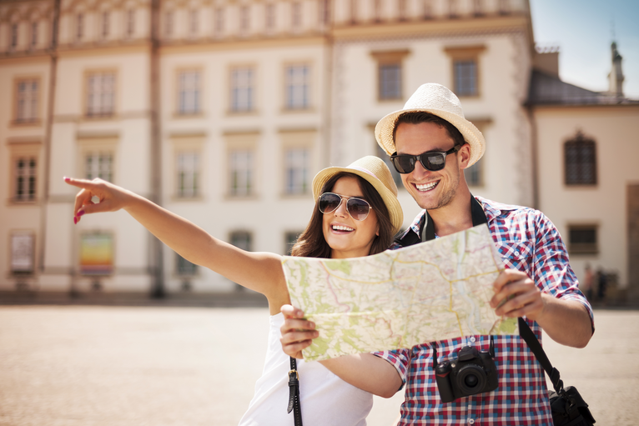
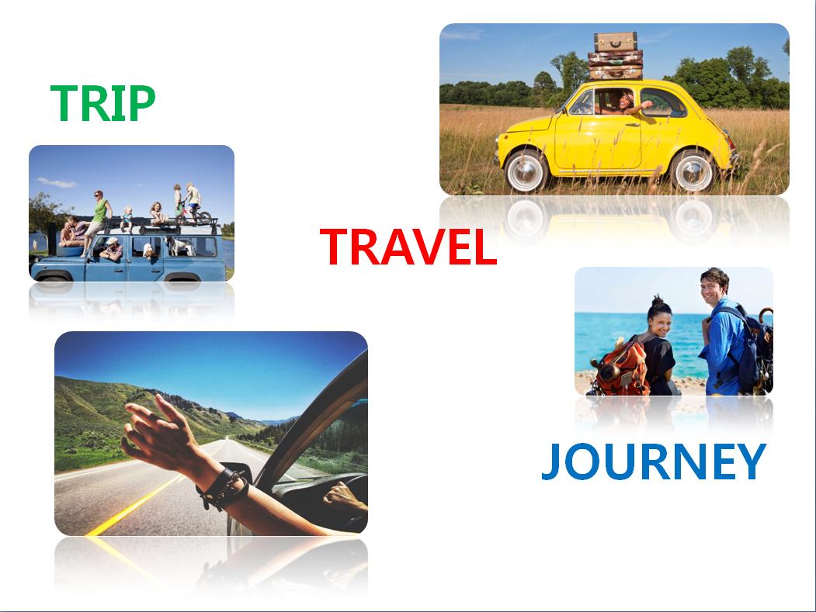
- Powerpoint

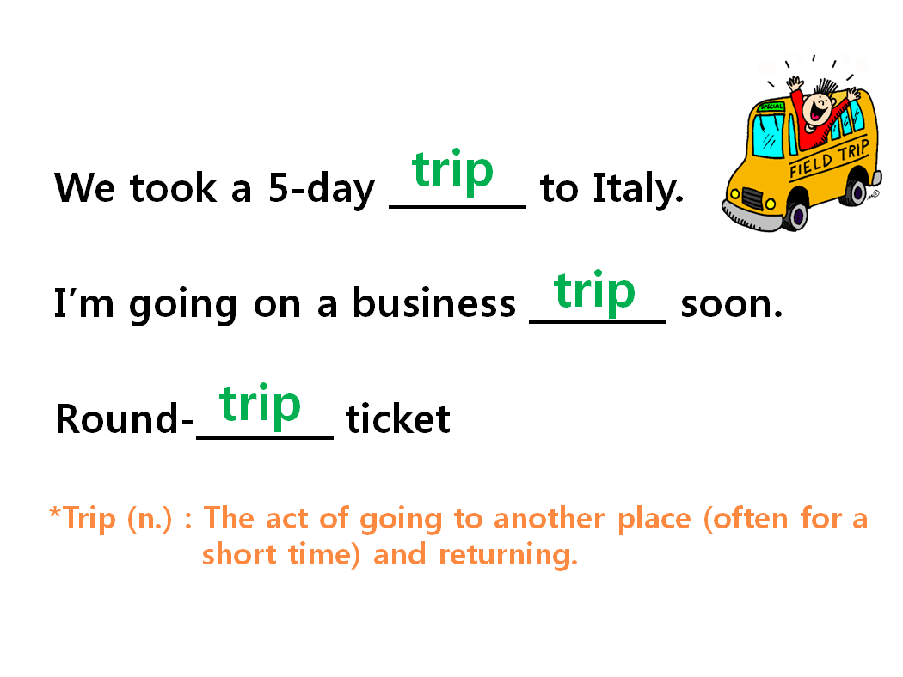

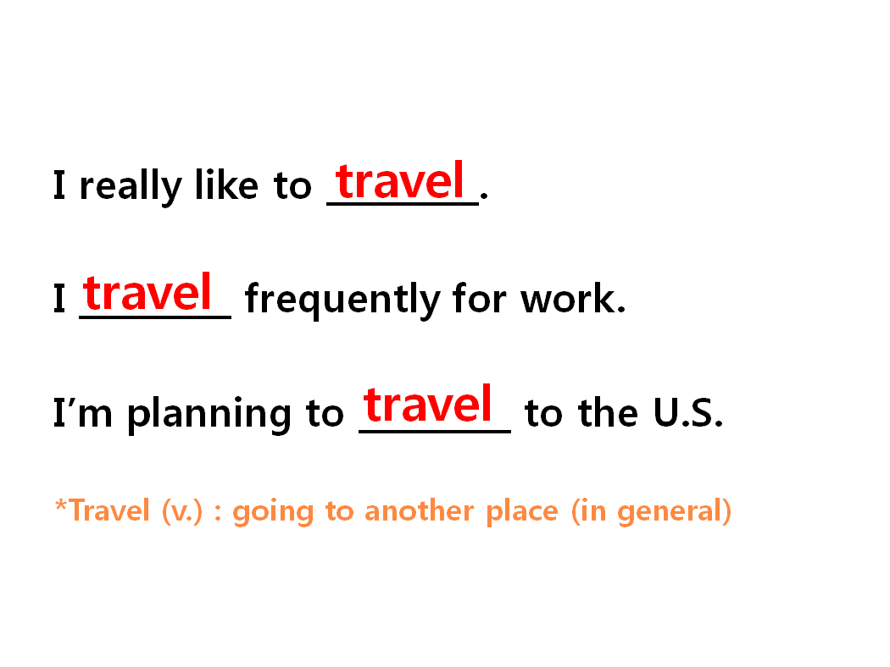

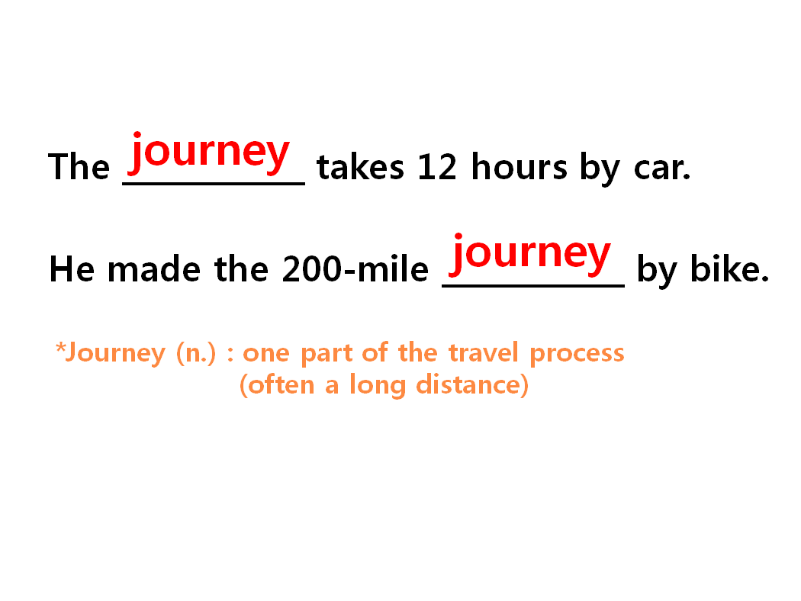

- Worksheet #1
1. Where did you spend your last vacation? What did you do?

2. What is your most memorable travel experience?

- Worksheet #2

1. Where are the best places for…

► Historical vacations?

► Shopping vacations?

► Party vacations?

► Relaxing vacations?

2. What are some of the benefits of…

► traveling alone?

► traveling with a group?
- Worksheet #2

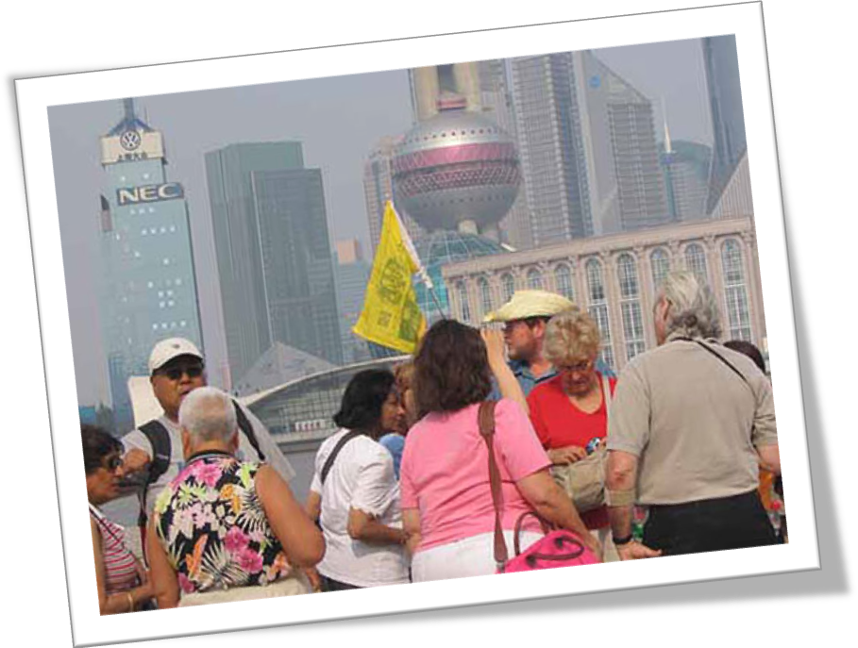

Do you prefer package tours or making your own trip?
What is the reason for?

