XXX Listening Speaking Reading Grammar Writing
Topic: Vacation

Instructor:  Grace | Students Competency Level :  Intermediate | Number of Students:  5 | Lesson Length:  50 minutes
Materials:(List the Names of all materials used in the lesson. Materials must be shown at the end of this document)
- Choose The Place Where Students Want To Go Worksheet
- Only 5 Things You Need To Take Worksheet
- White Board and Markers

Aims:(What students will be able to achieve by participating in the activities of the lesson. (Ss gain or get by doing…)
- Ss can improve speaking skills by talking with their group and answering teacher.
- Ss can introduce the specific place to their friends of family.
- Ss can listen to the teacher and other Ss’ traveling experience.
- Ss can improve interaction and communication skills by having discussion.
- Ss can improve writing skills by writing in a worksheet.

Language Skills:(Lists what activities language skills students will be using by participating in the activities of the lesson.)
- Reading: (Where did reading occur in the lesson?)
worksheets
- Listening:(Where did listening occur in the lesson?)
Teacher talk, discussion, during the others’ introducing
- Speaking: (Where did speaking occur in the lesson?)
Introducing, discussion with a partner
- Writing: (Where did writing occur in the lesson?)
Write in a worksheet

Language Systems: (Lists what language systems students will be using by participating in the activities of the lesson.)
- Phonology: (sound)
Discussion, teacher talk.
- Function:(situation)
Introduction, vacation
- Lexis: (meaning)
Vocabulary about vacation
- Grammar:(language structure)
Be verbs and will (future tense)
- Discourse: (communication)
Discussion, responding the teacher

Assumptions:(What students must already be able to do and what concepts must already be mastered before the lesson in order to achieve the aims of the lesson.)
- All Ss have already gone to a vacation more than once.
- All Ss know the vocabularies about the vacation.
- All Ss have an experience to make trip plan
- All Ss have opinions where they want to go.

Anticipated Errors and Solutions:(What things might go wrong in the lesson and what the solution will be. An SOS activity should also be included)
- If Ss may not have many ideas. ->Solution : T gives them little examples.
- If activity lasts too long ->Solution : T cuts the unnecessary parts.
- If activity finished too soon. ->Solution : T does the other activity with Ss.
- If Ss may not understand ->Solution : T shows demonstration.
- If certain Ss are shy ->Solution : T encourages them, gives positive feedback.

References:
http://blog.naver.com/abc929292/220379639828

Lead-In or Pre-Task Part (Warm-Up Part to activate and create interest in the lesson.)
Materials: (List the Names of all materials used in the Lead-Inor Pre-Task Partof the lesson. Materials must be shown at the end of this document)

Time: | Classroom Set Up: | Student Activity and Goals: | Teacher Procedure &Instructions:
3min  3min | Whole  Whole | Greeting  Ss listen to teacher and answer. | Hello, everyone~ good morning!  How was your weekend?  Question  If you have a free time for a week  What would you do?

Pre-Activity or Task Familiarization Part (Presentation PartPresenting the language structure to be covered in the lesson. Prepares students for the communication activity.)
Materials: (List the Names of all materials used in the Pre-Activity or Task Familiarization Part of the lesson. Materials must be shown at the end of this document)
- Choose The Place Where Students Want To Go Worksheet
- White Board and Markers

Time: | Classroom Set Up: | Student Activity and Goals: | Teacher Procedure &Instructions:
1min  4min | Whole  Whole | Listening  Listening and Answering | If I have a time for a week I will go for a vacation and I want to see many beautiful places.  Question  Do you like to go vacation?  When is your memorable vacation?  Can you tell us?

Main Activity or Task Realization Part(Practice to Production PartTeacher lead practice of the language presented and move to communication based more student centered activity)
Materials: (List the Names of all materials used in the Main Activity or Task Realization Partof the lesson. Materials must be shown at the end of this document)
- Choose The Place Where Students Want To Go Worksheet
- White Board and Markers

Time: | Classroom Set Up: | Student Activity and Goals: | Teacher Procedure &Instructions:
2min  5min  1min  10min  9min | Whole  Individual  Whole  Individual  Whole | Listening  Think about where they want to go and write the feature of that.  Listening  Make their own poster of the place  Introduce their vacation to other students. | I’ll give you a paper. (Worksheet 1)  First of all, choose a place where you want to go for a vacation and write the characteristic of the place in the paper.  (Give out Choose The Place Where Students Want To Go Worksheet to students.) I’ll give you 5 minutes.  (Monitor students.)  Ok. Time’s up!  From now, You are going to make a poster of the place with the features.  You can make a poster in the back of the paper.  I’ll give you 10 minutes.  Let’s get started!  Now, it’s time to introduce your vacation with your poster.  For example, in case of me,  I recommend Hawaii.  This place is famous for beautiful beach.  So, it’s very romantic place. If you like to take a picture, It’s very good place. Also, there are many delicious food, you can experience to eat a variety of food.  (Each of students introduces their own vacation.)

Post Activity or Post Task Part (Wrap-Up Part Close the Lesson on a high note to and consolidate language learned in a communication based activity new situation.)
Materials: (List the Names of all materials used in the Post Activity or Post Task Part of the lesson. Materials must be shown at the end of this document)
Only 5 Things You Need To Take Worksheet
Time: | Classroom Set Up: | Student Activity and Goals: | Teacher Procedure Instructions:
2min  5min  4min  1min | Whole  In pairs  Whole  Whole | Listening  Discuss  Ss do activity. One group at a time other group watches listens and enjoys.  Listening and Answering | (Give out Only 5 Things You Need To Take Worksheet)  To go for vacation,  We need some things.  In the paper, there are several stuffs.  But, you can choose only 5.  Discuss with your partner and tell us why you choose those.  (Monitor students)  (Give Ss positive feedback, and comments. Facilitates class members’ feedback.)  How was your class?  I hope you enjoyed the class.

Choose The Place Where Students Want To Go Worksheet
I want to go to ___________________________ for my vacation, because ________________________________________________________________________________________________________________________________________________________________________________________________________________________________________________________________________________________________________________________.
Delicious foods / Beautiful sightseeing / historical place / funny activities / famous place/etc.

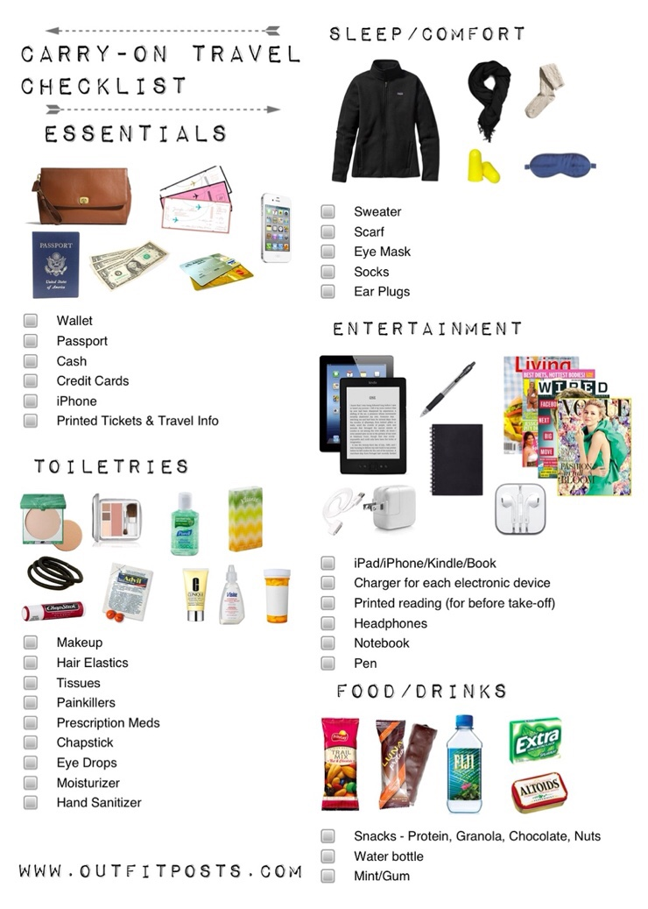
Only 5 Things You Need To Take Worksheet

