Listening XX Speaking Reading Grammar Writing
Topic: Finding A Way
Instructor:  Olivia |  | Students Competency Level  Pre-intermediate |  |  | Number of Students:  8 |  |  | Lesson Length:  55 minutes
Materials: (List the Names of all materials used in the lesson. Materials must be shown at the end of this document)
Role Play Maps
Notice the Way Map
Find the Way Map
Teachers Demonstration Map
Aims: (What students will be able to achieve by participating in the activities of the lesson. (Ss gain or get by doing…)
- Ss can feel accomplishment by finding a way where they are going to reach.
- Ss can improve their English speaking skills and speak more fluently, by discussing how they have to find a way
- Ss can learn about interaction with other students and feel comfortable each other by listening to expressions which will be used to find a way.

Language Skills: (Lists what activities language skills students will be using by participating in the activities of the lesson.)
- Reading: (Where did reading occur in the lesson?)
Role Play Map
- Listening: (Where did listening occur in the lesson?)
Students discussion, teacher explanation, role play
- Speaking: (Where did speaking occur in the lesson?)
Finding a way, explanation by students, Feedback
- Writing: (Where did writing occur in the lesson?)
Taking notes and preparing for role play
Language Systems: (Lists what language systems students will be using by participating in the activities of the lesson.)
- Phonology: (sound)
Map explaining, teacher feedback, instruct direction
- Function: (situation)
Question, explanation, kindly answer
- Lexis: (meaning)
words about asking direction and destination
- Grammar: (language structure)
be exact and formal
- Discourse: (communication)
role play, share question and answer, modification of teacher
Assumptions: (What students must already be able to do and what concepts must already be mastered before the lesson in order to achieve the aims of the lesson.)
- All students understand how to read the map and will know about explaining direction
- All students already know the words used to discuss.
- All students should be familiar the map which teacher will give so that they can explain well.
- All students must know about words which indicate place
Anticipated Errors and Solutions: (What things might go wrong in the lesson and what the solution will be. An SOS activity should also be included)
- When they don’t know how to explain by English, they probably use Korean.
- Body language also can be used when they don’t know what to say
- Teacher should lead them to use right expression, but do not help them everything.
- If Ss are wrong, give positive reaction so that they can solve their problem by themselves
References:

Lead-In or Pre-Task Part (Warm-Up Part to activate and create interest in the lesson.)
Materials: (List the Names of all materials used in the Lead-In or Pre-Task Part of the lesson. Materials must be shown at the end of this document)

Time: | Classroom Set Up: |  | Student Activity and Goals: | Teacher Procedure & Instructions:
1 min  7 min  7 min | Whole  Whole  Ss |  | Ss greet the teacher.  Ss listen to teacher.  Ss talk their stories. | Greeting teacher  Tell teacher's difficult experience during travel somewhere.  Let's discuss about stories with Ss  Let’s do a role play about Finding a way
Pre-Activity or Task Familiarization Part (Presentation Part Presenting the language structure to be covered in the lesson. Prepares students for the communication activity.)
Materials: (List the Names of all materials used in the Pre-Activity or Task Familiarization Part of the lesson. Materials must be shown at the end of this document)
Role Play Maps
Notice the Way Map
Find the Way Map
Time: | Classroom Set Up: |  | Student Activity and Goals: |  |  | Teacher Procedure & Instructions:
4 min  1 min  4 min  5 min | Whole  Group  Group  Whole |  | Ss listen How to do T.  Ss make a group  Ss read Map and divide with partner.  Ss prepare for role plays |  |  | Introduce the role play and explain by teacher demonstrate.  Make four groups of two people each.  T give the role play maps.  Ask Ss to prepare for Role play. T will help and facilitates.
Main Activity or Task Realization Part (Practice to Production Part Teacher lead practice of the language presented and move to communication based more student centered activity)
Materials: (List the Names of all materials used in the Main Activity or Task Realization Part of the lesson. Materials must be shown at the end of this document)
Role Play Maps
Notice the Way Map
Find the Way Map
Time: | Classroom Set Up: |  | Student Activity and Goals: |  |  | Teacher Procedure & Instructions:
1 min  7 min  5 min | Whole  Groups  Whole |  | Ss get ready for role play.  Ss do activity. Ss watch listens and enjoys.  Ss listen what T says. |  |  | T gives role play map and enjoys role play and start role play.  T monitors role playing. T watches each groups and facilitates class to role play.  Give Ss positive feedback and comments.
Post Activity or Post Task Part (Wrap-Up Part Close the Lesson on a high note to and consolidate language learned in a communication based activity new situation.)
Materials: (List the Names of all materials used in the Post Activity or Post Task Part of the lesson. Materials must be shown at the end of this document)
Teacher Demonstration Map
Time: | Classroom Set Up: |  | Student Activity and Goals: |  |  |  | Teacher Procedure Instructions:
4 min  4min  4min | Whole  Whole  Whole |  | Ss discuss activity with T and listen to T.  Ss prepare a Map.  To their home Ss present their map and give directions to their home. |  |  |  | T discusses second activity about draw Rough map, introduce how to reach your home and demonstrate.  Give Ss time to prepare a map to their home. Ask Ss to present their Map and give directions to them.  Close by giving Ss feedback about their improvement. Check Ss Listening and Speaking skills.

Notice the Way Map
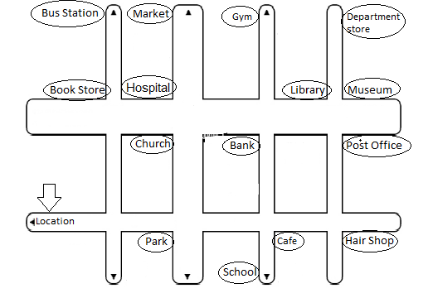

1. Students work in pairs.
2. One student plays a pedestrian who just got lost and the other plays a hero who is to save the pedestrian by explaining the right direction.
3. The student cast as pedestrian chooses a place he/she wishes to be regardless of the numbers.
4. Exchange the roles with the partner and do it again

Find the Way Map
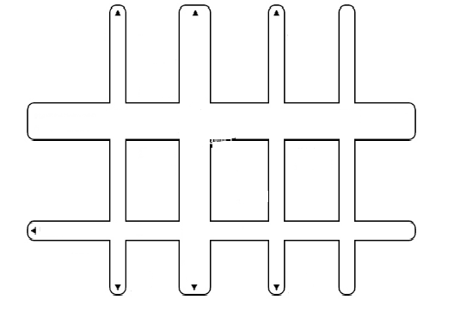
1. Bus Statin 2. Market 3. Gym 4. Library 5. Museum
6. Department store 7. Book Store 8. Hospital 9. Church 10.Bank
11. Post Office 12. Park 13. School 14. Café 15. Hair Shop

1. Students work in pairs.
2. One student plays a pedestrian who just got lost and the other plays a hero who is to save the pedestrian by explaining the right direction.
3. The student cast as pedestrian chooses a place he/she wishes to be regardless of the numbers.
4. Exchange the roles with the partner and do it again

Teacher’s Demonstration Map

