Listening Speaking x Reading Grammar Writing
Topic: To Save The Earth

Instructor:  Kimberly | Students Competency Level  Intermediate | Number of Students:  6 | Lesson Length:  60minutes
Materials:(List the Names of all materials used in the lesson. Materials must be shown at the end of this document)
- White Board and Markers,
- “Our Earth Can Get Dirty, Why?” Work Sheet
- “A Better Earth” Reading Work Sheet
- After Reading Work Sheet
- Discussion Work Sheet
- Pieces of paper and color pencils

Aims:(What students will be able to achieve by participating in the activities of the lesson. (Ss gain or get by doing…)
- Improve speaking skills discussing groups and answering teacher and talking about the slogan.
- Improve listening skills by listening to T introduction, questions and listening to other Students’ statement during group discussion, ICQ-CCQs.
- Improve writing skills by writing during discussion and making a slogan.
- Improve reading skills by reading the work sheet and making a slogan.

Language Skills:(Lists what activities language skills students will be using by participating in the activities of the lesson.)
- Reading: (Where did reading occur in the lesson?)
Text and Worksheets, slogan

- Listening: (Where did listening occur in the lesson?)
Teacher instruction and explanation, discussion, slogan

- Speaking: (Where did speaking occur in the lesson?)
Answering Teacher’s question and discussion in group, slogan

- Writing: (Where did writing occur in the lesson?)
Writing work sheet of pre activity and post activity work sheet, slogan

Language Systems: (Lists what language systems students will be using by participating in the activities of the lesson.)
- Phonology: (sound)
Discussion, teacher talk, Students’ talk
- Function:(situation)
Discussion in group, making a slogan
- Lexis: (meaning)
Vocabulary
- Grammar:(language structure)
Present tense
- Discourse: (communication)
Discussion, responding the teacher

Assumptions:(What students must already be able to do and what concepts must already be mastered before the lesson in order to achieve the aims of the lesson.)
- All students should have an idea to save the earth.
- All students know about the recycling.
- All students enjoy completing their own work sheets.
- All students enjoy discussion and sharing their opinions and making a slogan.

Anticipated Errors and Solutions:(What things might go wrong in the lesson and what the solution will be. An SOS activity should also be included)
- If students may not have many ideas → Solution: Teacher gives them little examples.
- If activity lasts too long → Solution: T cuts the unnecessary parts.
- If activity finished too soon → Solution: Teacher makes suggestion and shares ideas.

References:

Lead-In or Pre-Task Part (Warm-Up Part to activate and create interest in the lesson.)
Materials: (List the Names of all materials used in the Lead-In or Pre-Task Part of the lesson. Materials must be shown at the end of this document)

None

Time: | Classroom Set Up: | Student Activity and Goals: | Teacher Procedure &Instructions:
1min  3min  3mins | Whole  Whole  Whole | Students greet the teacher.  Students listen to teacher.  Students talk about their story | Greeting  Tell teacher’s stories about the experience with polluted air in interesting gesture.  Elicit the stories from students.  Let’s talk about “Our Earth Can Get Dirty, Why?

Pre-Activity or Task Familiarization Part (Presentation Part Presenting the language structure to be covered in the lesson. Prepares students for the communication activity.)
Materials: (List the Names of all materials used in the Pre-Activity or Task Familiarization Part of the lesson. Materials must be shown at the end of this document)

- “Our Earth Can Get Dirty, Why?” Work Sheet

Time: | Classroom Set Up: | Student Activity and Goals: | Teacher Procedure &Instructions:
1min  2min  10min | Whole  Group  Group | Students move into a group.  Each group receives the worksheet and start.  Students read and complete the worksheet in group and share their ideas with other students. | Introduce the activity.  Teacher asks students to make a group.  Ask students to read and complete the worksheet in group.  Teacher monitors group work and encourage them about their ideas. Teacher asks student to share their ideas and give them feedback.  Let’s read a reading text to find out how we can help the earth.

Main Activity or Task Realization Part(Practice to Production Part Teacher lead practice of the language presented and move to communication based more student centered activity)
Materials: (List the Names of all materials used in the Main Activity or Task Realization Partof the lesson. Materials must be shown at the end of this document)
- White Board and Markers,
- “A Better Earth” Reading Work Sheet
- After Reading Work Sheet
- Discussion Work Sheet

Time: | Classroom Set Up: | Student Activity and Goals: | Teacher Procedure &Instructions:
5min  4min  3min  1min  10min  5min | Whole  Whole  Whole  Group  Group  Group | Listen to Teacher. Receive the text and read it.  Students share their thought with other students about text.  Students get the work sheet and start to work out. Students answer the question.  Students move into group and receive the discussion worksheet.  Students share their thoughts with their group students and make a list.  Students share their list with other groups. | Teacher tells introduce the topic of the text and hand it out the students and gives some time to read the text.  Teacher asks students to share their thought about the text and facilitate the classroom discussion and feedback.  Teacher hands out the worksheet and ask students to start to fill out and monitors.  Teacher goes over the worksheet with students after students finish the worksheet.  Teacher asks students to make groups and hand out the discussion worksheet and ask students to share their thought and make a list.  Teacher observes students and facilitates class.  Teacher asks students to share their list with other groups and encourage them and give them feedback.  Let’s make a slogan about the topic.

Post Activity or Post Task Part (Wrap-Up Part Close the Lesson on a high note to and consolidate language learned in a communication based activity new situation.)
Materials: (List the Names of all materials used in the Post Activity or Post Task Part of the lesson. Materials must be shown at the end of this document)

Time: | Classroom Set Up: | Student Activity and Goals: | Teacher Procedure Instructions:
1min  10min  1min | Group  Group  Whole | Students listen and start making a slogan.  Students present their slogan together in group. | Teacher shows the slogan teacher made first and then asks students to make a slogan and give students some time to do.  Teacher asks students to present their slogan together. Teacher encourages the students to facilitate the class and give them feedback.  Close by giving student feedback about their accomplishment and participation.

Before Reading Work Sheet

Question: Our Earth Can Get Dirty, Why?

Talk to your partner and write down the list.
1)_________________________________________________________________________________
2)_________________________________________________________________________________
3)_________________________________________________________________________________
4)_________________________________________________________________________________
5)_________________________________________________________________________________
6)_________________________________________________________________________________
7)_________________________________________________________________________________
9)_________________________________________________________________________________
10)_______________________________________________________________________________

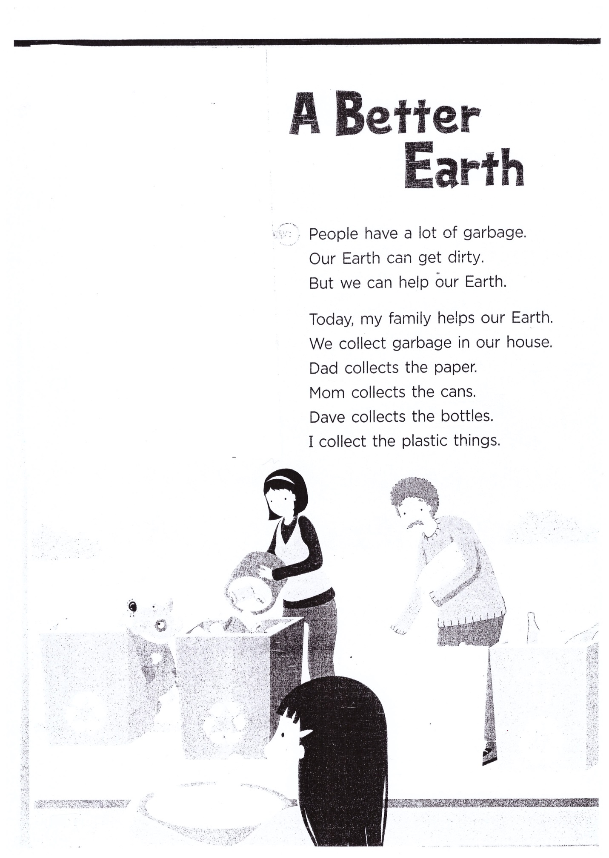

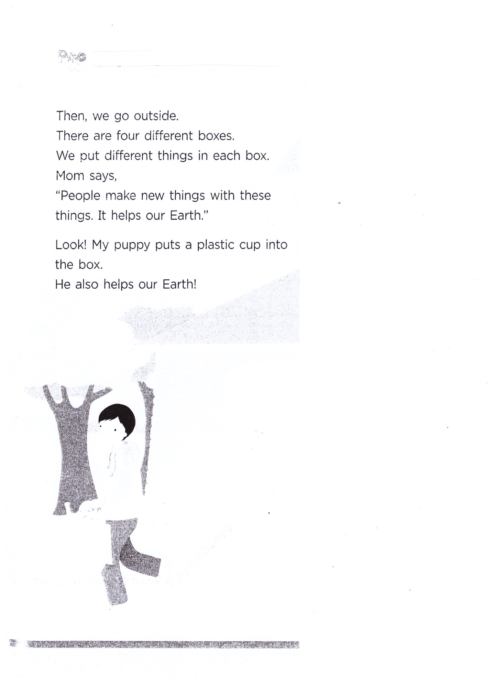

After Readking Work Sheet
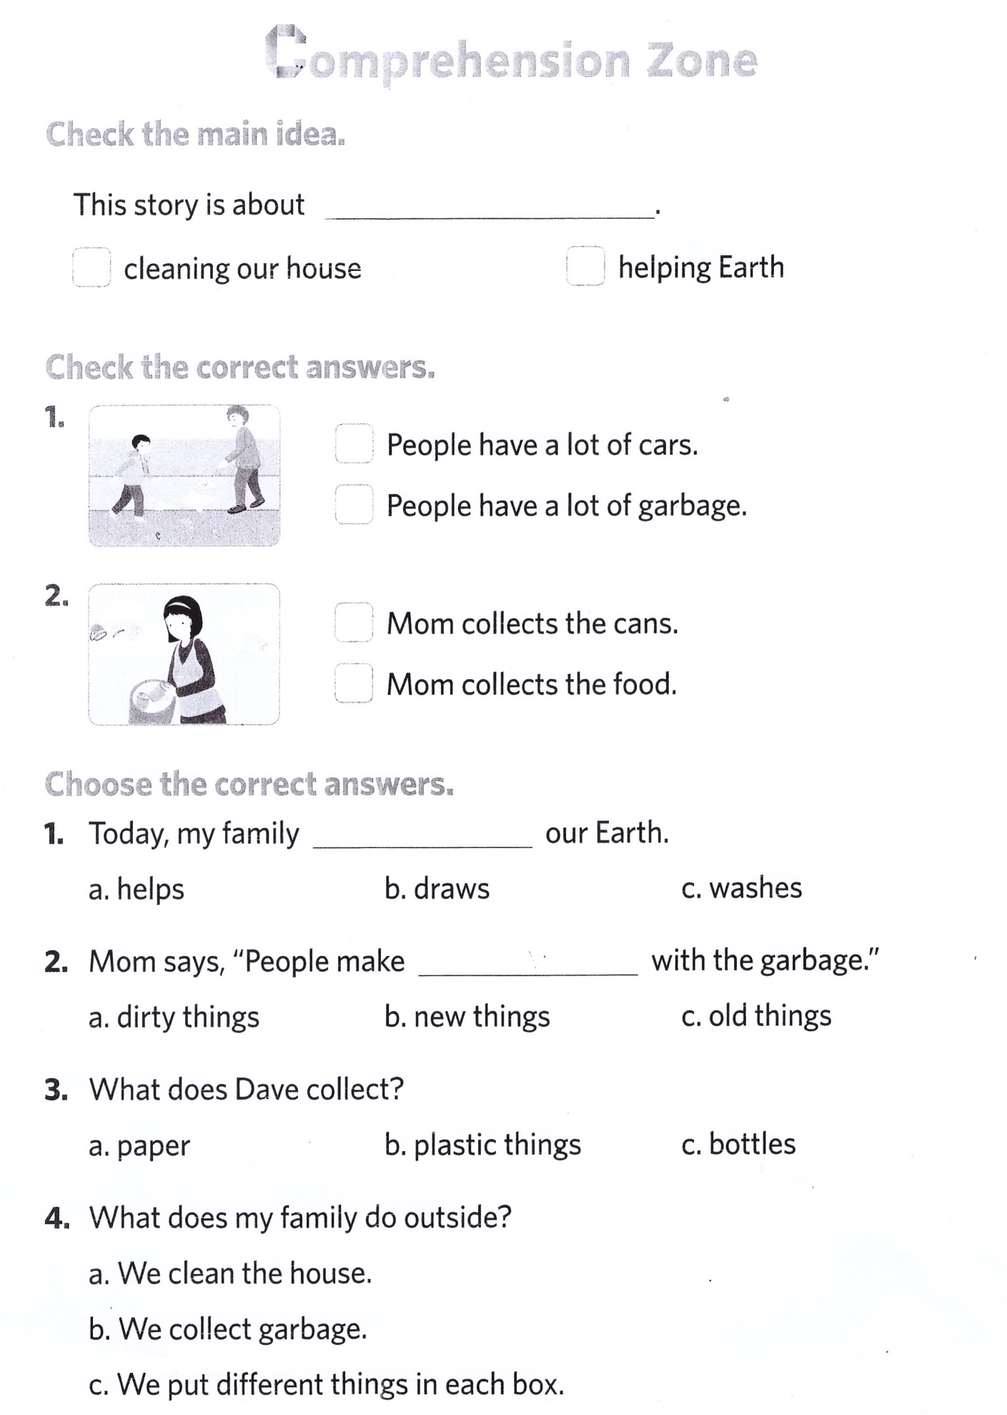
Discussion Work Sheet
What can you do to save the Earth in your daily life?
1)________________________________________________________________________________________

2)________________________________________________________________________________________

3)________________________________________________________________________________________

4)________________________________________________________________________________________

5)________________________________________________________________________________________

6)________________________________________________________________________________________

7)________________________________________________________________________________________

8)________________________________________________________________________________________

9)________________________________________________________________________________________

10)______________________________________________________________________________________

