Listening Speaking Reading Grammar Writing
Topic: I‘d like to return these!

Instructor:  Eun | Level:  Intermediate(Adults) | Students:  5Students | Length:  30 Minutes

Materials:
- Flash cards, white board/ marker and survey about stressful situation -pre activity
- Pick paper for role play –main activity
- White board and marker for writing relaxation tips –post activity
- A4 paper for drawing picture about today your emotion -SOS activity

Aims:
- Main aim: Ss will be able to share their stressful experience and give suggestions to their classmates.
- Secondary aim: Ss will be able to know what makes them stress out.
- Personal aim: I want Ss should know when you feel stressful, you should use some tips for your feeling.

Language Skills:
- Reading: Ss will read on the board about stressful moments word..
- Listening: Ss will listen to their opninons in discussion and role-play
- Writing: Ss will write a list of tips for relaxation with a partner.
- Speaking: Ss speak during role-play, pair work and Ss work together to brainstorm vocab.

Language Systems:
- Phonology: st (stress), f/p (stressful)
- Lexis: New vocabulary (stress, stressful, stress-free/ relay, relaxation)
- Grammar: if I were you ~, I would~ / when I ~ , I am ~.
- Function: asking for partner opinions, giving suggestion(how to relax about stressful moments)
- Discourse: responding the teacher, discuss about activity and share opinions

Assumptions:
- Ss already know that what makes them stressful moments.
- How the class is set up (3 Ss at each desk)
- Ss already know their own relaxation about stressful.

Anticipated Problems and Solutions
- If students don’t have enough suggestion about relaxation in moments.
- Share the tips with a pair. T should give some examples.
- If students don’t listen how can the worksheet or act role-play
- T should explain to students in minute detail.

References:
https://www.healthstatus.com/health_blog/depression-stress-anxiety/top-5-stressful-situations
→ T should tell to Ss about stressful situation.
https://www.google.co.kr/search?q=stressful+moments&rlz=1C1CAFB_enKR614KR628&espv=2&biw=1086&bih=931&source=lnms&tbm=isch&sa=X&ved=0ahUKEwizzM_Nlu7NAhXFX5QKHXDfCs0Q_AUIBigB#imgrc=pPSqyZdINmyuGM%3A
→ flash cards

worksheet
http://www.cdc.gov/diabetes/ndep/pdfs/stressful-situation-activity-nb-guide.pdf
→survey about stressful situation –pre activity

Lead-In
Materials:

Time | Set Up | Student Activity | Teacher Talk
1min | Whole  class | Listening/Answering Teacher’s questions. | “Good morning everyone!”  “How are you today?”  “Have you ever felt stressful?”  (student answer)  “Do you have your own relaxation tips about stressful moments?”  (student answer)  “Thank you, now let’s start our speaking ”.

Pre-Activity
Materials:
Flash cards
Worksheet ( stressful moments in survey)
White board and marker ( Ss will write about their moments just simple word)
Time | Set Up |  | Student Activity | Teacher Talk
1min  2min  2min | Whole  Class  Individually  In pair |  | Listening ,  Guessing  and answering  Writing and listening  Listening and writing | Elicit  Show students flash cards (appendix1)  “look at these cards!.”  “Do you come up with something?”  “What do you think when you see these cards?”  (wait for Ss responses)  “Yes, they are very stressful from something.”  Instruction  “I am going to give worksheet of survey.”  Give survey to Ss (appendix2)  ”Think of what has happened to you in the past year as you read through the following list of life activities.”   “ In the right hand column, jot down the point values for events that apply to you; then add up your score. “  “The guidelines for interpreting the total score are at the end.”  “You can fill it for 2min individually!  “What is your score?”  (wait for Ss responses)  “if your total is under 150, you won’t have any problems”  “score or 150-199 indicates a mid problem”  :from 200-299 it is moderate problem, chance of experiencing a change your health”  ICQ  -How long can you work for it?  -is it enough to fill out?  Checking answers  “Time’s up.  “Great job everyone! Do you have a question about this activity?  Instruction  “Nice guys, now we are going to write your own stressful moments on the board”  “J teams and anabel and Christy teams”  “What makes you feel stressful and when?”  “Just write simple word on the board”  “I will give in 1min for thinking”  “Now, each teams write teams opinions”  “Wow guys! Many things make our stress out right?”  Check answers  “Wow too many stressful moments in our class”  “That is great! “  “Well, everybody great job  Model  “Today, we are going to talk about when you feel stressful, and share relaxation tips.”  CCQ  “When did you feel stress out?”  “When you were student, did you take exam?”  “How was your feeling?”  (wait for Ss responses)
Main Activity
Materials:
Ss choose Paper cards for role play.

Time |  | Set Up | Student Activity |  | Teacher Talk
1min  3min  10min  1min |  | Whole  Group  In pair  In pair  Whole group | Listening  Listening and think about how to act role play  Role-play  Listening, answering |  | “Now, we are going to do role play activity!”  Instruction  “I make a two situation , and guys pick a paper cards randomly.”  (Ss will choose cards randomly)  “Now you choose your own role play position”  “Team 1 is mid-term”  “Team 2 is have a presentation”  -Ss pick their paper cards  “In this situation, team 1 has very important mid-term exam so stressed person feel stress and nervous from the exam but the other relaxed person give some relaxation tips for stressful person”  “Another situation, team2 has a presentation in front of many students, so presentation person feel very nervous and stressful therefore, the other person give your own tips and say anything for presentation person”  “Guys! hope act actress”  -if Ss don’t know how to say to stressful person, T should say some tips  Ex:” if you have presentation, you should hold something”  “I will give 3min to ready for the role play”  ICQ  -How much time do you have?  -What should you do?  -Is it enough time to prepare?  “Okay, Are you ready?  “I will give 5min to each team to act role play”  “Let’s get it start”  ICQ  -What did you do in role play?  -How much time can you have?  -Are you working with your partner?  Monitoring  Teacher monitors how do Ss good act to role play  Time warning;  “Time’s up team 1”  “time’s up team 2”  Checking answers  “Wow guys are awesome to act role play”  “How was your role play?”  “Are you enjoy your role play ?”  “Thank you everyone for the role-plays! Hope you learned a lot and enjoy it!”

Post Activity
Materials:
White board and marker
Time | Set Up | Student Activity |  | Teacher Talk
1min  2min  1m  in  1min | In pair  In pair  In pair  Whole group |  | Guess and listening  Thinking  Writing and listening  Listening | [T give blank a4 paper to each team ]  “Guess! What are we going to do?”  (Just guessing and carouse their curiosity)  Instruction  “I give a blank paper each team. right?  Two teams compete to write down as many unique relaxation tips as possible when you are stressful”  “if one team write same tips on the board, that team lost one point so, please too fast write your teams opinion”  “Now you should think about it in 2min!”  “Now two teams write your team’s opinions on the board”  Ex) ”Oh! Team 1 writes same tips on the board, so lost your point too sad! But don’t worry you can do it!”  “Times up guys”  “Wow guys! Great work to do it!”  Monitoring  Teacher monitors if each teams are writing same word and catch it. And, if they don’t catch same word by themselves, T should let them know.  ICQ  -How many tips are there?  -Is your team wrote same tips compare to other team?  Conclude lesson(TTT)  “Today when you feel stressful from any situation, we learned how to relax your feeling and know some tips, as well as we will tell suggestion for your friends by doing activity”.  Feedback(TTT)  “Stressful moments situations very common and also relaxation tips are useful”.  So I hope you will not afraid in this situation, and don’t forget some tips and tell when your friends feel stress out”  “OK, great job! See you next time! Hope you are feel happy overcome feel stress out!”
SOS Activities
Materials: blank a4 paper.
Time | Set Up |  | Student Activity | Teacher Talk
3min  2min | Individually  Whole group |  | Drawing picture  Check answer | Instruction  (Appendix1)  Now, we are going to draw picture!  About what drawing?  (wait Ss respond)  Drawing about your today emotion! I don’t care how to draw and don’t have a rules.  Drawing the pictures in 3min!  ICQ  What are we going to do?

Appendix1

(Appendix1)
What’s your score on the stress test?
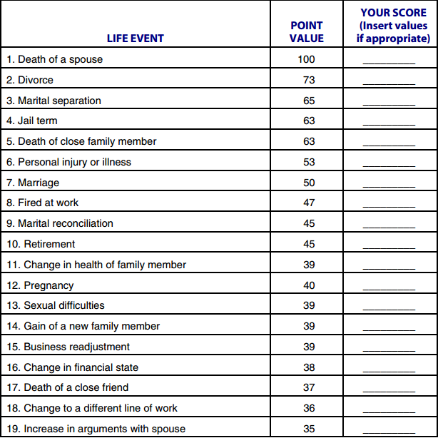

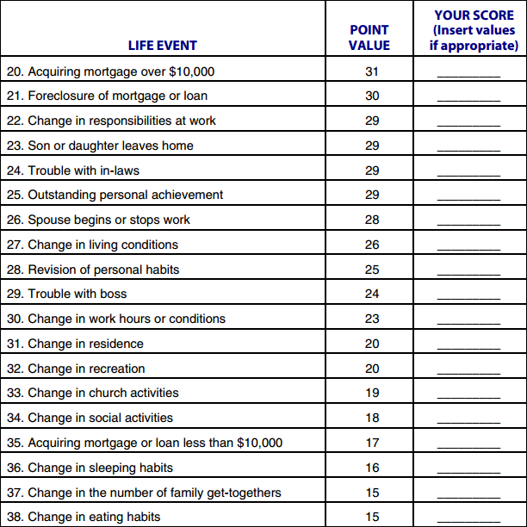

(Appendix2)

