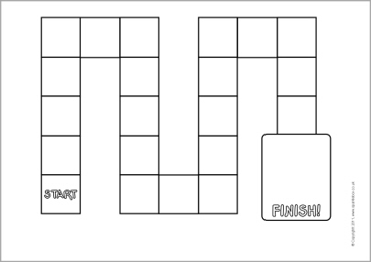 **BOARD GAME**

**GOto make GO back 1**

**Q&sentence**

**Make**

**Q&sentence**

**Go ahead2**

**I GET COFFEE**

**Go back 2**

**Board game cards**

|  |  |  |  |
| --- | --- | --- | --- |
| **cappuccino.jpg** | **caramel coffee.JPG** | **dunkin.png** | **EDIya.jpg** |
| **coppuccino** | **Cramel coffee** | **Cramel coffee** | **Americano** |
| **f.png** | **coffees.jpg** | **coffee.jpg** | **esopresso.jpg** |
| **Americano(grande)** | **3 coffees** | **Kanu coffee** | **Espresso** |

**Board game cards**

|  |  |  |  |
| --- | --- | --- | --- |
| **large coffe.png** | **Mc coffee.jpg** | **Mocha coffee.jpg** | **다운로드.jpg** |
| **Caffee latte** | **Americano** | **Mocha Coffee** | **Miss a turn** |
| **icedespresso.png** | **348s.jpg** | **다운로드 (1).jpg** | **제목 없음.png** |
| **Esopresso** | **Americano** | **Greentea latte** | **Instant Coffee** |