◘ Listening ☐ Speaking ☐ Reading ☐ Grammar ☐ Writing

Title: Where am I?

Instructor:  Joanne Lee  (Ji Weon) | Level:  Intermediate  (Middle School) | Students:  12 students | Length:  30 Minutes

Materials:
- Realia: the real map
- Power Point
- Expressions and Prepositions work sheets for (12 copies)
- Fill in the blanks worksheet (12 copies)
- Scripts for audio file (12 copies)
- Computer for audio file
- An eye patch

Aims:
- Students will be able to improve their listening skills and use expressions in a real situation.
- Students will be able to find the right direction of a map by listening.
- Students will be able to understand the scripts.

Language Skills:
- Writing: Students will fill in the blank of the script.
- Reading: Students will read the script.
- Listening: Students will listen the audio file
- Speaking: Students will practice speaking with pairs.

Language Systems:
- Phonology: /l/, /r/
- Lexis: New vocabularies (prepositions)
- Grammar: Wh-question
- Function: To find the direction
- Discourse: Conversation

Assumptions:
- Students have seen the map.
- Students already know how the class is set up and run. (2 pairs)
- Students can speak and write in English but not very accurately.
- Students already know the basic vocabulary. (Hospital, Post office, Theater)

Anticipated Errors and Solutions:
- If students need linguistic help to express their opinions during discussion.
→ give some examples and explains the sentences.
- If students don’t participate in the activity
→ find out the problem and solve it (give motivation to do the activity).
- If students need problems to follow the activity
→ make students help each other first then give advice.

References:
① Map
http://bit.ly/29WGimP
② Job Images
http://bit.ly/2a1FVTt
③ Direction
http://bit.ly/2an8226
④ Preposition
http://bit.ly/2aqrhcf

Lead-In
Materials: Map
Time | Set Up | Student Activity | Teacher Talk
3 min | Whole  class | 〮 Answering teacher’s questions | 〮 Hello Everyone. I am Joanne teacher.  〮 How are you today?  CCQ  〮 Have you guys seen this picture(Map)before?  (Ss answer : Yes or no!)  〮 Do you guys know what it is called?  (Ss answer: “Map”)  〮 What can you see in the map?  (Ss answer: bank, school, station…)  〮 Good job everyone!  〮 Today, we are going to learn how to find a direction.  〮 Let’s start the class.

Pre-activity
Materials: Power Point
Time | Set Up | Student Activity | Teacher Talk
10min | Whole class | 〮 Answering teacher’s questions  〮 Reminding the last lesson  〮 Learning new expressions  〮 Listening and repeating.  〮 Learning the prepositions | ① Brainstorming  Elicit  (T shows the Visual aid-picture on PPT)  〮 Before we start, here is pop-quiz based on what we learned last class.  〮 There are many people in the picture.  〮 Do you think what kind of people are they? And Where do they work?  - Hair salon – Hair dresser  - Bakery – Baker  - Hospital - Doctor  - Department store – Clerk  - Bank – Banker  〮 Good job everyone.  〮 Let’s move on  (Distribute the worksheet)  Expressions  〮 All right. Now, we are going to learn some new expressions and prepositions.  〮 Everyone look at the screen please.  〮 Can you read out loud?  (Ss answer: turn right, go past, cross)  〮 Everyone listen first and repeat after me.  〮 Be careful between L & R sound.  (Listen and repeat)  Prepositions  (T shows the Visual aid-picture on PPT)  〮 Do you guys guess what the preposition is?  〮 Preposition is showing where the object is placed.  (Listen and repeat the prepositions)  ICQ  〮 What is it?  (T point out the screen and ask question to student)  - Turn right, Turn left….  〮 Is David(S’s name) in front of Amy(S’s name)?

Main Activity
Materials: Audio file, work sheet #2
Time | Set Up | Student Activity | Teacher Talk
2 min  5 min  5 min | Whole  Class  Whole  Class  Whole  Class | 〮 Listening the teacher’s instruction  〮 Listening the audio file and filling in the blank  〮 Checking the answer together and reading. | 〮 Now, we are listening the audio file. You will hear twice. At the first time, you just listen to the audio. Then, you will fill in the blank.  If you can’t fill in the blank, it is okay. We can match it together later. Do you have any questions?  〮 Okay. Are you guys ready?  ( Listening to audio file)  〮 Okay guys. Do you guys all finish?  〮 Let’s check the answer.  (Check the answer together)  〮 Everyone seems to be all correct.  〮 Well done.  〮 So, we are going to read the script together and everyone will play a role.  (Listen and repeat)  〮 First, I will be A and you will be B. Then, we will switch the role.  (Paly the role)

Post-activity
Materials:
Time | Set Up | Student Activity | Teacher Talk
1 min  5 min  4 min | Whole  Class  pairs  Whole  Class | 〮 Listening what teacher is saying.  〮 Playing a role activity  〮 Volunteering and playing a role activity in front of people. | 〮 Okay Everyone. Now, we are going to practice together.  〮 Everyone has a partner right?  〮 The one who sit right side will be an A and the other one will be a B.  〮 You can do differently from the script.  〮 Frist, you will do it and switch the role.  〮 I will give you 5 min.  〮 If you have a question, feel free to ask me at any time.  〮 Now, let’s start.  Monitoring  (Teacher is observing that everyone is doing the group activity.)  → If Students need help, give advice and help to do it.  → If Students need more time, give time warning and make them finish.  〮 All right guys. Times up.  〮 Now, who want to be a volunteer?  (Students volunteer and play a role.)  → If nobody volunteer, give them a prize or motivation to do  〮 Wow, we did a lot of thing today.  〮 Everyone has really great job.  ICQ  〮Before we finish the class, what we have learned today?  (Ss answer : Blah blah)  〮 All right. Let’s finish our class. We don’t have homework today. But remember the today’s expression. I will ask you again.  See you next class. Good bye.

SOS Activity
Materials: An eye patch
Time | Set Up | Student Activity | Teacher Talk
If the time is available | Whole  Class | 〮 Watching the teacher or volunteering the game | Demonstration  〮 Who want to be volunteer?  (One student come out)  〮 So, David will cover his eye by this eye patch.  Then, I will give direction for him. So, he can go what I’ve mentioned.  (Playing game)

Study Material
# 1 Power Point

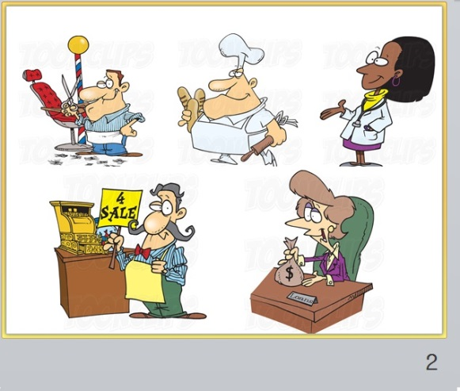
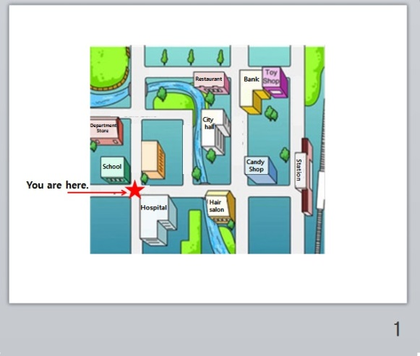

① Map ② Job

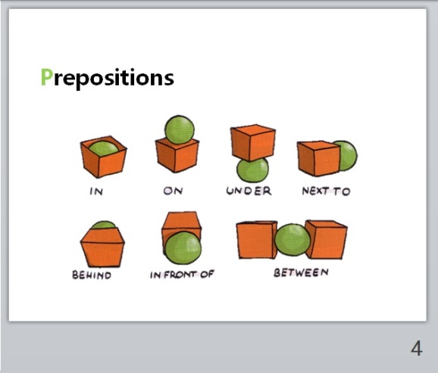
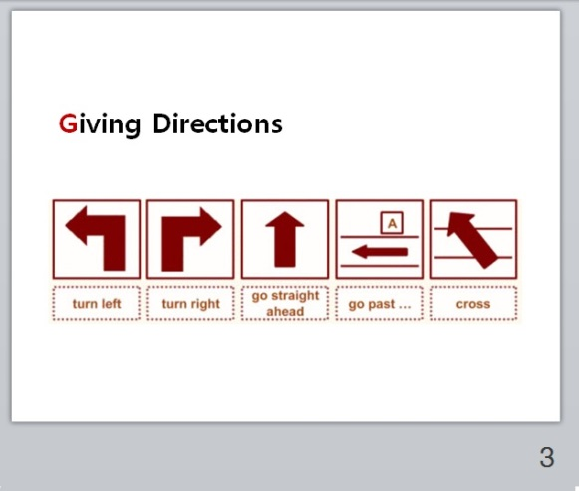
③ Giving Directions ④ Prepositions

# 2 Script

① Fill in the blank
A: Excuse me.
B: How can I help you?
A: I am looking for the ________. But, I can’t find it. Where is the ________?
B: First, you need to go straight two blocks and __________.
Then, go straight ahead. You will find the bank.
A: So, when should I turn left?
B: If you ____ _____________ two blocks, you can see the candy shop at the _________.
A: Okay. What buildings are there near bank?
B: If you turn left, you can see the ________. So, go straight again and you will find it.
It is _________ Restaurant and Toy shop.
A: Thank you so much.
B: You are welcome.

② Script
A: Excuse me.
B: How can I help you?
A: I am looking for the bank. But, I can’t find it. Where is the bank?
B: First, you need to go straight two blocks and turn left.
Then, go straight ahead. You will find the bank.
A: So, when should I turn left?
B: If you go straight two blocks, you can see the candy shop at the corner.
A: Okay. What buildings are there near bank?
B: If you turn left, you can see the hospital. So, go straight again and you will find it.
It is between Restaurant and Toy shop.
A: Thank you so much.
B: You are welcome.

