☐ Listening ☐ Speaking ☐ Reading ☐ Grammar ☐ Writing

Title: What is in your neighborhood?

Instructor:  Julia :JiHyun Jang | Level:  Intermediate | Students:  10 students | Length:  30Minutes

Materials:
Listening CD&CD player (tracks 24-26)
Photo Card Set 5.8
Supplements 8.1,8-2,and 8-3,a box ,Tape
Listening worksheet(10 copies each )
Before listening worksheet
: To practice using vocabulary for clothing in a meaningful Context
Complete the sentences worksheet (10copies)

Aims:
Conversation objective:
Ss will be able to talk about buildings in a city using the key language.
Ss will understand the overall topic or a conversation by listening
Understanding Organization conversation.
Identifying Main Ideas:
Ss will realize the speaker's intention or purpose in an aside - a remark unrelated
to the main subject of a conversation.

Language Skills:
Reading skill: Notice how you read at a different rate or speed depending on the topic.
Listening skill: Have students close their books and tell them to listen for words for buildings in a city in the chart also develop gestures to go along with lyrics
by repeating CD.
Speaking Skill: Ss will present a dialog to class to talk about buildings in a city.
A: Where is the nearest gas station?
B: Go straight for two blocks and turn right at the bakery.
Writing skill: Ss will practice taking notes on details and create sentences using the key vocabulary and grammatical concepts

Language Systems:
Lexis: New vocabularies for building in a city in a meaningful context
: popular , perform, international, airport, flight, directions)
Phonologies : /d/, /id/ or / t/
Function: To talk about the city students live in by asking questions
Structure: common regular verbs in affirmative statements in the simple past tStruc

Assumptions:
Students already know:
- how the class is set up and run ( there will be 5-6 students at each table)
- Different expressions have understanding of city's official homepage.

Anticipated Errors and Solutions:
Students may not able understand of the following vocabulary
-Have students look at the photos and read the highlighted key vocabulary words out loud
Students may not able to pick up detail from the listening
- Encourage students to read the sentences out loud, pausing after each pair of sentences, and have students repeat.
Students will confuse how to explain each situation
- Encourage students keep doing the activity every has participate
:have students on each team pair up : Tell students that have S1 pick a card from supplement from the table and ask S2 using the building on the card, have S2 run outside

References:
Picture of directions given in the dialogue
http: www.google.com / http://c.asstatic.com/images/1188609_634515687132305000-1.jpg
Visual aid
- Listening script by track 43
What you understand the question types by TOEFL

Lead-In
Materials: Board

Time | Set Up | Student Activity | Teacher Talk
1min | Whole class | Answering teacher's questions  such as Yes/ No Question and  Wh-Question | Hello, everyone!  How are you today?  Are you happy or not today?  What is the weather like today?  What do you see in your town around your house?  What is your favorite place in your town?

Pre-activity
Materials: Board , Board markers, Teacher's Audio CD, Photo Card Set 5.8,Worksheet1
a timer
Time | Set Up | Student Activity | Teacher Talk
3min  3min  5min  4min | Whole class  Whole Class  individually  Whole class | Answering teacher's question  and guessing what it is in the picture.  Students start to complete each words.  Check answers. | Procedure:  1. Motivation  I will show you a picture that I prepared.  What do you think this picture?  It is a beautiful town? Why?  What place can see in the picture?  What is your favorite place in this town?  Further clarification  Prepare a drawing town  To draw line to connect the activities to the right place because it use your notes to help you.  Practice taking notes  Enlarge copy of worksheet and cut out the cards  Divide into teams: A and B. Tape one of the worksheet cards onto the whiteboard  Have the teams try to write the correct sentences during listening to CD  Model  Write the subject “Comparing places of your neighborhood" on the board.  CCQ  Is the neighborhood even more convenient ?  Are there many things for you to do in your neighborhood?  New vocabulary  :Instruction  “We are going to learn the following vocabulary before listening to the dialogue in a book.  I will give you a worksheet to complete the blanks. First read quickly the definitions of words with the blanks and fill in the blanks with the correct form of the words given in the box  Work together with your team. I give you 4minutes to correct definition  (Distribute the worksheet #1)  "Look at the answer sheet in order to solve #1 together."  Demonstration  Everyone ,look at the number 1 question is  Correct!, it means  ICQ  What number did you write in the blanks?  What does it mean?  Did you correct words with correct form?  How did you feel while solving these questions?  Were you working in groups?  How long did you take to complete them?  " Everyone let's get it started"  Monitoring  Look around carefully. Asking relative questions If someone is done.  Tell an exact time again.  Time is over  Check answers  Let's check the answers one by one.

Main Activity
Materials: computer or CD player for computer, student book
Time | Set Up | Student Activity | Teacher Talk
3min  3min  2min | individually  Individually | Students guess which picture best describes the situation  Listening to the whole story  Students check each questions | Prediction  As you know, we are going to learn about neighborhood and talk about visiting the special places.  Instruction  "I will give you three pictures before listening. We are able to describe each picture with your partners guess which picture best describes the situation.  Then, share your ideas together.  I will give you 3minutes  (Distribute the book #2)  ICQ  Were you working in pairs?  What do you think they will probably do next?  Is each of the following true except?  How do they think about the neighborhood at the end?  Okay! Everyone, the time is up.  You did well done .So let's listen to the story and check the answers.  Listening for the main idea  Instruction  "Listen it carefully while taking notes on the transition in their feelings.  And then find out correct answers."  ICQ  Do you need to take notes while listening?  (Listen to CD again without pausing or stopping)  Check answers  "Everyone, it is time to check which picture best describes by yourself".

Post-activity
Materials:
Computer or CD player for listening, workbook

Time | Set Up | Student Activity | Teacher Talk
3min | Group | Students in group talk about the  discussion topic  Students prepare the speech | Free production:  Discussion and speech  Instruction  “Everyone, we are going to make a discussion in three groups. Each group will discuss "what are the reasons that the speaker thinks his neighborhood is fantastic?"  Groups need to report to present your opinions. I am going to give 3minutes for discussion.  ICQ  Are you working in groups?  What do you have to prepare for discussion?  Do you find out the features of his neighborhood?  Monitoring  Monitor discreetly. Talk about this topic.  Feedback  It is time to listen to each group’s reporter their discussion.  Please, come up to the front to report what reasons the speaker thinks his neighborhood is fantastic.  Speak clearly and loudly, please.  Others have to pay attention to the reporter.  Conclude Lesson  Summarize our lesson by checking new vocabulary and the contents in workbook.  Then, make an effort to correct errors from your grammar and pronunciation while during discussion.  Please, understand what we learned today’s lesson and your works were excellent, and have a great day!!  See you later.

SOS Activity
Materials:
Worksheet3

Time | Set Up | Student Activity | Teacher Talk
3min  3min | Individually  Whole class | Students listen to the story and complete the sentences in the worksheet.  The answers are checked by students | Complete the sentences  Instruction  Everyone, we are going to listen to the story the second time. You need to fill in the blanks with correct words as you listen to the CD. Please, work it by yourself.  (Distribute the worksheet#3)  ICQ  Do you know what answers are in the blanks when you listen to CD immediately or several times?  As teacher plays the CD Player, have students to complete the sentences while listening.  “Do you think you have to listen to CD one more time?  If you want to do it, let’s listen one more!  Check answer  Let’s check your answers.  Please, read each sentence loudly one by one.

My special neighborhood –Visual Aid
: Talking about our neighborhood

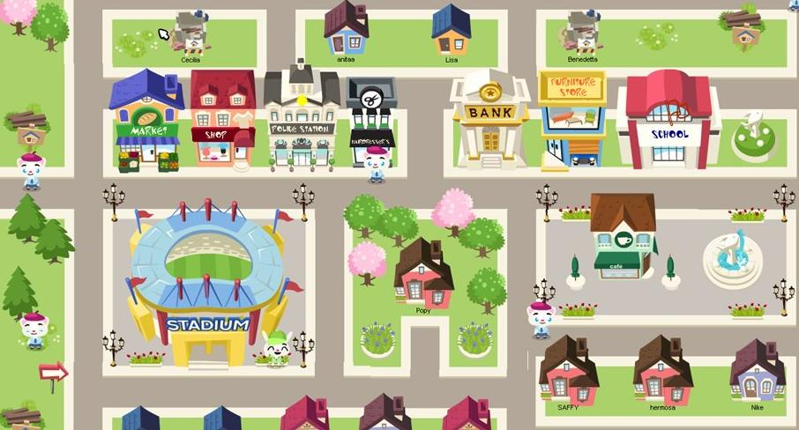

New vocabulary and fill in the blanks
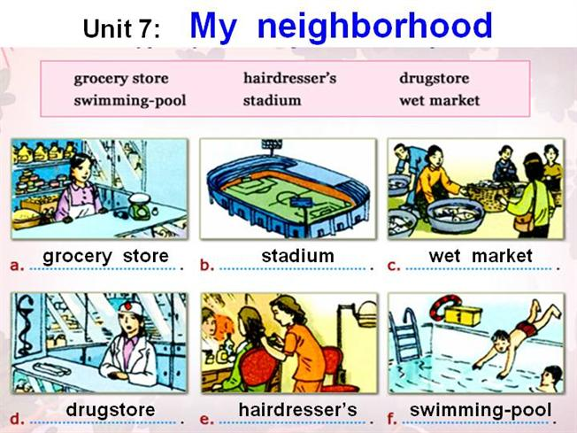

As you listen ,pay attention to reasons the speaker thinks his neigborhood is fantastic.
-Taking notes

Dictation
: listen and complete the sentences.

- I think my --------------- is a ------------- ------------- to live.

2.The school in my neighborhood are ------------- ------------- -------------in the country.

3.--------------------------------------------------------------------------------------------------------.

4. My ------------- center has a ---------- team, and we play every ----------.

