■ Listening ☐ Speaking ☐ Reading ☐ Grammar ☐ Writing

Title: The Internet gives new meanings to common words (20th October, 2016)

Instructor:  Eun A Kim  (Ella) | Level:  Intermediate(Adult) | Students:  10 students | Length:  45 Minutes

Materials:
- White board and board markers
- Power point (vocabulary)
Before listening
- Worksheet #1 (completing the table)
- Worksheet #2 (matching the paragraph)
After listening
- Worksheet #3 (filling the blank)
- Worksheet #4 (asking the question)
- Worksheet #5 (numbering in correct order)

Aims:
- Main aim: Ss will improve their listening skill by listening to the news.
- Secondary aim: Ss will be able to share their thoughts about the news.
- Personal aim: I want them to know they can learn English with every material from their daily life.

Language Skills:
- Reading: Ss will read scripts of the news.
- Listening: Ss will listen to the news about how the Internet affects the word’s meanings.
- Speaking: Ss will be able to talk about their opinions and experience about word’s meanings.
- Writing: Ss will write the words in the blanks of the news.

Language Systems:
- Phonology: /f/, /v/, /p/
- Lexis: New vocabularies in the news
(troll, viral, cloud, tablet etc.)
- Function: Asking the question
- Grammar: present perfect
- Discourse: news

Assumptions:
Students already know
- How the class is set up and run
- How they share their opinions with their peers in a class
- Four language skills and language systems
- The internet is changing many things in our lives including the word’s meaning.

Anticipated Errors and Solutions:
If students need linguistic help when they are talking with their partners during the class
→give them linguistic support to continue their conversation.
If students are not able to understand the instructions
→check why they are having difficulty in getting the instructions and help them using ICQ.
If students want to listen to the news more
→let them listen once more or give them soundtrack by an e-mail.

References:
-The news, the sound track, activities
http://www.breakingnewsenglish.com

Lead-In
Materials: None
Time | Set Up | Student Activity | Teacher Talk
1mins | Whole  class | Answering teacher’s questions | Good morning, everyone! How are you today? Is it good or tough day?  When you are going to work what do you usually do?  Is there any word that you found new meanings on the internet?

Pre-activity
Materials:
Power point
Work sheet #1 (completing the table)
Time | Set Up | Student Activity | Teacher Talk
5mins  10mins  2mins | Whole  class  Whole class  Whole class | Answering teacher’s questions  Completing the table of worksheet #1  Talking with their classmates about the answers | Procedure:  1. Brainstorming  Elicit  (Show the ppt to the students.)  These are the words related to the Internet.  Do you know the meanings of these words?  Is there any word which has new meaning on the Internet?  Why do you think so?  In what situation do you use these kinds of words?  CCQ  Do many Koreans use these words on the Internet?  Have you been in trouble because you did not know the word’s new meaning on the Internet?  2. Learning the Background of news and meanings of words  Instruction  “You will be given the worksheet #1 and can see the table.”  “Complete this table and share what you wrote with a whole class. I will give you 10mins to finish.”  (Distribute the work sheet #1 )  ICQ  What do you write in the blanks?  Are you filling the blanks by yourselves?  How much time do you have?  What are we going to do after completing the table?  “Let’s start.”  Monitoring  Walking around the class. Help the students when they want more explanation.  Give time warning:  2mins left. Try to finish what you are doing.  “Okay, everyone. You are really doing well.  Share the answers  Let’s share what you wrote for 5mins. If you want to add other students’ answers there is no problem.  “Who wants to volunteer?”  After sharing the answers, do complement.

Main Activity
Materials:
Computer for listening
Worksheet #2 (matching paragraphs)
Worksheet #3 (filling the blanks)
Time | Set Up | Student Activity | Teacher Talk
3mins  2mins  3mins  1mins  5mins  1mins | Pairs  Pairs  Whole class  Whole class  individually  Whole class | Matching the paragraphs of worksheet #2  Sharing the answers  Listening the news  Checking the answers with teacher  Filling the blanks of worksheet #3  Checking the answers | 1. Overview of the news  “Before listening, let’s try to match the paragraph. It helps you to listen to the news easily.  Instruction  “I will give you worksheet first. There are two columns. First, read all these and connect the numbers and alphabets drawing the line. And then check your answers with your partners. I will give you 3mins to match paragraphs and 2mins to compare with your partners.  (Distribute the worksheet #2)  ICQ  Are you working in individuals?  Do you share your answers with your partner after connecting the paragraphs?  How much time do you have for matching answers?  “Okay, it’s time to move on sharing your answers and talking about it with your partner.  “Alright, two more minutes left”  “Ok, the time is up. You all did very well. Now, it’s time to listen to the news. Also, you can find out the answers of this activity.  2. Listening for the main idea.  “Today’s topic is about words given new meanings on the internet. You can listen to the news for several times. You don’t need to worry about missing.”  Instructions  “First, listen it carefully and check the answers.  ICQ  What do you do when you are listening?  (Play the listening CD without pausing or stopping)  Check answers  “Very good. Did you check all? Let’s check answers together.”  Check answers with teacher  “Listening for details is important to improve your listening. You need to make sure that you know new words, expressions and pronunciation.”  Instruction  “While you are listening to the news twice more, you have to fill the blanks. You don’t need to be perfect at first time. Just try to focus on the word and pronunciation”  ICQ  What do you write in the blanks?  Is this individual work?  (play the news line by line with pausing or stopping)  Check answers  “Now, I have written the answers on the board. Please check these for 1mins.”

Post-activity
Materials:
Worksheet #4
Time | Set Up | Student Activity | Teacher Talk
5mins  5mins | Pairs  Whole class | Asking the questions of worksheet #4  Comparing Ss opinions | 1. Sharing the opinion  Instruction  “We will have the time to share opinions asking the questions in pairs. Each will be given the worksheet #4. But it is different each other. You are not allowed to show the questions. I will give you 5 minutes to ask questions and answer it”  (Distribute the worksheet #4)  Monitoring  Monitor discreetly walking around the class  ICQ  What does A person do at first after getting the worksheet #4?  And then what B person does after A person?  How much time do you have?  “Are you ready for the last activity? Let’s begin.”  Feedback  “It is time to listen what each pairs’ talked. Please speak loudly. Let’s go clockwise.”  2. Conclude Lesson  Summarize the class by asking what students can remember. Then correct the errors that most of the students made when they were talking.  “Okay, it is the end of the today’s class. Thank you for your participation so much.  You were excellent. Please use the vocabularies we learned in daily life or at work. Have a good day.”

SOS Activity
Materials:
Work sheet #5
Time | Set Up | Student Activity | Teacher Talk
5mins  2mins | Pairs  Whole class | Numbering the paragraphs of worksheet #5 in correct order  Checking the answers | 1. Put the text back together  Instruction  “We are going to number the paragraphs in correct order. Put the numbers reminding what you listened. I will give you 5 minutes to find out. Work in pairs”  ICQ  What do you have to write in the blanks?  Are you working in pairs?  “Do you need more time to think?”  Check answer  “Let’s check the answers together. Please tell us your answer clockwise.”

- News script

The fast pace at which the Internet has entered and transformed our lives has had an impact on the words and language we use. It is 20 years since the website Dctionary.com was created, and it has looked back at the past two decades to see how the worldwide web has created additional definitions to many commonly used words. Dictionary.com boss Liz McMillan says it’s interesting to see, “just how much the rise of technology has shaped our word use over time”. She said: “To commemorate the 20th birthday of Dictionary.com, we look back at 20 words that have expanded in meaning over the last 20 years.” The website has been documenting new lexical uses since, “the dawn of the Internet era”.
Perhaps one of the most easily recognisable changes is to the word “friend”. For centuries, this word has been a noun. However, with the meteoric rise of Facebook, this very common word is now also a verb, as in, “Can you friend me?” A variant of this word is “befriend,” which means to become friends with someone (usually in the real and not cyber world). The word “tablet” used to commonly refer to a flat piece of stone, clay, or wood that is used to write on. Now it’s more likely to mean a touchscreen device that is Internet-enabled. Other words that have new definitions include “cloud,” “wireless” ”viral,” ”tweet” and “troll”. There’s no knowing which new words will have new meanings in the next two decades.
- Power point

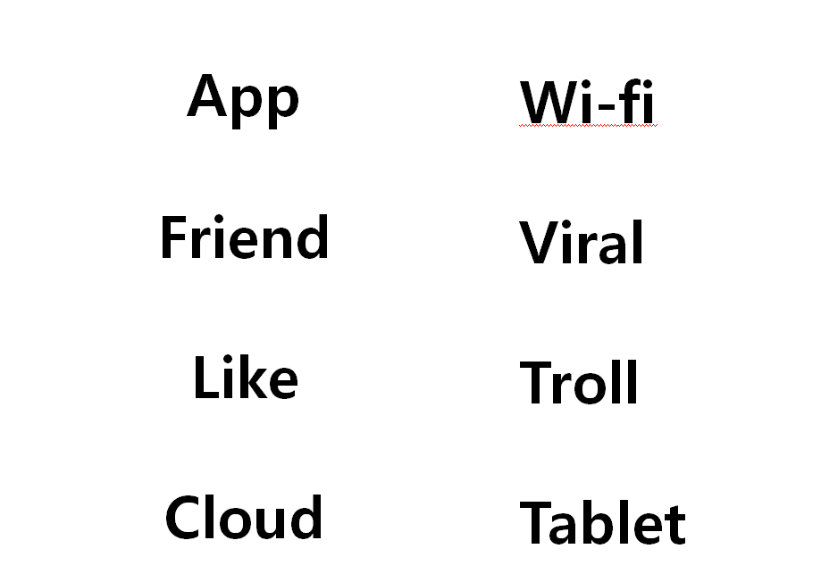

- Worksheet #1

Think about old meanings and new meanings of these words and write it down.
And then compare the answers in a class.

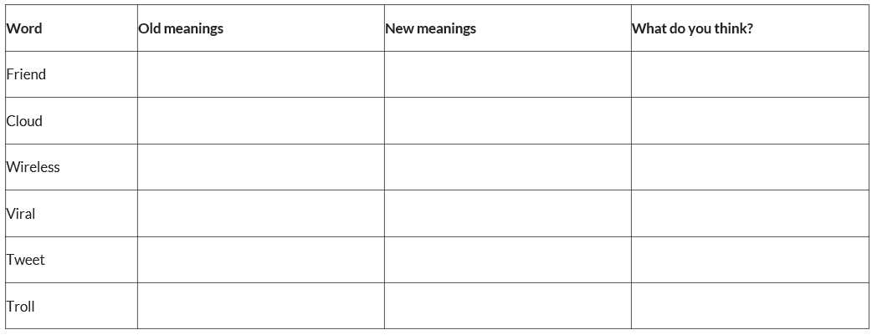
- Worksheet #2

Match the paragraph.

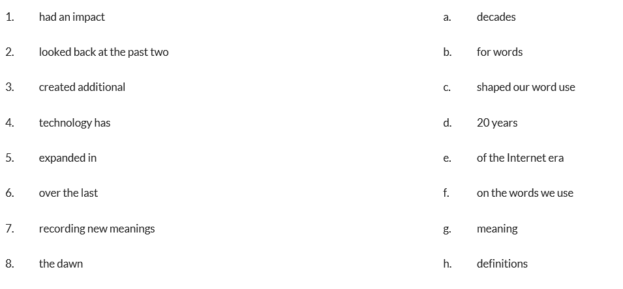
l

- Worksheet #3

Fill in the blanks listening to the news. You will listen to the news for two times.
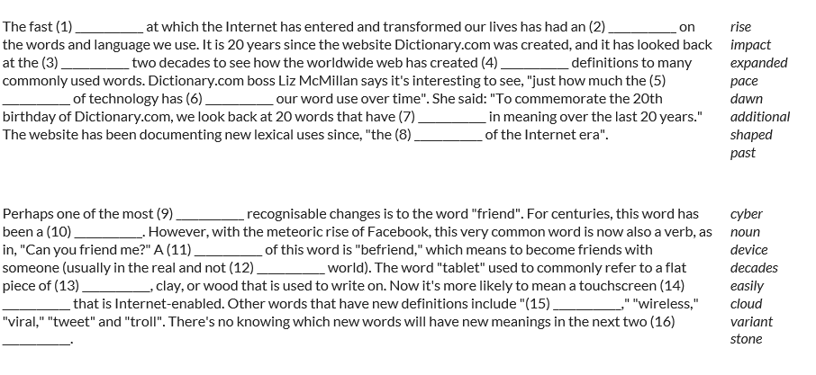
- Worksheet #4

Ask the questions to your partner.
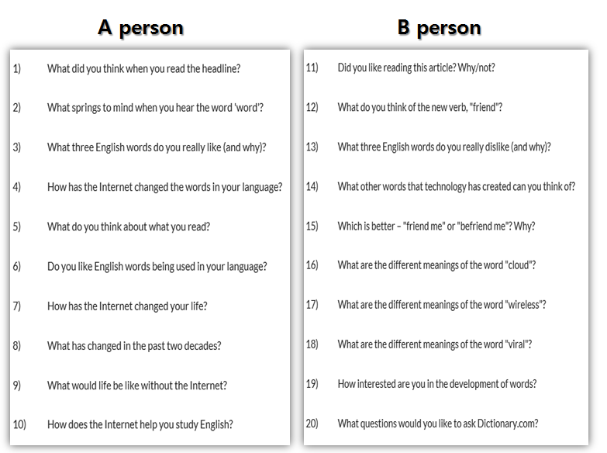
- Worksheet #5`.

Number the sentences in correct order.

