Listening Speaking Reading Grammar Writing

Topic: Robbery at the bank

Instructor:  Haeok(Jane)Kim | Level:  Intermediate | Students:  4 students | Length:  30 Minutes

Materials:
- Pictures of bank robbery (appendix1_1,1_2)
- Alibi game worksheet (appendix2)
- Alibi game answer sheet (appendix3)
- The police’s questions (appendix4)
- The citizen’s statements (appendix5)
- Criminal law revision word search (appendix6)

Aims:
- Main aim: Ss will be able to pick and obtain useful information from the text (newspaper article)
- Secondary aim: Ss will prepare questions/statements to defeat themselves.
- Personal aim: I want STT up in large and to provide useful contents.

Language Skills:
- Reading: Ss will read the newspaper article.
- Listening: Ss will listen to instructions and other Ss opinions.
- Speaking: Ss will debate with other teams.
- Writing: Ss will write down the answers and questions/statements.

Language Systems:
- Phonology: /ry/ /zy/ /dy/ /gy/ /sy/ ,…
- Lexis: robbery, crime, criminal, accountant, etc.
- Grammar: “Where was~”, “What were~”, “When was~” ,..
- Function: Acknowledging the procedure of investigation, the expression of interrogation, etc.
- Discourse: Discussion, Debate, Role-play, etc.

Assumptions:
Ss already know
- What robbery is
- What alibi is
- How the bank system operates
- Overall procedure of investigation by police
- How the speaking class operates and perform it

Anticipated Problems and Solutions:
In the case of
- Ss may have limited words related to crime
- Give them hints
- Allow them to search on the internet for new vocabularies
- Ss may have restricted number of sentences (questions/statements)
- Give them guidance, i.e. provide them certain situation and ask Ss what they will react, etc. Therefore, elicit their ideas more.

References:
https://en.islcollective.com/resources/search_result?Tags=robbery&searchworksheet=GO&type=Printables
http://e-lawrevision.org.uk/actus-reus-word-search.php

Lead-In
Materials: None

Time | Set Up | Student Activity | Teacher Talk
1min | Whole class | Listen to instructions and answer based on experience. | “Hi everyone, how do you feeling today?”  “Has anyone been stolen something from the strangers?” (Listen and react)  “Really? Did you find your belonings?”  “Have you caught the criminal as well?”

Pre-Activity
Materials: Pictures of bank robbery (appendix1_1,1_2)

Time | Set Up | Student Activity | Teacher Talk
1min | Whole class | Listen to instructions  Guess what picture indicates  Discuss about the topic | Elicit  Show Ss pictures (appendix1_1)  “What are these men doing in the pictures?” (wait for responses and write down on the board)  “Robbery? Threatening? Trying to hide the evidence?”  Show Ss (appendix1_2)  “What about this picture? What is it?”  “The Simpsons~ Yeah~!”  “What are they doing?” (wait and listen)  “Not sure, but like J said, probably the boy is threatening the girl, because he wants to hide his fault by blocking her mouth.”  “Great. What do you guys come up with?” (wait and write on the board)  “Crime? Threat? Thief?”  “Yes, today our main topic is~ robbery at the bank!”  CCQ  “What do we call people who stealing something without paying for it?”  “Yes, thief! Robbery!”

Main Activity
Materials: Alibi game worksheet (appendix2), Alibi game answer sheet (appendix3)

Time | Set Up | Student Activity | Teacher Talk
1min | Whole class | Listen to instructions  Read the news article  Answer the questions  Discuss with other Ss  Speak out answers | Instruction  “Today, we will do an alibi game.”  “Firstly, we will read a news article about the bank robbery, and based on the information in the article, we will put answers with your partners.”  “Ignore the third part in the worksheet (appendix2). We will do other activity.”  “I will give you 7 minutes to read and answer the questions. Work in pairs.”  ICQ  “What are you going to do now?”  “Do you work alone?”  “How long do you have?”  “Good, let’s begin.”  Monitoring  If Ss are finding answers alone, encourage them to discuss answers with partners  If Ss are struggling, give them some hints or/and let other Ss help  Time warning  “Now, time is up.”  Check answers  “Both team A and B, come out here and write your answers on the board.”  Compare each other’s answers and correct the wrong answers with guidance.  “Awesome, thanks everyone.”

Post Activity
Materials: The police’s questions (appendix4), The citizen’s statements (appendix5)

Time | Set Up | Student Activity | Teacher Talk
1min | Whole class | Listen to instructions  Prepare the questions/statements  Write them down  Discuss with partners  Debate with other teams | Instruction  “Now, instead of the third part of worksheet (appendix2), we will do the alibi game.”  “Team A will be the police team and team B will be the citizen but who is one-party of the criminals.”  “So, the police want to investigate the real spot, asking questions to the citizens who were there at the time of robbery.”  “On the other hand, the citizen who is the other party of criminals, pretend to be a normal person and make alibi for his parties.”  “In team, prepare questions/statements to defeat yourself in the investigation.”  “I will give you 10 minutes to work on it, try to make 7 to 10 statements. The more questions/statements you prepare, the more likely to win this game.”  Demonstration  “If I were police, I might think that citizen is suspicious, as his statement is different from the news. So I will narrow the questions to obtain more specific information.”  “Conversely, if I were that citizen, I not only direct the police to the wrong direction of investigation, but also try not to reveal, i.e. if I give totally weird replies, they will see me as the suspect.”  ICQ  “So! How long do you have?”  “Do you share statements with other teams before debate?”  “As many questions/statements as possible is good?”  “Now, start!”  Monitoring  If Ss do not make sharp questions/statements, encourage them to develop sentence more.  If Ss are struggling with lack of words related to crime or/and lack of ideas for making sentence, let them search for sources on the internet.  Time warning  “10 minutes up!”  Presenting  Make team A&B debate and score.  The more sharp sentence will get a score.  Conclude lesson  “Well done everybody. Did you enjoy the activities?”  “I hope you enjoyed and learned a lot. Thank you for participation and see you next time~”
SOS Activities
Materials: Criminal law revision word search (appendix6)

Time | Set Up | Student Activity | Teacher Talk
1min  3min  1min | Whole class | Listen to instructions  Guess answers  Share ideas  Review | Brief instruction  “We have few minutes left, we will do the word search reviewing criminal law that we learned today.”  “If you find it difficult, work with each other.”  “I will give you 3 minutes to work on.”  CCQ  “What was the key topic of the day?”  “Yes, robbery.”  “Is robbery a crime?”  “Absolutely! Let’s find words.”  ICQ  “Do you work alone?”  (“No, work with whole class.”)  “How long do you have?”  (“3 minutes.”)  “That’s right, let’s begin!”  Check answers  Check students answer and if something is missing, let others help.  Conclude the lesson  “I hope you learned a lot from today’s lesson. Thanks everyone.”

Pictures of bank robbery (appendix1_1)
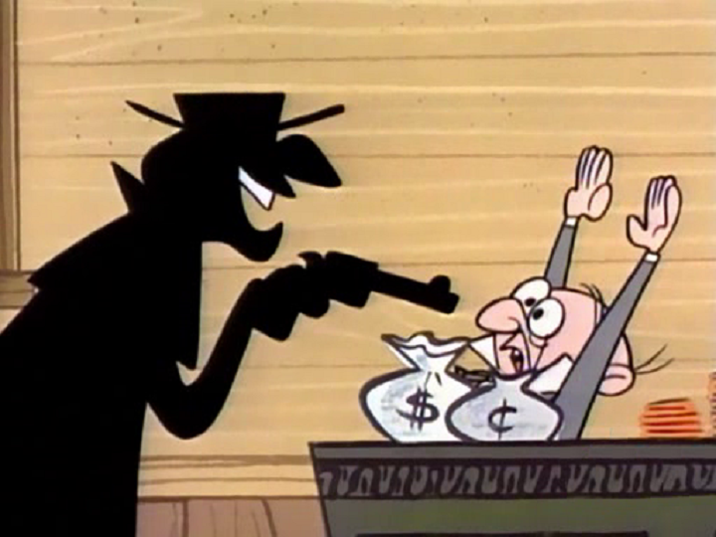


Pictures of bank robbery (appendix1_2)
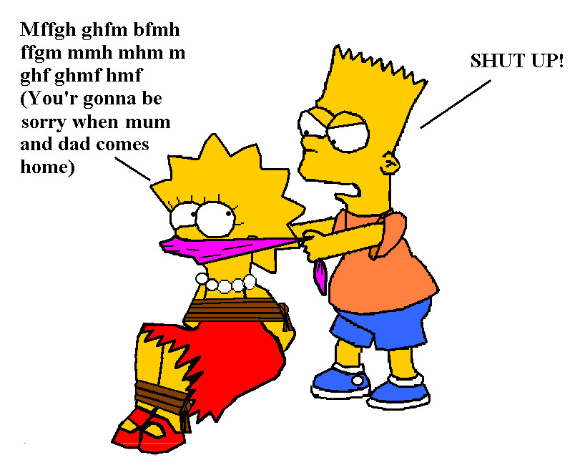

Alibi game worksheet (appendix2)
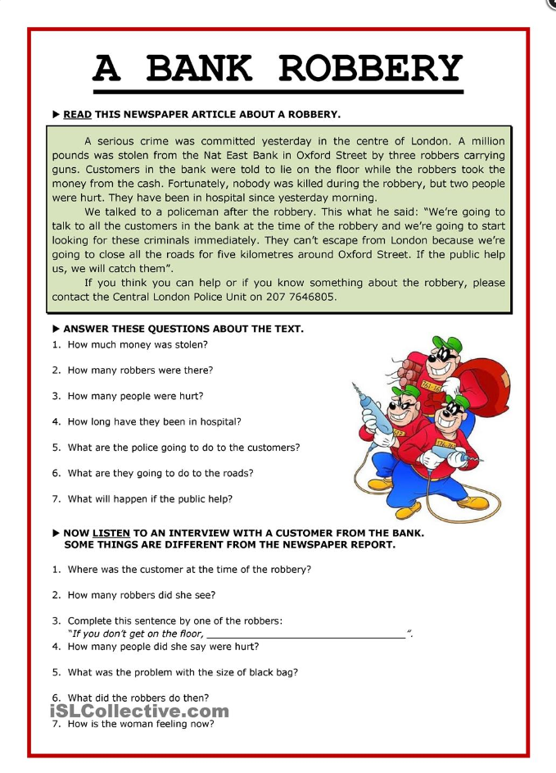

Alibi game answer sheet (appendix3)
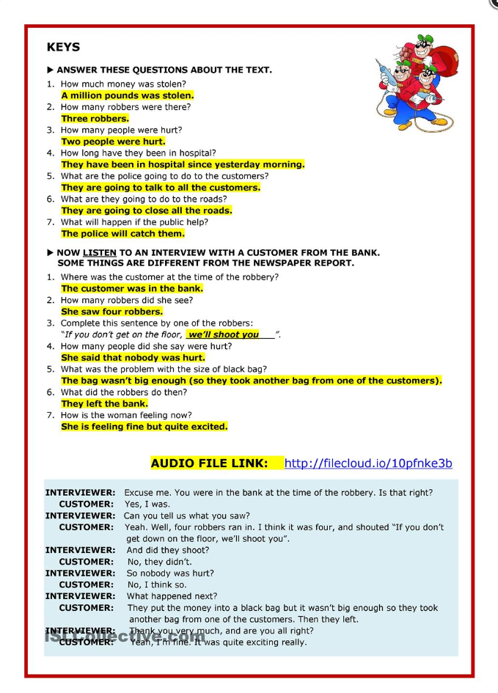
The police’s questions (appendix4)

1. _______________________________________________________

2. _______________________________________________________

3. _______________________________________________________

4. _______________________________________________________

5. _______________________________________________________

6. _______________________________________________________

7. _______________________________________________________

8. _______________________________________________________

9. _______________________________________________________

10. _______________________________________________________
The citizen’s statement (appendix5)

1. _______________________________________________________

2. _______________________________________________________

3. _______________________________________________________

4. _______________________________________________________

5. _______________________________________________________

6. _______________________________________________________

7. _______________________________________________________

8. _______________________________________________________

9. _______________________________________________________

10. _______________________________________________________
Criminal law revision word search (appendix6)



