☐ Listening ■ Speaking ☐ Reading ☐ Grammar ☐ Writing

Topic: Finding DORY

Instructor:  Kim & Joanne | Level:  Intermediate | Students:  10 students | Length:  30 Minutes

Materials:
- White board and markers
- Flash cards (vocabulary)
- Worksheet (10 copies)
- Computer with sound ( for visual and audio materials)

Aims:
- Ss will be able to practice the present continuous tense while questioning other Ss of their actions during interviewing (Grammar).
- Ss will work cooperatively in a group by sharing information that is unique to each student(Group Dynamics)
- Ss will learn vocabulary related to synopsis from teachers example of the picture sequence (vocabulary)
- Ss will be able to speak fluently by giving their opinions to solve the picture sequence(communication)

Language Skills: Integrated
- Listening : Teacher’s elicitation ; teacher’s example of vocabulary ; background information of movie; other Ss’s responses to interview ; other Ss’s opinion in discussion.
- Reading : flash cards
- Speaking : asking and answering during discussion of movie
- Writing : bridging the gap between A and B

Language Systems: At least 3
- Function : asking for information ; giving information ;hypothesizing
- Phonology : correct pronunciation after monitoring
- Lexis : vast, console, offer, meddlesome, nonetheless
- Discourse : discussing about which scene should go inside of whole story to be natural.
- Grammar : present continuous tense interrupted by connecting each story of flash cards.

Assumptions:
- Some SS may already know the vocabulary to present.
- Ss enjoy playing of the imagination
- Ss are able to logical thinking

Anticipated Errors and Solutions:
- If students need linguistic help to express their opinions.
→ give some examples and explains the sentences.
- If students need problems to follow the activity
→ make students help each other first then give advice.

References:
- https://www.youtube.com/watch?v=MKJA-VLpiCo
- Naver image file
- http://www.synonym.com/synonyms/
- http://www.storyboardthat.com/

Pre-task
Materials: board, markers, computer, visual file, video/ audio file.
Time | Set Up | Student Activity | Teacher Talk
2 min  3 min  3 min | whole class  Whole class  Whole class | Watching visual materials.  Answering teacher’s questions  Watching visual materials.  Answering teacher’s questions  Watching at video | < Greeting and Brief rapport >  (Show some animation movie posters.)  T : Has anyone seen one of these great animation movies lately?  If anyone says yes,  -> ask him/her which and how was it?  (showing visual file of several posters of animation)  -> How is the story of movie?  -> Which part did you like?  < Warm-up >  Eliciting  (showing statistics and explain phenomenon that adult like animation, too)  T : Why do you think people enjoy good animation movies?  How is OST ? Are these animation movies giving instructive lessons?  Try elicit that …  -> People like to get vicarious satisfaction, feel a sense of accomplishment.  -> People like to get feeling of happiness .  -> Those are uplifting story.  -> Weary adults of harsh reality want healing. Sometimes to wish to return to the innocence of children.  -> Recognition of animation movie is changing. People who is young and old is touched by the animation movie.  -> Characteristic of an adventured film.  T : Do you thrive on adventure?  Okay, let’s go venture together!!  < Introduction of task >  ( Write on the board “ Finding dory”)  T : Today we will be doing picture sequence of one animation.  First, I will give you the background information on picture sequence. Listen carefully  ( Showing video)  < Background Information >  https://www.youtube.com/watch?v=MKJA-VLpiCo  T : Do you need to watch one more time?  - Yes : show once again.  - No : continue with next part.

Task- preparation
Materials: Work Sheet
Flash card
Time | Set Up | Student Activity | Teacher Talk
2 min  1 min | Whole  Class  Whole  Class | Listening to teacher’s instruction  Comparing the work. | Instructions  (Attaching some flash cards to make students understand what is sequence)  T : We are going to do an activity called ‘Picture Sequence’.  Do you know what does sequence mean?  (Ss answer: _______).  Picture sequence is the photo showing the series of story from beginning to end.  (Pointing out the flash card.)  First, everybody look at the piece of paper. In the paper, there are 3 pictures and 3 blanks.  Who get the Students A paper get number 1,3,5 pictures and Student B will get 2,4,6 pictures. You can’t see each other’s picture.  What we are going to do is ask questions and answer to get information of the picture. You will draw the picture and write the balloon word based on your partner’s saying.  Student A will ask your partner first and you will switch the role. I will give you 5 min to do the activity. If you have more time, think about the answer of the questions below the picture.  ICQ  ① Are you working in a pair?  (Ss answer: Yes.)  ② Can we see each other’s picture?  (Ss answer: No.)  ③ Then, how we can fill in the blank?  (Ss answer: ask a questions)  ④ How much time do we have?  (Ss answer: 5 minutes.)  Okay. Let’s start the activity. You should make a full sentence when you ask questions and answer.  Monitoring  (Teacher is observing that everyone is doing the group activity.)  → If students need help, give advice and help to do it.  → If students need more time, give time warning and make them finish.  Time’s up.  Let’s compare the work each other.  Are you guys doing well?  (Ss answer:___________)

Task Realisation
Materials: board, markers
Time | Set Up | Student Activity | Teacher Talk
3 min  5min | Individually  Group | Ss listen to teacher  Student start discussion | 3. discussion  < instruction>  T : Alright, now I want you to give me your flash cards.  (collect flash cards)  T : At this time, I want to arrange your seats so you can have a group discussion. I want you to discuss about sequence of picture.  ( write ‘picture sequence’ and attach first flash cards)  T : You may use your worksheet with the writing in present continuous that you imagined. I’ll give you 5 minutes.  CCQ  How much time do we have?  What do we discuss?  Which tense do you use?  T : You may begin  (Discretely monitor and correct errors in language Ss make)  T: 2 minutes left  (Ask if they need more time. If so, give them 2 more minutes)  T : OK, now I need a representative to tell me your conclusion of what happened during finding DORY. You may use present continuous tense.  (listen to student’s explanation and attach each of flash cards)

Post-task
Materials: Work Sheet
Time | Set Up | Student Activity | Teacher Talk
1 min  2 min  2 min  3 min | Whole  Class  Pair  Group  Whole  Class | Listening teacher’s instruction  Discussing the work sheet questions.  Discussing each other.  Sharing the ideas. | Now, let’s move on to the questions below the picture. Discuss with you partner first and talk about the answer in a group. Then, we will share the idea all together. I will give you 3 minutes to discuss.  Monitoring  → If students have a linguistic problem, support them to give an idea.  If you finish talking with your partner, discuss in a group.  Are you guys done?  Okay. Let’s find the answer together.  ① Why did Dory need to reach the City Marline Life Center?  (S answer:__________)  ② Who did start the adventure with Dory?  (S answer:__________)  ③ Do you know Present Continuous Tense?  (S answer:__________)  Present Continuous Tense is grammatical aspects that express incomplete action (“to do”) or state (“to be”) in progress at a specific time.  For example, Dory is swimming under the sea. You can see ‘is swimming. That’s a Present Continuous. It is happening right now.  ICQ  Can you make any sentence using Present Continuous Tense?  (Ss answer:____________.)

SOS Activity
Materials:
Worksheet ( vocabulary and grammar)
Flash card
Time | Set Up | Student Activity | Teacher Talk
If the time is available. | Whole  Class | Listening to teacher’s instructions and volunteering. | (Showing the flash card)  CCQ  (Showing the flash card)  What can you see in the picture?  What they are doing?  Concole - try to make someone feel better.  Vast – extremely large  Offer – provide something to someone  Meddlesome – try to influence or change things that do not concern them  Nonetheless- despite anything to the contrary  Let’s make some sentence using the words.  Who want to be a volunteer?  (Students are volunteering.)  Well done guys.  Did you guys have fun?  (Ss answer:__________)  What’s the best part in the class?  (Ss answer:__________)  All right everyone really good job.  See you next class.

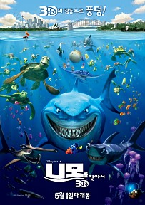

Finding
Student A
Dory is a very lovable neighbor fish. He liked to help others. But this dory suffered from short term memory loss.
He just could remember what happened only for 10 seconds, but he was very positive and quite, no..actually being meddlesome a lot in good way, nonetheless.
One day, he recalled his family existed and decided to venture to find them with his friends. Will this travel ever become a reality?
Let's venture together! Here we go!!

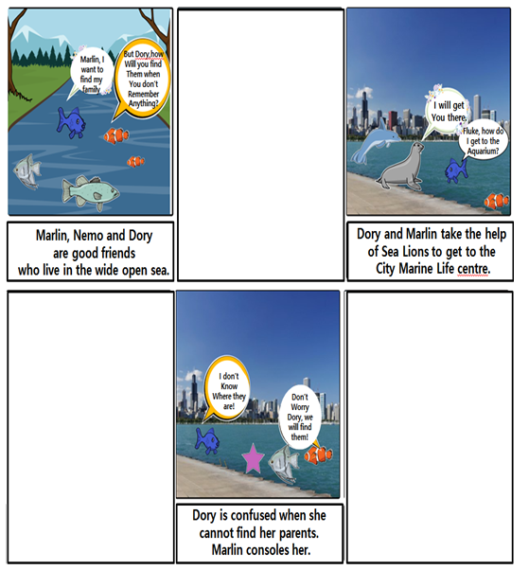

Q1. Why did Dory need to reach the City Marline Life Center?
Q2. Who did start the adventure with Dory?
Q3. Do you know Present Continuous Tense?

Q1. Why did Dory need to reac Q1. Why did Dory need to reach the City Marline Life Center?
Q2. Who did start the adventure with Dory?
Q3. Do you know Present Continuous Tense?

h the City Marline Life Center?
Q2. Who did start the adventure with Dory?
Q3. Do you know Present Continuous Tense?

Finding
Student B
Dory is a very lovable neighbor fish. He liked to help others. But this dory suffered from short term memory loss.
He just could remember what happened only for 10 seconds, but he was very positive and quite, no..actually being meddlesome a lot in good way, nonetheless.
One day, he recalled his family existed and decided to venture to find them with his friends. Will this travel ever become a reality?
Let's venture together! Here we go!!

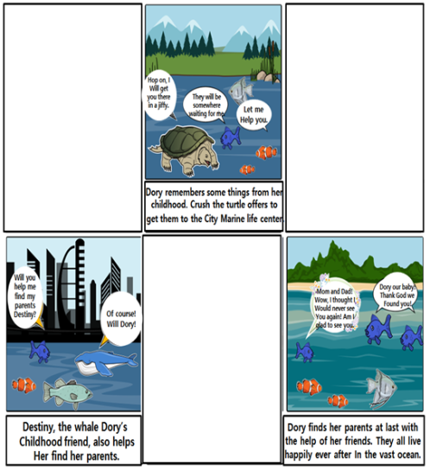

Q1. Why did Dory need to reach the City Marline Life Center?
Q2. Who did start the adventure with Dory?
Q3. Do you know Present Continuous Tense?

Q1. Why didDory need to reach the City Marline Life Center?
Q2. Who did start the adventure with Dory?
Q3. Do you know Present Continuous Tense?

Flash Card
⑤ Nonetheless
④ Meddlesome
③ Offer
② Vast
① Console

