|  |
| --- |
| ☐ Listening ■ Speaking ☐ Reading ☐ Grammar ☐ Writing |
| **Topic:** Thee Items Survival a Deserted Island |

|  |  |  |  |
| --- | --- | --- | --- |
| Instructor:  **Euna &Julia** | Level:  **Intermediate**  **(Adults)** | Students:  10 students | Length:  **30 Minutes** |

|  |
| --- |
| **Materials:**   * 3 Sets of Role cards (one for two or three people) * 10 Items Flash Card * Worksheet #1 with escaping from the deserted Island (pair work) * Worksheet #2 (Criss-cross puzzle activity) * White board and makers * A timer |

|  |
| --- |
| **Aims:**   * To encourage Students to speak fluency choosing items and strategizing (Communication) * Students will learn vocabulary related to items flash card proven ways to get away from the island. (Vocabulary) * Listen fluency to sharing information that is unique to each group. (Group work) * Students will do role play/ problem-solving task. (task-based activity) * To encourage Students to practice using of the future tense while strategizing and doing role play (Grammar) |

|  |
| --- |
| **Language Skills:**   * Speaking : planning , strategizing and escaping in the circumstance through role play * Reading : role cards * Listening : teacher’s instruction, interacting with a partner. * Writing : choosing items and during strategizing |

|  |
| --- |
| **Language Systems:**   * Function : asking for information in a group * Grammar: Using the future tense during creating their own scripts * Discourse: discussing which team is well done as strategic planning through a difficult task |

|  |
| --- |
| **Assumptions:**   * All of Students know they should speak in English during class. * Most Students have to imagine in a difficult circumstance when they lost their bearings. * Students enjoy solving in a difficult situation. |

|  |
| --- |
| **Anticipated Errors and Solutions:**   * If Students do not have full knowledge of their role after getting the Task-Preparation, encourage them to refer to their role cards during strategizing, but they must not write these on the worksheet. * If Students may be unable to create their role of the script, provide them with some ideas while asking the best way to escape in the difficult situation. * If there is the spare time than expected, give students more time for the connecting game. (SOS activity) |

|  |
| --- |
| References:  <http://www.google.co.kr/url>? |

|  |  |  |  |
| --- | --- | --- | --- |
| **Pre-task** | | | |
| Materials:  Board, Board markers, List of items, Front side of worksheet | | | |
| Time | Set Up | Student Activity | Teacher Talk |
| 2min  3min | Whole  class  Whole  class | Students listen carefully as the teacher explains how to do this game also answers teacher's questions. | **1. Greeting & Brief Rapper**  **Instruction**  T: Good morning, everyone!  Do you like to travel around world? Why?  (Show the island picture)  Everyone, have you ever imagined when you got lost in a strange island?  If you are stranded on the island what would you do and what needs of items to escape from the place?  Eliciting  Asking some questions and praise for good work  **2. Introduction of Task**  **Instruction**  (Write some items on the board without explaining)  T: Today we are going to do this game, getting out of deserted island called a ranking game and a role play activity.  First, I will give you the information on the shipwreck. Pay attention, please as I reading it.  **3. Background information**  **Explaining about the game**  (Distribute worksheet #1)  T: Oh my god, how could such a thing happen!  Your ship was wrecked on an isolated island, and then you are mistaken.  You were thrown on the island shore after surviving a terrible shipwreck.  Each team needs to find a way like a safe island to get out from this dangerous island within an hour.  Every team will have a chance to get three items that you get out from this island alive.  Each island is a unique location- so does not think it will be an easy place for your team.  Which items are most essential to survive and return home? Think them carefully!  T: Do you want to listen one more time?  - Students: No need.  T: Okay, I will ask some questions about this game.  **ICQ**  What are you going to do?  How much time do you have?  How many items do you have? |

|  |  |  |  |
| --- | --- | --- | --- |
| **Task- preparation** | | | |
| Materials: Role cards, Board, Board markers, Back side of worksheet | | | |
| Time | Set Up | Student Activity | Teacher Talk |
| 3min  5min | Whole  Class  Group | Students try to choose three items and strategize how to  get out of a deserted island | **1. Role cards & Item cards**  **Instruction**  T: First, we are going to divide into three groups of two or three.  These teams will be called as Team A, B or C.  (Ask the students who chose Team A, B or C to arrange their seats and take a sit with your teams.)  T: Okay. Before you pick your 3 items. Let’s check the vocabulary together.  (Move to a white board)  **Vocabulary check**  T: Have you ever heard of these words of items?  Could you tell me what It is?  (If someone does not know this meaning, the teacher explains briefly.)  T: It’s time to pick three items.  (Students pick their items)  **2. Making the strategy**  **Instruction**  T: As I had said in the background information you were also at this reunion.  Each team will pick a role card and then your team  should use this role-card and three items chosen by your team have to plan, strategize how to get out of the deserted island with using back side of worksheet with your team together in 5minutes.  T: Let’s begin to discussion on this situation and choosing each role in each team.  After deciding each role in your team, you have to practice how to do role play with your partners who comes to the front to the role play.  **ICQ**  Can you show your card to your partners?  How much do we have?  Can you discuss with other group?  **Monitoring**  (Monitor while Students discuss and make a role play also takes notes of any errors)  **Time warming**  (Remind students how much time they have left.)  T: After finish time, at this time I want each team comes up to the front to do role play.  (Encourage each team to be conference and praise for making an effort.) |

|  |  |  |  |
| --- | --- | --- | --- |
| **Task Realisation** | | | |
| Materials: Name cards | | | |
| Time | Set Up | Student Activity | Teacher Talk |
| 6min | Whole  class | Presenting role-plays in front of the class | **1. Presenting the Role-play**  **Instruction**  T: Alright. Time is up. Everyone was doing very well. It is time to present role-play in a class that you have prepared with your partner.  Before each team comes out here let me know what your items are first. And introduce your role to your classmates briefly. Then I will mark whose team gets what items on the board. I'll give each team 2 minutes to present.  (Distribute the name cards)  **ICQ:**  What do you have to tell before you present?  How much time do you have to present?  T: Okay. Good. Who wants to do first? Is there any volunteer?  (If there is no volunteer, each team will vote to present the role play in order)  (Then determining which team will do it first, second and third)  T: What are your items?  (Mark items on the board)  T: Okay, thank you. Are you ready to present the role play? / Are you ready? / Can we start?  (The first team will do the role-play)  T: Good job! / Great! / It was so fun. /Let's give _team a clap! Move on to the next team.  (The second and third team will do the role-play)  T: I was greatly impressed with your performances (After finishing the last team, looking at all teams)  T: You are all perfect! Great!  (Give compliments to every team) |

|  |  |  |  |
| --- | --- | --- | --- |
| **Post-task** | | | |
| Materials: Name cards | | | |
| Time | Set Up | Student Activity | Teacher Talk |
| 5min  1min | Whole  Class  Whole  class | Choosing the best team  Students learn future tense pattern. | **1. Feedback & Error correction**  **Instruction**  T: Please, could you tell me which team was the best and tell me the reasons why the team was perfect?  (Ask A, B, and C team about a great team for a good work)  (If there is the team that gets the most points, teacher let the students give a big hand to a winner team)  T: Everyone gives a clap and cheers to a great team and your team.  **Grammar**  T: I will describe to express using the future tense.  (Write be + going to on the board)  T: You can use this grammar pattern to say your plan. Okay?  T: I hope you had a fun planning a strategy with limited items. There is no homework today. You did a good job. See you tomorrow! |

|  |  |  |  |
| --- | --- | --- | --- |
| **SOS Activity** | | | |
| Materials: Worksheet #2, Cross-clue, Down-clue | | | |
| Time | Set Up | Student Activity | Teacher Talk |
|  | Individually  Pairs | Reading their clues  Sharing their answers with a partner | **1.Criss-cross puzzle for vocabulary**  **Instruction**  T: Now, we are going to do criss-cross puzzle for vocabulary.  (Distribute the worksheet #2)  (Distribute the cross clues to left-side student and the down clues to right-sided student)  T: First, read your clues and find out the answers individually for 2 minutes. And then you will share your answers with your partners. I'll give you 3 minutes to share.  **ICQ:**  What are you going to do first individually?  How much time do you have for sharing your answers with your partner?  T: Let's start!  (After 2 minutes)  T: Okay, good.  Please, share your answers with your partner.  **Monitoring**  (Discretely monitor Ss doing their work & help Ss when they need advice)  (After 3 minutes)  T: Alright. Have you got your all answers? Great! |

**Work sheet #1**

**Front side of worksheet #1**

[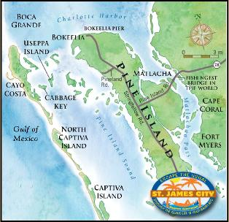](http://www.google.co.kr/url?sa=i&rct=j&q=&esrc=s&source=images&cd=&cad=rja&uact=8&ved=0ahUKEwiOhpiz5p7OAhWJp5QKHQimDUsQjRwIBw&url=http://www.saintjamescity.org/&psig=AFQjCNEXK5F0rV6zsMw8TT3E1993opf9lw&ust=1470078294624075)..

.

.

**Back side of the worksheet #1**

**(Not need to write down on the worksheet)**

TEAM NAME

|  |  |  |
| --- | --- | --- |
| **chosen three items** | **deciding roles** | **strategizing how to escape** |
| **1.**  **2.**  **3.** | **1role:**  **Name:**  **2role:**  **Name:**  **3role:**  **Name:** | **:**  **:**  **:**  **:**  **:**  **:**  **:**  **:**  **:**  **:**  **:**  **:**  **:**  **:** |

**3 Sets of Role cards**

|  |  |
| --- | --- |
| **A** | 그림입니다.There are three people in your family.  Dad is the type of person who loves his family too much.  Mom is adventurous and active.  Tom is 7 years old and a troublemaker.  He loves to eat snacks and climb the tree. Now, he is so exciting. |
| **B** | 그림입니다.Two friends were on the way to go back home.  Two friends did too much shopping.  So they have big pink case each.  Both of them want to take their suitcase. |
| **C** | Three people were on the way to Barcelona for business.  그림입니다.There is a boss, Sophia with glasses. She always likes to make plans  Diana has worked for this company for 3years. She wants to be promoted.  Den is a new employee. He is really working hard but timid. |

**10 items flash cards**

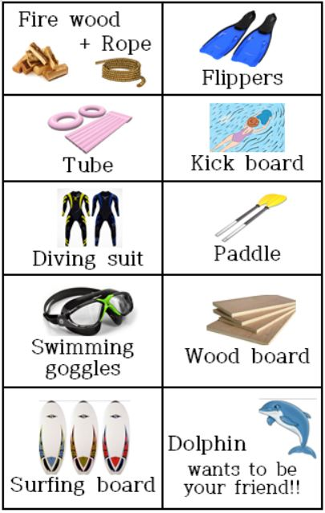

**Work sheet #2**

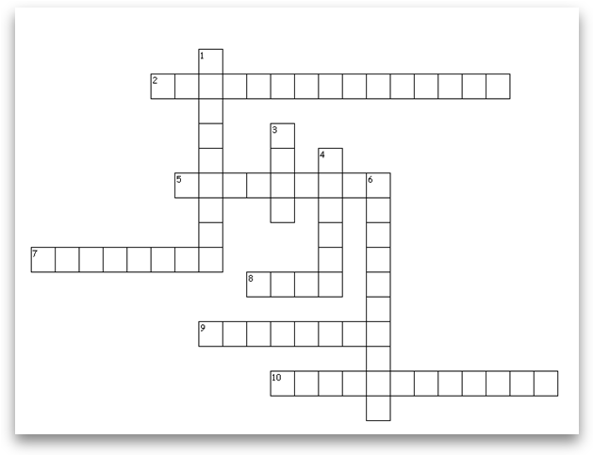Across

**2. you can stare with your eyes wide open when you are under the water**

**5. a flat, thin, rectangular piece of wood used for a particular purpose**

**7. cut into pieces so that it can be burned on a fire**

**8. a thick cord or wire**

**9. flat pieces of rubber that you can wear on your feet**

**10. a flat, thin board for riding on the top of a wave while standing on it**

Down

**1. a flat, thin board used for swimmer to practice kicking**

**3. a long hollow object, usually round**

**4. a short pole with a wide flat part at one end or at both ends**

**6. a waterproof suit, air supply**