☐ Listening ☐ Speaking ☐ Reading ☐ Grammar ☐ Writing

Topic: Phrasal Verbs in Relationship

Instructor:  Mia (Mi Jang) | Level:  Intermediate - Adult | Students:  9 | Length:  35 Minutes

Materials:
- PowerPoint for lead-in
- Worksheet #1 : 9 copies
- Worksheet #2 : 9 copies
- Worksheet #3 : 3 copies
- Phrasal verb cards
- Computer with speakers
- Whiteboard and markers

Aims:
- Students can learn what phrasal verbs are used in relationship.
- Students will be able to practice using the phrasal verbs by making sentences and stories in advance.
- Students will be able to speak fluently by presenting their story.
- Students will work cooperatively in a group by sharing opinions.
- Students can learn phrasal verbs through fun activities so that they don’t get boredom on learning grammar.

Language Skills:
- Listening: two women’s conversation played by T, other Ss’ sentences, other group’s stories
- Reading: the conversation script, phrasal verbs’ definitions
- Speaking: discussion on making a sentence and story
- Writing: Making a story by writing on the worksheet.

Language Systems:
- Phonology: correct pronunciation by listening to the native speakers’ conversation
- Function: hypothesizing, discussing, presenting
- Lexis: multi-words – the definitions of phrasal verbs
- Discourse: discussion on making a story
- Grammar: phrasal verbs

Assumptions:
- All Ss can speak and write in English.
- Ss may already have heard of phrasal verbs before.
- Ss are interested in relationship.

Anticipated Errors and Solutions:
- Some Ss may not understand the instructions clearly.
→ Explain more in details and ask more ICQ’s and CCQ’s.
- If a S in a group seems not participated enough,
→ Give him or her a hint and encourage other Ss in the group to ask him or her opinions.
- If Ss need more time to finish their activity
→ Give them a time warning beforehand, give a couple of more minutes to finish their activity.
- If Ss finish their activity early (SOS plan)
→ Give Ss an extra activity to work on.

References:
Definition of phrasal verb
http://google.com

Audio & Script of conversation for ‘present’ activity
https://www.espressoenglish.net/phrasal-verbs-for-romantic-relationships/

Music for ‘SOS’ activity
http://www.calmenglish.com/blog/taylor-swift-phrasal-verbs

Lead-in
Materials: computer, power point file

Time | Set Up | Student Activity | Teacher Talk
3 min | Whole class |  | Good morning, everyone.  How was your weekend?  I will show you some pictures now.  (Show Ss the power point.)  Can you guys guess what today’s topic for the lesson is?  (Elicit Ss guesses.)  Yes, the topic for today’s lesson is relationship.  Have you guys been in a relationship?  How did you feel when you first start the relationship?  How about when you had to finish the relationship?

Present
Materials: audio file about relationship, worksheet #1, speaker, whiteboard, markers

Time | Set Up | Student Activity | Teacher Talk
2 min  1 min  2 min  1 min  5 min | Whole class | Filling out the blanks in the worksheet #1.  Answering the blanks. | Now, you will be listening to the two women’s conversation. Just close your eyes and try to catch the whole idea what they are talking about.  (Play the phrasal verbs for romantic relationships audio file.)  What are they talking about?  Weren’t there any particular phrases that you have problems on understanding?  Here, I will pass you out a worksheet with its script.  (Passing out the worksheet #1.)  Can you see the blanks in the worksheet?  Weren’t they the tricky parts to understand?  Ok, I will play the conversation again. Now, as you listen, please fill out the blanks in the worksheet and try to guess what they mean as you follow the conversation’s flow.  (Play the conversation.)  Did you all fill in all the blanks?  Does anyone need to listen one more time?  (If yes, play it one more time.)  Let’s see what you have for the blanks.  From ○○○(whoever is seating in the very left side), would each of you tell me what you’ve put in the blank?  Ok, ○○○, next blank please……. So on.  Very good, everyone.  Can you recognize what the phrases in the blanks are? Do you know what they called?  Yes, they are called ‘Phrasal verbs.’  Phrasal verbs are a very important part of spoken English grammar.  What is a phrasal verb?  How does a phrasal verb consist of?  Look at the first blank in the worksheet.  ‘Hitting on.’  Hit ☞ verb  On ☞ preposition  (Write ‘Verb + preposition’ on the board.)  A phrasal verb describes when a verb plus one or more other words, such as an adverb or a preposition, combine to create a new meaning. They’re sometimes also called multi-words or compound verbs.  I am going to give you one example.  (Write ‘pick on’ on the board.)  What’s verb here?  What’s ‘on’?  What does ‘pick’ mean?  pick = to select or choose  on = ‘on top of’ (one meaning of many!)  If we say pick with on together, its meaning becomes totally different.  pick + on = to bully  As you can see here, the meanings that these words create together can be so different from what the original verb has.  CCQ  Can we easily guess what the phrasal verbs mean from their individual parts?  How does the phrasal verb consist of?

Practice
Materials: worksheet #2, phrasal verb cards to Ss pick up, basket

Time | Set Up | Student Activity | Teacher Talk
3 min  3 min | Individually  Individually | Matching  – working on worksheet #2  Picking up one phrasal verb card and make a sentence with it. | Matching Activity  We’ve just listened Emily and Sarah’s conversation, right?  Let’s find out what each phrasal verb means through another worksheet here.  (Passing out the worksheet #2.)  Please Match the phrasal verbs to their correct meanings.  I will give you 3 minutes to work on it.  Time’s over.  Let’s check the answers!  Hit on someone – E  Ask someone out – H  Lead someone on – C  Hit it off with someone – J  Fall for someone – B  Split up / break up – I  Drift apart – M  Hook up with – A  Make up – K  Put up with someone/something – F  Cheat on someone – O  Make out with someone – L  Jerk someone around – G  Go out with someone- D  Settle down – N  Make a Sentence Activity  Let’s move on to the next activity.  Here are the cards for the phrasal verbs we’ve just learned. Please pick one and make a sentence with the phrasal verb that each of you has picked.  Your sentence should be able to convey the phrasal verb’s meaning.  For example, I broke up with my last boyfriend because he wanted kids and I didn’t. You cannot just say I broke up with my boyfriend.  Well done, everyone!

Produce
Materials: Worksheet #3

Time | Set Up | Student Activity | Teacher Talk
1 min  5 min  9 min | Group | Making a story in a group.  Presenting their story to the whole class. | Make a Story Activity  From making a sentence activity, let’s make it advanced!  Let’s make 3 groups.  3 Ss in one group.  Work in a group and make a story with containing these phrasal verbs we’ve learned so far. I expect the story to be fun, romantic, or scary. You can use as many phrasal verbs as possible and you can choose any phrasal verbs to describe in your story.  It should be long enough to present for at least 3 minutes to the class.  (Passing out the worksheet #3.)  I will give you 5 minutes to work on writing the story in the worksheet #3.  (Each group presents their story for 3 minutes.)  Feedback  Which group’s story was funniest?  How was today’s lesson?  Which activity did you enjoy the most?  Hope you all can speak the phrasal verbs from today’s lesson freely and fluently in your future speaking.  Thank you for you participation.  Have a wonderful time for the rest of the day!

SOS Activity
Materials: computer, url: http://www.calmenglish.com/blog/taylor-swift-phrasal-verbs, speaker

Time | Set Up | Student Activity | Teacher Talk
5 min | Individually | Listening to the music and writing down the phrasal verbs  Figuring out the phrasal verbs’ meanings as homework | I will play one song!  It’s Taylor Swift’s ‘We are never ever getting back together.’  (Write the title on the board.)  What is the phrasal verb in this title?  Good, now as you listen to the music, please write down as many phrasal verbs as you can.  And, if you don’t know the meanings of them, it’s your homework to figure them out by tomorrow!

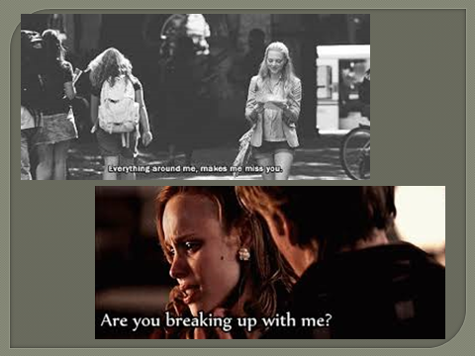
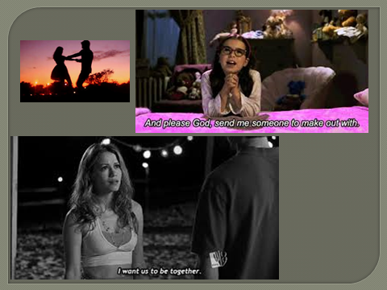
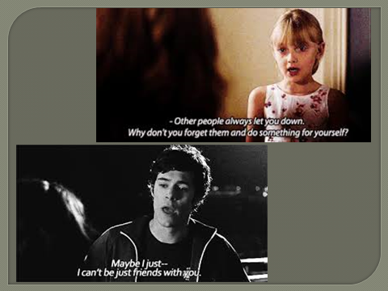
Phrasal Verbs for Romantic Relationships

Emily: Who was that guy you were talking to at the bar? It looked like he was hitting on you.
Sarah: Yeah, we struck up a conversation, and eventually he asked me out. I gave him my number, but I’m not sure if I’ll actually go out with him.
Emily: Oh? How come?
Sarah: He’s nice, but I just don’t feel like we have much chemistry – so I don’t want to lead him on.
Emily: Well, don’t be too quick to judge. My last boyfriend and I didn’t hit it off right away – I only started to fall for him after we went out a few times and I got to know him better. We were together for 3 years.
Sarah: So why’d you split up? If you don’t mind my asking.
Emily: Not at all. We just started to drift apart – different interests, different plans for the future. The breakup was mutual.
Sarah: Ah, that’s great. My last relationship was a nightmare – I hooked up with a guy at a New Year’s party and we were together for six months – but we were constantly fighting and making up. I don’t know how I put up with him for so long.
Emily: How’d it end?
Sarah: He cheated on me – I caught him making out with his ex. He begged me for another chance, but I know he was just trying to jerk me around – so I said no.
Emily: Ugh! Good for you.
Sarah: Heh, thanks. So how about you – are you going out with anyone at the moment?
Emily: Oh, I’ve gone on a few dates here and there, but nothing serious. To be honest, I’m not really interested in settling down just yet – I’m enjoying the single life too much!
Worksheet #1: Fill in the blanks.
Emily: Who was that guy you were talking to at the bar? It looked like he was .
Sarah: Yeah, we struck up a conversation, and eventually he . I gave him my number, but I’m not sure if I’ll actually go out with him.
Emily: Oh? How come?
Sarah: He’s nice, but I just don’t feel like we have much chemistry – so I don’t want to .
Emily: Well, don’t be too quick to judge. My last boyfriend and I didn’t right away – I only started to after we went out a few times and I got to know him better. We were together for 3 years.
Sarah: So why’d you ? If you don’t mind my asking.
Emily: Not at all. We just started to – different interests, different plans for the future. The was mutual.
Sarah: Ah, that’s great. My last relationship was a nightmare – I a guy at a New Year’s party and we were together for six months – but we were constantly fighting and . I don’t know how I for so long.
Emily: How’d it end?
Sarah: He – I caught him his ex. He begged me for another chance, but I know he was just trying to – so I said no.
Emily: Ugh! Good for you.
Sarah: Heh, thanks. So how about you – are you anyone at the moment?
Emily: Oh, I’ve gone on a few dates here and there, but nothing serious. To be honest, I’m not really interested in just yet – I’m enjoying the single life too much!
Worksheet #2: Match phrasal verbs to definitions
Phrasal Verb | Answer | Definition
Hit on someone |  | - (slang) have sex with
Ask someone out |  | - Fall in love with the person
Lead someone on |  | - Give the person false hope or expectations about the relationship
Hit it off with someone |  | - Go on a date with the person once / Be in a relationship with the person
Fall for someone |  | - Demonstrate romantic / sexual interest
Split up / Break up |  | - Tolerate a difficult, annoying, or unpleasant person or situation
Drift apart |  | - Manipulate the person or use them for your own advantage
Hook up with |  | - Invite someone for a date (a romantic encounter)
Make up |  | - Separate, end the relationship
Put up with someone or something |  | - Have a great connection form the first moment you meet the person
Cheat on someone |  | - Reconcile after a fight
Jerk someone around |  | - Kiss the person very passionately
Go out with someone |  | - Slowly go in different directions over time
Settle down |  | - Be in a long-term stable relationship
Make out with someone |  | - Kiss or have sex with another person who is not your husband/wife/boyfriend/girl-friend

Drift apart | Settle down
Hit it off with | Go out with
Fall for | Make up
Cheat on | Lead someone on
Put up with | Ask someone out

Worksheet #3: Make a Story by Using the Phrasal Verbs

