☐ Listening ☐ Speaking ☐ Reading ☐ Grammar ☐ Writing

Topic: Travelling around the world

Instructor:  Chloe | Level: Intermediate (Adults) | Students:  10 | Length:  30 Minutes

Materials:
White board and markers
Powerpoint
Worksheets #1, #2
Card game

Aims:
- Main Aim: Ss will be able to understand question tags clearly by looking at a picture and reading a dialogue.
- Secondary Aim: Ss will practice how to ask and answer to question tags.
- Personal Aim: I would like the Ss to think that grammar is not boring and difficult but fun and easy.

Language Skills:
- Listening: teacher’s elicitation, teacher’s instructions, conversation
- Reading: conversation script, worksheet to answer questions
- Speaking: worksheet answers, drilling, practice activities and sharing ideas
- Writing: worksheet answers, interviews

Language Systems:
- Phonology: drilling
- Lexis: passport, duty free, destination, carryon
- Grammar: use of question tags
- Function: asking and answering question tags

Assumptions:
  - Ss have been to the airport before.
  - Ss have already learned simple yes/no questions.
  - Ss have learned and know how to use first auxiliary.
  - Ss know how to make a positive and negative sentence

Anticipated Errors and Solutions:

Ss may have difficulty in understanding the meaning
→ T provides more examples.
Ss may have trouble with drilling practice
→ T have the Ss read the dialogue and worksheet answer more slowly.
Ss need more time to finish their activity
→ Be flexible with the time and give them more time to finish their activity and cut off the time of post activity.

References:
http://bit.ly/1m9Imoq
http://bit.ly/1Nes2n0
http://bit.ly/2aFCFDn (Dubai Departures)

Lead-in
Materials: White board and markers

Time | Set Up | Student Activity | Teacher Talk
1min  1min | Whole class | Listen to T  Ss answer  Listen to T | Procedure  <Greeting & Eliciting>  T: Hello, everyone. Did you all have a nice weekend?  For me, I went to the airport to see my friend off who was leaving for a long trip. Also, lots of other people were leaving and coming too, and I could feel their excitement so I envied them and also felt excited.  Could you tell me some words related to the airport?  (Elicit: Ss answer and T write the answers on the board. Some expected answers are; luggage, baggage, carry-on, duty free, airplane tickets, lost & found, name of countries, destination, pet, transportation, passport, aisle seat, window seat, flight attendants, airplane…)  Yes! These words are all related to airports. Good job!

Presentation
Materials: Powerpoint(Picture of an airport), conversation script, sound effects of an airport

Time | Set Up | Student Activity | Teacher Talk
2min  3min  2min  1min | Whole class  Ss answer | Listen to T  Ss answer  Listen to T  Ss solve worksheet  Ss read answers  Listen to T  Ss answer  Listen and answer to T | Procedure:  <Introduction of Task>  Now, I would like you to look at the picture on the board. I will read a dialogue that is related to the picture for you to listen. Listen to the dialogue while looking at the picture.  CCQ  1. What can you see on the board?  2. What should you do when I read the dialogue?  (Ss look at the picture on the white board and listen to T read the dialogue. T read clearly and slowly with correct intonation and action. Use different voice for each role.)  1. Recall  T: Now, I will hand out a worksheet for you. Listen to the conversation once more and try to fill in the blanks.  (T reads the conversation once more this time without acting.)  2. Reflect / Controlled Practice 1  Did you fill in all the blanks? Now, from OOO, could each of you read the sentence including the answers?  (OK, OOO, next sentence please… keep going till finished)  That was great! Now, can you recognize what you filled in? Do you know what they are called?  (Try to have the Ss elicit and say the word ‘question tags’ or ‘tag questions’.)  3. Conclude  Yes, they are called ‘Question tags’.  We use question tags at the end of sentences to turn them into questions. When do you think we use them?  (Ss answer. Some expected answers are; when we want to check something is true or have someone to agree. If Ss can’t answer, T shows PPT with answer and have Ss read it out.)  Then, how do we use questions tags?  If the main part of the sentence is positive we add…(have Ss answer first and then show the arrow)  If the main part of the sentence is negative we add…(have Ss answer first and then show the arrow)  Let me show you some examples.  (T show PPT with sentences, and have Ss answer and afterwards, show the answer.)  You understood how to make positive and negative sentences using question tags.  Now, focus on the verbs. Let’s answer some examples.  If there is an auxiliary, a modal verb or the verb to be in the main clause, we use that in the question tag. If there is another main verb, we use do in the correct form.  (T show PPT with sentences, and have Ss answer and afterwards, show the answer.)  Controlled Practice 2  Great job! Let’s look at the second worksheet I handed out and just read the sentence with the answers.  (Have Ss read each sentence. The person who read at the last starts first this time.)

Practice
Materials: One set of question cards and one set of tag cards per group

Time | Set Up | Student Activity | Teacher Talk
10min | Group Work | Discussion | Procedure:  Less- Controlled Practice  T: Alright, now I would like you to gather into 3 groups. 1, 2, 3, 1, 2, 3. Please move your seats.  We will play a matching game. I will give each group one set of question cards and one set of tag cards. Look at the instructions and play the game. When you have a winner, shout ‘I win!’ I will give you 5 minutes.  CCQ  1. What kind of game will you be playing?  2. When you win, what do you say?  3. How much time do you have?  Okay, let’s start the game! Have fun!  (Ss play the game. Time the game and stop when either time is finished or we have a winner for each group.)  T: Okay, ‘time is over’ or ‘we all have a winner!’  Congratulations!  You all did have fun, didn’t you?

Production
Materials: White board and markers

Time | Set Up | Student Activity | Teacher Talk
3min  5min  2min | Whole class  Or Individually  Pair Work  Whole Class | Drills  (transformation)  Interview  Ss share interviews | Procedure:  T: Now, I want to practice some drills. Make the sentence I am speaking into question tags. For example; She likes to travel. She likes to travel, doesn’t she?  Now, let’s change this sentence.  ‘She has been to Croatia.’  Ss say ‘She has been to Croatia, hasn’t she?’  ‘I didn’t miss the train to Rome.’  Ss say ‘I didn’t miss the train to Rome, did I?  T: Good job! Now, OOO your turn. ‘You like to travel.’  (OOO change to ‘You like to travel, don’t you?  T: Can you answer the question OOO?  (have another Ss answer to his/her experience)  T: OOO your turn. ‘You’ve visited more than 4 countries.’  (OOO change to ‘You’ve visited more than 4 countries, haven’t you?  T: Can you answer the question OOO?  (have another Ss answer to his/her experience)  Excellent!  Free Practice  T: Now, I would like you to get into groups. Look at the person next to you and gather into two.  You will be interviewing each other. The topic will be about ‘Travelling to another country’.  Make three sentences using question tags and answer them correctly. I will give you 5 minutes.  T: Can I have volunteers?  (one or two Ss come out and perform their interviews)  T: Great job! Learning about question tags was fun, wasn’t it? I hope you can use them in your daily conversations with confidence!  Have a great day! This is the end of class.

SOS Activity
Materials: Role play cards that are related to the main activity but new words (train, bus, airplane, ferry, bicycle, on foot, helicopter), tape

Time | Set Up | Student Activity | Teacher Talk
5min | Pairs | Taboo: What am I? | Ok, class. Now we will do a simple game called ‘What am I?” Each will get into pairs and pick a new card. The most important thing is that you should NOT look at the card you picked. You will stick it on your forehead with a tape and each take turns to ask questions to your partner for clues. You should use question tags!!!  ex) I have four wheels, don’t I?  When you think you know what it is you can guess. The person who first guesses what is on their foreheads is the winner! We will give you five minutes.  ICQ  1. Can you look at the card you picked?  2. Will you take turns when asking the questions?  3. How much time do you have?

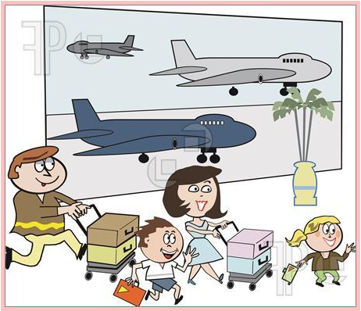
Dad: We are finally at the airport, aren’t we?
Mom: Yes, we are. I’m so glad we made it on time.
Dad: Let’s check-in first. We brought all our luggage, didn’t we?
Mom: Yes, we did. You didn’t forget to bring our passports, did you?
Dad: No, I didn’t. I have all the passports with me. You have the tickets, don’t you?
Mom: No, I don’t. Oh, no! Where are they?
James: Don’t worry, I have them. We should go to gate no. 7, shouldn’t we?
Sally: No, we shouldn’t. We should go to gate no. 17.
James. Oh, thank you, Sally. Mom, we have time to go to the lounge, don’t we? I’m hungry.
Mom: Yes, we do. We still have four hours left for our plane.
Sally: We can also go to the duty free, can’t we? I want to but some sweets.
Dad: Yes, we can. But you get to choose only one.
Sally: Okay, daddy….. We should buy some gifts for our grandmother, shouldn’t we?
Dad: Yes, we should. I’ll let you and James choose her gift.
James: Okay, Still, we are going to the lounge first, aren’t we?
Dad: Yes, we are. Let’s first go check in.

Worksheet #1

Dad: We are finally at the airport, aren’t we?
Mom: Yes, we are. I’m so glad we made it on time.
Dad: Let’s check-in first. We brought all our luggage, didn’t___ we?
Mom: Yes, we did__. You didn’t forget to bring our passports, did you__?
Dad No, I__ didn’t. I have all the passports with me. You have the tickets, did____ you__?
Mom: Yes, we did__. Oh, no! Where are they?
James: Don’t worry, I have them. We should go to gate no. 7, didn’t___ we__?
Sally: Yes__, we are___. We should go to gate no. 17.
James. Oh, thank you, Sally.
Mom, we have time to go to the lounge, did___ you__? I’m hungry.
Mom: Yes, we did._. We still have four hours left for our plane.
Sally: We can also go to the duty free, did___ you__? I want to but some sweets.
Dad: Yes, we did._. But you get to choose only one.
Sally: Okay, daddy….. We should buy some gifts for our grandmother, did___ you__?
Dad: Yes__, we are___. I’ll let you and James choose her gift.
James: Okay, Still, we are going to the lounge first, did____ you?
Dad: Yes, we did._. But first, let’s first go check in.
Worksheet #2

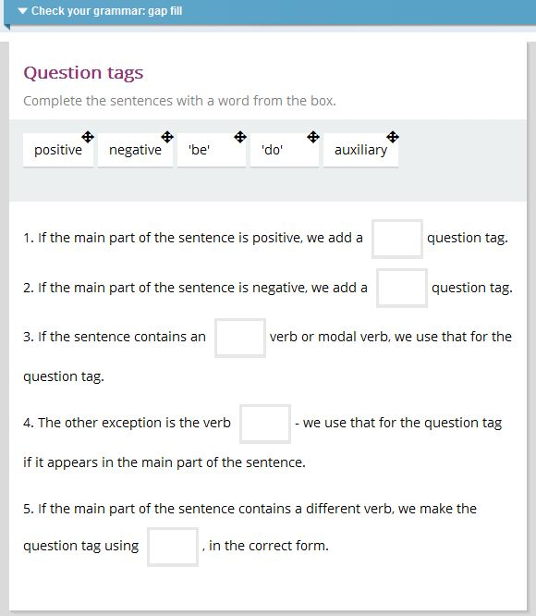

Worksheet #2 answers

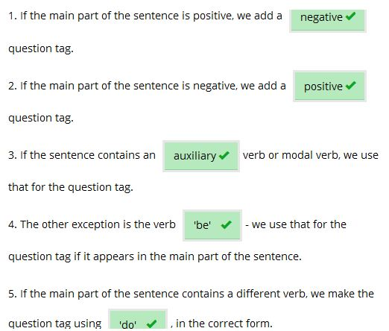

★☆ FIND MY PAIR!! ★☆

<Directions>

- Give each group one set of question cards and one set of tag cards.
- Shuffle all the cards together and hand them out so that each member gets the same number of cards. DO NOT LOOK AT THE CARDS.
- Choose order by rock, scissors and paper.
- The first player lays down a question card.
- The player with the matching tag card should then lay down their card and ask the full question.
- The first player must reply.
- When the first player has answered the question, he/she can keep the cards.
- The player with the most cards is the winner. Shout ‘I win!’

Question cards (Cut the dotted lines)
You haven’t taken the bus, | He brought the tickets,
I am going the right way, | She will take the train,
They haven’t eaten since 10:00, | We didn’t lose our way,
He didn’t ask for my help, | Mary didn’t miss the ferry,
You did make the reservations, | Kim hasn’t been to Paris,
They didn’t forget our luggage, | You checked the lost and found.
The pets won’t miss us, | Mary and Dory brought a map,
I think she went by bus, | He thinks Chloe went  to Bangkok,
You should have bought a camera at the duty free, | I told him to exchange  the wons to dollars,
We are on right track, | You didn’t tell her to change  the time,
She couldn’t have met  the gypsies, | I can bring some medicine,
They are going to the beach, | They can come with us,

Tag cards (Cut the dotted lines)
have you? | didn’t he?
aren’t I? | won’t she?
have they? | did we?
did he? | did she?
didn’t you? | has she?
did they? | didn’t you?
will they? | didn’t they?
didn’t she? | doesn’t he?
shouldn’t you? | didn’t I?
aren’t we? | did you?
could she? | can’t I?
aren’t they? | can’t they?

