☐ Listening ☐ Speaking ☐ Reading ■ Grammar ☐ Writing

Title: future plan

Instructor:  Eun A Kim  (Ella) | Level:  Intermediate(Adult) | Students:  10 students | Length:  30 minutes

Materials:
- Power point
- Worksheet# 1
- Worksheet# 2
- Timer
- Board, Board markers
- Worksheet # 3
- Worksheet # 4

Aims:
- Students will predict the meaning of the future perfect tense by answering the teacher's warm up questions, time lines and CCQ.
- Students will know the form of the future perfect tense by teacher's explanation and substitution table.
- Students will know the future perfect tense's interrogative, affirmative and negative form by teacher's explanation.
- Students will practice speaking skill by sharing the graph's information with a partner and bucket list using future perfect tense.

Language Skills:
- Reading: Ss will read presentation, questions on worksheet.
- Listening: Ss will listen to the teacher's questions, instructions, explanation.
- Speaking: Ss will answer the teacher's questions, practice activities and sharing ideas.
- Writing: Ss will write answers on worksheet, bucket lists.

Language Systems:
- Lexis: New form of verb
- Grammar: use of future perfect tense
- Function: telling the future plan

Assumptions:
Students already know
- How the class is set up and run
- How they share opinions with their partners
- Four language skills and language systems
- How to use simple future tense
- Students are adults

Anticipated Errors and Solutions:
If student have difficulties in changing the verb to make future perfect tense form.
→ provides right form to complete the sentence.
If students are not able to understand the instructions
→checks why they are having difficulty in getting the instructions and help them using ICQ.
If students doesn’t understand how to share the graph’s information
→gives demonstration to make Ss do the activity smoothly.

References:
www.likedin.com
www. screeninsults.com
http://personalexcellence.co/blog/bucket-list/
http://myinfinitebucketlist.tumblr.com/

Lead-In
Materials: None
Time | Set Up | Student Activity | Teacher Talk
1min | Whole class | Answering the questions | 1. Greeting  T: Good morning, everyone! How are you today? Is it good or tough day?  Everyone, can you tell me.... what will you have done by 3pm Friday August the 19th?  Can you believe that we will finish our course next week?

Presentation
Materials: Power point
Time | Set Up | Student Activity | Teacher Talk
2mins  1min  2mins | Whole class  Whole class  Whole class | Looking the Ella’s life curve  Answering the question  Answering the question | 1.Do: inductive grammar warm-up  (show Ella’s life curve on the screen)  T: This is Ella. She is 15 years old now.  In school, she draws her life curve. She has a big plan for future.  Let’s look at her curve.  By the time she is 25, she will have opened her own bakery. And by the time she is 40, Ella will have built her lovely house. And the last, she will have traveled to space with her dog by she is 55.  CCQ  Have you made life curve?  Do you think she can travel to space?  2.Recall  T: Have you used this kind of sentence?  When do we use this sentence?  3.Reflect  Can you remember how I explained Ella’s plan?  (write By the time she is 25, she will have opened her own bakery.)  What do you see in the form of this sentence?  (Or)How can we make the sentence?  (on the board, will + have + p.p)  What is the meaning?

Practice
Materials: Worksheet# 1.Worksheet# 2 Timer, Board, Board markers.
Time | Set Up | Student Activity | Teacher Talk
3mins  3mins  2mins  1min  3mins | Whole class  Whole  class  individually  Whole class  Pairs | Listening the teacher’s explanation  Listening the teacher’s explanation  Completing the sentence  Answering the teacher’s question  Sharing the graphs | 1. Conclude(Elicit 1)  ①Form  Instruction  T: The future perfect form is will plus have plus past participle.  (write down the form  Subject + will + have + past participle + objective)  T: Usually future perfect tense is used with -by + future time.  (write down -by + future time)  Do you remember what I asked to you in the beginning of the class? I said by the end of September and by the end of the TESOL class.  Also by the time + S + V is often used with future perfect tense.  (write down by the time + Subject + Verb)  There is an example.  (EX: It could be ‘By the time I finish the TESOL course, I'll have learned a lot’.)  There is a rule that students need to know, after by the time you have to use present simple tense.  Conclude(Elicit 1)  ②Meaning  T: You already know the meaning. But, it is better to check accurately. The meaning is to talk about something that will finish before a specific time in the future.  This is the time lines to help you understand meaning.  (draws Time lines on the board)  T: We don't use future perfect tense like present perfect in spoken English. But we add an adverb to express degree of likelihood.  Let me show you an example.  (write the example on the board)  By tonight, I'll probably have uploaded my homework.  1. Controlled practice activity (Gap fill)  We've just learned how to use future perfect tense. Right?  So it's time to practice the grammar.  Here is gap fill worksheet# 1  (Distribute the worksheet# 1)  Instruction  First, read the sentence carefully and check the basic verb in brackets.  Second, complete the sentence changing the verb into correct form of the future perfect. I'll give you 2 minutes.  ICQ  What do you have to change?  How much time do you have?  Time warming  1 minutes left.  Checking the answers  T: Alright. Time’s up. Let's check the answers together.  T: What is the answer of the number 1?  ∙∙∙∙∙number 5.  You don't need to worry about the wrong answers. Just read the sentence again and think one more time.  1.Less controlled practice activity  T: Now, you will do more activity with your partner.  Imagine you and your partner are working in a different department. Before attending the conference or meeting you need to share your graph's information.  Instruction  T: You and your partner will receive two different graphs with blanks and missing parts. Both of you need to describe the graphs each other to complete.  (Distribute the worksheet #2)  Try to use the future perfect tense spontaneously. I will give you 3 minutes to talk.  ICQ  Are you working alone?  How much time do you have?  Time warming  Set the timer.  One minute left.  T: Good. Please, pay attention.  Compare the graphs with your partner for one minute.  (after one minute)  Do you think you can attend the conference?

Production
Materials: Pictures, Worksheet# 3, Timer
Time | Set Up | Student Activity | Teacher Talk
2mins  3mins  3mins  2mins  1min | Whole class  Individually  Whole class  Whole  class  Whole  class | Answering the questions  Writing the lists  Sharing their bucket list with classmates  Checking the errors | 1. free production activity  T: Everyone.  (show the bucket picture)  Just look this picture and tell me the word that comes up?  (listens the Ss' answer)  Anything else?  T: At the beginning of the class we talked about our plan for next 10 years.  Have you seen this movie?  (shows the movie poster:  THE BUCKET LIST)  This movie is about two terminally ill met on their trip road with a wish list of things to do before they "kick the bucket"/die.  Bucket list is not about your huge wish.  (shows the picture #1)  T: It could be what you have always wanted to do but have not done yet. Or any countries, places or locations you want to visit.  Here are some examples. Look at the screen.  (shows the picture# 2,3,4,5,6)  Now, I will give you time to think your bucket list. Write at least 3. I will give you 3 minutes to think and write.  ICQ  How many lists do you have to write?  How much time do you have?  (Sets the timer)  Monitoring  (after 2 minutes)  Time warming  One minute left.  T: Do you need more time?  Okay, it will be interesting to share your bucket list. Choose one of your list and share with your class. Also, please tell us the reason briefly.  2.Feedback &Error correction  T: While you were doing the activity there were some errors. Let’s correct together.  3. Conclude the lesson  T: Did you enjoy the activity?  I hope you have a fun today. We will talk about the future progressive next lesson. There is no homework. Try to practice future perfect tense in your life and conversation.  See you next lesson.

SOS Activity
Materials: Worksheet #4
Time | Set Up | Student Activity | Teacher Talk
3mins  2mins | Individually  pairs | Correcting the mistakes of the conversation  Comparing the answers | 1. Correcting the mistakes  Instruction  T: Now, we will correct the mistakes of the conversation. Think you are a teacher. In the class, your student makes mistakes writing the conversation. So as the teacher, you need to correct. Read, check carefully and correct thinking about the reason. I will give you 3 minutes. And then, I will give you time to compare the answers with your partner.  Everyone, start.  CCQ  How much time do you have?  What do you have to do first?  Time warming  One minute left.  (after 1minute)  T: Alright. Compare the answers. If you get different answers you need to have little discussion.

Worksheet # 1- Gap fill

1. By the time the mother arrive, I the kitchen.
(clean)

2. By this time next year, I from the university.
(graduate)

3. The restaurant by the time we arrive there.
(not, close)

4. What by the end of this year?
(you, do)

5. By the end of the day, do you think reply by her?
(you, receive)

6. You your homework by the deadline.
(not, finish)

7. By the time we the office, all lights .
(leave, turn off)

Worksheet # 2- sharing the information

Student A
Describe you graph to your partner.
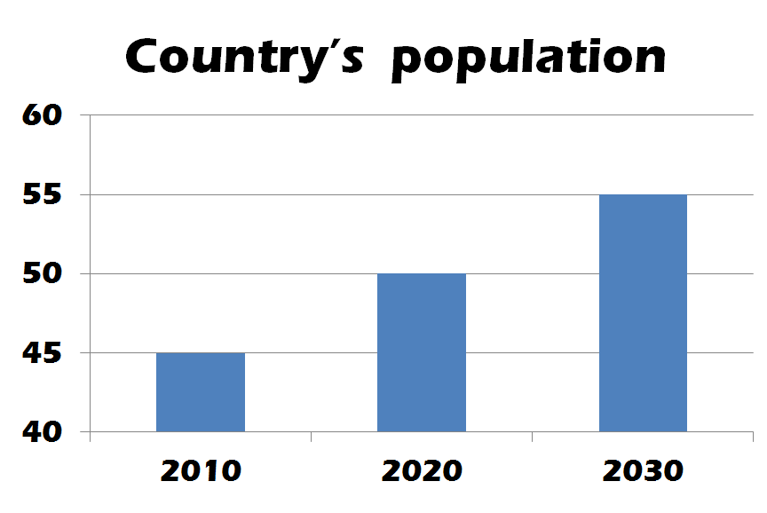

Student B

Worksheet # 2- sharing the information

Student A

Student B
Describe you graph to your partner.

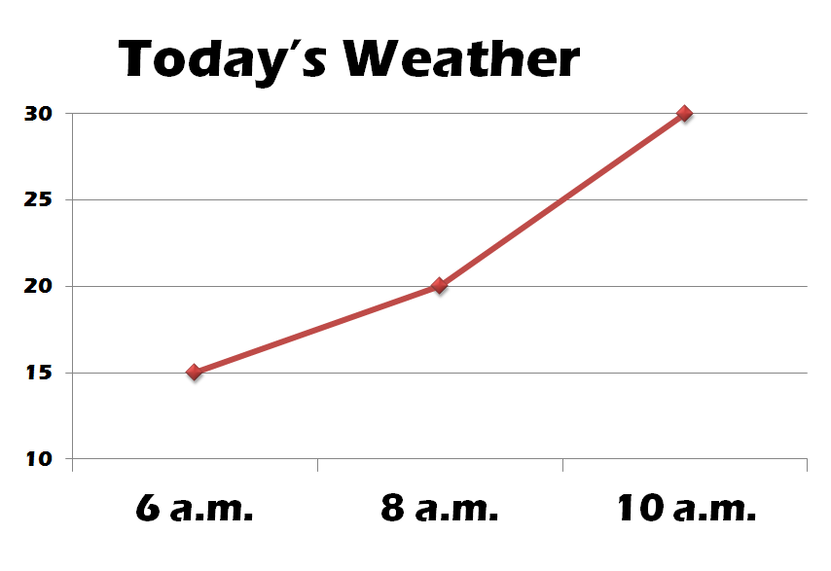

Worksheet # 3- Making Bucket list

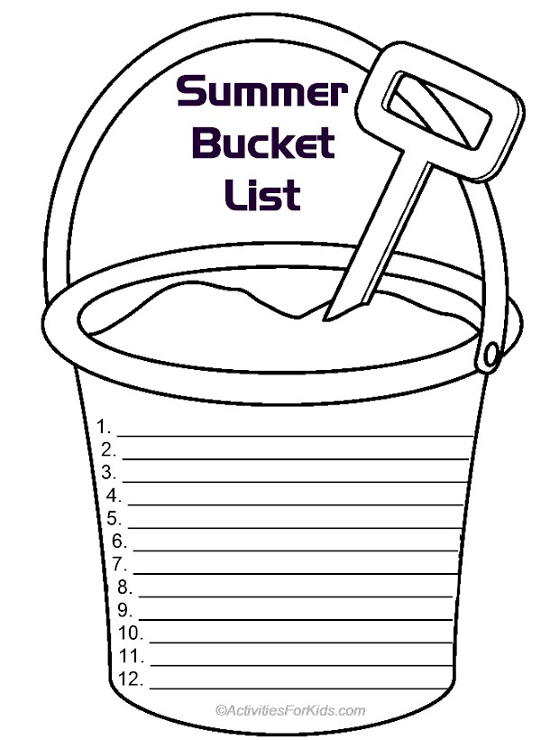

Worksheet # 4- Correcting mistakes

1. I will get a job by the time I will graduate.

2. This time tomorrow you’ll finish your report.

3. By 2030, I will become an English teacher.

4. I’ll have finished the book next week.

5. By the end of the trip, she will make many friends form different countries.

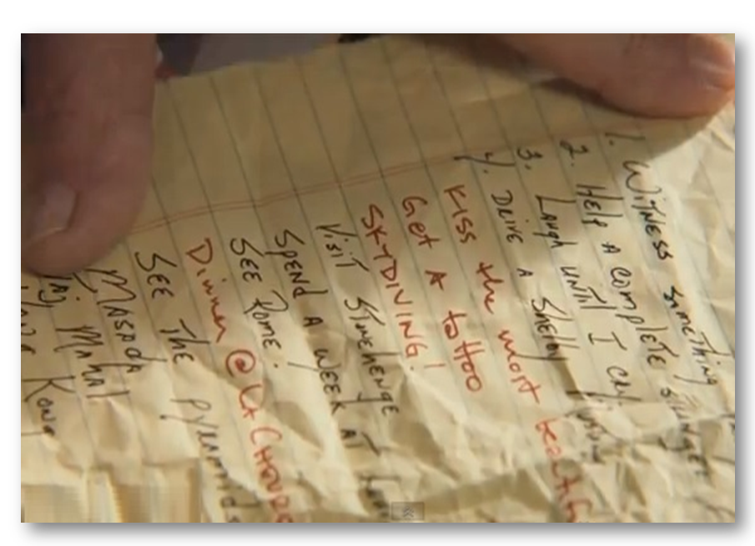
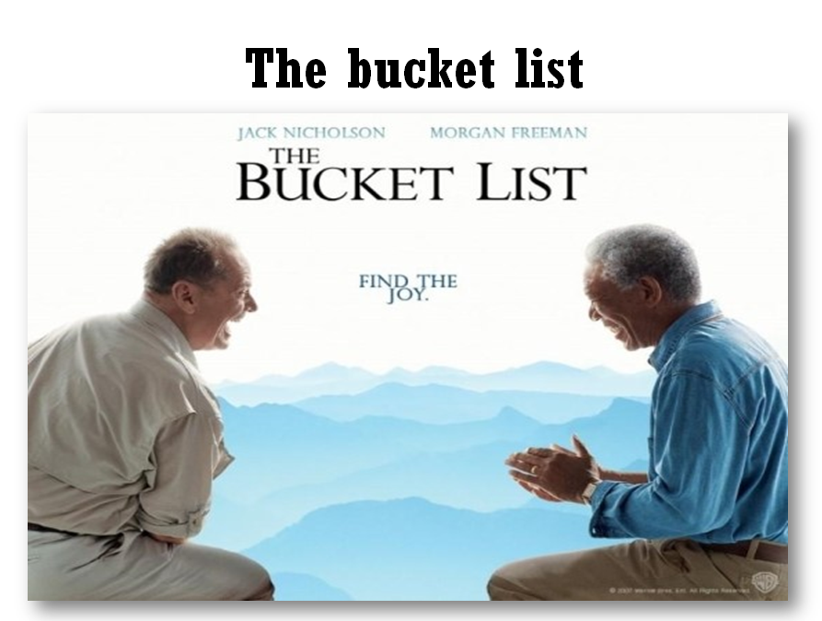
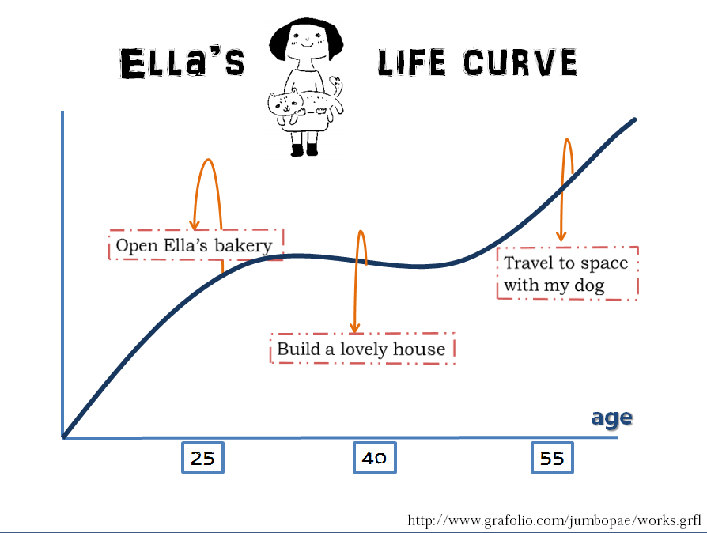
Power point slides

