☐ Listening ☐ Speaking X Reading ☐ Grammar ☐ Writing

Topic: Sign Language

Instructor:  Chloe and Kim | Level:  Intermediate | Students:  10 Students | Length:  35 Minutes

Materials:
- Video
- White Board and Markers
- Reading material
- 10 copies of worksheet #1, #2

Aims:
- Ss will improve writing skills through answering applied questions.
- Ss will improve reading skills through reading the material and try to
understand the context.
- Ss will improve speaking and listening abilities by sharing ideas related
topic in a group.

Language Skills:
- Reading : reading and understanding
- Writing : describing and explaining
- Speaking : sharing ideas in a pair/group
- Listening : listening to Teachers and Students presentation, instruction,
demonstration.

Language Systems:
- Lexis : sign, deaf, palm, upward, downward, guts, tilt, stimulate,
self-esteem
- Function : understand how to show feelings by using sign language
- Discourse: asking and answering to “How are you?” using the sign
language each pair/group of Ss studied.

Assumptions:
- Ss can move their body without problem.
- Ss know how to express their feelings in spoken English.
- Ss are not shy.

Anticipated Errors and Solutions:
- Ss may not understand pictures on the worksheet #3
→ draw a sketch on the board or allow them to google it
- Some Ss may finish the main tasks earlier than others
→ let them to continue working with other pictures.

References:
- Title : What is sign language ?
Link : Youtube : http://www.lifeprint.com/asl101/pages-layout/concepts.htm
- Title : Sign language about feelings
Link : Google image

Lead-In
Materials: White board & Markers(write class itinerary on the left side of the board : date, vocabulary, text reading, comprehension task, writing task)
Time | Set Up | Student Activity | Teacher Talk
3 min  1min | Whole class  Whole class | Greeting  Answering questions  watching at the video | Procedure  -Greeting  Good morning. How are you?  -Guiding questions  Have you ever been in a situation with someone who didn’t use same language?  When you are under the situation that you cannot leave even a memo, but you need to transfer your word in silence like library or during conferences what do you do?  ( Doing sign language  How are you? I am happy and you?)  Do you know what I am doing now?  -Introducing today’s topic  Today, we will talk about “Sign Language”  Now I will show you one video and we will share what is sign language.  This video, It is helpful for you to understand today’’s topic.  Focus on perceiving what is sign language.  ( Play the video : 1 min )

Pre-Reading
Materials: White board & Markers,

Time | Set Up | Student Activity | Teacher Talk
2 min | Whole class | Learn Vocabulary | Procedure  -Instructions  Before we start, I would like to check some important vocabulary we will be learning today. Please, look at the white board. Do you see any words you find difficult? Let me ask some of you and share each word’s meaning.  (ask Ss the meaning of some words;  palm (keyword method), guts,  stimulate (synonyms).)  Good job! Now, let’s get into the reading materials!

Main Reading
Materials: White board & Markers, Reading material, worksheet #1, #2

Time | Set Up | Student Activity | Teacher Talk
5min  6min  1min | Whole Class  Individual  Whole class | Read the article  Solve the worksheet  Check the answers | Procedure  -Instructions  I will hand out the reading material. First, read the reading material individually. I will give you 5 minutes to read. While reading, here are two questions to think about.  1. How can sign language be helpful to not only the deaf but others?  2. What is the most important thing to keep in mind when doing sign language?  Now, let’s start!  (Ss read the article and when the 5min is almost finished, hand out worksheet #1.)  While you were reading, I handed out a worksheet for you to fill out. It is individual work, but you can ask me or the person next to you if you have any questions or difficulties. I will give you 6 minutes.  ICQ  1. What should you do now?  2. Are you working alone or as a group?  3. Can you ask the person next to you?  4. How much time do you have?  (Ss do the worksheet.)  Now we will check the answers together. Let’s take turns starting from OOO.  (Ss take turns answering. There is no right answer for question 1. Hear Ss idea and see if the answers are related to the paragraph.)

Post Reading
Materials: 10 copies of worksheet # - writing task ( applied questions ) , poster of feeling in sign language.

Time | Set Up | Student Activity | Teacher Talk
2 min  5 min  9 min  1 min | Whole class  In pairs  Whole class  Whole class | Listen to the teacher  Students will work in pair  Make presentation  Answering in sign language, greeting | Procedure:  Instructions  ( Hand out worksheet #2 )  Look at the worksheet.  Can you see some pictures of feeling alongside spaces to write?  You will write down explanation how to use sign language with description.  Three or four sentences will be enough so don’t feel to be pressure.  Work with your partner.  When you complete writings, we will share how to express each feelings in sign language and have a conversation with whole class using gestures..  Demonstration  First, Chloe and I will show you the way how to work.  ( demonstration -Thirsty)  Look at this picture.  What do you think she is doing, Kim?  She close her fist with pointing a finger at throat.  And She put index finger to her neck.  And.. what do you think Chloe?  She is moving forefinger downward.  Ah.. so let’s writhing down and practice to show how to express “thirsty” to other students.  Do you understand?  You have 5 min.  CCQ  1. What will you do?  2. How much time do you have?  3. Who do you work with?  ( Run task, monitoring, error correcting )  You have 1 min left!  Time’s up!  Have you all finished?  From now on, we will share how to talk in sign language.  Come forward and make presentation of your working with partner.  When other group teaches you, try to follow the gestures. .  Closing  It’s time to wrap up.  Today, We talked about “Sign Language.” Did you enjoy it?  So, How are you? (in sign language)

SOS Activity
Materials:

Time | Set Up | Student Activity | Teacher Talk
5min | In Groups | Speed game | Procedure  Instructions  We will play a speed game. Look at the poster of the sign language once more. You will be divided into two groups. Group 1 will first use sign language to ask “How are you?” Group 2 will use sign language to answer. Group 1 has to guess what feeling they expressed. When they get the answer, switch roles and this time Group 2 will ask and Group 1 will answer. Keep on going.

-Reading material-
Sign Language
______________________________________

Sign language is a form of communication that uses hand movements instead of sound. It is not just a way for deaf people to communicate; researchers have found that sign language can help many people, especially young children. Researchers say sign language is good for our brains and emotions. Since we use our hands, body, and facial expressions to communicate, we are able to show our feelings in more ways. These body movements are connected to the advancement of the brain, and also influence the self-confidence and emotions of children. Here, we would like to introduce some body languages that express our emotions and feelings. The body languages you will learn below are from the American Sign Language.

______________________________________

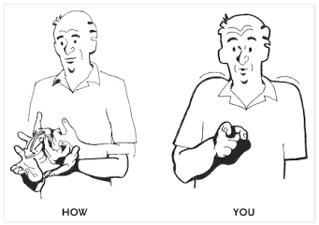
When we meet someone we can start by asking the other “How are you?” The sign for “How are you?” is first made by placing both hands in front of you. Raise your two thumbs and have the other fingers’ back meet. Both hands move at the same time and in the same direction; from in front of your chest to the front so that the palm faces above. Next point at the person you are talking to. “How are you?” is the two motions combined.

______________________________________
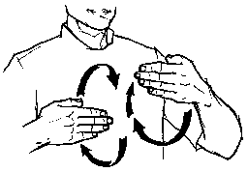
The sign for "happy" is made by placing one or both of your hands in front of you. Use "flat" hands, palms pointing back. Circle your hands forward, down, back, up, forward, down, back, up. Both hands move at the same time and in the same direction. On the upward swing the hands are very close to your chest or touch your chest. On the downward swing your hands are further away from your chest.

__________________________________
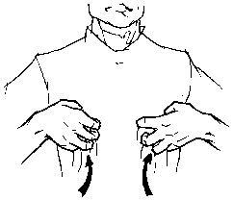
The sign for "angry" is made by forming "claw" hands and placing your fingertips against your stomach. Pull both hands forcefully up and outward. As a hint for your memory, think as if being so mad you could rip your guts out.

________________________________________
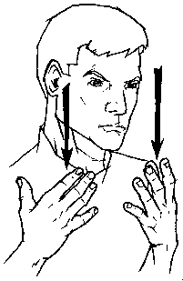
The sign for "sad" is made by placing both hands in front of your face, palms in. Bring both of your hands down the length of your face. Tilt your head forward slightly, and make a sad face.

___________________________________

The sign for “love” is made by first forming fists with your two hands. Afterwards, you should make a cross with your both hands and place them over the middle of your chest.

____________________________________

These are just a very few of sign languages that express feelings. There is one very important thing that you should keep in mind. Along with the sign language, it is also important to use facial expressions. When you are making a sign for “happy”, you can smile and show that you are happy. When you are angry, it is important to use an angry facial expression. Sign language stimulates our brain’s language abilities and also allows us to express ourselves and increase our self-esteem. So, how about learning this interesting language?

Worksheet #1
1. Go back to the reading material and write a heading for each paragraph.

2. Read the article again in more detail. After reading, answer the questions below.
a. Is sign language a way for only the deaf people to communicate? ( T / F )

b. What movement does NOT express the sign language for “How are you?”
① You should raise your two thumbs and have the other fingers’ back meet.
② You should move the hands in different directions.
③ You should point at the person you are talking to.
④ You should move your hands from the chest to the front.

c. What movement expresses the sign language for “happy”?
① Make a cross with your both hands.
② Circle your hands forward, down, back up twice.
③ Tilt your head forward slightly.
④ Act as if you could rip out your guts.

d. What is the most important thing you should keep in mind when you use sign language?

_______________________________________________________________________

e. What is NOT true about sign language?
① It can help stimulate our brain’s language abilities.
② It can help the emotions of the young children.
③ It can help build our physical abilities.
④ It can help increase our self-esteem.

f. What do you think is more important; to show our feelings or to hide our feelings?

_______________________________________________________________________

g. If you were to teach sign language, what would you teach first? Why?

_______________________________________________________________________

ANSWERS for Worksheet #1

1. Go back to the reading material and write a heading for each paragraph.

2. Read the article again in more detail. After reading, answer the questions below.
a. Is sign language a way for only the deaf people to communicate? ( T / F )

b. What movement does NOT express the sign language for “How are you?”
① You should raise your two thumbs and have the other fingers’ back meet.
② You should move the hands in different directions.
③ You should point at the person you are talking to.
④ You should move your hands from the chest to the front.

c. What movement expresses the sign language for “happy”?
① Make a cross with your both hands.
② Circle your hands forward, down, back up twice.
③ Tilt your head forward slightly.
④ Act as if you could rip out your guts.

d. What is the most important thing you should keep in mind when you use sign language?

It is most important to also use facial expressions.

e. What is NOT true about sign language?
① It can help stimulate our brain’s language abilities.
② It can help the emotions of the young children.
③ It can help build our physical abilities.
④ It can help increase our self-esteem.

f. What do you think is more important; to show our feelings or to hide our feelings?
g. If you were to teach sign language, what would you teach first? Why?
Ss write their own thoughts for f and g.
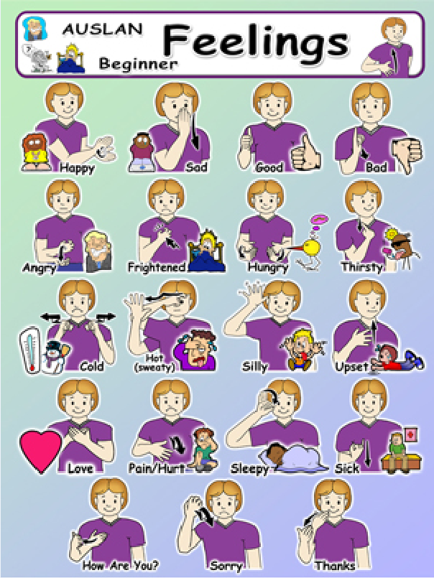

Worksheet #2 ( Writing Task )
Applied question
: Describe gestures below.
: Talk in sign language about feelings.

_________________________________________________________

__________________________________________________________

 



