☐ Listening ☐ Speaking ☐ Reading ☐ Grammar ☐ Writing

Topic: Wedding in Different Countries

Instructor:  Jihyun(Jihyun Jang), Mia(Mi Jang) | Level:  Upper Intermediate | Students:  8 | Length:  35 Minutes

Materials:
- Lead-in: Justin & Emily’s wedding video(2:50), computer, speaker
- Pre-reading: whiteboard, markers, broom(realis), pictures of porcelain, pictures of ornaments, necklace made by Jihyun and Mia, Mia’s cross-stitch work, Mandarin duck(realis)
- Main reading: Worksheet #1(8copies),Teacher’s answer sheet, White board and markers
- Post-reading: stainless bowls and cups, tumbler with attached printed pictures of porcelain, wedding shoes, name tags, blue blanket, Jihyun’s red handbook dress, handkerchief with attached printed pictures of mandarin duck, long necklace made by Mia and Jihyun, ring made by the lord of the rings team, worksheet#2(4copies) and #3(8copies)
- SOS activity: worksheet#4(8copies), color papers, color pens, color markers

Aims:
- Students can learn 4 different countries’ cultural wedding through reading a passage.
- Students will be able to practice skim and scan reading.
- Students will be able to understand clearly the main point of the reading by answering the questions in the worksheet and describing activity.
- Students will work cooperatively in pair by sharing opinions.
- Students can learn how to present their speech without shyness through describing activity.

Language Skills:
- Listening: T’s explanation on vocabularies, T’s instruction, other Ss’ opinions
- Reading: reading material about wedding, answering the questions on worksheets
- Speaking: discussion on the way how to describe the country’s wedding with their partner, presenting the description of the country’s wedding, discussion on which country’s wedding is the most interesting with the reasons
- Writing: answering the questions on worksheets

Language Systems:
- Function: discussing, presenting, reading
- Lexis: key vocabularies explanation before reading (Give examples)
- Discourse: discussion on describing the country’s wedding ceremony in pair

Assumptions:
- All Ss can speak and write in English.
- Most Ss usually enjoy doing a role-play.
- Ss are about the age to get married.
- Some Ss are already married and some are not yet.
- Some Ss are from different country.

Anticipated Errors and Solutions:
- Some Ss may not understand the instructions clearly.
→ Explain more in details and ask more ICQ’s and CCQ’s.
- If a S in a group seems not participated enough,
→ Give him or her a hint and encourage other Ss in the group to ask him or her opinions.
- If Ss need more time to finish their activity
→ Give them a time warning beforehand, give a couple of more minutes to finish their activity.
- If Ss finish their activity early (SOS plan)
→ Give Ss an extra activity to work on.

References:

Video for lead-in
https://www.youtube.com/watch?v=ZxL81hkk-4I

Reading material for main activity
http://www.onestopenglish.com/

Videos for post-activity after Ss’ role plays
Germany wedding: https://www.youtube.com/watch?v=xCurMrTmuXY
Turkey wedding: https://www.youtube.com/watch?v=2TSWSnDL-IM
The Maasai wedding: https://www.youtube.com/watch?v=EW-Ku8wm-7Q
Chinese wedding: https://www.youtube.com/watch?v=gpxpO0GuYzE

Pictures for explaining the vocabularies
http://google.com

Lead-In
Materials: Justin & Emily’s wedding video(2:50), computer, speaker

Time | Set Up | Student Activity | Teacher Talk
4 min | Whole class | Ss thinks this issue and answer their opinions | Good morning, everyone!  How was your weekend?  Today, we are going to learn about different cultural weddings around the world.  For those of you are not married yet, have you ever planned how you will make your wedding ceremony?  Before we start, let’s watch a video which shows Justin and Emily’s wedding in Corona, California.  (Play the video for 2:50)  Their marriage vows are really touching, aren’t they?  I know some of you already got married and some of you didn’t yet. Let’s share each of your opinions on marriage.  Who thinks marriage life is better than single life and who thinks not?  Which is better, being single or being marriage?  (Ss sharing their opinions)

Pre-Reading
Materials: whiteboard, markers, broom(realia), pictures of porcelain, pictures of ornaments, necklace made by Jihyun and Mia, Mia’s cross-stitch work, Mandarin duck(realia)

Time | Set Up | Student Activity | Teacher Talk
2 min  3 min | Whole class  Whole class | Ss answering T’s Qs  Ss listening to T’s explanation and trying to understand the meanings of vocabularies | - Sharing different cultural weddings with Ss from other countries  There’re a lot of countries in the world, and each country has its own culture, right?  How about wedding?  We, Jihyun and Mia, found out some of countries have really interesting wedding ceremonies.  Have you ever been to any wedding ceremony in the United States, Suntaek?  If so, would you tell us how it was, and is there any difference with Korean wedding?  How about Italy? How is wedding in Italy, Gian?  Ok, thank you for sharing, Suntaek and Gian.  We prepared the reading which is about different countries’ different cultural weddings.  Aren’t you guys curious about how the weddings are different in other countries?  - Vocabulary  But, before we start reading, let’s learn some vocabularies that might be tricky to know the meanings in the reading.  (Write the 8 words below on the board)  Polterabend – definition: a German wedding custom in which on the night before the wedding, the guests break porcelain to bring luck to the couple's marriage.  Porcelain – tumbler that is attached with printed picture of it  Sweep up – acting out with broom  Elaborate – story with cross-stitch by showing Mia’s work of cross-stitch  Went down – showing the necklace made by Jihyun and Mia and acting out  Ornament – realia, picture  Cattle – definition: cows, bulls, or steers that are kept on a farm or ranch for meat or milk.  Mandarin duck - realia  Did everyone understand what these words mean?  (Checking Ss if they understood)

Main Reading
Materials: Worksheet #1, Teacher’s answer sheet, White board and markers

Time | Set Up | Student Activity | Teacher Talk
1 min  2 min  3 min  2 min | Individually  Whole class  Individually  Whole class | Ss have to read quickly as soon as possible  Ss try to find out in each blank  Ss complete all questions | - 1st reading  Ok, let’s start reading the passage now.  I will give you 1 minute to read. Just skimming and scanning need the reading.  ICQ) How much time are you given for reading?  - Guessing the 4 countries’ weddings.  Could you see the blanks in the reading?  There should be the countries name in them. Can you guess what country may fit in each blank?  Here, I will give you the options.  (Write 4 countries on the board)  China, Germany, Turkey, the Maasai(who live in Tanzania and Kenya)  Do you want to read again to guess?  (If so, give them 1 more minute)  Now, can you guess what country should be in each blank?  (After Gathering Ss’ guesses, let them know the answers.)  Can you identify the different culture in each country?  Who knows each country’s name is?  Let’s compare your answers with class.  - 2nd reading in details and answering the questions in worksheet  Now, please look at the worksheet#1.  I want you to do all exercises in 4 minutes and then we will check the answers all together.  Are you ready? Let’s get it started.  (Checking the answer)

Post Reading
Materials: stainless bowls and cups, tumbler with attached printed pictures of porcelain, wedding shoes, name tags, blue blanket, Jihyun’s red handbook dress, handkerchief with attached printed pictures of mandarin duck, long necklace made by Mia and Jihyun, ring made by the lord of the rings team, worksheet#2

Time | Set Up | Student Activity | Teacher Talk
1 min  2 min  3 min  4 min  1 min  3 min  1 min  3 min | Whole class  Pair work  Pair work  Pair work  Whole class  Whole class  Whole class  Whole class | Ss listening to T’s instructions  Ss choosing the country and listening to T’s instructions  Ss preparing their role-play as pair  Ss doing a role-play as pair  Ss listening to T’s instructions  Watching the video and comparing their act with the actual situation in the video  Ss listening to T’s instructions  Ss working on the worksheet#2  Ss discussing with the whole class | - Role-play Activity: describing each country’s wedding by using realias  (Spread all the realias on the front table)  As you can see here, we’ve prepared lots of materials.  Let’s have a fun pair-work!  We are going to do a role-play activity.  Sounds fun, isn’t it?  (Make 4 teams with 2 Ss in each – T’s choice)  First, let’s decide which team will describe which country’s wedding ceremony.  Which team wants to do Germany?  How about Turkey?  And the Maasai?  Lastly, China!  (If more than two teams want the same country, let them do a rock-scissor-paper)  Here I will give you some guidelines.  #1. You can write a script to do a role-play with your imagination based on the reading you’ve just read. If you can act without making a script, you don’t have to make it. But, I recommend you to make it to act well.  #2. Each team should be consisted of two students, right? So, one student should be a husband. The other student should be a bride. And, the situation is you are about to get married. It’s on the wedding day.  #3. Each team role-paly should last for 1 minute.  #4. Each team, come up here and take anything you want for your role-play.  #5. You will have 3 minutes to prepare and 1 minute to act.  ICQ)  How much do you have for the preparation?  How about for acting?  CCQ)  What will you do first?  What will you do with the materials?  (Monitoring Ss working on preparing their role-play)  (Ss doing a role-play about their chosen country’s wedding ceremony by using the materials)  (After finishing the describing activity)  Very well done, everyone!  - Showing each country’s actual wedding video to check if Ss described well or not.  Aren’t you wondering how these 4 countries’ wedding ceremony is like actually?  Here, I will show you a video. You will be watching the actual wedding ceremonies of these 4 countries. You can check how it is different from you’ve just acted.  (Play the video for 3:25)  - Discussion  Now, let’s have some time for discussion all together as the whole class.  Please look at the worksheet#2.  I will give you 1 minute to think about how to answer these 3 questions in the worksheet#2.  Can you tell me any differences between the actual wedding and your act?  Which team has acted the most closely to the actual wedding situation according to the video?  Which country’s wedding do you think the most interesting and why?  - Feedback  How was today’s lesson?  Did you have fun acting for the role-play?  It was interesting to know the different countries cultural weddings, isn’t it?  Ok, today’s lesson is over.  Hope you stay cool since the weather is burning these days!  Good-bye!

SOS Activity
Materials: Create a wedding invitation
Some color paper, Set of color pencils, Set of crayons. markers
Time | Set Up | Student Activity | Teacher Talk
5 min | Individually | Making their own wedding invitation | Have you thought how you will invite your friends to your wedding?  (Ss see the wedding invitation for 1min)  Imagine this invitation is for you to invite your friends and family to your actual wedding in the future.  You can draw and maybe write a letter in the invitation.  Please make your own invitation!  Be creative!  I will give you 5 minutes to work on it.

Pictures of Porcelain
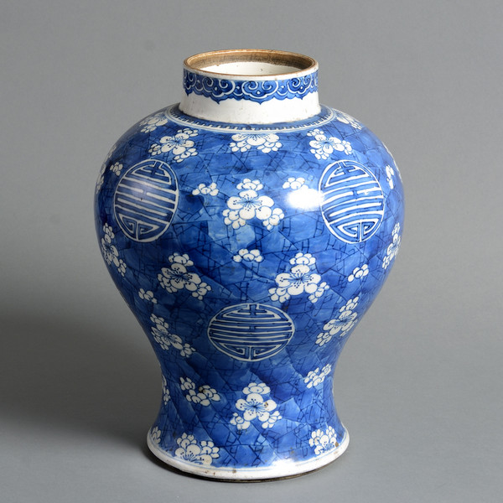

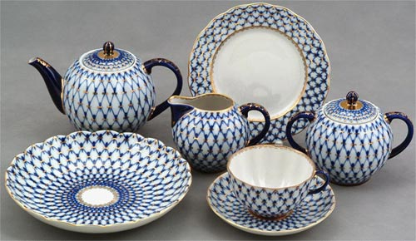

Pictures of Ornaments
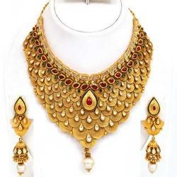

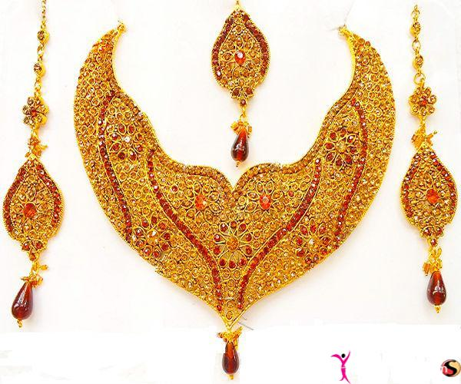
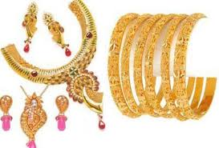

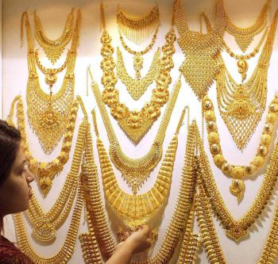

Pictures of Mandarin Duck
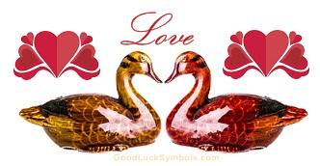
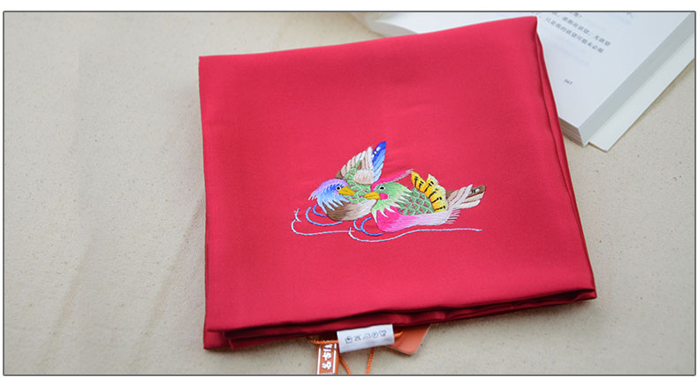
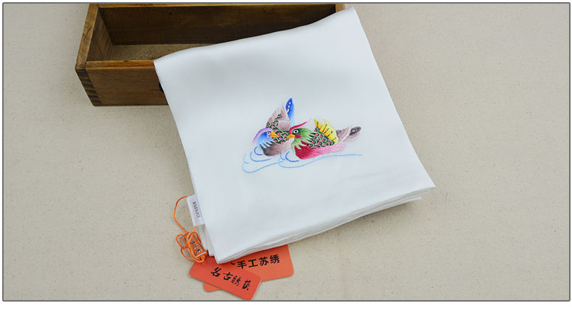
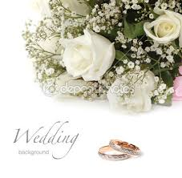
READING: WEDDING
Olga:
I have two weddings days! The first was a civil wedding in the city hall and then, two days later; I had another wedding in a church! In (a) ---------- everybody must have a civil ceremony, and a lot of couples choose to have a church wedding as well. After the civil wedding there was a small party with close friends and family, and in the evening we had the Polterabend. People brought old porcelain, you know plates, cups and things like that, and they throw them on the ground in front of my new husband and me. Of course, everything broke and there was lot of noise and laughing!
We had to sweet up the broken pieces together, but this symbolized that nothing would get broken in our new house again while we lived together, and is meant to bring good luck. So far it’s worked.

Meryem:
My wedding, which began with separate celebration for my family and the groom’s family, lasted five days. During this time we, my husband-to-be and me, weren’t allowed each other. Then on the day of the wedding ceremony my girlfriends took my shoes away from me! With a lot of giggling they wrote their names inside the shoes and then gave them back. After the ceremony I took my shoes off and looked at the names. In (b)---------- if one of the names is rubbed of off and can’t be read anymore it means that this person is going to get married next, When I looked in my shoes I saw that my sister’s name had disappeared, and guess what? She got married six months later!

Noshilu:
As you glow older, unmarried women can wear and more jewelry but nothing beats the colorful, beaded necklace that is worn by (c) ---------- women on their wedding day! As id the tradition my necklace was made by my mother and was presented to me by my father. It was very elaborate and went down to my knees. I wore all my necklaces, earrings and ornaments that day and in fact it was a little tricky to walk. My husband collected me from my parents’ home and took me to his home where I received gifts of cattle. Along with other clothing I now wear a blue cloth which symbolizes being a married woman.

Lin:
In china red is most important color for our wedding ceremonies. For us it symbolizes love, joy and prosperity. Although a lot of brides were white these days my wedding grown was the traditional red, and so were the invitations I sent out to our guests. Before I was married my husband’s family came to my family’s home with wedding gifts in red baskets. These contained, among other things, personal items for me. Before the evening party started y husband and I went to a nearby park and had a video made. We also exchanged handkerchiefs and wished each other good luck. Each handkerchief had a picture of a mandarin duck on because they symbolize faithfulness as ducks always stay together. And the color of the hankies? Why, red of course!
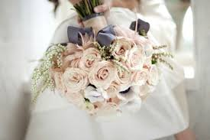

Worksheet #1
Reading comprehension

1~4. Read the passage about wedding again and answer the following questions.

- What is the passage mainly about?
- The reason people spend a lot of money
- The relationship between husband and wife
- The wedding ceremonies in different countries
- The common expressions in all cultures

- What item is not mentioned by Noshilu?
- ornaments
- earrings
- bracelets
- necklaces

- What object is important in Orga’s wedding ceremony?
- blue cloth
- handkerchief
- porcelain
- jewelry

- Complete each sentence with the phrases in the box.

in Chinese wedding write their names clean up shattered plates knees

- In Germany, The bride and groom are expected to -------------------------- together thus showing that they get along well.
- As you know probably guessed by the symbol’s colors, red is most important color -----------------------.

- In the Maasai, the bride wears a very elaborate and heavy beaded necklace on their wedding day. The necklace often hangs down to the bride’s ------------------- so can make it very difficult for walk.

- In Turkey, when a woman gets married, her friends----------------- on the inside of the shoes which is to be worn by the bride on her wedding day.

5~6. Write T if the sentence is true or F if the sentence is false.

- Meryem and her husband-to-be began their wedding by celebrating with her family and his family all together. (T/F)
- Lin and her husband gave each other mandarin ducks and wished each other good luck. (T/F)

7~10. Write the answer in the box for the question.

- Who had restrictions on what they could not see each other?

- What did Olga and her husband have to do with the broken pottery?

- Why do unmarried women wear lot of jewelry which the colorless is?

- What expression did Meryem use to describe her husband?

(Answer sheet for worksheet #1)

1~4. Read the passage about wedding again and answer the following questions.

- What is the passage mainly about?
- The reason people spend a lot of money
- The relationship between husband and wife
- The wedding ceremonies in different countries
- The common expressions in all cultures

- What item is not mentioned by Noshilu?
- ornaments
- earrings
- bracelets
- necklaces

- What object is important in Orga’s wedding ceremony?
- blue cloth
- handkerchief
- porcelain
- jewelry

- Complete each sentence with the phrases in the box.

in Chinese wedding write their names clean up shattered plates knees

- In Germany, The bride and groom are expected to clean up shattered plates together thus showing that they get along well.
- As you know probably guessed by the symbol’s colors, red is most important color in Chinese wedding

- In the Maasai, the bride wears a very elaborate and heavy beaded necklace on their wedding day. The necklace often hangs down to the bride’s knees so can make it very difficult for walk.

- In Turkey, when a woman gets married, her friends write their names on the inside of the shoes which is to be worn by the bride on her wedding day.

5~6. Write T if the sentence is true or F if the sentence is false.

- Meryem and her husband-to-be began their wedding by celebrating with her family and his family all together. (T/F)
- Lin and her husband gave each other mandarin ducks and wished each other good luck. (T/F)

7~10. Write the answer in the box for the question.

- Who had restrictions on what they could not see each other?
Meryem

- What did Olga and her husband have to do with the broken pottery?
They had to sweet up the broken pieces together

- Why do unmarried women wear lot of jewelry which the colorless is?
Because women will wear a very elaborate and heavy beaded necklace on their wedding day.

- What expression did Meryem use to describe her husband?
One of the names is rubbed of off and can’t be read anymore it means that this person is going to get married next.

Worksheet #2
Role-play script

Country Name:
Objects to need:

Worksheet#3
Discussion

Can you tell me any differences between the actual wedding and your act?

Which team has acted the most closely to the actual wedding situation according to the video?

Which country’s wedding ceremony do you think the most interesting and why?

Worksheet#4
SOS Activity: Make your own wedding invitation by using color papers, color markers, pens, etc.
(Wedding invitation example as reference)
