Listening ■ Speaking Reading Grammar Writing

Topic: Useful expression : at the post office

Instructor:  Jennis Choi | Level:  Intermediate (Adult) | Students:  8 students | Length:  30 Minutes

Materials:
♦ Realia : picture and video
♦ White board and board marker
♦ Activities worksheet(8 copies)
♦ SOS activity worksheet(8 copies)
♦ Computer (for the video)

Aims:
♦ Main aim: Students will be able to improve their speaking skills with the dialogue and their role play.
♦ Secondary aim: Students will be able to discuss about postal services.
♦ Personal aim: I want them to enjoy their talking time, and to share their idea.

Language Skills:
♦ Speaking: Students will discuss about the topic.
♦ Listening: Students will listen to other students’ presentations.
♦ Reading: Students will read the sentences in the worksheet.
♦ Writing: Students will answer the questions in the worksheet.

Language Systems:
♦ Phonology: /t/ vs /d/
♦ Lexis: measurement, fragile, insurance, jiffy, package, signature, delivery, perishable
♦ Grammar: I`d like to
♦ Function: giving and getting information.
♦ Discourse: discussion, role play.

Assumptions:
Students already know
♦ What the shape of our desk will is and how many classmates there have in this class.
♦ What they will learn and what activities they will do.
♦ The language skills and systems.

Anticipated Errors and Solutions:
♦ If students are not able to understand the activity,
- I will give them a demonstration.
♦ If students do not finish their work because of time constraint.
- I will give them to the remaining activities and questions as homework.
♦ If students finished their work ahead of time,
- I will give the SOS activity.

References:

♦ Image : https://www.usps.com/
♦ Definition : http://dictionary.cambridge.org
♦ Dialogues : http://www.learn-english-conversation.net/post-office/#.V7wq-5iLTIU
https://www.speaklanguages.com/english/phrases/at-the-post-office
♦ Video : https://www.youtube.com/watch?v=pOenyWBrIeI
♦ SOS activity : http://www.puzzlefast.com/

Lead-In
Materials: None
Time | Set Up | Student Activity | Teacher Talk
1mins | Whole class | Answering teacher’s questions | Good afternoon, everyone.  Where do you go when you would like to send your package? How often do you visit a post office? What do you do in the post office?

Pre-Activity
Materials: Visual Aid, Whiteboard, Board markers, Worksheet #1, Computer
Time | Set Up | Student Activity | Teacher Talk
1mins  2mins  1mins | Whole class  individually  Whole class | Answering teacher’s questions  Answering worksheet’s questions  Checking answers | 1. Brainstorming  Eliciting  (show the students visual aid-pictures)  “I will show you pictures. Do you know this place? Where is it? What can you do there?  Additional explanation  When we need to buy stamps, send mail, or use other services, we visit a post office.  Modeling  Show the subject ‘At the post office’  (Write on the board)  2. Vocabulary  Instruction  “We are going to learn some vocabulary. I will give you the paper.  First, read the words carefully, and then find the answer. I will give 2 minutes to finish it.”  Demonstration  “No.1 is.. (with gesture)”  Pronunciation checking  : Click the English homepage.  ICQ  What will you do?  Are you working in group?  How much time do you have?  Let’s start.  Monitoring  Answer students if they have questions.  “Time’s up, everybody”  Check answers  “ Let’s check the answer together”  Let students answer one by one.  -Write the words if necessary.  “What a nice work!”

Main Activity
Materials: Whiteboard, Board markers, Worksheet #2, Computer, Video 1
Time | Set Up | Student Activity | Teacher Talk
10mins | Whole class  groups  pairs | Reading and speaking the dialogue.  Practice the dialogue. | Dialogue  Instruction  “We are going to learn expressions. Now I will give another paper. First, please read to follow the dialogue.”  (with the video1)  Demonstration  I will read part S and Ct.  [Make groups]  “This group is S, this group is C. This group will do it first. And the next is…  Good job. Next, change roles. Very good!”  Now, please practice with your partner. You can change roles and the words. I will give you 3 minutes.”  Demonstration  I will speak only one sentence to change the words.  ICQ  “What will you do with your partner?  How many minutes do you have?”  “Let’s start.”  “Okay, time’s up”  Monitoring  Answer students it they have questions.  Feedback  “Great job. Very good”

Post Activity
Materials: Whiteboard, Board markers
Time | Set Up | Student Activity | Teacher Talk
10mins | Whole class | Role paly | 1. Free Production  Instruction  “Would you visit a post office near the school? Image your own post office, and make your own role play in your group. Next please present it. I will give 3 mins.  Demonstration  I will show a role paly with students. (but very quickly)  ICQ  “How much time do you have?  Let’s start.”  Monitoring  Answer the students’ questions if they need it.  Feedback  “Speak loudly and clearly”  “Well done!”  2. Conclusion  “Today we have learned words and expressions. When you go to a post office, please use the expressions. Thank you for your participations.  See you next class.”

SOS Activity
Materials: SOS worksheet #3
Time | Set Up | Student Activity | Teacher Talk
If needed | Pairs | Finding the words. | Instruction  “Let’s find the words. The words which we have learned can be found here. Please circle the word if you find them. You have 3 minutes to do it.”  Demonstration  “The first word is…”  ICQ  “How much time do you have?  Can you talk with your partner?”  Monitoring  Monitor discreetly.  If they have questions, answer it.  Feedback  “Time is up. Job well done."

Visual aid
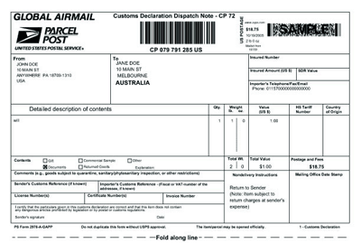

Worksheet # 1
Word

Delivery, Jiffy, Signature, Delivery, Insurance
Package, Measurement, Perishable, Fragile

- _________ : length, width, depth and height.
- _________ : easily damaged, broken, or harmed.
- _________ : the agreement in which you pay a company money and the company pays the cost if you have an accident, injury, or loss.
- _________ : a very short time.
- _________ : a box or container in which something is put, esp. to be sent or sold, or a group of objects wrapped together.
- _________ : your name written in the particular way you write it, esp. on a printed document to show that you have written it yourself.
- _________ : the act of taking goods, letters, or packages to people's houses or places of work.
- _________ : Food that is perishable has to be used quickly or it will decay so that you cannot eat it.

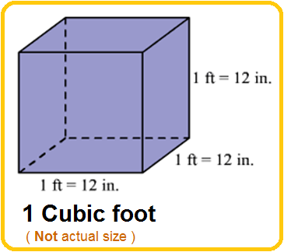 # 10 pound ≑ 4.5kg

Worksheet # 2 Dialogues

At the post office

S : staff, C: customer

______ Change the words

S : Good morning. May I help you?
C : Yes, please. I’d like to mail a package.
S : Alright, how big is it?
C : It’s about one cubic foot, and it weighs ten pounds.
S : Alright, let’s check those measurements.
C : Okay!
S : Yes, you were about right. Now, do you have enough stamps?
C : Yes, I put three. It’s going across the country.
I'd like to send this to Korea/Japan/Canada.
S : Oh, okay. That should be enough. How would you like to send it?
C : What is the cheapest way to send it?
S : Shipping is the cheapest. But you need to wait for 1 week/ 1 month/ 3 months.
C : I'd like to send it by EMS/air plane/ship.
S : Could you fill in this form, please?
Ah! And please, write your signature on the delivery receipt.
C : Alright, here you go. So, how much will it cost to send it to Korea/Japan/Canada?
S : It will cost 200 dollars and ten cents.
C : I'd like to pay this bill by credit card/cash.
S : Are there any perishable food /fragile items in the package?
C : No.
S : Would you like an insurance?
C : How much is it?
S : It's $10.55.
C : O.K. Here you are.
S : Do you need anything else?
C : Yes. I'd like an envelope/ a packet of envelopes/ a jiffy bag, please.
S : You can buy it in the next corner. Is that all?
C : What time do you close/open?
S : We close/open at 6:30 p.m.
C : Awesome. Thanks for all your help.
S : No problem. Please feel free to come again.

SOS Worksheet #3

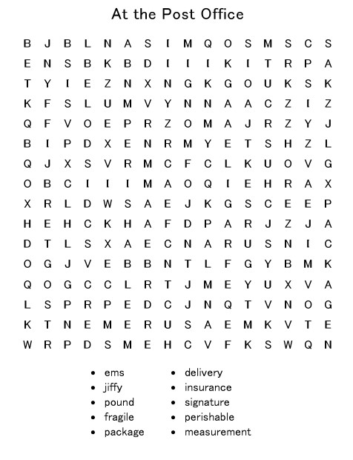

Answer
