Integrated Skill Lesson Plan
Title: What would you want to wear on a picnic?

Instructor:  Mi Jang (Mia) | Level: 6yrs+  Pre-intermediate | Students:  8 students | Length:  30 minutes

Materials:
- Whiteboard, markers
- ‘Let’s Chant’ syllabus
- Worksheet #1 and #2 (8 pieces each)
- Computer with speakers

Aims:
- Students will learn the key words: pants, socks, a hat, a jacket, a shirt.
- Students will be able to practice making sentences using ‘I want to wear …’.
- Students will be able to work cooperatively in pair and in group by sharing opinions.
- Students will be able to manage the time to work on assignment efficiently.

Language Skills:
- Reading: chant, worksheet instructions
- Listening: ‘Let’s Chant’ song, words what teacher says to answer the worksheet #1
- Speaking: brainstorming what to wear for the picnic while lead-in, sing the ‘Let’s Chant’ song, group discussion to vote for the best artist
- Writing: worksheet #1 and #2

Language Systems:
- Phonology: jacket, pants, hat, socks, shirt – each word’s pronunciation
- Lexis: key vocabularies – jacket, pants, hat, socks, shirt
- Function: ask how people wear for picnic
- Grammar: present tense – I want to wear…, She or he wants to wear…(if possible)
- Discourse: asking ‘what do you want to wear?’ and answering

Assumptions:
- Students went to a picnic last month and they remember what they wore on that day.
- Students have their own closet at home.

Anticipated Errors and Solutions:
- Students can’t answer the worksheets.
→ Provide them word bank or have other student help them.
- Students don’t draw because they don’t want to.
→ Make them to work with their friend.

References:
- Images for worksheets
http://google.com

- The whole idea of the lesson plan with CD
A book ‘I can write English! Starter 1’

Lead-In
Materials: Whiteboard, markers

Time | Set Up | Description of activities
3 min | Whole Class | <Greeting>  <Rapport and classroom procedure>  <Warmer>  T: Do you all like to go on a picnic? Yes, picnic is exciting! Then, what clothes are for the picnic? What did you wear on our latest picnic last month?  (Try to elicit the key words: pants, socks, a hat, a jacket and write them on the board)

Presentation
Materials: CD track 24 for listening to the chant, computer, speaker, ‘Let’s Chant’ syllabus

Time | Set Up | Description of activities
4 min | Whole Class | T: Today we are going to learn about what to wear on a picnic. You’ve just told me, we wear different types of clothes. Now, let’s see what they are while listening to this song!  (Play the CD track 24: 1 min.)  In the chant, what do you wear?  Now, we are going to sing this song all together!  (Pass out the syllabus and play it one more time)  Look at the paper I just gave you and let’s all sing together!

Practice
Materials: Worksheet #1 and #2

Time | Set Up | Description of activities
2 min  1 min  5 min | Individually  Pair work | <Controlled Practice>  T: Here, I will give you one more paper. You will see 3 pictures on it. I will tell you a word. You will check which word I say and then write the word. Let’s do no.1 together.  Socks.  Did you check? Let’s see what your friend next to you checked. Did you and your friend check for the same word?  And then, write the word, ‘socks’ in the box below.  Ok, well done!  Please do #2 and #3 individually and check your answers with your friend again. I will give you 1 minute.  ICQ) How much time do you have? (1 min.)  I will tell you the word for #2. Jacket.  #3. Hat.  <Controlled Practice>  T: Now, I will give you another worksheet. Let’s have a fun crossword puzzle!  (Pass out the worksheet#2)  Please write the word on each blank line and also in the crossword puzzle. I will give you 3 minutes.  Please check your answer with your friend!  Are your answers same or different?  Anyone has different answer?  (If yes, go to them and check what was wrong. Correct them with the rest of students in class by writing the answers on the board clearly.

Production
Materials: Color crayons, blank paper for drawing

Time | Set Up | Description of activities
7 min  6 min  2 min | Individually  Pair work  Whole class | Now, we are going to have some fun drawing activity!  Would you please draw the clothes that are in your closet?  You can draw as many as you want by using the color crayons on your desks. You can draw pants, hat, jacket, socks that we learned today. It’s ok even if you don’t know the name of clothes. I will tell you the names later!  Ok! I will give you 7 minutes to draw. Let’s start!  Is everyone done?  Then, next please pick 5 items that you want your friend to wear on a picnic.  Now, draw your friend wearing your chosen items.  You have 5 minutes again.  If you are done drawing, let’s make 2 groups to share each of your drawing. 4 of you are in one group, and the other 4 are in another group.  Can you all share your drawing with other group members?  And, would you vote whose drawing is the best?  Big hand for the best artist!  <Closing>  Did you enjoy drawing?  What clothes did you learn today? (shirt, pants, hat, jacket, socks)  Tomorrow, please remember these words as you wear the clothes!
Let’s Chant

What do you wear? What do you wear?
Shirt! I wear a shirt!

What do you wear? What do you wear?
Shoes! I wear shoes!

What do you wear? What do you wear?
Pants! I wear pants!

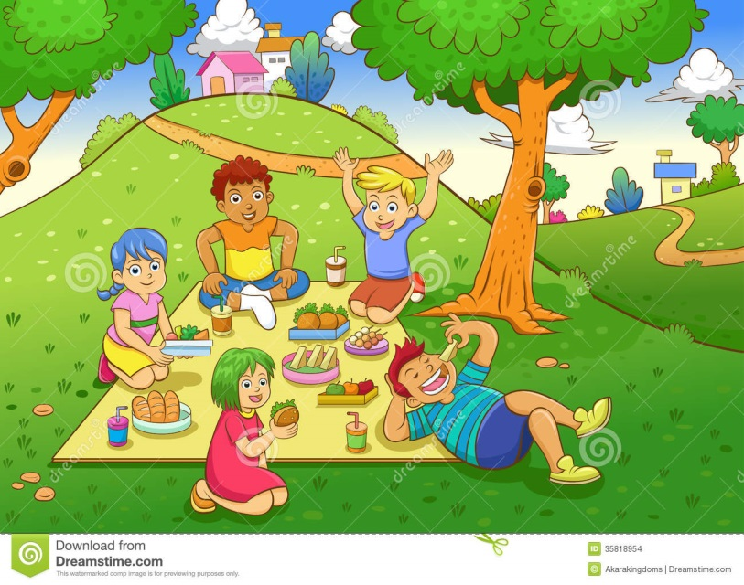
Worksheet #1
Listen, check(), and then write the word.
1.
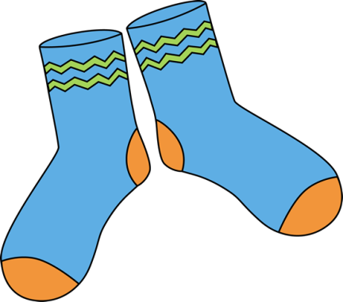
- Shoes
- Socks

2.
- Shirt
- Jacket
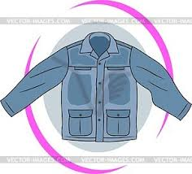

3.
- Hat
- Pants

Worksheet #2
Complete the sentences below and fill in the crossword puzzle.
1.
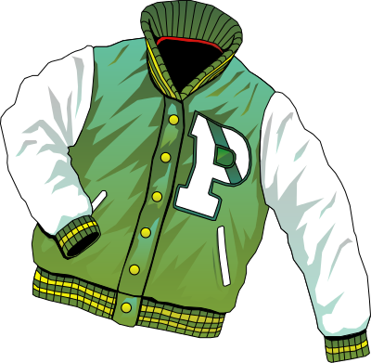
I wear a .
2.
I wear .
3.
She wears a .
4.
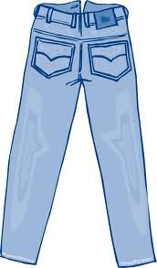
He wears .

Crossword Puzzle
④
①
②
③

