Title: All Grown up

Instructor:  Kimmy | Level:  Pre-Intermediate | Students:  8 | Length:  30min

Materials:
- Board and marker

Aims:

- Main aim: Ss will be able to learning about how to show the stages of growing up.
- Secondary aim: Ss will be able to share their own ideas.
- Ss will be familiar with key vocabulary thought T’s explanation.

Language Skills:
- Reading: Ss will read vocabulary and reading worksheet
- Listening: Ss will listen to script
- Speaking: Ss will do drilling
- Writing: Ss will fill out the worksheets.

Language Systems:
- Phonology: drilling
- Lexis: vocabulary
- Discourse talking about the topic or family

Assumptions:
- All Ss can speak and write full sentences in English.
- Ss will understand the script without problems

Anticipated Problems and Solutions:
- If Ss can’t complete the worksheet.
T give more time and figure out together.
- Ss might not understand some key vocabularies.
give more example and information.

References:
www.google.com
Book: Reading-vocabulary

Lead-In
Materials:

Time | Set Up | Teacher Talk
2min | Whole class | <Greeting>  Hello everyone! How are you today?  Did you talk with your family today?  <Warmer>  T: I want you to write down five things that is about your family on a piece of paper.  (Ss share their ideas)

Presentation
Materials:
- Worksheet #1

Time | Set Up | Teacher Talk
3min  5min | Whole class | T: Today we are going to learn about grow up!  First, we will be listening to a script. Please listen carefully.  Are you ready? Ok then...  Listen: People grow and change. We eat food. We sleep.  We grow taller. We get older. First we are all babies.  We are babies when we are born. Babies can’t walk or talk.  But they can eat and sleep. Babies are very cute.  Next we are toddlers. Toddlers can walk and talk.  But toddlers don’t go to school. They are still too young.  Toddlers play all day long. Then we are children.  Children go to school. We learn many things as children.  We learn how to ride a bike. We learn how to draw and color.  Next we are teens. Teens can be tall.  We are teens in high school. Then we become adults.  Your mom and dad are adults. One day you will be an adult too!  T: Now, I’ll read first line and you are going to repeat after me  (Teacher will doing drilling)

Practice
Materials:
-worksheet #2, 3

Time | Set Up | Teacher Talk
4min  4min | In pair | (control practice)  T: Great! Now, we are going to try match the pictures with the correct words. You will work with… you two gather, you two gather...... Now, everyone has a partner right?  Ok then, I’ll give you 3minutes  T: Ok, Let’s check the answer  And here has another worksheet in my hand. It’s a bit difficult. But I know you guys can do it very well.  It’s simple just a circle the correct answer. You can work with your partner.  I’ll give you 3minutes  (monitor the Ss solving the worksheets and give hints when they are stuck.)  T: Times up! Are you guys done?  Good, now let’s check the answers. Could you read the first sentence and tell me the answer too?  (Ss read the sentence and answer. If someone made a mistake, have other Ss help correct their mistakes.)

Production
Materials:
- worksheet #4
- color pencils
Time | Set Up | Teacher Talk
10min  2min | Whole class | T: Now, I will give you an another piece of paper. As you can see it, you just draw the you grow up  Imagine what will you do and your looks like in the future.  Use your imagination  I’ll give you 10minutes  CCQ  1. Will you draw the picture?  2. What will you draw?  3. How much time do you have?  Ok, now let’s share the ideas. Who want to be first?  (Ss will share their own ideas)  <Closing>  T: Did you enjoy today’s activity? You all did a great job! Well done! There’s no homework today. So, take your time and then see you tomorrow.

Reading Worksheet #1

People grow and change.
We eat food.
We sleep.
We grow taller.
We get older.
First we are all babies.
We are babies when we are born.
Babies can’t walk or talk.
But they can eat and sleep.
Babies are very cute.
Next we are toddlers.
Toddlers can walk and talk.
But toddlers don’t go to school.
They are still too young.
Toddlers play all day long.
Then we are children.
Children go to school.
We learn many things as children.
We learn how to ride a bike.
We learn how to draw and color.
Next we are teens.
Teens can be tall.
We are teens in high school.
Then we become adults.
Your mom and dad are adults.
One day you will be an adult too!

Worksheet #2

Match the pictures with the correct words.

1. teen

2. child

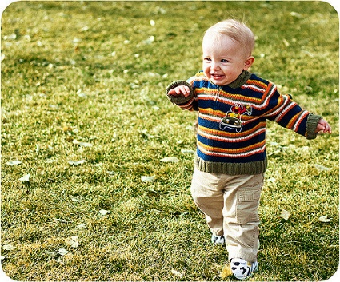

3. baby

4. adults

5. toddler

Worksheet #3

Which word best fits in the blank? Circle the correct answer.

My (1) brother was born yesterday. He is very small now.
But he will (2) taller.

- a. baby 2. a. show
b. animal b. remember
c. young c. jump
d. sleeping d. grow

My sister can walk but don’t go to school. Because she is a (3) . I go to high school because I’m a (4) .

- a. lair 4. a. magician
b. musician b. teen
c. baby c. baby
d. toddler d. children

I learn many things at school. Because I am a (5) . but I will be an
(6) like my dad.

- a. child 6. a. over
b. baby b. adult
c. teacher c. age
d. singer d. egg

worksheet #4

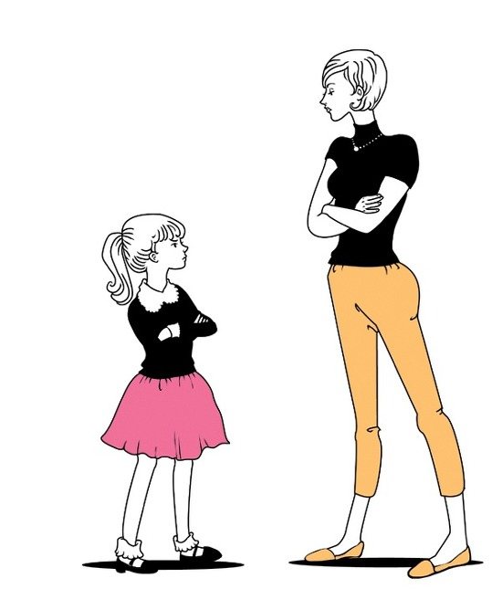
Imagine what will you do and your looks like in the future. And draw when you are adult. Use your imagination.

