Name & Class |  | Date & Place | Lesson Type |  |  | Plan |  | Topic |  |  | Length | Level
Kelly  TESOL 141WD |  | 07/10/2016  Room 601 | Listening |  |  | PPP |  | Ban Ki-moon's life |  |  | 45 min | Int.
Class profile
Number of students:13 Age: Adults(+25 years) Nationality: Korean
Motivations: Demonstrating knowledge and understanding and building research skills
Individual or class hobbies and interests: Current affairs and discussing world news
Special considerations: Ss are mature, reserved, and inclined to be rule-formers. Students are all male.
Main aim (skills)
- Students practice and learn listening comprehension, using a combination of top-down and bottom-up models.
Subsidiary aims (Language focus / skills)
- Students practice speaking fluency during an informal discussion and in a formal public setting.
- Students learn keywords and lexis from an article about Ban Ki-moon.
Description of language skills specifically used/practiced:  - Listening– Ss listen an audio, to their partner  - Reading– Ss read an article to check their answer  - Speaking–Ss pair discussion – small talk about current affairs |  |  |  |  |  |  | Description of language systems specifically used/practiced:  - Lexis – minister, reputation, ambition  - Discourse – small talk, informal, opinion sharing

Anticipated difficulties with lesson activities and classroom management:
- Sensitivity to the eulogistic nature of the topic.
- Students are inclined to be overly cautious so as not to make any mistakes.

How I can deal with these difficulties:

Lesson was announced yesterday - all students are okay. Show and encourage a respectful attitude for the topic during class.
- Lead-in to encourage warm, relaxed classroom atmosphere, reducing anxiety and increasing self-esteem and motivation.
Assumptions: Ss have learnt the word ‘eulogy’ in a previous lesson.
All students have expressed interest in improving informal and unprepared speaking, and so would enjoy trying it in class.
Material(s) needed: computer; whiteboard, eraser and pens; 13 copies of handouts; word-synonym match cards, etc.

Checklist. Mark down those included in this lesson plan (or N/A)
n/a | model sentences for target language |  |  | √ | concept questions for target language |  |  |  | √ | analysis sheet for target language
√ | stages clearly titled and separated |  |  | √ | purpose of each stage indicated |  |  |  | √ | anticipated timing included
√ | interaction pattern marked |  |  | n/a | a board plan (if relevant) |  |  |  | √ | examples of all tasks used
√ | answer sheet to all exercises |  |  | √ | Tape or text script |  |  |  | √ | all materials labelled and numbered
Personal aim: What I most hope to demonstrate in this lesson is the ability to maximize student-student interactions by encouraging peer-checking after each task, pair work, and class participation during the discussion.

Stage 1:_Lead-in  The purpose of this stage is to ease into the topic, relaxing both teacher and students by focusing their attention on an interesting subject and encouraging the class to share their opinions freely, thus increasing STT and participation. This stage may be used to create a basis from which to elicit ideas and lexis relating to the text. | Inter  action | Time | Instructor’s comments
Guessing the mystery celebrity  Today we are going to introduce a mystery celebrity, but first you need to guess who it is.  There are clues to help you guess the the person is.  Instructions :  "Have you ever seen or met a celebrity before?(yes)  Talk to your partner about someone famous you've seen.  "Who did you see? Where did you see them? And what happened?"  Ss share their experiences for about a minute in pairs. Monitor  Show #1 – Collage of Ban Ki-moon  Feedback orally. “Who is the mystery celebrity?”(Ban Ki-moon) | T  S-S  T-S | 30sec  1min  30sec

Stage 2: Presentation  The purpose of this stage is to make the listening less challenging to the students by making use of guiding questions which help predict expected content; answers to these questions may be guessed during this stage and checked later in the lesson; pre-teaching keywords and phrases from the text. Knowledge of the purpose of the text, form and style could be highlighted to further aid comprehension. Thus, schema is activated. | Inter  action | Time | Instructor’s comments
Pre-teach vocabulary - minister, reputation, ambition.  Feedback with the projector.  Briefly elicit /ccq the keywords that students had difficulty with, using the picture #1  Drill the pronunciation of specific words.  Guiding questions Show worksheet 1.  Instructions:  1. Circle the answer you think is correct. Discuss each question with your partner.  2. Demonstrate guessing the answer for question 1 as an example.  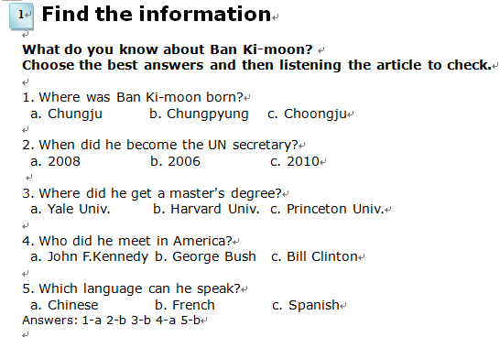  Hand out worksheet 1.  Students work individually.  Pair-work. Ss compare their answers.  Monitor for completion.  No feedback required yet. | T-S  T  S  S  S-S | 4min  1min  2min  30sec  1min

Stage 3: Practice - Listening for gist comprehension  The purpose of this stage is to allow the students to practice gist skills to identify the main idea and key points of interest. Specific and authentic exercises designed to encourage this skill should be used in a natural way. Students draw on their world-knowledge (top-down) to make an initial impression and general sense of the text and perhaps comparing the accuracy of their guesses to the guiding questions used for the text. | Inter  action | Time | Instructor’s comments
This is an news article about Ban Ki-moon(Show the article) Did you know?  Instructions:  1. Listening the audio to check if you guessed correctly.  2. You have 1 minute, so work quickly.  3. You must stop after 1 minute and compare your answers with your partner.  ICQs:  1. Should you listen all the words in the whole article? (No.)  2. Must you quickly check your answers? (Yes.)  3. How much time do you have? (1 minutes.)  Ss work individually  Announce stop and pair-check, even if ss have not finished.  "Stop. Turn over the text now. Compare your answers."  Ss pair-check their answers.  Feedback. Nominate each student for an answer and compare each answer with the classes' answer.  If most have a wrong answer, refer to the text, referencing the paragraph, and invite the students to re-answer correctly.  Commend their speed, and perhaps encourage them to be faster next time. | T  T-S  S  S-S  T-S | 30sec  30sec  1min  1min  1min

Stage 4: Practice - Literal comprehension  The purpose of this stage is for students to focus on literal meaning, e.g. of vocabulary, phrases, details, ideas etc. A variety of exercises may be used and should be constructed for short responses e.g. objective questions. The information highlighted should, ideally, be of significance to the next stage. | Inter  action | Time | Instructor’s comments
Instruction:  1. For exercise2, listen again and fill in the gaps.  2. Work individually. You have 2 minutes.  Students listen and work individually.  Pair check.  Feedback. Nominate. Board correct answers.  Instructions:  1. Individually, listen again and match the phrases from the article.  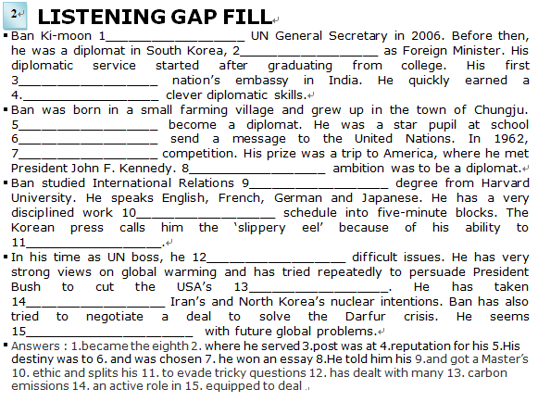  2. Check with your partner. Explain to your partner why two phrases match  3. For example, number1....(refer to the article indicating the statement is matched.)  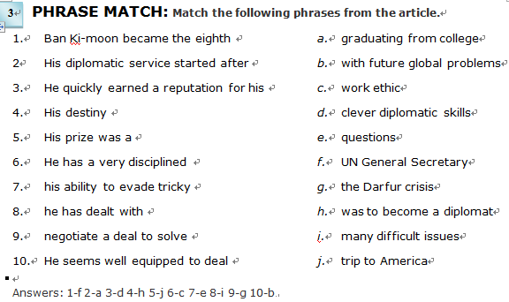  4. You have 1 minutes.  Students work individually for 1 minutes.  Pair check answers, explaining reasons for  matched phrases.  Feedback. Verbal only. Nominate for phrase match and explanations. | T  S  S-S  T-S  T  S  S-S  T-S | 3min  2min  1min  1min  2min  1min  1min  1min

Stage 5: Practice - Interpretive comprehension  The purpose of this stage is to allow student to listen intensively for inference. Discriminating between fact and opinion and understanding the writer’s true thinking are possible considerations during this stage. Contrasting ideas may be highlighted, and use of certain language which affects meaning can be analysed in context. | Inter  action | Time | Instructor’s comments
Instructions:  1. For exercise 4, write your answers briefly to these questions by referring to the article.  2. Explain your answer to your partner after you have finished.  ICQs:  1. Are you writing your answers first? (Yes.)  2. When you have finished writing all the answers, must you talk to your partner? (Yes.)  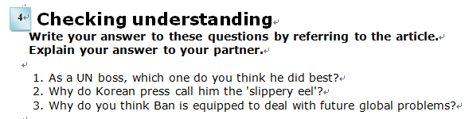  Students work individually. Monitor, pointing out relevant paragraphs if the student is stuck.  Pair check.  Feedback. Verbal. Nominate 2 students for each question if possible. | T  T-S  S  S-S  T-S | 1min  1min  4min  2min  2min

Stage 6:_Production - Applied Comprehension  The purpose of this stage is to complete the final step in reading comprehension by getting students to apply to themselves the information from the text and which was focused on during the practice stages. The task should take into account your students’ background information in order to be suitable as an applied task. Speaking or writing skills may be practiced here. This stage is an important part of language acquisition. | Inter  action | Time | Instructor’s comments
Instructions:  Discuss any of these questions in pairs or groups.  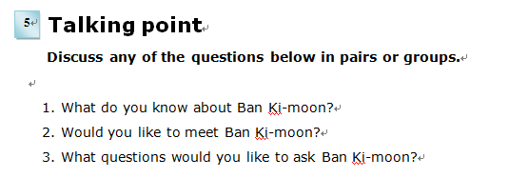  Students discuss in pairs. Monitor for strong student pairs to answer afterwards.  Backup talking point, if there is additional time after talking point 5. | T  S-S | 1min  6min

Stage 7:_Wrap-up  The purpose of this stage is to end the lesson with some positive feedback about the lesson and the students’ participation. Review the ideas from the production stage if possible, and perhaps offer error correction. Classroom management should be considered, such are collecting worksheets, giving homework, stimulate interest in the next class or arranging the desks etc. | Inter  action | Time | Instructor’s comments
Feedback. Ask a discussion question from the task above to nominated students.  Scaffolding techniques may be used.  Offer any error correction after several students have spoken.  Then proceed with the next question.  Announcements:  - Please keep your listening text and bring it to class tomorrow. We will use it.  - Arrange the desks and chairs.  Class dismissed. | T-S  T/  T-S  T
Instructor’s Final Comments
Overall strengths of this lesson (planning and teaching) | Areas to work on

Overall comment

For this stage of the course, your lesson today was

- Above standard

- To standard

- Below Standard

Instructor: …………………………… Date: …………/……………/…………

