Why You Shouldn't Smoke
Tobacco is the leading cause of lung disease. Smoking is also linked to heart disease, stroke and many kinds of cancer. So-called light or low-tar cigarettes are no safer. Smokeless tobacco and cigars also have been linked to cancer. The World Health Organization estimates that almost five-million people a year die from the effects of smoking. At current rates of growth, the WHO says tobacco use will kill more than eight-million people a year by 2020. Studies have found that nicotine can be as powerful as alcohol or cocaine. Nicotine is a poison. But it also is the major substance in cigarettes that gives pleasure to smokers. The body grows to depend on nicotine. When a former smoker smokes a cigarette, the nicotine reaction may start again, forcing the person to keep smoking. So experts say it is better not to start smoking and become dependent on nicotine than it is to smoke with the idea of stopping later.

http://www.manythings.org/listen/smoking.html
Worksheet 1

Listen to the audio “Why You Shouldn't Smoke.”.
Check true or false on each statements below.

True or False?

- Smoking is linked to the heart disease. True False

- Low-tar cigarettes are safer. True False

- Four-million people a year die from smoking. True False

- Nicotine doesn’t give pleasure to the smokers. True False

- Nicotine is as powerful as alcohol. True False

- The body can grow to dependent on nicotine. True False

- Nicotine forces people to smoke. True False

Why People Shouldn’t Smoke POSTER
Make a poster that inform people why smoking is bad.

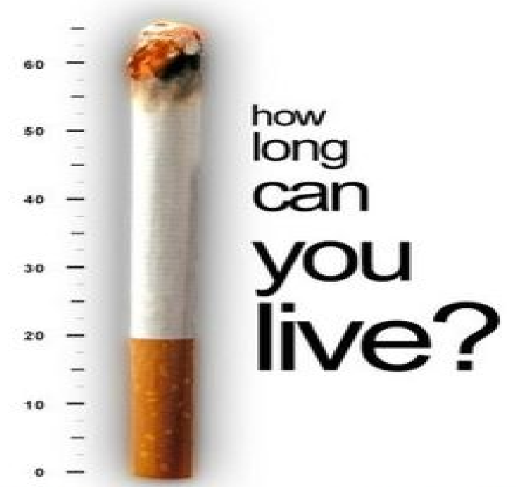

Smoking can lead you to dangerous diseases.
Second-hand smoking is bad for your family and friends.

Pictures for presenting vocabulary (PPT)
- Disease
- Nicotine
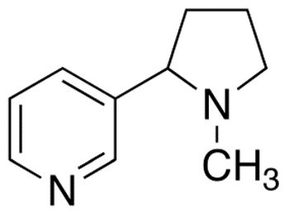
- Tobacco and Cigarettes

