Name & Class |  | Date & Place | Lesson Type |  |  | Plan |  | Topic |  |  | Length | Level
Rory  TESOL 141 |  | 07/10/2016  Room 601 | Listening |  |  | PPP |  | Pros and Cons: Making a New Year's Resolution |  |  | 45min | Intermediate
Class profile
Number of students: 12 Age: Adults Nationality: Korean
Motivations: Demonstrating knowledge and understanding and having real effect on the outcomes of the lesson in terms of ideas
Individual or class hobbies and interests: Interest in TV show
Special considerations: Personality traits, Socio-economic status and Preferred learning styles and strengths.
Main aim (Select: language focus / skills)
- Students learn new vocabulary by listening and work sheet for gap-fill.
Subsidiary aims (Select: language focus / skills)
- Students identify the main idea of the listening script by repeated listening and doing worksheet and answering guiding questions.
- Students practice speaking by discussing with pairs.
Description of language skills specifically used/practiced:  - Listening – Ss listen to MC’s telling of pros and cons  - Speaking – Ss pair discussion – talk about their pros and cons of making new year’s resolutions. |  |  |  |  |  |  | Description of language systems specifically used/practiced:  Lexis - making headlines; setting; taking a look; making;  Breaking; charity; hung over; social media; selfie  Discourse – sharing information

Anticipated difficulties with lesson activities and classroom management:
1) Audio equipment may fail
How I can deal with these difficulties:

1) Use script for this TV show
Assumptions: (What students must already be able to do and what concepts must already be mastered before the lesson in order to achieve the aims of the lesson.)
Ss are able to express their opinions in English.
Most Ss like to watch TV show so that they might have interest with this class..
Material(s) needed: PPT; computer(for listening); whiteboard and board markers, 12 copies of handouts
Video clip address: http://serviceapi.nmv.naver.com/flash/convertIframeTag.nhn?vid=3BA5004DB53E90CDD8BF06621F9117D30005&outKey=V123ac0f6ff1b48f914172cca441f1d0f2b1465f02cde4790a6822cca441f1d0f2b14&width=544&height=306

Checklist. Mark down those included in this lesson plan ( or N/A)
 | model sentences for target language |  |  | √ | concept questions for target language |  |  |  | √ | analysis sheet for target language
 | stages clearly titled and separated |  |  | √ | purpose of each stage indicated |  |  |  | √ | anticipated timing included
 | interaction pattern marked |  |  | N/A | a board plan (if relevant) |  |  |  | √ | examples of all tasks used
 | answer sheet to all exercises |  |  | √ | Tape or text script |  |  |  | √ | all materials labelled and numbered
Personal aim : What I most hope to demonstrate in this lesson is the ability to give clear instruction and try to ask questions to students for eliciting.

Stage 1:_Lead-in  The purpose of this stage is to ease into the topic, relaxing both teacher and students by focusing their attention on an interesting subject and encouraging the class to share their opinions freely, thus increasing STT and participation. This stage may be used to create a basis from which to elicit ideas and lexis relating to the text. | Inter  action | Time | Instructor’s comments
Procedure: (Separated into titled stages with inclusion of target language, instructions, concept questions, answers to tasks etc., where appropriate)  Materials: PPT1  Greetings  Hello everyone! How’s feeling today?  Procedure  Show one screen shot for the video to the Ss.  “Today we are going to see a short video clip.” “What kind of TV program is this? “  “It’s ‘Late Night with Jimmy Fallon Show’. “Do you like American talk show? “  “He will describe some pros and cons funny.”  “Have you ever made a new year’s resolution? “  (Elicit the main idea of this lesson from the students)  Before we listen to the audio, we’ll learn some key words.  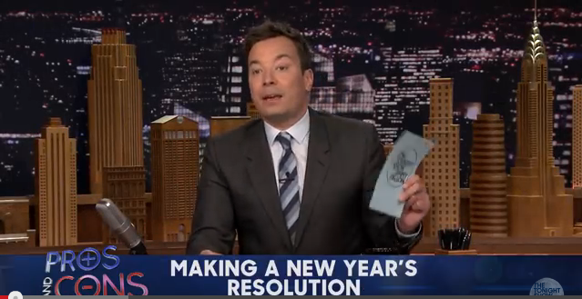 | T  T-S | 30sec  1min

Stage 2: Presentation  The purpose of this stage is to make the listening less challenging to the students by making use of guiding questions which help predict expected content; answers to these questions may be guessed during this stage and checked later in the lesson; pre-teaching keywords and phrases from the text. Knowledge of the purpose of the text, form and style could be highlighted to further aid comprehension. Thus, schema is activated. | Inter  action | Time | Instructor’s comments
Materials Whiteboard  Pre-teaching vocabulary (Making headlines, Pros and cons, Social media, Selfie)  - Use whiteboard to write the words and read each of the words.  - Ask students to guess individually and elicit.  I.C.Q.  Can you take notes?  Are you working in pairs?  Elicit vocabulary from the Ss  1) Making headlines  Q. What can you do if you want the news or something become famous by being reported in the news?  2) Pros and cons  (Give some examples to the Ss.)  ex1) Everything has pros and cons.  ex2) They debated the pros and cons of setting up their own firm.  CCQs  1. Do you have pros and cons of your personality? (Yes)  2. Is it used for discussion? (Yes)  3) Social media  Q. If you want to post your daily pictures, where do you post it?  Q. Can you make relationship with someone that you don’t know online? Where can you make this relationship?  4) Selfie  (Miming)  Q. What am I doing now?  Q. Do you take picture by yourself?  Guiding questions (Talk with your partner.)  Did you make new year’s resolutions this year? Are you sticking to your New Year's resolution?”  Give me 3 examples of making a new year’s resolution are there? | T  T-S  T-S | 1min  30sec  5min

Stage 3: Practice - Listening for gist comprehension  The purpose of this stage is to allow the students to practice gist skills to identify the main idea and key points of interest. Specific and authentic exercises designed to encourage this skill should be used in a natural way. Students draw on their world-knowledge (top-down) to make an initial impression and general sense of the text and perhaps comparing the accuracy of their guesses to the guiding questions used for the text. | Inter  action | Time | Instructor’s comments
Materials PPT2 (showing Gist listening questions)  Instructions  Now, you will see the show. Please listen carefully once.  Play the video for the students.  Gist listening questions  “Try to guess individually. Who is he speaking while the MC is telling about pros and cons?”  “Do they agree with the pros and cons of making new year’s resolution that the MC introduces?”  Feedback  Nominate 3 Ss and ask their answers. | T  T-S | 30sec  1min  30sec  2min

Stage 4: Practice - Literal comprehension  The purpose of this stage is for students to focus on literal meaning, e.g. of vocabulary, phrases, details, ideas etc. A variety of exercises may be used and should be constructed for short responses e.g. objective questions. The information highlighted should, ideally, be of significance to the next stage. | Inter  action | Time | Instructor’s comments
Materials PPT3, worksheet 1  Instructions  Please look at these questions. And read the questions for the Ss.  Literal listening questions  “How many pros and cons are there?”(seven)  “What is con of making a new year’s resolution January 1?” (Breaking them January 2)  Instruction  Now we are going to gap-fill exercise individually. Do you need to listen again?  Please fill in the blanks. You have 5 minutes.  I.C.Q.  Are you working alone? (Yes)  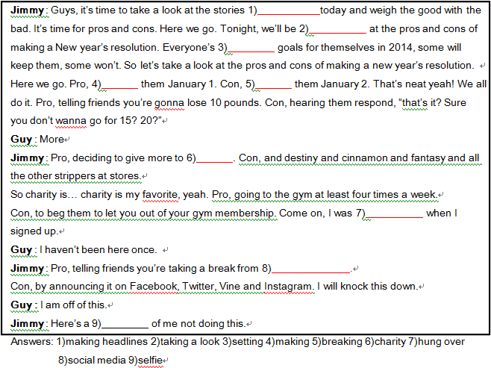  For how long? (5 minutes) Worksheet 1  Feedback  Check the answers as a whole class after all Ss fill out  the gap-fill. | T  T-S  T  T-S  T-S | 20sec  1min  30sec  30sec  5min

Stage 5: Practice - Interpretive comprehension  The purpose of this stage is to allow student to listen intensively for inference. Discriminating between fact and opinion and understanding the writer’s true thinking are possible considerations during this stage. Contrasting ideas may be highlighted, and use of certain language which affects meaning can be analysed in context. | Inter  action | Time | Instructor’s comments
Materials PPT4  Instructions  Please look at these questions. And read the questions for the Ss.  We are going to listen to the clip again. And then try to guess the answer for these questions.  (Ss listen to the clip from 1:00 to the end 1:49)  Interpretive listening questions  “Why the MC introduce the pros and cons of making new year’s resolutions?”  “What is the guy’s role of this TV show?”  I make group of 3 and let Students discuss their answer in groups.  Feedback  Nominate at least half the class and listen carefully what they say. | T  S-S  T-S | 1min  3min  3min

Stage 6:_Production - Applied Comprehension  The purpose of this stage is to complete the final step in reading comprehension by getting students to apply to themselves the information from the text and which was focused on during the practice stages. The task should take into account your students’ background information in order to be suitable as an applied task. Speaking or writing skills may be practiced here. This stage is an important part of language acquisition. | Inter  action | Time | Instructor’s comments
Materials PPT5  Instructions  Please look at these questions. And read the questions for the Ss.  Discuss with your partner. You have  Applied questions  Q1) If you were a MC, would you say your personal opinion for introducing pros and cons of making a new year’s resolution?  Q2) If you were a MC, how would you wear when showing TV show?  After discussing in pairs of the questions and nominate 3 students. | T  S-S  T-S | 30sec  10min  3min

Stage 7:_Wrap-up  The purpose of this stage is to end the lesson with some positive feedback about the lesson and the students’ participation. Review the ideas from the production stage if possible, and perhaps offer error correction. Classroom management should be considered, such are collecting worksheets, giving homework, stimulate interest in the next class or arranging the desks etc. | Inter  action | Time | Instructor’s comments
Feedback  It’s time to wrap up today’s class. All of you are excellent.  What do you think? Did you have fun today?  Homework  For homework, I want you to make 5 sentences with the word ‘pro and con’ by tomorrow.  I.C.Q.  Are you working alone? (Yes)  Would you make sentences by yourself or find internet? (make sentences by myself)  Ok, See you guys tomorrow!  - Class dismissed - | T  T  T-S | 20sec  30sec  1min
Instructor’s Final Comments
Overall strengths of this lesson (planning and teaching) | Areas to work on

Overall comment

For this stage of the course, your lesson today was

- Above standard

- To standard

- Below Standard

Instructor: …………………………… Date: …………/……………/…………

