Background Information Sheet – Complete all sections accurately.
Name & Class |  | Date & Place | Lesson Type |  |  | Plan |  | Topic |  |  | Length | Level
Shine Kim  TESOL 141th WD |  | 10/07/2016  Room601 | Listening |  |  | PPP |  | How to tell a girl you like her |  |  | 45 min | Intermediate
Class profile
Number of students: 12 Age: Adult Nationality: Korean
Motivations: Social relationships, Personal advancement, Cognitive interest
Individual or class hobbies and interests: Current affairs and discussing opinions
Special considerations: Ss are mature, reserved, and inclined to be rule-formers.
Main aim (skills)
- Students practice listening comprehension, using a video and discussion.
Subsidiary aims (language focus / skills)
- Students practice speaking freely during small talk with classmates.
- Students practice learning keywords and lexis in class.
Description of language skills specifically used/practiced:  - Speaking – Ss pair-work, group-work  - Listening – to listen a recording |  |  |  |  |  |  | Description of language systems specifically used/practiced:  - Lexis – affection; confidence; conversational; groom; genuine  - Discourse – opinion sharing

Anticipated difficulties with lesson activities and classroom management:
- Students are inclined to be overly cautious so as not to make any mistakes.
- Can be passive students during class.
How I can deal with these difficulties:
- Lead-in to encourage relax classroom atmosphere, reduce anxiety and increase self-esteem and motivation.
- Lesson has pair works and group works.
Assumptions:
- Students would have taught that how to tell a girl/boy you like her/him.
- Students will understand the script without having problems.
Material(s) needed:
Beam projector; computer; whiteboard; eraser and pens; 12 copies of worksheet
References: a video clip
http://www.youtube.com/watch?v=eo-0NZ0M1dk

Checklist. Mark down those included in this lesson plan ( or N/A)
N/A | model sentences for target language |  |  |  | concept questions for target language |  |  |  |  | analysis sheet for target language
 | stages clearly titled and separated |  |  |  | purpose of each stage indicated |  |  |  |  | anticipated timing included
 | interaction pattern marked |  |  | N/A | a board plan (if relevant) |  |  |  | N/A | examples of all tasks used
 | answer sheet to all exercises |  |  | N/A | Tape or text script |  |  |  |  | all materials labelled and numbered
Personal aim: What I most hope to demonstrate in this lesson is the ability to give clear instructions and speak slowly to students.

Stage 1:_Lead-in  The purpose of this stage is to ease into the topic, relaxing both teacher and students by focusing their attention on an interesting subject and encouraging the class to share their opinions freely, thus increasing STT and participation. This stage may be used to create a basis from which to elicit ideas and lexis relating to the text. | Inter  action | Time | Instructor’s comments
Greeting:  “Hi, everyone. How was the weather this morning? And please, tell me about your feelings today.”  Students respond.  Instructions:  “Today we are going to find out how to tell someone I like you, but first you need to guess what emotions are. Have you ever been in love? How did you feel? And talk to your partner about it.”  Students share their experiences for about a minute in pairs.  Monitor whole-class.  Feedback orally: nominated 1 person from 2 or 3 pairs. “Tell me about first feeling on your date?” | T  S-S  T-S | 1min  1min  1min | Interesting approach, using the lexis as part of the lead-in activity

Stage 2: Presentation  The purpose of this stage is to make the listening less challenging to the students by making use of guiding questions which help predict expected content; answers to these questions may be guessed during this stage and checked later in the lesson; pre-teaching keywords and phrases from the text. Knowledge of the purpose of the text, form and style could be highlighted to further aid comprehension. Thus, schema is activated. | Inter  action | Time | Instructor’s comments
Pre-teach vocabulary: affection  Show PPT 1.    Instructions:  - “Look at this picture. What can you see in this one?” (a man, woman, love, propose, heart)  - “How about a man’s feeling?” (nervous, shake, beat high, hope, expect)  - “Why do he nervous?” (to propose, to tell get married, to fall in love, to cherish)  - “Excellent, I think so. And could you say ‘love’ in other words?” (affection)  CCQ:  - Do you have affection to your puppy? (yes)  - Does mother have affection to you? (yes)  Instruction:  ”Talk to your partner about the answer to 2 questions for about a minute.”  Show PPT 2  Guiding Questions:  - What is a ‘love’? (devotion, affection, like, cherish, belief)  - For whom you write a love letter by hand? (boyfriend, girlfriend, spouse, husband, wife, teacher, mom)  Students share their ideas with their partner.  Feedback: nominate a student from 2 or 3 pairs. | T-S  T-S  T  S-S  T-S | 3min  1min  30sec  2min  1min

Stage 3: Practice - Listening for gist comprehension  The purpose of this stage is to allow the students to practice gist skills to identify the main idea and key points of interest. Specific and authentic exercises designed to encourage this skill should be used in a natural way. Students draw on their world-knowledge (top-down) to make an initial impression and general sense of the text and perhaps comparing the accuracy of their guesses to the guiding questions used for the text. | Inter  action | Time | Instructor’s comments
Show PPT 3. Prepare a listening text: a video clip  Instructions:  “Listen and have to match the situation. After matching individually, compare to your partner.”  Play the text.  Students listen carefully and match the situation (kind of guessing).  Monitor to whole-class  - Find the situation  Select correct situation.  a. b.  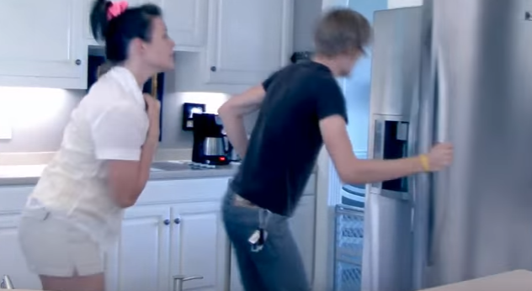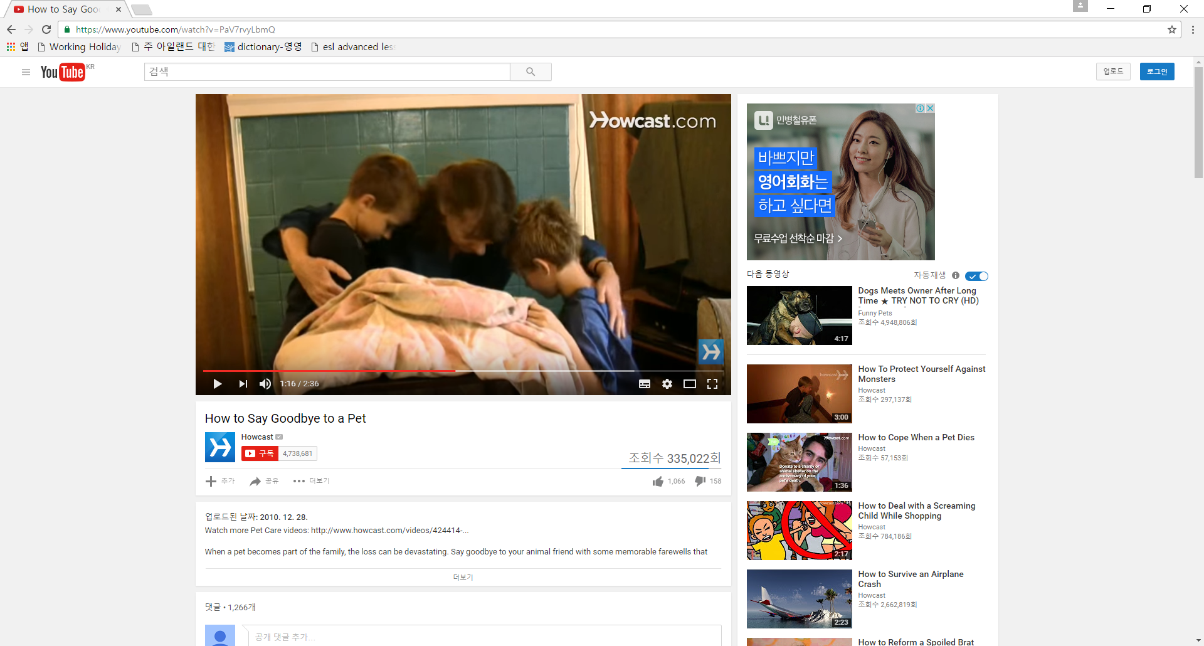  c. d.  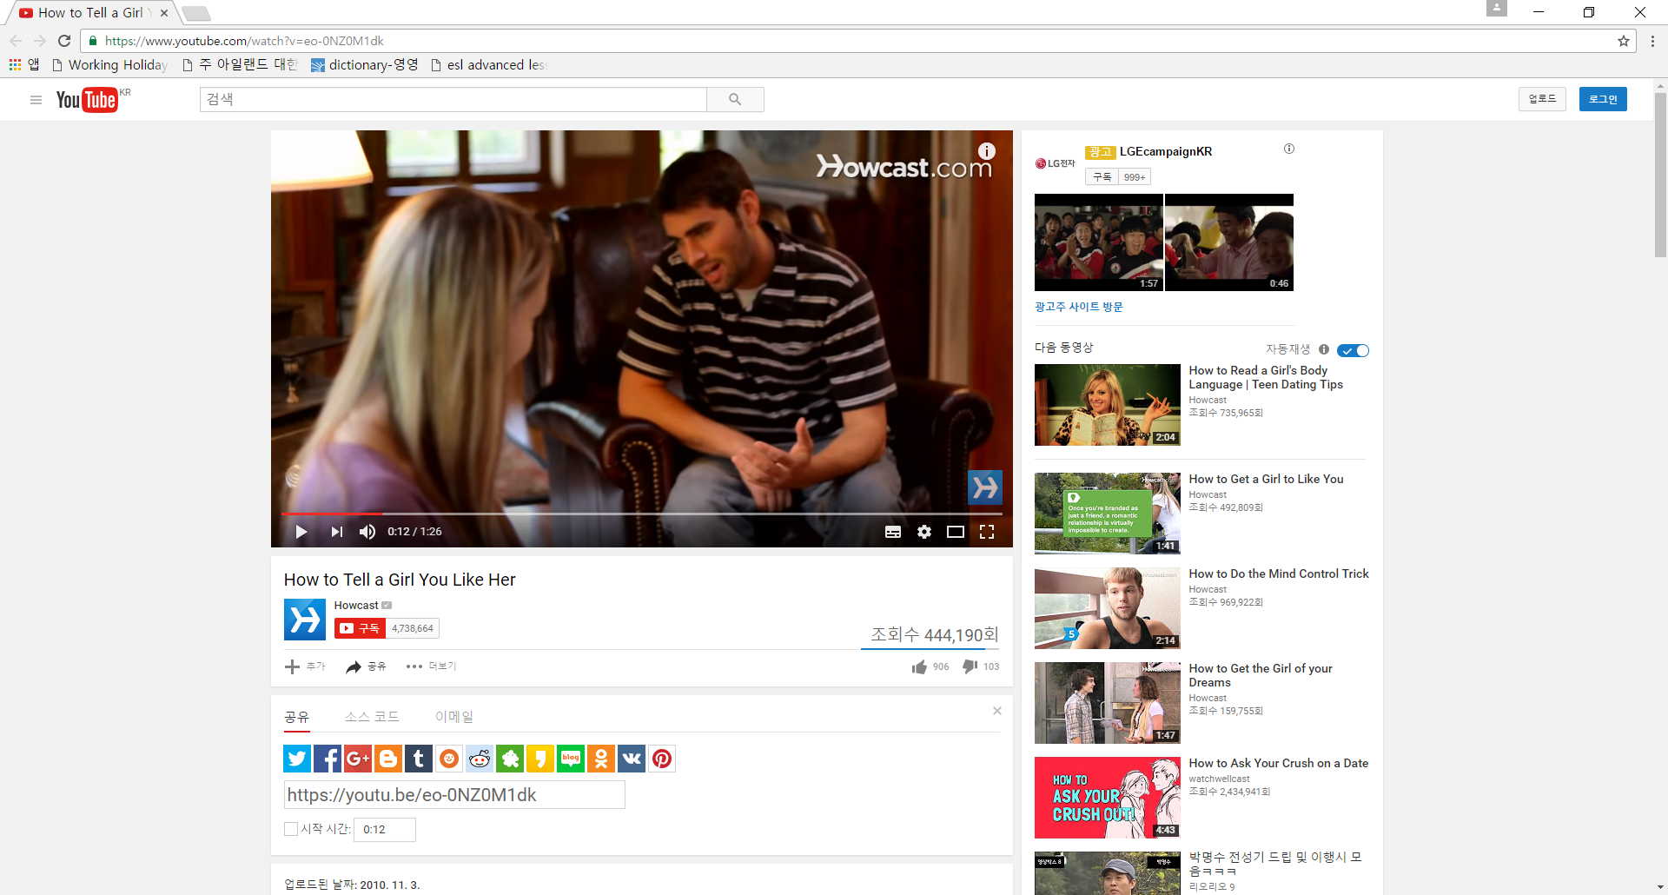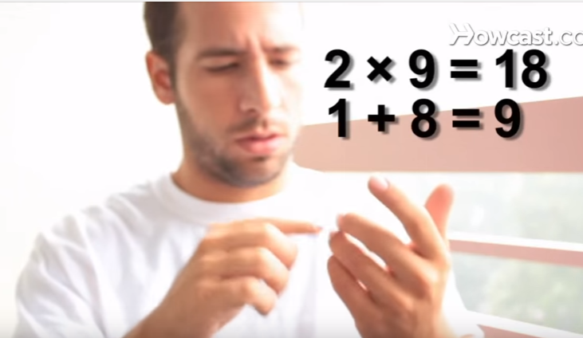  Students compare to the answer with their partner.  Feedback: Nominate. (Answer: c) | T  S  S-S  T-S | 30sec  2min  2min  1min

Stage 4: Practice - Literal comprehension  The purpose of this stage is for students to focus on literal meaning, e.g. of vocabulary, phrases, details, ideas etc. A variety of exercises may be used and should be constructed for short responses e.g. objective questions. The information highlighted should, ideally, be of significance to the next stage. | Inter  action | Time | Instructor’s comments
Show PPT 4. Worksheet about gap-fill.  Instructions: “This is a video clip about that how tell a girl you like her. Listen carefully and I’m going to give you a question. Discuss with your group”  Play a video clip  Concept Question: What order it express? Step 1, step 2, ...  Discuss about steps in groups.  Feedback. Nominate 2 or 3 person  Instructions: “Listen again and write the words on your worksheet to fill in blanks and you have 4 minutes.”  Replay  - Find the phrase  Find a phrase in the step.  Step1. Keep your tone ________ so that you don’t sound rehearsed.  Step2. Remember you’re ________ good news.  Step3. Ask her if you can talk to her ___ _______.  Step4. Tell her the ________ things you like about her.  Step5. Give her a letter, poem, rose, or another _______ but _____ gift.  Step6. If she rejects you, accept it and _____ __.  Students work individually.  Pair-check.  Feedback: Nominate from step1 to step 6. Board correct answers.  Answers: 1-conversational, 2-delivering, 3-in private, 4-specific, 5-meaningful / small, 6-move on | T  S  S-S  T-S  T  S  S-S  T-S | 30sec  1min  2min  2min  30sec  1min  2min  1min

Stage 5: Practice - Interpretive comprehension  The purpose of this stage is to allow student to listen intensively for inference. Discriminating between fact and opinion and understanding the writer’s true thinking are possible considerations during this stage. Contrasting ideas may be highlighted, and use of certain language which affects meaning can be analysed in context. | Inter  action | Time | Instructor’s comments
Show PPT 5. Interpretive questions  Instructions:  “Listen and think about these questions individually. And then talk to your partner.”  CQs:  - What will you need to express your affection? – practice, confidence, patience, honesty, a gift and plan  - How tell you her/him? – in person, on face-book, by text message, over the phone.  Play the video clip  Students think individually.  Pair-work. Share ideas in pair.  Feedback:  Ask question to 1 person from 2 or 3 pairs | T  S  S-S  T-S | 30sec  2min  4min  2min

Stage 6:_Production - Applied Comprehension  The purpose of this stage is to complete the final step in reading comprehension by getting students to apply to themselves the information from the text and which was focused on during the practice stages. The task should take into account your students’ background information in order to be suitable as an applied task. Speaking or writing skills may be practiced here. This stage is an important part of language acquisition. | Inter  action | Time | Instructor’s comments
Show PPT 6. Applied 3 questions to students  Instructions:  - Think about it individually.  - “Now, discuss these questions with your partner and share ideas for about 5 minutes.”  CQs:  - If someone like you, how do you like how to tell you?  - Why do you like it?  - Do you think need special event? Why/why not?  Students have pair-work.  Monitor for strong student pairs to answer afterwards.  Feedback: Nominated.  Backup talking point, if there is additional time after talking 3 questions.  Think about a small gift worth giving and draw it if possible. | T  S  S-S  T-S | 30sec  1min  5min  2min

Stage 7:_Wrap-up  The purpose of this stage is to end the lesson with some positive feedback about the lesson and the students’ participation. Review the ideas from the production stage if possible, and perhaps offer error correction. Classroom management should be considered, such are collecting worksheets, giving homework, stimulate interest in the next class or arranging the desks etc. | Inter  action | Time | Instructor’s comments
“Okay, great everyone. If you practice again and again, you will be a good listener rather than now.”  Feedback:  - Ask a discussion question from the task above to nominated students.  Announcement:  - There’s no homework today but please listen to today’s recording again.  - Arrange the desks and chairs.  “See you next class. Bye.”  Class dismissed. | T  T-S  T | 30sec  1min  30sec
Instructor’s Final Comments
Overall strengths of this lesson (planning and teaching) | Areas to work on

Overall comment

For this stage of the course, your lesson today was

- Above standard

- To standard

- Below Standard

Instructor: …………………………… Date: …………/……………/…………

How to tell a girl you like her

Want to be her next boyfriend or turn your friendship into something more?
Take a chance
Express how you feel to the object of your affection
You will need: practice, confidence, patience, honesty, a gift and a plan
Step 1: think about what you are going to say to her and practice a little
But once you see her
Keep your tone conversational so that you don't sound rehearsed

Step 2: be confident and smile when you see her
Remember you're delivering good news
Make sure you're well groomed for the event

Step 3: wait until the time is right or ask her if you can talk to her in private

Step 4: tell her how you feel. Be honest and genuine
Tell her the specific things you like about her
Tell her in person and not online, on face-book, by text message or over the phone.

Step 5: give her a letter, poem, rose, or another meaningful but small gift.

Step 6: plan a date if she accepts, if she rejects you, accept it and move on.
She may change her mind one day. But until then there are plenty of another fish in the sea.
Did you know?
43 per cent of women prefer their partner to not sign a card with “love” unless they’re ready for commitment.

https://www.youtube.com/watch?v=eo-0NZ0M1dk

- Find the situation
Select correct situation.
Answer: c
a. b.
c. d.
- Find the phrase
Find a phrase in the step.
Step1. Keep your tone ________ so that you don’t sound rehearsed.
Step2. Remember you’re ________ good news.
Step3. Ask her if you can talk to her ___ _______.
Step4. Tell her the ________ things you like about her.
Step5. Give her a letter, poem, rose, or another _______ but _____ gift.
Step6. If she rejects you, accept it and _____ __.
Answers: 1-conversational, 2-delivering, 3-in private, 4-specific, 5-meaningful / small, 6-move on

