Name& Class | Date & Place |  | Lesson Type |  | Plan |  | Topic |  |  | Length | Level
Rose & Kelly  141WD | 12/Oct/2016  Room 602 |  | Speaking |  | TBL |  | Korean superstition |  |  | 40min | Advanced
Class profile
Number of students: 10 Age: Adults(+25 years) Nationality: Korean
Motivations: 1. Demonstrating knowledge and understanding 2. Building research skills 3. Developing powers of independent reasoning 4. Writing for one and others 5. Preparing for professional practice 6. Social relationships 7. External expectations 8. Social welfare 9. Personal advancement 10. Escape/stimulation 11. Cognitive interest
Individual or class hobbies and interests: Discussing general topic
Special considerations: Ss are mature, reserved, and inclined to be rule-formers. Students are male and female
Main Lesson aim (skills)
- Students learn / practice to collocations through various speaking activities to develop speaking fluency.
Subsidiary aims (language focus / skills)
- Students practice to clarify lexical association of superstition
- Students practice to overcome a fear about superstition.
Description of language skills specifically used/practiced:  - Speaking:Ss group discussion (or debate)  - Reading:Ss read handout.  - Listening: Ss listen to their group. |  |  |  |  |  | Description of language systems specifically used/practiced:  - Discourse: group talk, informal, opinion sharing  - Lexis: superstition, belief  - Function: agree/disagree expressions (on the contrary, so do I, etc.)

Anticipated difficulties with lesson activities and classroom management:
- Sensitivity to the nature of the topic.
- Students are inclined to be overly cautious so as not to make any mistakes.

How I can deal with these difficulties:

Lesson was announced yesterday - all students are okay. Show and encourage a respectful attitude for the topic during class.

Lead-in to encourage warm, relaxed classroom atmosphere, reducing anxiety and increasing self-esteem and motivation.
Assumptions Ss have different beliefs in superstition.
All students have expressed interest in improving informal and unprepared speaking, and so would enjoy trying it in class.
Material(s) needed: picture, white board, eraser, pens ; 10 copies of hand-outs

Checklist. Tick those included in this lesson plan (or N/A)
model sentences for target language |  |  |  | concept questions for target language |  |  |  | √ | analysis sheet for target language |  |  | √
stages clearly titled and separated |  | √ |  | purpose of each stage indicated |  |  |  | √ | anticipated timing included |  |  | √
interaction pattern marked |  |  |  | a board plan (if relevant) |  |  |  |  | examples of all tasks used |  |  | √
answer sheet to all exercises |  |  |  | tape script |  |  |  |  | all materials labelled and numbered |  |  | √
Personal aim:What I most hope to demonstrate in this lesson is the ability tomaximize student-student interactions by encouraging peer-checking after each task, pair work, and class participation during the discussion.

Stage 1:_Pre-task  The purpose of this stage is to focus students’ attention and involve them in an interesting task(e.g. brainstorming to the board; help complete a chart etc.) that encourages the class to share their ideas freely, thus increasing STT and participation. Visuals may be used to introduce this task; be specific and focus on what is needed for students to complete the task. Provide the class with the basic inspiration and language they need before going to the next stage(e.g. topic, context, useful grammar/lexis, and an example/demonstration). | Inter  action | Time | Instructor’s comments
“Hello, everyone. How are you today?”  Show picture of four leafclover(# 1)  “Guess what this picture is!”  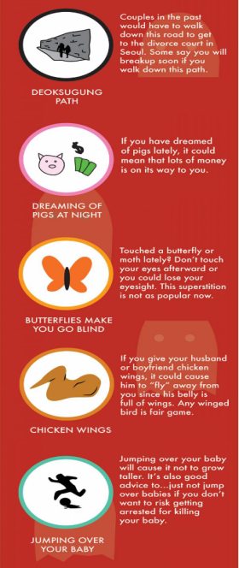  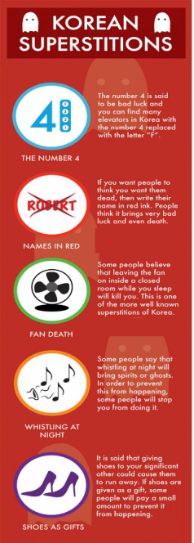  Students chat with whole class and speak out different guesses.  Get few answers from the students.  (Nominate students if there is silence.)  “Right. Now look!”  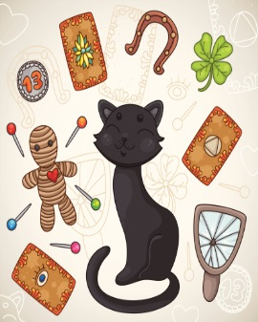  Point out the picture with slight nodding to the students.  Students answer “four leaf clover”  Show picture of black cat (#2)  “What comes to your mind when you see this picture?”  Get few answers from the students.  Students answer “bad luck”  Pre-teach vocabulary – superstition  Eliciting questions for superstition.  - Show the superstition picture(#3)  - “What do you think about this picture?” | T-S | 5 min
Stage 2: Task Preparation  The purpose of this stage is for students to work communicatively in pairs or groups to prepare a communicative task (e.g. roleplay, discussion, debate etc.) which they will deliver to the class/teacher. Student’s may research the task, use dictionaries and ask the teacher for guidance. Instructions, groupings handouts/worksheets and resources, should be given at the start of this stage. Students should know exactly what is expected of them, and have enough time to prepare and practice well. Any or all of the skills may be integrated. | Inter  action | Time | Instructor’s comments
Instruction:  - Give the hand-out (#5) to the students.  - Ss should match the picture to their appropriate meaning.  #5  - Ss individually should answer the questions to their handout.  - Share with your partner and make conclusion to prepare for class presentation.  - Each of you will discuss the answers by two questions.  Questions :  - Which superstition scared you most when you were young?  - Which superstition do you still believe?  - Which of these you don’t believe anymore?  - How to overcome this. Give at least one piece of advice to your partner.  Teacher :  Think and write individually your answers– monitor  If they work well as partners.  If they practice speaking fluency. | T  S | 3 min  12min

Stage 3: Task Realisation  The purpose of this stage is for the students to perform/deliver the task they prepared in the previous stage, focusing on their speaking skills such as fluency and pronunciation. Briefly set the students up so they may begin. The teacher should monitor from a distance, i.e. not interrupting this student-centred stage. | Inter  action | Time | Instructor’s comments
Instruction:  - I want you to share your answers in our class.  - Let’s start with group 1……  - Could you tell us your conclusions of your answers?  Teacher listen all answers’ presentation.  Discretely monitor and jot down errors in languages Students make. | T  S-S | 10min

Stage 4 : Post Task  The purpose of this stage is to provide meaningful feedback, error correction and suggestions for further study or homework. Another brief communicative task could be done which is designed to summarise the lesson e.g. write a report; groups vote for a winner; correct their scripts for grammar and practice saying it. | Inter  action | Time | Instructor’s comments
On your hand out, there are checklists how to overcome belief in superstition.  Check it if you have ever done it before, write x , if not.  I’ll give you 2 minutes to answer it.  Show the steps how to overcome belief in superstition.  - Be aware that the first source of superstitious belief is your own family  - Write down a list of your superstitious beliefs that you can identify  - Note how much each superstition is impacting you and the way you lead your life.  - Start dealing with the superstition.  - Do your research.  - Face one superstition at a time.  - Educate your family about not being superstitious.  - Get professional help if you are still in the grip of superstitions and feeling anxious all the time.  Okay, now let’s have some conclusion on your hand-out.  (Nominate give them to speak their answers.  Did you get some ideas how to overcome belief in superstition? (Yes)all  I will give you homework to research about different countries’ superstitions.  And we will discuss it tomorrow.  Okay, that’s all today. See you tomorrow. | T-S | 10min

Instructor’s Final Comments
Overall strengths of this lesson (planning and teaching) | Areas to work on

Overall comment

For this stage of the course, your lesson today was

- Above standard

- To standard

- Below Standard

Instructor: …………………………………….… Date: …………/……………/..……….

