Background Information Sheet
Name & Class | Date & Place |  | Lesson |  | Plan |  | Topic |  |  | Length | Level
Rory & Yena 141 WD | 10/19/2016  Room 602 |  | Grammar |  | PPP |  | Talking about the past |  |  | 40 | Elementary level
Class profile
Number of students: 10 Age: Adults Nationality: Koreans / Filipino
Motivations: Demonstrating knowledge and personal advancement
Individual or class hobbies and interests: Students are interested in improving English
Special considerations: (Refer to individual Learner Differences List): Students gender may vary, First language is Korean
Main aim (language focus)
- Students practice the function.
Subsidiary aims (language focus / skills)
- Students practice speaking freely with partners
- Students practice to make full sentence using the targeted grammar.
Description of language skills specifically used/practiced:  - Speaking |  |  |  |  |  | Description of language systems specifically used/practiced:  - Function – Use of Past Simple  - Grammar – Rules of Past Simple

Anticipated difficulties with lesson activities and classroom management:
- Students could face difficulty in talking freely in English during freer practice.
- Students might now recognize the meaning for flashcards
How I can deal with these difficulties:

Provide students with sample questions and flashcards

Provide pictures for flashcards
Assumptions: (That which provides insight about your choice of material, selection of target language etc.)
Students already learned the “Simple present” to be
Material(s) needed: PPT, pencil, worksheet, flashcards, pin, Prize

Checklist. Tick those included in this lesson plan (or N/A)
model sentences for target language |  | v |  | concept questions for target language |  |  |  | v | analysis sheet for target language
stages clearly titled and separated |  | v |  | purpose of each stage indicated |  |  |  | v | anticipated timing included |  |  | v
interaction pattern marked |  |  |  | a board plan (if relevant) |  |  |  |  | examples of all tasks used |  |  | v
answer sheet to all exercises |  |  |  | tape script |  |  |  | N/A | all materials labelled and numbered |  |  | v
Personal aim : What I most hope to demonstrate in this lesson is the ability to clearly give instruction and teach correct grammar.

Stage 1:_Lead-in  The purpose of this stage is to relax both teacher and students by focusing their attention on an interesting subject and encouraging the class to share their opinions freely, thus increasing STT and participation. This stage should be used to create an appropriate situational context. | Inter  action | Time | Instructor’s comments
Procedure: (Separated into titled stages with inclusion of target language, instructions, concept questions, answers to tasks etc., where appropriate)  Introduction (Yena speak)  “Hi, everyone! How’s everyone doing today?” (students answer)  Short role-play (Yena and Rory)  Rory: What’s that on your hair?  Yena: I was so tired this morning I could not dry my hair.  Yena : How are you today Rory?  Rory: I was busy this morning too. I took my baby to my mom.  Show PPT 1 (classroom pictures)  - Show the pictures to the class  - “What do you guys think about these pictures? Do you remember that day?”  - “How did you feel? How were you guys that day?”  - Talk to your partner about the pictures  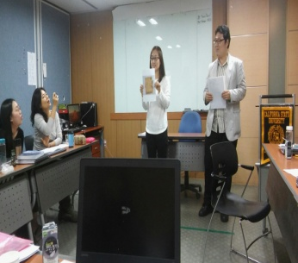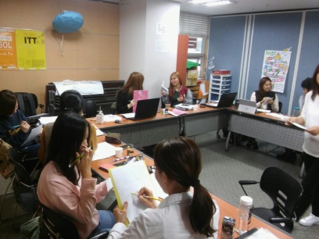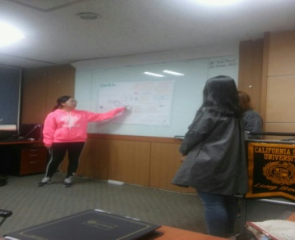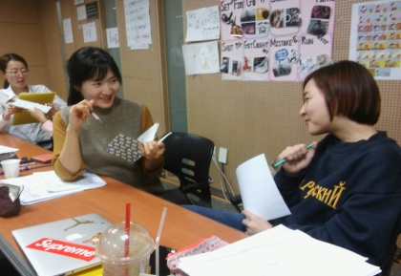 | T-S  T-T  T-S  S-S | 1 min  1 min  1 min  3 min

Stage 2: Presentation  The purpose of this stage is to teach the target language inductively, referring to the situational context from the lead-in. Meaning, form and pronunciation should be covered with appropriate methods such as a model sentence, CCQs, timelines, substitution tables and indication of phonology etc. | Inter  action | Time | Instructor’s comments
Show PPT2 – show our pictures  Yena – baby Rory - single  Instructions (Rory speak)  “What is this picture? What do you think? (cute, single)  Yena say “I was cute. Rory say “Yes, you were cute.”  Rory say “I was single.” Yena say “Yes, you were single.”  Explanation  (“am+is = was” , “are = were”)  “When you use the Past Simple tense, you can use like this. (showing PPT3)  “am and is changed to was and are is changed to were.”  Example sentences (Show PPT4)  - I was happy yesterday.  - I am upset now.  Yesterday Today  CCQ  Am I happy? (No)  Was I happy? (Yes)  Substitution table  (Show PPT5) Make Students repeat after me and nominate 2-3 people.  And let students know interrogative form for example ‘Was I happy?’ and nominate 2-3 people.  Singular I was happy  You were  He She was  Plural You We They were  Ask questions  (Show ppt6) Leave blanks and ask questions to students.  “What is the appropriate Past Simple tense?”  1) He _____ sad. (was)  2) ______ he sad? Yes. He _____. (was)  (Yesterday) | T-S  T  T  T  T-S  T-S  T-S | 20sec  20sec  30sec  1min  20sec  5min  1min

Stage 3: Controlled Practice  The purpose of this stage is to allow the students to accurately practice working with the target language by doing easy, or controlled tasks. This helps build confidence before trying something more challenging. Students should apply the rules that were presented in a meaningful way whenever possible. Peer-checking before feedback is important in these practice stages. | Inter  action | Time | Instructor’s comments
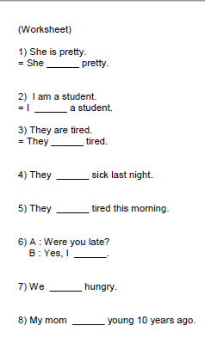  Instruction (Rory speak)  “Now I will distribute a worksheet. Complete the sentences using ‘was’ or ‘were’.”  “Work individually and compare answers with your partner.”  Give hand out  Monitor and wait a minute for everyone is finished.  Feedback  Nominate students and ask answers. | T  T  T-S | 20sec  5min  2min

Stage 4: Less controlled practice  The purpose of this stage is to allow students to practice the target language more thoughtfully, in terms of either structure manipulation, meaning, function or other aspects of language. Accuracy is checked before moving to the next stage. | Inter  action | Time | Instructor’s comments
Instructions (Yena speak)  Arrange seating before doing anything. Make 5 in to a group.  Give out flashcards first on their desk.  “Okay, Class. As a group of 5, you are going to make 6 sentences using these flashcards in front of you as a group.”  Demonstration (on the board)  Demonstrate one sentence on the board using the flashcards.  Students work in groups (5 in each group)  Give them 7 minutes to make the sentences.  “Okay class, Are you guys finished with the sentences?” If not, give them one more minute to wrap up their activity.  Feedback / error correction  - “Now, one from each group come up to the wall and let’s pin up our flashcards.”  - As students come up to pin up, help them with pins and try to shorten the process by helping.  - After they finished pinning the flashcards on the board, Nominate students to read the sentences.  - Make error corrections right away | T  S-S  SS | 30sec  7min  2 min

Stage 5:_Freer Practice  The purpose of this stage is to allow student to practice using the target language productively in an authentic way. The focus is to encourage fluency, not accuracy, therefore errors should be monitored and only addressed if necessary. Correction should be given during the next stage. | Inter  action | Time | Instructor’s comments
( When one teacher is talking to correct the error, the other teacher should take down the flashcards we are going to use for this practice. )  Instruction  “Class, you are all going to be given a flashcard for the practice. Give them flashcard and a worksheet.  “Were you ______ last week?” is our question. (show ppt for example)  “Now, everyone come up to the middle and ask questions to each other using the flashcard. “  Demonstration  Nominate one student and ask before starting. “Jenny, what is your flashcard?” (Jenny tells her flash card) “Okay, so Jenny is going to ask people: Were you ____ last week?”  Student’s task  After asking each other, make a check mark Yes, and No. Give them about 5 minutes to talk and mark down.  “Okay everyone sit down please”  Ask “Who has more than 5 yes’s?”  Wrap-up the activity  Give a prize to whoever has the most Yes’s | T  T-S  S-S | 1 min  30sec  5 min

Stage 6:_Wrap-up  The purpose of this stage is to end the lesson with some positive feedback about the lesson and the students’ participation. Review the main points briefly, either deductively or inductively, or perhaps during error correction. Classroom management should be considered, such are collecting worksheets, giving homework, stimulate interest in the next class or arranging the desks etc. | Inter  action | Time | Instructor’s comments
Feedback (Rory speak)  “We’re finished today. Did you have fun today?”  Correct errors if needed. (Write on the board for confirmation.)  Homework  “For homework, make 10 sentences using ‘was’ or ‘were’ by tomorrow.”  “Ok, Thank you every one. I hope you enjoyed the class.”  - Class dismissed - | T-S  T  T | 20sec  1min  30sec

Instructor’s Final Comments
Overall strengths of this lesson (planning and teaching) | Areas to work on

Overall comment

For this stage of the course, your lesson today was

- Above standard

- To standard

- Below Standard

Instructor: …………………………… Date: …………/……………/………… Student/s: ……………………….. .…………………………..

