Background Information Sheet
Name & Class | Date & Place |  | Lesson |  | Plan |  | Topic |  |  | Length | Level
Aileen&Kelly  141WD Class | 19/10/2016  room 601 |  | Grammar |  | PPP |  | the elephant is bigger than the mouse  (comparatives adjectives) |  |  | 40min | Elementary
Class profile
Number of students: 10 person Age: 25+ adult Nationality: Korean + 1 Philipino
Motivations: e.g. 1. Demonstrating knowledge and understanding. 3. Developing powers of independent reasoning 4. Writing for oneself and others 5. Preparing for professional practice 6. Social relationships 8. Social welfare 9. Personal advancement 10. Escape/stimulation 11. Cognitive interest
Individual or class hobbies and interests: current affairs and discussing life style.
Special considerations: (Refer to individual Learner Differences List): most of them are female, 2person are male. Ss are mature. 1 comes from Philippines, 1 pregnant student
Main aim (language focus on grammar )
- Students learn the knowledge of making comparisons between two things.
Subsidiary aims (language focus / reading skills)
- Students practice writing skills by filling comparisons according to given pictures.
- Students practice speaking of comparisons through repeating comparatives adjectives.
Description of language skills specifically used/practiced:  - Speaking: repeating  - Writing: filling in the worksheets.  - Speaking: Speaking through the board game activity. |  |  |  |  |  | Description of language systems specifically used/practiced:  - Discourse: discussing which couple matched to which house  - Function: comparing between two things.  - Grammar: adj + er than  - phonology: repeating the model sentence

Anticipated difficulties with lesson activities and classroom management:
1. The comparative of two-syllable adjectives ending in –y is formed by adding –ier (e.g. easy-easier )
2. The usage of comparatives is too range. (For example, we often compare things, products, prices, etc.)
How I can deal with these difficulties:
1. I will teach new structures and exceptions step by step and with many examples and exercises.
2. I can categorize the usage of comparatives and students see more clearly to use which adjective in which comparison.
Assumptions: (That which provides insight about your choice of material, selection of target language etc.)
1.All Ss understood adjectives according to their knowledge.
2.All Ss have ability to understand when they can use comparative adjectives .
Material(s) needed: board, boardmarker, PPT(video, pictures), handouts, computer, projector, 3 squares,

Checklist. Tick those included in this lesson plan (or N/A)
model sentences for target language |  | v |  | concept questions for target language |  |  |  | v | analysis sheet for target language |  |  | v
stages clearly titled and separated |  | v |  | purpose of each stage indicated |  |  |  | v | anticipated timing included |  |  | v
interaction pattern marked |  | v |  | a board plan (if relevant) |  |  |  | n/a | examples of all tasks used |  |  | v
answer sheet to all exercises |  | n/a |  | tape script |  |  |  | n/a | all materials labelled and numbered |  |  | v
Personal aim : What I most hope to demonstrate in this lesson is the ability to give clear instructions to try and reduce T.T.T
Stage 1:_Lead-in  The purpose of this stage is to relax both teacher and students by focusing their attention on an interesting subject and encouraging the class to share their opinions freely, thus increasing STT and participation. This stage should be used to create an appropriate situational context. | Inter  action | Time | Instructor’s comments
Before the class, set seating arrangements to 3groups per 3-4person.  Greet - “Hello everyone. we are going to learn certain grammar.”  Instructions  - Do you know the fairy tale about the race of a rabbit and a turtle? (yes, no)  - Which animal you think is fast?  Ss – answer randomly (rabbit, turtle, I don’t know)  I’ll show you a real race of these animals, after then, let’s discuss which is faster.  Show PPT 1 (video - The real race of a rabbit and a turtle)  Instructions  -Ask “which is faster?”  Ss - (actually rabbit is faster, but a turtle win!, we can’t sure)  Feedback  – yes, everyone has different opinions of their speed.  thank you for your opinions! | T  T-S  T  (video)  T  T-S | 30sec  30sec  40sec  30sec  30sec
Stage 2: Presentation  The purpose of this stage is to teach the target language inductively, referring to the situational context from the lead-in. Meaning, form and pronunciation should be covered with appropriate methods such as a model sentence, CCQs, timelines, substitution tables and indication of phonology etc. | Inter  action | Time | Instructor’s comments
Show PPT 2 (Picture of an elephant and a mouse) ----- situational context.  Instructions (Model sentence: the elephant is bigger than the mouse.)  1)Look at this picture. what is these? (an elephant, a mouse)  2) Are their sizes same? (no)  3) Which animal looks big? (elephant)  4) Which animal looks small? (mouse)  In this situation, we say ‘the elephant is bigger than the mouse’  what’s the sentence?  Ss – repeat ‘the elephant is bigger than the mouse’  T – yes, when we compare more than two things about size, speed, appearance, features and etc.  we use comparatives adjectives.  Form: A is adjective + -er than B. (writing on the board)  Pronunciations practice.  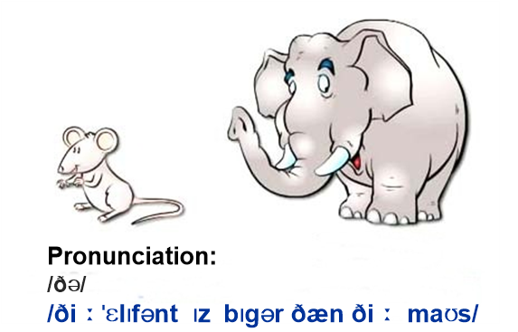  Instructions:  1) Listen and repeat.  Say the sentence one at a time, nominating choral and individual drilling.  Ss – repeat ‘the elephant is bigger than the mouse’  Show PPT 3 (starbucks coffee image)---------------Dialog. (eliciting and guided discovery)  - Let’s see another example, ln the cafe. you can compare their size, determining which is bigger.  <situational context> ---- In starbucks  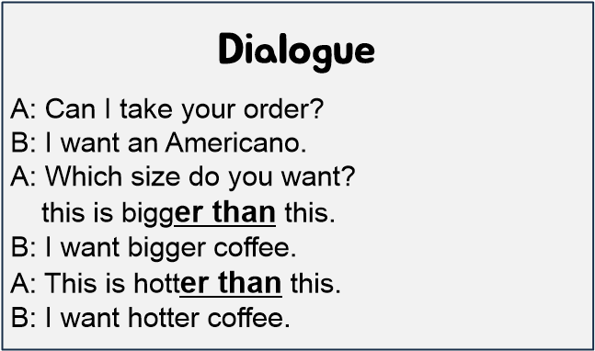  - When we order coffee, how can we tell the size? (big size, small size..)  - Yes, this is bigger than short size coffee.  Show PPT 4-5 (comparative adjectives image)  Instructions  1) Look at the pictures, and speak what comparative adjective is proper.  Ss Speak | T  T-S  T  S  T  S  T-S | 30  sec  1min  1min  30  sec  1min  30  sec  1min

Stage 3: Controlled Practice  The purpose of this stage is to allow the students to accurately practice working with the target language by doing easy, or controlled tasks. This helps build confidence before trying something more challenging. Students should apply the rules that were presented in a meaningful way whenever possible. Peer-checking before feedback is important in these practice stages. | Inter  action | Time | Instructor’s comments
Give worksheets 1 for each.  Instructions:  1) Read and answer the worksheet individually.  2) then, Check the answer with your partner.  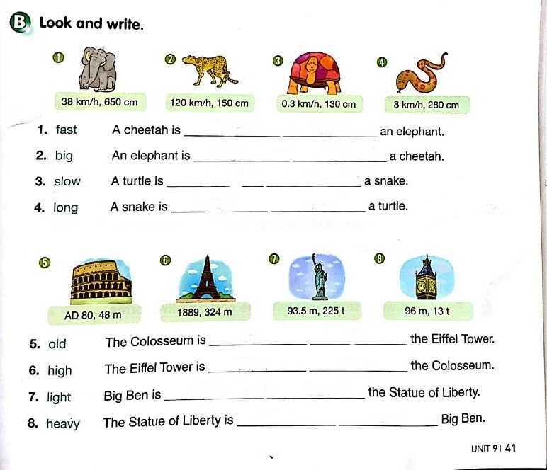  Ss read the worksheet once individually. Monitor closely for correct phonology and accuracy  Pair checking  Feedback: Nominate a student(s) who really did well.  Error correct by nominating weak students, using stronger students are as a model.  Refer to board as needed.  CCQs to establish meaning.  1) Do we use comparatives when we compare 3 things? (yes)  2) Do this comparatives only used in comparing size? (No)  3) When we can use comparison? (when we compare size, speed, appearance,..etc.) | T  S  T-S | 30  sec  2min  1min
Stage 4: Less controlled practice  The purpose of this stage is to allow students to practice the target language more thoughtfully, in terms of either structure manipulation, meaning, function or other aspects of language. Accuracy is checked before moving to the next stage. | Inter  action | Time | Instructor’s comments
Instruction:  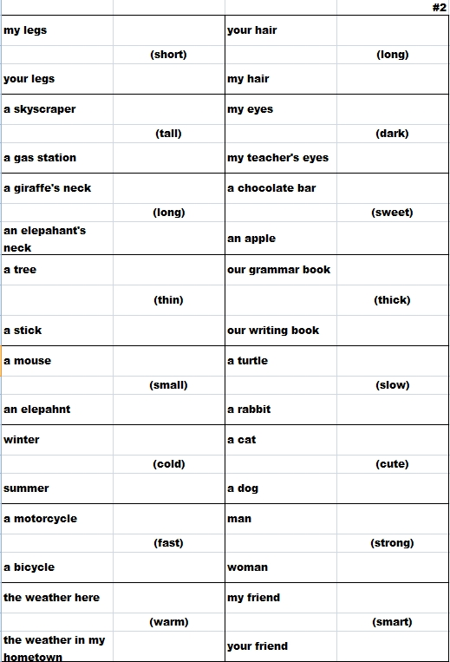  -" Okay, you'll practice to make comparison sentence in this time."  -Explain how to do activity.(Show them the cards)  "One student draws a card and makes two comparative sentences using the two nouns and adjective on the card. “  For example: My legs/ Your legs (short)  Student sentence: My legs are shorter than your legs.  Your legs are shorter than my legs.  "The other students in the group judge whether the sentence used the correct comparative form and decides if it is logical/correct."  "Take turns in pairs choosing cards and making sentences until you finish all the cards or time is up."  (Make comparison sentence using the opposite adjective on the card if time is enough.)  I.C.Q  - "Are you clear with what you are doing?"  - Set the time “you have 5 min.”  -Hand out comparison card set. #2  - "Start the activity."  Practice  (Teacher monitors discreetly students, if they ask some questions, answer. Give time warning. )  - Finish the activity.  - "Okay, you guys good job !"  - "Let's share your sentences.(nominate and check students did correctly. If they make mistakes, fix it immediately.) | T  S-S  T-S | 1min  30  sec  5min  30  sec
Stage 5:_Freer Practice  The purpose of this stage is to allow student to practice using the target language productively in an authentic way. The focus is to encourage fluency, not accuracy, therefore errors should be monitored and only addressed if necessary. Correction should be given during the next stage. | Inter  action | Time | Instructor’s comments
Instruction:  - ”Now, we will do another activity, Comparative Board Game."(Show them #3.)  - Work in group of 3~4.  - "First, decide order. Roll the dice in turn. Make comparison sentence using the comparatives  in the boxes."  - Peer check.  - "If you didn't make the sentence, there would be no opportunity to roll the dice for the next time."  - "If you arrive arrow or directives, follow the instruction."  - "The first people arrive in the end wins.”  - "If time's up, finish the game."  I.C.Q  - "Are you clear with what you are doing?"  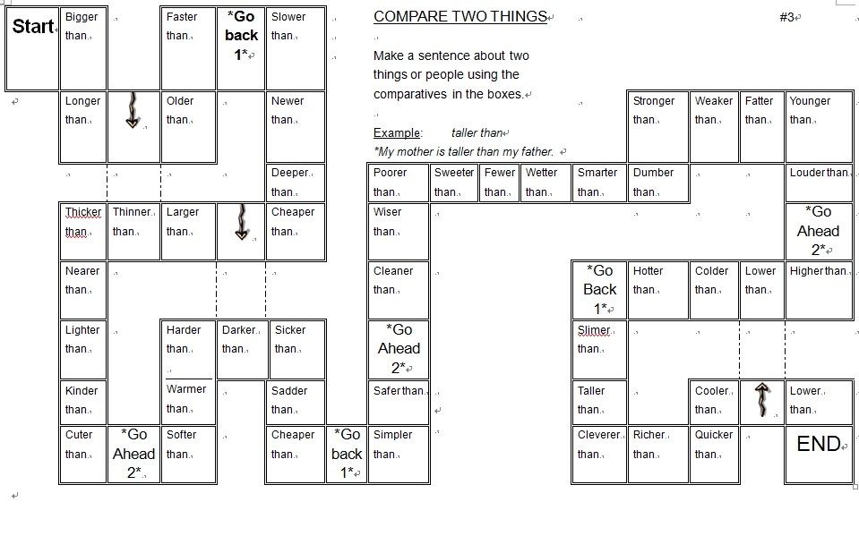  - Check the rules of game.  - Set the time “You have 10 min.”  - Distribute the handouts.#3  - Start the activity.  - Monitor the students.  - Finish the activity.  - Give feedback. | T-S  S-S  T-S | 1min  10 min  30sec

Stage 6:_Wrap-up  The purpose of this stage is to end the lesson with some positive feedback about the lesson and the students’ participation. Review the main points briefly, either deductively or inductively, or perhaps during error correction. Classroom management should be considered, such are collecting worksheets, giving homework, stimulate interest in the next class or arranging the desks etc. | Inter  action | Time | Instructor’s comments
Wrap-up :  -General feedback and summary  - "Everybody, let's think about what you have learned today."  " Would you tell what you have learned?"  -Get the answers.  (Ask to students in class. If there is no one to answer it, nominate some of students and let them answer.)  -Write them on the board :  The form. A is adjective + -er than B.  -"Well done, everyone. Did you enjoy the class?"  Closing:  - Notice the next class.  -"Okay, we'll learn about the comparative of two-syllable adjective and three-syllable adjectives."  - "See you next class." | T-S | 1min  30  sec
Instructor’s Final Comments
Overall strengths of this lesson (planning and teaching) | Areas to work on

Overall comment

For this stage of the course, your lesson today was

- Above standard

- To standard

- Below Standard

Instructor: …………………………… Date: …………/……………/………… Student/s: ……………………….. .…………………………..

Language Analysis Sheet – Grammar
Item:  The elephant is bigger than the mouse. | Anticipated Problems | Possible solutions
Meaning: the act of comparing two or more people or things the act of comparing two or more people or things  - big: large in size or amount  - the act of comparing with the elephant and the mouse | Meaning:  SS may be unfamiliar with some adjectives. | Teach some adjectives before starting the class.
Form:  Subject + be verb + adjective(er) + than  Adjective(er): taller; smaller; faster. | Word order: e.g. The elephant is than bigger the mouse.  May be due to confusion in mistakenly expressing ability to use comparative word order.  Word form: e.g. fater, sader.  Don't know how to form the rules of 1 syllable comparative words. | Exercise comparative word order.  e.g. The elephant bigger is than the mouse.  Practice the formation rules of 1 syllable comparative words.  e.g. fatter, sadder.
Pronunciation:  /ðə/  /ðiːˈɛlɪfənt ɪz bɪgər ðæn ðiː maʊs/  ⓘ One or more forum threads is an exact match of your searched term. Click here. | - Pronunciation of consonant + -er  - Double consonant + /ər/ | - Board and highlight pronunciation.  - Drill chorally and individually

