Background Information Sheet

|  |  |  |  |  |  |  |  |  |  |  |  |  |
| --- | --- | --- | --- | --- | --- | --- | --- | --- | --- | --- | --- | --- |
| **Name & Class** | **Date & Place** | | **Lesson** | | **Plan** | | **Topic** | | | **Length** | **Level** | |
| **Lisa & Rose** | **10/19/2016**  **Room 601** | | Grammar | | PPP | | Determiners (This, These, That, Those) | | | 40mins | Elementary | |
| **Class profile**  **Number of students:** 10 **Age**: 25-35 years  **Nationality: korean**  **Motivations**: e.g. 1. Demonstrating knowledge and understanding 2. Building research skills 3. Developing powers of independent reasoning 4. Writing for oneself and others 5. Preparing for professional practice 6. Social relationships 7. External expectations 8. Social welfare 9. Personal advancement 10. Escape/stimulation 11. Cognitive interest  **Individual or class hobbies and interests:** Students are interested in learning grammar.  **Special considerations:** (Refer to individual Learner Differences List): | | | | | | | | | | | | |
| **Main aim** (language focus / ~~skills~~)  Students will understand the meaning of new words and be able to use the words in grammatically correct sentences.  **Subsidiary aims** (language focus / skills)   1. Students practice spontaneous speaking during the freer practice. 2. Students practice fluency using the target language. | | | | | | | | | | | | |
| Description of language skills specifically used/practiced:  * Speaking – Spontaneous dialog during freer practice * Writing – Answering worksheets | | | | | | Description of language systems specifically used/practiced:  * Phonology – stress and intonation words. * Grammar - How to use determiners correctly. * Discourse – informal dialogue between students. | | | | | | |
| Anticipated difficulties with lesson activities and classroom management:  1. Students can’t distinguish this and these well. 2. Students don’t know plural nouns exactly. | | | | | | | | | | | | |
| **How I can deal with these difficulties:** Teacher provides more examples.  1. Demonstrate to the students using pictures. | | | | | | | | | | | | |
| **Assumptions:** Students can solve worksheets easily by themselves. They also have strong interpersonal intelligence and get more confident to make a sentence by themselves. | | | | | | | | | | | | |
| **Material(s) needed: PPT, pictures, board game, dice, board, pens, worksheets, and eraser.** | | | | | | | | | | | | |
| Checklist. Tick those included in this lesson plan (or N/A) | | | | | | | | | | | | |
| model sentences for target language | | v | | concept questions for target language | | | | v | analysis sheet for target language | | | v |
| stages clearly titled and separated | | v | | purpose of each stage indicated | | | | v | anticipated timing included | | | v |
| interaction pattern marked | | v | | a board plan (if relevant) | | | | n/a | examples of all tasks used | | | n/a |
| answer sheet to all exercises | | v | | tape script | | | | n/a | all materials labelled and numbered | | | v |
| **Personal aim :** What I most hope to demonstrate in this lesson is the ability to follow the lesson plan correctly and follow the time management. | | | | | | | | | | | | |

|  |  |  |  |
| --- | --- | --- | --- |
| **Stage 1:_Lead-in**  **The purpose of this stage is to relax both teacher and students by focusing their attention on an interesting subject and encouraging the class to share their opinions freely, thus increasing STT and participation. This stage should be used to create an appropriate situational context.** | **Inter**  **action** | **Time** | **Instructor’s comments** |
| **Teacher (Lisa & Rose) :**  **Good morning class! How are you today?**  **Today we are your grammar teachers ( introduce us)**  **Teacher Rose:**  **-Show a picture using ppt. and teacher will draw thought bubble above the boy’s head.**  **Ask questions 1 and 2, and talk with their partner.** **화면 캡처**  **Questions:**   1. Where are they? (they are in the toy store) 2. Mom asks to the boy “Do you like this toy? (no) 3. Can you guess what does the boy think about? (different answers)  * I want you to share your answers with your partner. * Get feedback from the students and nominate   .   * Write on the board, all of the student’s answer.   **Now show them the model sentence**  **.**   * **“I want to buy this toy car:”**   **C.C.Q**  **1.** Does he like that robot? (No)  **2.** Does he like a toy car? (yes) | T  T-S  S-S  T-S  T | 15sec  45sec  1min  1min |  |

|  |  |  |  |
| --- | --- | --- | --- |
| **Stage 2: Presentation**  **The purpose of this stage is to teach the target language inductively, referring to the situational context from the lead-in. Meaning, form and pronunciation should be covered with appropriate methods such as a model sentence, CCQs, timelines, substitution tables and indication of phonology etc.** | **Inter**  **action** | **Time** | **Instructor’s comments** |
| **Teacher Lisa**  **Using the model sentence “I want to buy this toy car.**  **-Teacher will speak 3 sentences.**   1. I want to buy this toy car. 2. I don’t want to buy this robot. 3. Do you want to buy this toy car?   - Can you repeat after me? Students will repeat what the teacher says.  - Nominate some students to drill.  **Instruction(material:picture cards)**   1. Look at this. I have a present box. Let’s guess what’s inside. 2. What’s this? This is a book. Teacher moves a few steps from it. 3. Am I near or far from a book? (using gesture) SS will answer far. In that case I will use “that” 4. Now I will ask What’s that? That is a book. 5. Pick 5 more cards and practice.   Draw substitution table on the board showing the differences between this, these, that and those.  Teacher will explain.   |  |  |  |  |  | | --- | --- | --- | --- | --- | | **I** | **want** | **to buy** | **this** | **toy car.**  **pencil.** | | **that** | | **these** | **robots.**  **pencils.** | | **those** | | T  T-S  T-S  T-s | 30sec  30sec  5 min  3 min |  |

|  |  |  |  |
| --- | --- | --- | --- |
| **Stage 3: Controlled Practice**  **The purpose of this stage is to allow the students to accurately practice working with the target language by doing easy, or controlled tasks. This helps build confidence before trying something more challenging. Students should apply the rules that were presented in a meaningful way whenever possible. Peer-checking before feedback is important in these practice stages.** | **Inter**  **action** | **Time** | **Instructor’s comments** |
| **Instructions:**   1. I will give you worksheets, please circle the correct answer on the paper. 2. Hand out the worksheets1# 3. Explain the situation, Let’s think we are in front of the first desk 4. Think of question number 1 is computer near or far? ( so the student will say far ) 5. Give sample answer, So the answer is ( that). 6. You can start now.   Students will answer the worksheets. **Monitor closely** if they answering correctly.     * If students finish ask them to compare their answers with their partners. * **Feedback :** Nominate a students for each group.   . | T  S  S-S  T-S | 2min  1min  1min  1min |  |

|  |  |  |  |
| --- | --- | --- | --- |
| **Stage 4: Less controlled practice**  **The purpose of this stage is to allow students to practice the target language more thoughtfully, in terms of either structure manipulation, meaning, function or other aspects of language. Accuracy is checked before moving to the next stage.** | **Inter**  **action** | **Time** | **Instructor’s comments** |
| **Instructions:**   1. Show them the worksheet.2# 2. Explain and give an example number1.   (I want you to make a sentence according to the pictures)   1. Handout the worksheets to the students.You have three minutes. 2. Let them start to answer   (you can start now)  Students will answer the worksheets. **Monitor closely** if they answering correctly.   * If students finish ask them to compare their answers with their partners. * **Feedback :** Nominate students for each group.   .before revealing the correct answer. | T  S  S-S  T-S | 2min  3min  1min  2min |  |

|  |  |  |  |
| --- | --- | --- | --- |
| **Stage 5:_Freer Practice**  **The purpose of this stage is to allow student to practice using the target language productively in an authentic way. The focus is to encourage fluency, not accuracy, therefore errors should be monitored and only addressed if necessary. Correction should be given during the next stage.** | **Inter**  **action** | **Time** | **Instructor’s comments** |
| **Instructions:**   1. Show them the board game. 2. Ask them if they are familiar playing board game.   Today we will play board games with your partners.   1. Demonstrate how to play the board game   ( Lisa and Rose will demonstrate together )   1. The first pairs who will finish both will be considered as a winner team. 2. Hand out the board game sheets.   ICQ:How many groups do you have? (5)  Do you make sentence when you go to the next space? (yes)  How many spaces will you move?( same as dice number)  Now you can begin. Group-work. Monitor. | T  S-S | 2min  10min |  |

|  |  |  |  |
| --- | --- | --- | --- |
| **Stage 6:_Wrap-up**  **The purpose of this stage is to end the lesson with some positive feedback about the lesson and the students’ participation. Review the main points briefly, either deductively or inductively, or perhaps during error correction. Classroom management should be considered, such are collecting worksheets, giving homework, stimulate interest in the next class or arranging the desks etc.** | **Inter**  **action** | **Time** | **Instructor’s comments** |
| “We are finished today. Did you enjoy playing with your partners in our lesson?”  Encourage class to share their experiences while doing the activities.  Give highlights from the lesson.  Give brief explanation.  For homework draw 5 items and make sentences that we learn today.  Instruction:   1. Write your homework assignment down 2. Tomorrow we will check and compare your answers.   Students will write down their homework. Monitor  Thank you everyone for good work. We enjoyed watching your participation.  Well done today, See you tomorrow. | T-S  T | 1min  2min |  |

**Instructor’s Final Comments**

|  |  |
| --- | --- |
| Overall strengths of this lesson (planning and teaching) | Areas to work on |
| **Overall comment** For this stage of the course, your lesson today was   * Above standard * To standard * Below Standard | |
| **Instructor: …………………………… Date: …………/……………/………… Student/s: ……………………….. .…………………………..** | |

**Language Analysis Sheet - Grammar**

|  |  |  |
| --- | --- | --- |
| **Item:**  I want to buy this toy car. | **Anticipated Problems** | **Possible solutions** |
| **Meaning:**  **tell someone that I want the item**  **tell about person’s private preference**  **This/these –indicate something near**  **That/those-indicate something far** | Students can’t distinguish this and these well  Students don’t know plural nouns well | Show pictures to explain  Let them make sentences using determiners  Use realia |
| **Form:**  subject+verb+infinitive+determiners  +noun | Miss a word e.g.I want buy this.  Maybe due to confusion in mistakenly | Drilling sentences  Practice with substitution tables |
| **Pronunciation:**  ðɪs tɔɪ kar | Sentence stress and intonation | Drill chorally and individually. |

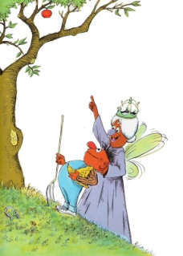

Worksheet 1

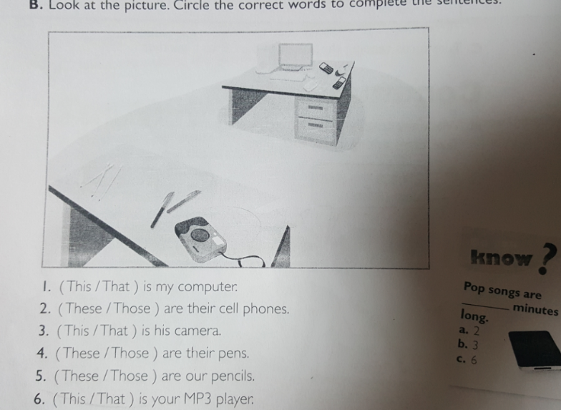

Answers

1.that

2.those

3.this

4.these

5.these

6.thaat

**Worksheet 2 answers**

**Make sentences according these pictures, Using This, These, That, and Those**

1.____________________________________. 2._____________________________________



These are oranges. Those are cookies.

3._____________________________________________ 4._________________________________________-



This is a dog. That is a bird.

5..________________________________________ 6.______________________________________________



These are socks. Those are shoes.

7.______________________________________________ 8._________________________________________________



This is a ruler. That is a board.

boa