Background Information Sheet
Name & Class | Date & Place |  | Lesson |  | Plan |  | Topic |  |  | Length | Level
Ahra & Sunah  TESOL 141WD | 10/19/2016 |  | Grammar |  | PPP |  | I have a ... |  |  | 40 min | Elementary
Class profile
Number of students: 10 Age: Adults Nationality: Korean / Filipino
Motivations: Social relationships , Personal advancement
Individual or class hobbies and interests: Current affairs
Special considerations: Some students know more grammar than others. Some students are shy to speak in class.
Main aim (language focus )
- Students learn the function of articles and use of articles in different situational contexts.
Subsidiary aims (language focus / skills)
- Students practice speaking fluency during the freer practice.
Description of language skills specifically used/practiced:  - Speaking - Expressing their ideas or opinions during the pair discussion, drill practice  - Writing - Making a dialogue  - Listening - Drill practice |  |  |  |  |  | Description of language systems specifically used/practiced:  - Grammar - Using proper articles  - Discourse - Social dialogue between friends, taking turns

Anticipated difficulties with lesson activities and classroom management:
1. There is a chance that the computer or internet is not working
2. If the students finish their tasks earlier than anticipated in freer practice
How I can deal with these difficulties:

1. Teachers come to class early and check the computer system. If it’s not working, write down dialogue on the board and show pictures by printed paper
2. Give students more time on post task (ask students to make more than 1 dialogue)
Assumptions: (That which provides insight about your choice of material, selection of target language etc.)
1. Students are adults
2. Students are used to the deductive teaching method
Material(s) needed: computer, projector, 5 copies of pictures

Checklist. Tick those included in this lesson plan (or N/A)
model sentences for target language |  | √ |  | concept questions for target language |  |  |  | √ | analysis sheet for target language |  |  | √
stages clearly titled and separated |  | √ |  | purpose of each stage indicated |  |  |  | √ | anticipated timing included |  |  | √
interaction pattern marked |  | √ |  | a board plan (if relevant) |  |  |  | √ | examples of all tasks used |  |  | √
answer sheet to all exercises |  | √ |  | tape script |  |  |  | n/a | all materials labelled and numbered |  |  | √
Personal aim : What I most hope to demonstrate in this lesson is the ability to maximize student talking time and give clear instruction

Stage 1:_Lead-in  The purpose of this stage is to relax both teacher and students by focusing their attention on an interesting subject and encouraging the class to share their opinions freely, thus increasing STT and participation. This stage should be used to create an appropriate situational context. | Inter  action | Time | Instructor’s comments
Ahra: A & Sunah: S  A & S: “Hello, everyone.”  A: “How are you?” Ss greet  Instruction  1) A do an action from the video (Pen-pineapple-apple-pen)  “Do you know this dance?” (Yes/No)  “Okay Look!”  2) (Play the video)  Ss watch the video.  <https://www.youtube.com/watch?v=d9TpRfDdyU0>  3) Pair the Ss.  “Talk to your partner. How was the video and what words you hear”  (fun, exciting, funny, good, and etc / words: pen, apple, and pineapple)  Feedback  As Ss are in elementary level, try to get answers by helping them with flash cards.  “Let’s talk about this together! Was it fun?” (Yes)  “What words did you hear, (Show mushroom flash card) did you hear the word ‘mushroom’?” (No)  (Show apple flash card) “did you hear the word ‘apple’?” (Yes)  (Show pen flash card) “What about this? did you hear the word ‘pen’?” (Yes)  “What else did you hear?” (expected: pineapple)  If Ss say a pineapple - show pineapple flash card “Yes, right!”  If no answer comes out - reveal the pineapple flash card from top the give them a hint  “So, where did he get a pineapple and an apple? Did he buy them?” (Yes) | T  S  S-S  T-S | 30 sec  1 min  30 sec  1 min

Stage 2: Presentation  The purpose of this stage is to teach the target language inductively, referring to the situational context from the lead-in. Meaning, form and pronunciation should be covered with appropriate methods such as a model sentence, CCQs, timelines, substitution tables and indication of phonology etc. | Inter  action | Time | Instructor’s comments
Instruction  Show PPT 1- Picture of the fruit seller and the guy in the market, talking. Situational context.  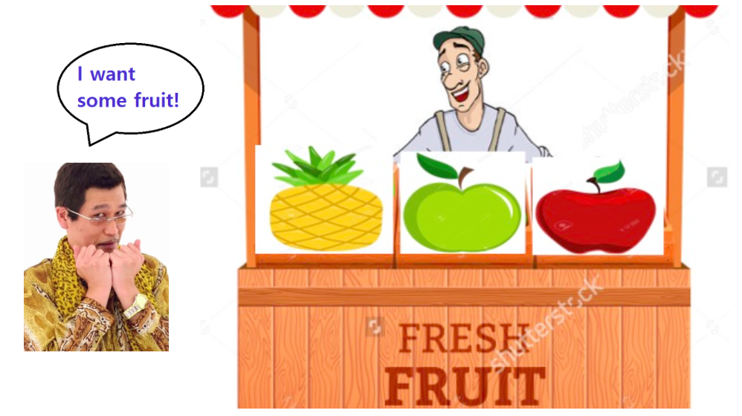  1) “Look at this picture. What do you think Kosaka is going to do?” (Buy fruits)  2) “Right! He is going to buy some fruit.”  2) (Show PPT 2) “This is the conversation between the fruit seller and Kosaka.”  3) “I will read it for you. Please listen carefully.” (T read the dialogue)  4) Ask CCQ.  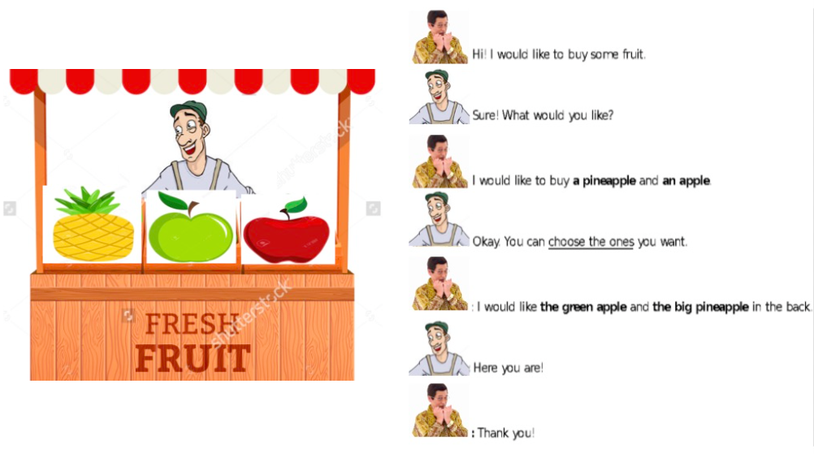  CCQ  1) “What does he want to buy?” (apple, pineapple)  2) “How many does he want?” (one of each)  3) “How many apples are there?” (two)  4) “What color does he want?” (green apple, a green apple, the green apple)  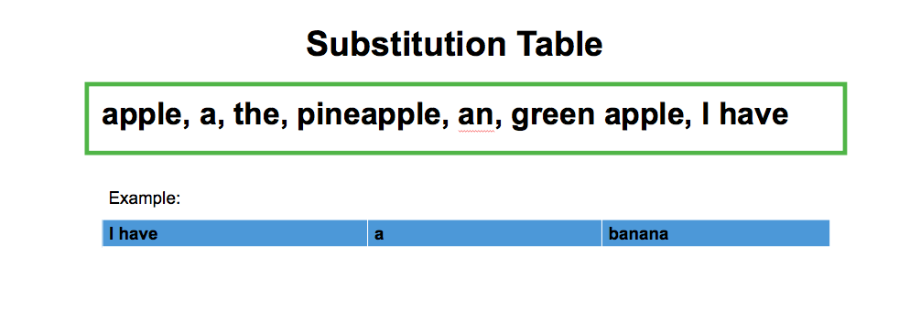  Substitutional Table  Show PPT 3  1) “Now, let’s look at this substitutional table.”  2) “In the box, words are not written in grammatical order. Every one will help me to arrange these words in order in the substitutional table.”  3) “Here is an example” -----> “I have a banana”  4) (T draw the substitutional table and ask students)  “Can anyone tell me which word comes first? second? last?”  5) “Write down the words on the substitutional table.” | T-S | 1 min  1 min  3 min

Stage 3: Controlled Practice  The purpose of this stage is to allow the students to accurately practice working with the target language by doing easy, or controlled tasks. This helps build confidence before trying something more challenging. Students should apply the rules that were presented in a meaningful way whenever possible. Peer-checking before feedback is important in these practice stages. | Inter  action | Time | Instructor’s comments
Instruction  1) “I will distribute a worksheet for everyone.”  2) “First, write down answers yourself.”  3) “Then, compare your answers with the partner, discuss why that is the answer there.”  4) “I will give 3 min to work”  ICQs  1) “Do you talk to your partner first?” (No, work myself)  2) “How long do you have?” (3 min)  T handout the worksheet.  Ss work individually.  Then, Ss talk to the partner, discuss the answer.  T monitor, give help if needed.  Feedback  Nominate pairs for each question to read with the answers. | T  T-S  S  S-S  T-S | 30 sec  30 sec  3 min  1 min

Stage 4: Less controlled practice  The purpose of this stage is to allow students to practice the target language more thoughtfully, in terms of either structure manipulation, meaning, function or other aspects of language. Accuracy is checked before moving to the next stage. | Inter  action | Time | Instructor’s comments
Instruction  Show PPT 4  1) “What is this picture about?” (Christmas)  2) “Right! This is a picture of Christmas! You will talk about this picture with your partners.”  3) “Here is the list of items that are in the picture.” (Show PPT 5)  “Please use “a”, “an”, and “the” and explain the items that you see in the picture to your partners.”  4) Teachers show a demonstration  A: I see a snowman!  S: Oh! I see the snowman too! I see a tree.  5) “I will give you 5 min to discuss this with your partners.”  Give handout(PPT 5) to Ss.  Expected answers:  I see a sleigh, I see a reindeer/I see the reindeers, I see a bag of gifts, I see a snowman, I see an ornament/I see the ornaments, (the red one, the orange one, the blue one), I see a tree/I see the trees, I see a house, I see the moon, I see the snow, I see a/the Christmas reef, I see a snowflake, I see a scarf, I see the gloves, I see the smoke, I see a chimney.  Students talk to pairs for 5 minutes  Teachers walk around and monitor students’ activity.  Write down errors if I hear any.  Feedback  Can each group tell me the sentences that you made with partners? | T  S-S  T-S | 2 min  5 min  3 min

Stage 5:_Freer Practice  The purpose of this stage is to allow student to practice using the target language productively in an authentic way. The focus is to encourage fluency, not accuracy, therefore errors should be monitored and only addressed if necessary. Correction should be given during the next stage. | Inter  action | Time | Instructor’s comments
Instruction  1) “We’ll do another activity at this time!”  2) “I have 2 different pictures. (Show PPT 6) What do you see here (Point to the left picture)?”  (robbery, Policeman, old man, truck, dogs, and etc.)  3) “Yes, I will ask each pair to work on one picture.” (assign which picture to work on for each group)  4) “Now, imagine this is happening in front of you and your partner.”  5) “What would you and your partner talk about? Make a conversation and write it down.”  “Use one ‘a’, one ‘an’, and one ‘the’ in the conversation.”  “Also, the conversation has to be 5 turns or more. (Point to one student) you talk once, (Point to his/her partner) and partner talks once, that is 1 turn.”  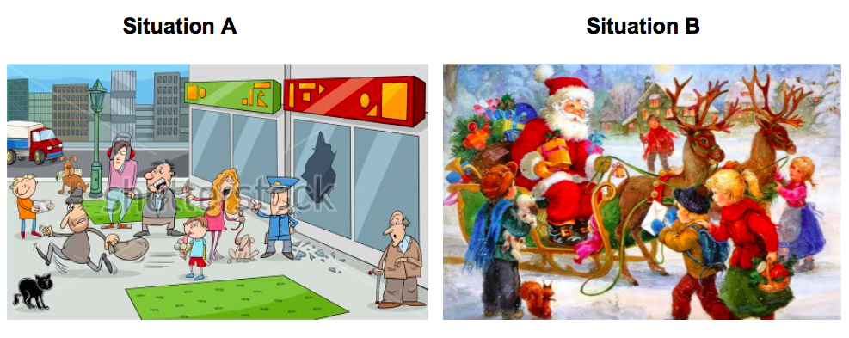  6) “I will give you 8 min to work”  “Do you have questions?” (Yes/No)  ICQs  1) “Do you work alone?” (No)  2) “What you have to use in the conversation?” (a, an, the)  3) “How long do you work?” (8 min)  Handout pictures to Ss.  Ss work in pair  T monitor, assist Ss when they stuck. Note significant errors and common errors.  Feedback  Nominate 2-3 pairs to present their conversation. | T  S-S  T-S | 2 min  8 min  2 min

Stage 6:_Wrap-up  The purpose of this stage is to end the lesson with some positive feedback about the lesson and the students’ participation. Review the main points briefly, either deductively or inductively, or perhaps during error correction. Classroom management should be considered, such are collecting worksheets, giving homework, stimulate interest in the next class or arranging the desks etc. | Inter  action | Time | Instructor’s comments
Error Correction  Write the problem sentence on the board and ask students to correct it.  If there is no errors; Example correction: I see the Santa / I see the Rudolph  Announcements  “It’s time to finish today’s lesson! Did you enjoy the lesson today?”  (Encourage class to share their highlights)  We don’t have homework today!  Please push in your chairs and arrange the tables before you leave.  Class dismissed | T-S  T | 4 min  1 min
Instructor’s Final Comments
Overall strengths of this lesson (planning and teaching) | Areas to work on

Overall comment

For this stage of the course, your lesson today was

- Above standard

- To standard

- Below Standard

Instructor: …………………………… Date: …………/……………/………… Student/s: ……………………….. .…………………………..

PPT 1

PPT 2

PPT 3
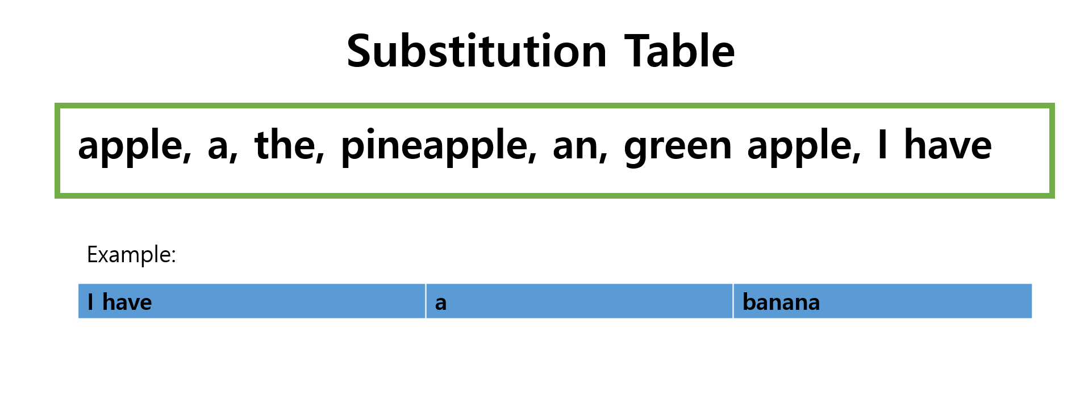

PPT 4

PPT 5

PPT 6

Picture (Situation A)

Picture (Situation B)

