< Worksheet 1 >
Read the text again. And put T (True) or F (False) next to each questions.

1) The word tip comes from an old English slang word that means service.
2) A tip shows that the customer is pleased with the service.
3) People such as parking valets or bellhops usually get higher tips.
3) Although you received bad service, you should tip for service providers.

< Worksheet 2 >
Check ( V ) the statements that describe appropriate tipping behavior. For the other items, what is acceptable?

1) Your haircut costs $30. You love it. You tip the stylist $2.

2) Your fast-food meal costs $8. You don’t leave a tip.

3) A porter at the airport helps you with three suitcases. You tip him $6.

답 지우고 11장 프린트!

Answer : 1)F 2)T 3)F 4)F
Answer : 1) - 2) V 3) V

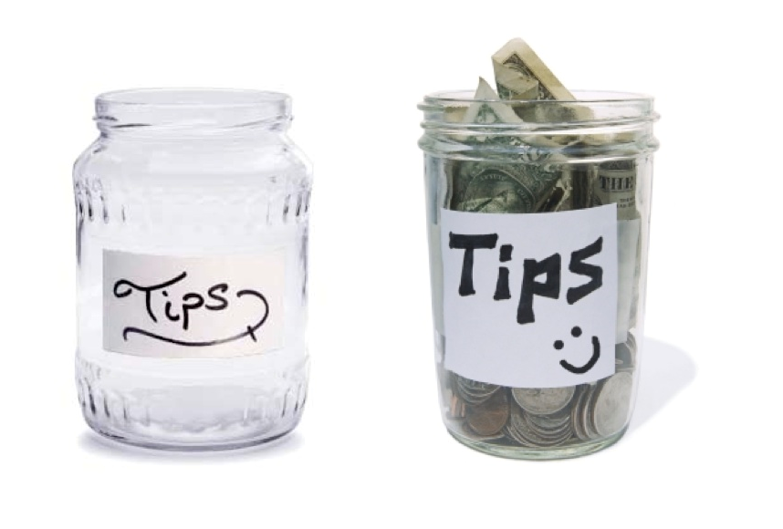
To tip or Not to tip?

The word tip comes from an old English slang word that means to give. It’s both noun and a verb. Americans usually tip people in places like restaurant, airports, hotels, and hair salons.

People who work in these places often get paid low wages. A tip shows that the customer is pleased with the service.

Sometimes it’s hard to know how much to tip. The size of the tip usually depends on the service. People such as parking valets or bellhops usually get smaller tips. The tip for people such as taxi drivers and waiters or waitresses is usually larger.
Here are a few guidelines for tipping in the United States:

Airport porters or hotel bellhops : $1 or $2 for carrying each suitcase
Parking valets : $1 for parking a car
Hotel door attendants : $1 or $2 for getting a taxi
Hotel maids : $1 to $5 per night
Taxi drivers : 15 percent of the bill; more if they help you with bags
Waiters and waitresses : 15 to 20 percent of the bill(There is no tipping in fast-food restaurants.)
Barbers or hairstylists : 15 percent of the bill

When you’re not sure about how much to tip, do what feels right. You don’t have to tip for bad service. And you can give a bigger tip for very good service. Remember, though, your behavior is more important than your money. Always treat service providers with respect.





